**Project Name** : Pokemon RYB on FPGA

**Project Details** :

Implement the fighting part in Pokemon Red/Yellow/Blue on the Basys 3 FPGA

USE VGA display and additional control

***Topic & cover :*** Finish the cover scene & scenes transition

***Basic :*** Complete fight scene(no special effect like skill animation or screen shaking) and attack functions

***Advance :*** Allow choosing multiple pokemon and fighting on two board

***Final (hope) :*** Fully reproduce the pokemon fighting system of the original game

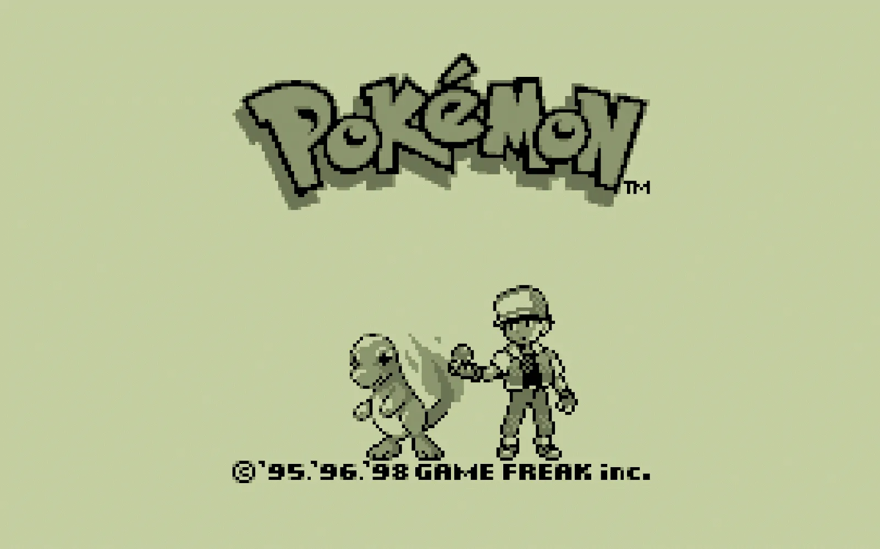cover

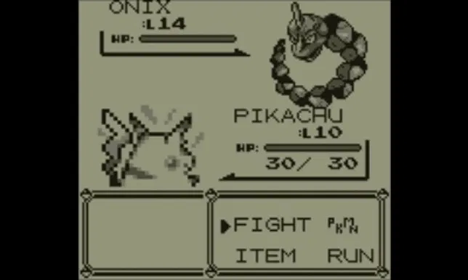

Battle scene

**Estimated cost** :

Controller : Keyboard($0)

Jumper * 30($200)

Speaker ($300)

Monitor : Already got one

**Schedule**