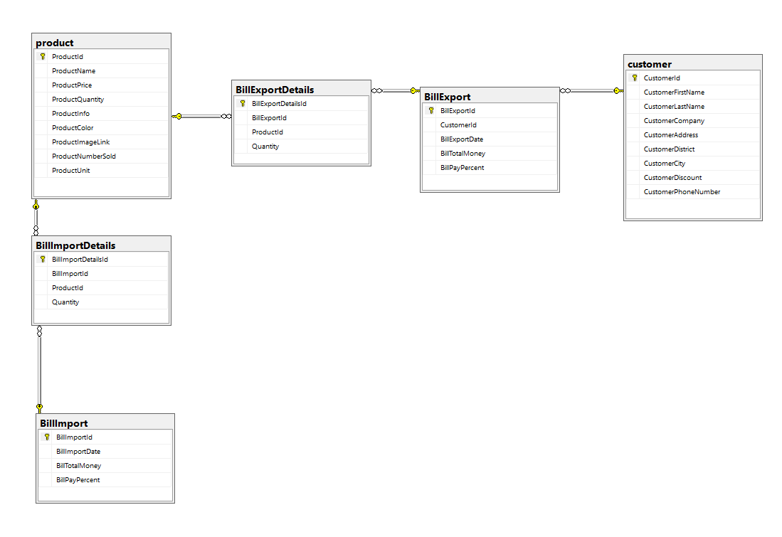

* Customer:
* CustomerId
* CustomerFirstName
* CustomerLastName
* CustomerCompany
* CustomerAddress
* CustomerDistrict
* CustomerCity
* CustomerDiscount(%)
* CustomerPhoneNumber
* Product
* ProductId
* ProductName
* ProductPrice
* ProductQuantity
* ProductInfo
* ProductColor
* ProductImageLink
* ProductNumberSold
* ProductUnit
* BillImport:
* BillImportId
* BillImportDate
* BillTotalMoney
* BillPayPercent
* BillExport:
* BillExportId
* CustomerId
* BillExportDate
* BillTotalMoney
* BillPayPercent
* BillImportDetails:
* BillImportDetailsId
* BillImportId
* Quantity
* ProductId
* BillExportDetails:
* BillExportDetailsId
* BillExportId
* Quantity
* ProductId