MOBILE MONEY FRAUD DETECTION
TrustRail
A machine-learning fraud detection console for mobile money transactions — synthetic-data MVP demonstrating end-to-end pipeline design, model evaluation discipline, and analyst-facing explainability.

0.987  PR-AUC (test set) | 95.1%  Recall @ 0.5 threshold | 0.15%  False positive rate

Executive Summary
TrustRail is a portfolio project demonstrating a complete fraud detection pipeline for mobile money transactions — the kind of system used by platforms like MTN MoMo, OPay, and PalmPay to catch account takeover, SIM-swap fraud, smurfing, and money-mule activity before funds settle.
Because production transaction data isn't available for a portfolio build, the project uses a synthetic dataset engineered to mimic real Nigerian mobile money behavior — including deliberately realistic overlap between legitimate and fraudulent transactions, so the model's performance numbers reflect a genuine precision-recall tradeoff rather than an artificially perfect score.
The result is a gradient-boosted risk model evaluated on operationally meaningful metrics, wired into an interactive case-review console that shows how an analyst would actually work the flagged queue.

The Problem
Mobile money fraud is asymmetric: fraud accounts for roughly 1–2% of transaction volume, but each missed case can mean a customer's entire balance drained in minutes. A usable detection system has to satisfy three competing constraints:
- Catch fraud fast enough to intervene before funds are withdrawn
- Keep false positives low enough that legitimate customers aren't blocked or delayed
- Give analysts a reason for every flag — a raw probability score isn't actionable on its own
Plain accuracy is meaningless here: a model that predicts "not fraud" every single time already scores above 98%. The evaluation approach has to be built around that imbalance from the start.

Approach
The system is built as four stages, each one testable and replaceable independently:

1. Synthetic Transaction Ledger
20,000 transactions across 2,000 synthetic users, with four injected fraud patterns: SIM-swap takeover, account takeover, smurfing (structuring under reporting thresholds), and mule-velocity funneling. 30% of fraud cases are deliberately "stealthy" — blending amount, timing, or device signals into the normal range — so the dataset isn't trivially separable.

2. Feature Engineering
Rolling per-user and per-recipient windows (1h / 24h / 7d transaction velocity, 30-day amount z-score, device and SIM change flags, recipient account age) computed with strict time-causality — every feature for a transaction is derived only from what happened before it, avoiding lookahead leakage.

3. Risk Model
A gradient-boosted tree classifier (XGBoost-class model) trained on a time-based 80/20 split — the model is trained on earlier transactions and tested on later ones, mirroring how it would actually be deployed. Class imbalance is handled with weighted loss rather than naive resampling.

4. Explainability Layer
Every flagged transaction surfaces the specific factors that drove its score (e.g. "recipient account is 4 days old," "12x the sender's typical amount"). In this build the explanations are generated with rule-based logic derived from the model's own top features; the planned production version calls the Claude API to render the same reasoning in natural analyst-facing language.

The Console
TrustRail's front end is a single-page monitoring console: a live scanning ledger showing transactions being scored in real time, model performance panels, and an interactive case-review table.
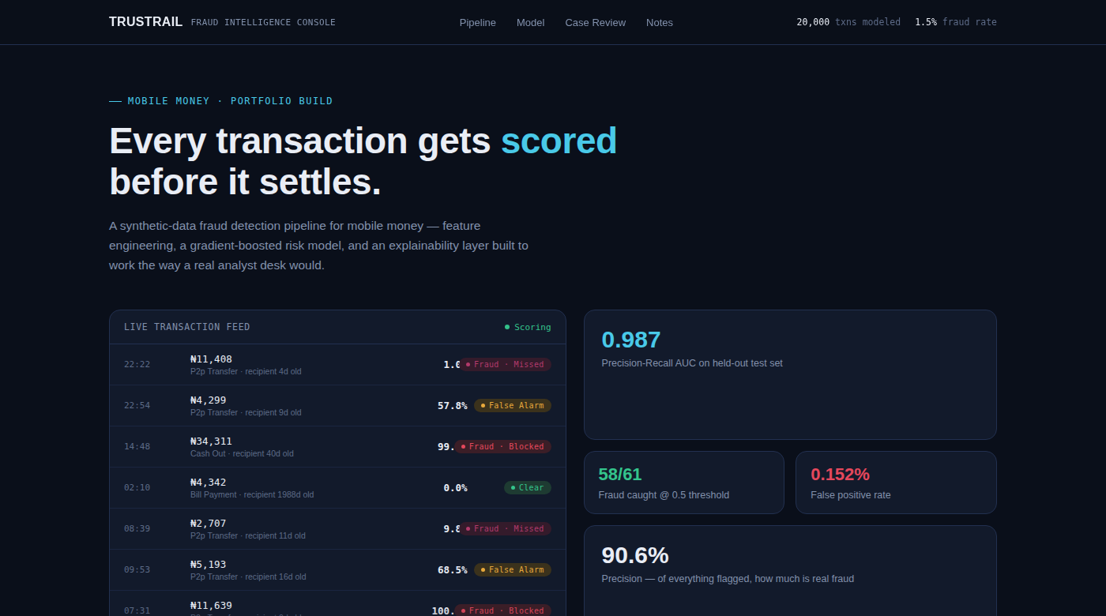
Live transaction feed and headline model metrics
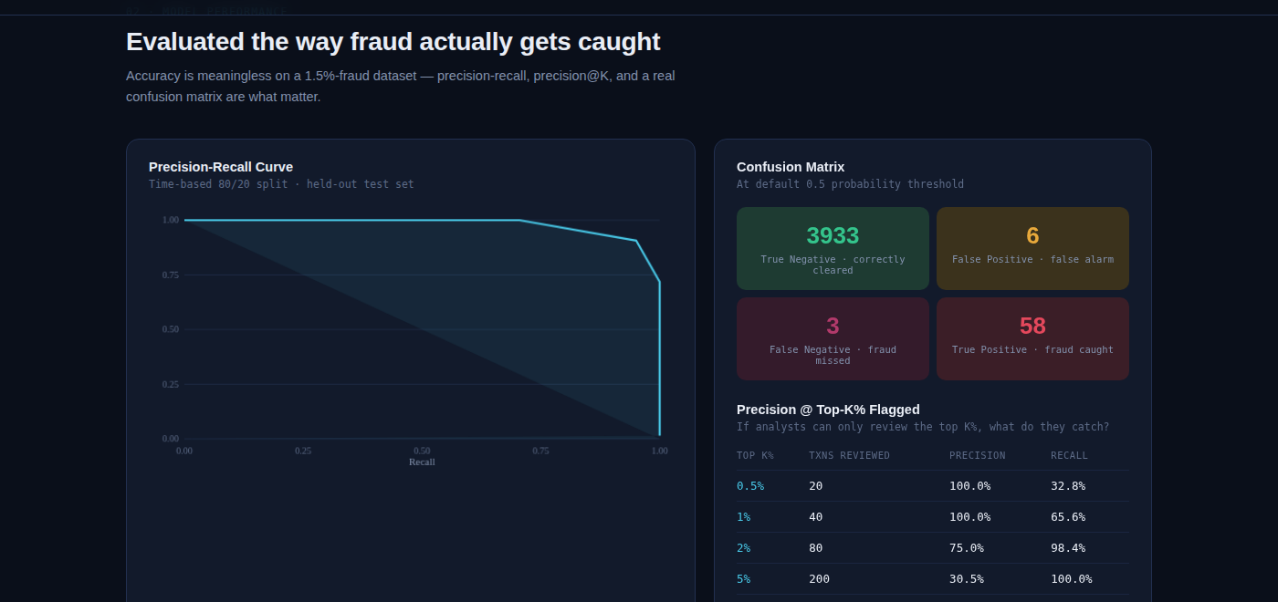
Precision-recall curve, confusion matrix, and precision@K operating table
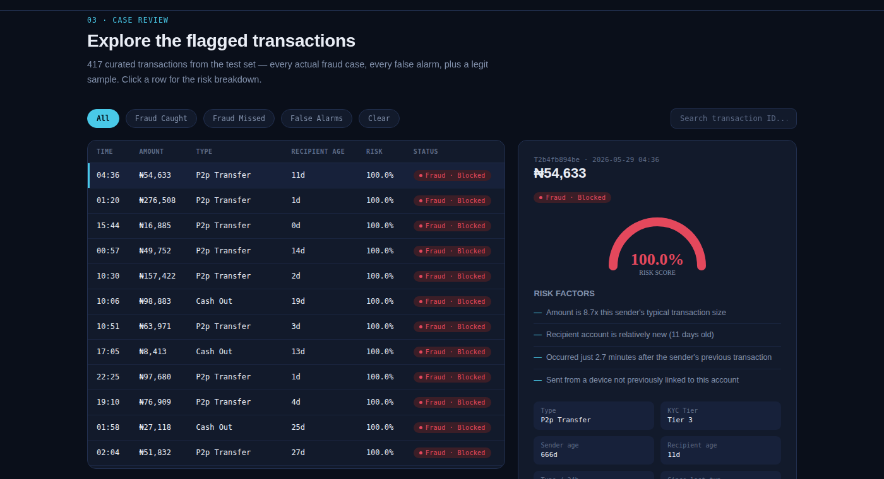
Case review: risk gauge and generated risk-factor breakdown for a flagged transaction

Model Performance
Evaluated on a held-out test set of 4,000 transactions (61 actual fraud cases), using metrics chosen for an imbalanced fraud-detection problem rather than plain accuracy:
Confusion Matrix @ 0.5 threshold
Outcome | Count | Meaning
True Negative | 3,933 | Legitimate transaction, correctly cleared
False Positive | 6 | Legitimate transaction, incorrectly flagged
False Negative | 3 | Fraud transaction, missed by the model
True Positive | 58 | Fraud transaction, correctly caught
Precision @ Top-K% Flagged
This is the operational view: if analysts can only review a fixed share of transactions, how much fraud gets caught?
Top K% | Txns Reviewed | Precision | Recall
0.5% | 20 | 100.0% | 32.8%
1% | 40 | 100.0% | 65.6%
2% | 80 | 75.0% | 98.4%
5% | 200 | 30.5% | 100.0%
10% | 400 | 15.3% | 100.0%
Top Features by Permutation Importance
Feature | Importance | What it captures
recipient_account_age_days | 0.588 | How new the money's destination account is
amount_vs_user_avg_ratio | 0.356 | How far the amount is from the sender's own norm
time_since_last_txn_min | 0.173 | Speed of repeat activity on the account
is_new_device | 0.036 | Whether the sending device is recognized
txn_count_last_24h | 0.023 | Transaction velocity in the past day
Notably, where the money is going and how it compares to the sender's own history matter far more than raw transaction amount or device signals alone — a finding that should inform where future feature engineering effort goes.

Known Limitations
- All data is synthetic — no real mobile money platform data was used or is claimed to be represented here.
- The mule-detection network feature (unique senders to a recipient) shows limited signal in the current dataset and needs a longer-horizon graph feature to properly capture collusion patterns.
- The explainability layer uses rule-based text generation as a stand-in; the Claude API integration for natural-language analyst notes is planned but not yet built.
- A perfect or near-perfect score on an earlier version of this dataset was treated as a red flag, not a result — the fraud generator was deliberately made noisier to produce a defensible, realistic precision/recall tradeoff.

Technical Stack
- Data generation & feature engineering: Python, pandas, numpy
- Model: gradient-boosted trees (XGBoost-class), scikit-learn for evaluation
- Explainability (planned): Claude API
- Console: single-file HTML/CSS/JS, no build step or server dependency

