

**DataQuest**

Account Management Database

Sahil Nanavaty

IST 659 M400

Fall 2021

**Table of Contents**

**Part One** ………………………………………………………………………………………… 3

Summary ………………………………………………………………………………… 3

Stakeholders ……………………………………………………………………………... 3

Business Rules …………………………………………………………………………... 3

Data Questions …………………………………………………………………………... 3

Conceptual Model ……………………………………………………………………….. 4

Logical Model …………………………………………………………………………… 4

**Part Two** ………………………………………………………………………………………... 5

Data Definition Language (DDL) Statements …………………………………………... 5

INSERT Statements ……………………………………………………………………... 6

Answering Data Questions ……………………………………………………………… 8

Form Mock-Ups ………………………………………………………………………... 12

Reflection ………………………………………………………………………………. 13

**Part One**

**Summary**

A massively multiplayer online game (MMO) refers to a genre of video games in which large numbers of players cooperate, compete, and interact with each other on persistent online servers. MMOs typically allow players to create user accounts in which they can store and manage one or more virtual characters (in-game avatars). These characters can then be optionally subscribed into guilds – groups of players who share a common goal or interest. In order to better visualize and organize a character management system for its player base, the developers of a newly released MMO titled *DataQuest* would like to build a database to store membership data.

**Stakeholders**

* *DataQuest* Publishers
  + Financial backers in charge of publishing and distributing the game
* *DataQuest* Developers
  + Software developers in charge of coding the game and its account systems
* *DataQuest* Players
  + Players of the game

**Business Rules**

* Each account can either be designated as a premium tier (Tier 1) or a free tier (Tier 2).
* Each account must have at least one character associated with it. There are no restrictions on the number of characters allowed per account.
* Each character can optionally belong to one or more guilds.

**Data Questions**

* Who are *DataQuest’s* players and what is their contact information?
* What is the average age of *DataQuest’s* players?
* What are the account names, email addresses, and character names of DataQuest’s free-to-play players (Tier 2 accounts)?
* Are there players who chose not to join any guilds and, if so, what are their account names?

**Conceptual Model**

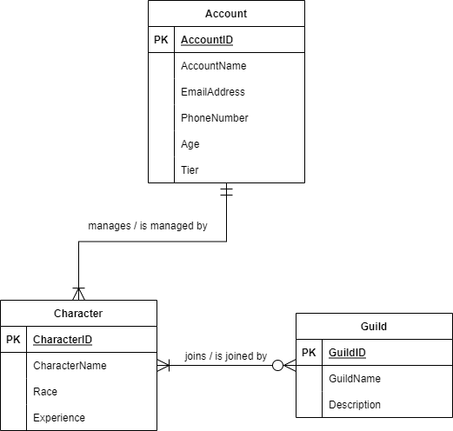

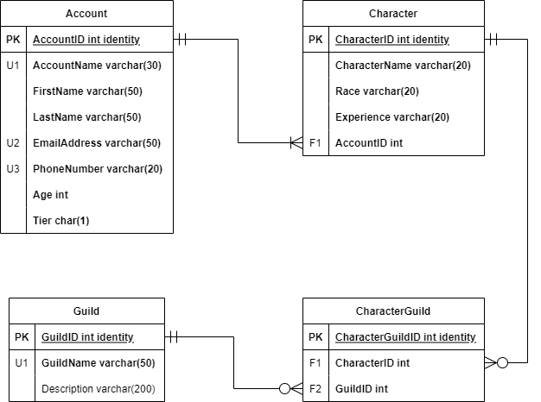**Logical Model**

**Part Two**

**Data Definition Language (DDL) Statements**

/*

Author : Sahil Nanavaty

Title : DataQuest Project

Course : IST659 M400

Term : December, 2021

*/

-- DDL STATEMENTS

-- Drop tables (when needed)

DROP TABLE CharacterGuild

DROP TABLE Guild

DROP TABLE Character

DROP TABLE Account

-- Creating the Account table

CREATE TABLE Account (

AccountID int identity PRIMARY KEY,

AccountName varchar(30) not null UNIQUE,

FirstName varchar(50) not null,

LastName varchar(50) not null,

EmailAddress varchar(50) not null UNIQUE,

PhoneNumber varchar(20) not null UNIQUE,

Age int not null,

Tier char(1) not null,

)

-- End creating the Account table

-- Creating the Character table

CREATE TABLE Character (

CharacterID int identity PRIMARY KEY,

CharacterName varchar(20) not null,

Race varchar(20) not null,

Experience varchar(20) not null,

AccountID int not null FOREIGN KEY REFERENCES Account(AccountID),

)

-- End creating the Character table

-- Creating the Guild table

CREATE TABLE Guild (

GuildID int identity PRIMARY KEY,

GuildName varchar(50) not null UNIQUE,

Description varchar(200),

)

-- End creating the Guild table

-- Creating the CharacterGuild table

CREATE TABLE CharacterGuild (

CharacterGuildID int identity PRIMARY KEY,

CharacterID int not null FOREIGN KEY REFERENCES Character(CharacterID),

GuildID int not null FOREIGN KEY REFERENCES Guild(GuildID),

)

-- End creating the CharacterGuild table

**INSERT Statements**

-- INSERT STATEMENTS (FOR THE SAKE OF READABILITY, ONLY THE FIRST 10 ROWS OF EACH TABLE)

-- Insert data into Account table

INSERT INTO Account (AccountName, FirstName, LastName, EmailAddress, PhoneNumber, Age, Tier) VALUES ('rwhardley0', 'Raynor', 'Whardley', 'rwhardley0@t.co', '819-964-0827', 19, 1);

INSERT INTO Account (AccountName, FirstName, LastName, EmailAddress, PhoneNumber, Age, Tier) VALUES ('ichaffin1', 'Ilsa', 'Chaffin', 'ichaffin1@alexa.com', '755-977-9471', 29, 1);

INSERT INTO Account (AccountName, FirstName, LastName, EmailAddress, PhoneNumber, Age, Tier) VALUES ('apena2', 'Aridatha', 'Pena', 'apena2@cargocollective.com', '602-256-4074', 22, 2);

INSERT INTO Account (AccountName, FirstName, LastName, EmailAddress, PhoneNumber, Age, Tier) VALUES ('mfollen3', 'Maryanna', 'Follen', 'mfollen3@apache.org', '206-757-0639', 24, 2);

INSERT INTO Account (AccountName, FirstName, LastName, EmailAddress, PhoneNumber, Age, Tier) VALUES ('hmacfarland4', 'Heddie', 'MacFarland', 'hmacfarland4@comcast.net', '327-712-4366', 17, 2);

INSERT INTO Account (AccountName, FirstName, LastName, EmailAddress, PhoneNumber, Age, Tier) VALUES ('fmoggach5', 'Freddy', 'Moggach', 'fmoggach5@360.cn', '875-510-3189', 24, 2);

INSERT INTO Account (AccountName, FirstName, LastName, EmailAddress, PhoneNumber, Age, Tier) VALUES ('lmackibbon6', 'Letitia', 'MacKibbon', 'lmackibbon6@meetup.com', '465-214-8915', 25, 1);

INSERT INTO Account (AccountName, FirstName, LastName, EmailAddress, PhoneNumber, Age, Tier) VALUES ('dscriven7', 'Doralia', 'Scriven', 'dscriven7@newsvine.com', '602-528-6005', 24, 1);

INSERT INTO Account (AccountName, FirstName, LastName, EmailAddress, PhoneNumber, Age, Tier) VALUES ('triggert8', 'Tyrone', 'Riggert', 'triggert8@eventbrite.com', '572-272-8814', 19, 2);

INSERT INTO Account (AccountName, FirstName, LastName, EmailAddress, PhoneNumber, Age, Tier) VALUES ('mbrunicke9', 'Mandie', 'Brunicke', 'mbrunicke9@yolasite.com', '853-654-2387', 28, 2);

-- Insert data into Character table

INSERT INTO Character (CharacterName, Race, Experience, AccountID) VALUES ('mgawthorpe0', 'Dwarf', 65, 32);

INSERT INTO Character (CharacterName, Race, Experience, AccountID) VALUES ('lpettiford1', 'Orc', 2, 65);

INSERT INTO Character (CharacterName, Race, Experience, AccountID) VALUES ('sgiberd2', 'Orc', 32, 59);

INSERT INTO Character (CharacterName, Race, Experience, AccountID) VALUES ('bbrownsey3', 'Orc', 48, 73);

INSERT INTO Character (CharacterName, Race, Experience, AccountID) VALUES ('rburton4', 'Dwarf', 59, 28);

INSERT INTO Character (CharacterName, Race, Experience, AccountID) VALUES ('gdemaria5', 'Human', 7, 28);

INSERT INTO Character (CharacterName, Race, Experience, AccountID) VALUES ('tglader6', 'Elf', 70, 62);

INSERT INTO Character (CharacterName, Race, Experience, AccountID) VALUES ('astarie7', 'Elf', 80, 24);

INSERT INTO Character (CharacterName, Race, Experience, AccountID) VALUES ('ecoffee8', 'Elf', 94, 63);

-- Insert data into Guild table

INSERT INTO Guild (GuildName, Description) VALUES ('Champion Clan', 'Nam congue, risus semper porta volutpat, quam pede lobortis ligula, sit amet eleifend pede libero quis orci. Nullam molestie nibh in lectus. Pellentesque at nulla.');

INSERT INTO Guild (GuildName, Description) VALUES ('Goblin Gang', 'Integer pede justo, lacinia eget, tincidunt eget, tempus vel, pede. Morbi porttitor lorem id ligula.');

INSERT INTO Guild (GuildName, Description) VALUES ('Scholar Society', 'Morbi porttitor lorem id ligula. Suspendisse ornare consequat lectus.');

INSERT INTO Guild (GuildName, Description) VALUES ('Mage ''Migos', 'Integer non velit. Donec diam neque, vestibulum eget, vulputate ut, ultrices vel, augue. Vestibulum ante ipsum primis in faucibus orci luctus et ultrices posuere cubilia Curae; Donec pharetra, magna vestibulum aliquet ultrices, erat tortor sollicitudin mi, sit amet lobortis sapien sapien non mi.');

INSERT INTO Guild (GuildName, Description) VALUES ('Soldier Squadron', 'Nullam molestie nibh in lectus. Pellentesque at nulla. Suspendisse potenti.');

INSERT INTO Guild (GuildName, Description) VALUES ('Knight Knation', 'Etiam vel augue. Vestibulum rutrum rutrum neque. Aenean auctor gravida sem.');

INSERT INTO Guild (GuildName, Description) VALUES ('Thief Team', 'Cum sociis natoque penatibus et magnis dis parturient montes, nascetur ridiculus mus.');

INSERT INTO Guild (GuildName, Description) VALUES ('Pirate Party', 'Duis bibendum, felis sed interdum venenatis, turpis enim blandit mi, in porttitor pede justo eu massa.');

INSERT INTO Guild (GuildName, Description) VALUES ('Crook Company', 'Donec odio justo, sollicitudin ut, suscipit a, feugiat et, eros.');

INSERT INTO Guild (GuildName, Description) VALUES ('Paladin Posse', 'Curabitur convallis. Duis consequat dui nec nisi volutpat eleifend. Donec ut dolor.');

-- Insert data into CharacterGuild table

INSERT INTO CharacterGuild (CharacterID, GuildID) VALUES (70, 2);

INSERT INTO CharacterGuild (CharacterID, GuildID) VALUES (20, 13);

INSERT INTO CharacterGuild (CharacterID, GuildID) VALUES (95, 8);

INSERT INTO CharacterGuild (CharacterID, GuildID) VALUES (102, 16);

INSERT INTO CharacterGuild (CharacterID, GuildID) VALUES (40, 12);

INSERT INTO CharacterGuild (CharacterID, GuildID) VALUES (119, 12);

INSERT INTO CharacterGuild (CharacterID, GuildID) VALUES (22, 3);

INSERT INTO CharacterGuild (CharacterID, GuildID) VALUES (4, 20);

INSERT INTO CharacterGuild (CharacterID, GuildID) VALUES (111, 19);

INSERT INTO CharacterGuild (CharacterID, GuildID) VALUES (50, 4);

**Answering Data Questions**

-- DATA QUESTIONS

-- Who are DataQuest's players and what is their contact information?

SELECT

Account.AccountName

, Account.FirstName

, Account.LastName

, Account.EmailAddress

, Account.PhoneNumber

FROM Account

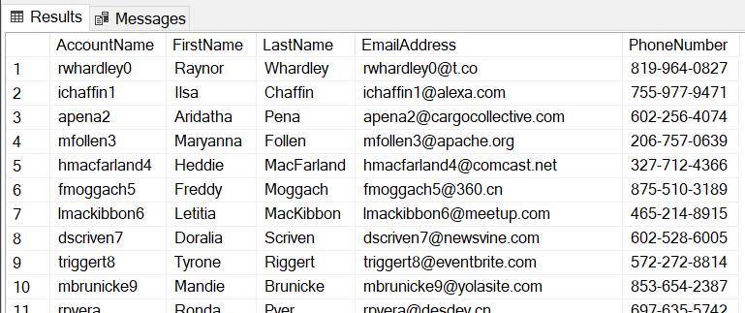

-- What is the average age of DataQuest's players?

SELECT

AVG(Account.Age) AS AvgAccountAge

FROM Account

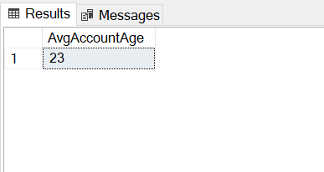

-- What are the account names, email addresses, and character names of DataQuest's free-to-play players (Tier 2 accounts)?

SELECT

Account.AccountName

, Account.EmailAddress

, Character.CharacterName

, Account.Tier

FROM Account

JOIN Character ON Account.AccountID = Character.AccountID

WHERE Tier = 2

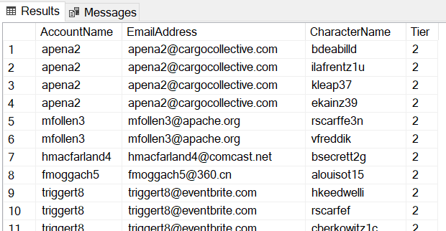

-- Are there characters not subscribed to any guilds and, if so, what are their character names and IDs?

SELECT

Character.CharacterID

, Character.CharacterName

FROM Character

WHERE CharacterID NOT IN (SELECT CharacterID FROM CharacterGuild)

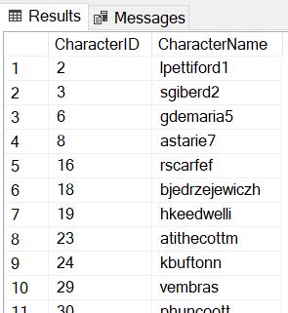

-- VIEWS

-- Contact information of DataQuest's players

CREATE VIEW AccountContactInfo AS

SELECT

Account.AccountName

, Account.FirstName

, Account.LastName

, Account.EmailAddress

, Account.PhoneNumber

FROM Account

GO

SELECT * FROM AccountContactInfo

-- Account names, email addresses, and character names of DataQuest's free-to-play players (Tier 2 accounts)

CREATE VIEW AccountFreeToPlay AS

SELECT

Account.AccountName

, Account.EmailAddress

, Character.CharacterName

, Account.Tier

FROM Account

JOIN Character ON Account.AccountID = Character.AccountID

WHERE Tier = 2

GO

SELECT * FROM AccountFreeToPlay

-- Character names and IDs of characters not subscribed to any guilds

CREATE VIEW CharacterNoGuild AS

SELECT

Character.CharacterID

, Character.CharacterName

FROM Character

WHERE CharacterID NOT IN (SELECT CharacterID FROM CharacterGuild)

GO

SELECT * FROM CharacterNoGuild

-- FUNCTIONS

-- Retrieve an Account ID for a given Account Name

CREATE FUNCTION AccountIDLookup(@accountName varchar(30))

RETURNS int AS

BEGIN

DECLARE @returnValue int

SELECT @returnValue = AccountID

FROM Account

WHERE AccountName = @accountName

RETURN @returnValue

END

GO

SELECT 'The AccountID for this account is:' , dbo.AccountIDLookup('bpapaj')

-- Retrieve a Guild Description for a given Guild Name

CREATE FUNCTION GuildDescriptionLookup(@guildName varchar(50))

RETURNS varchar(200) AS

BEGIN

DECLARE @returnValue varchar(200)

SELECT @returnValue = Description

FROM Guild

WHERE GuildName = @guildName

RETURN @returnValue

END

GO

SELECT 'The description for this guild reads:' , dbo.GuildDescriptionLookup('Goblin Gang')

**Form Mock-Ups**

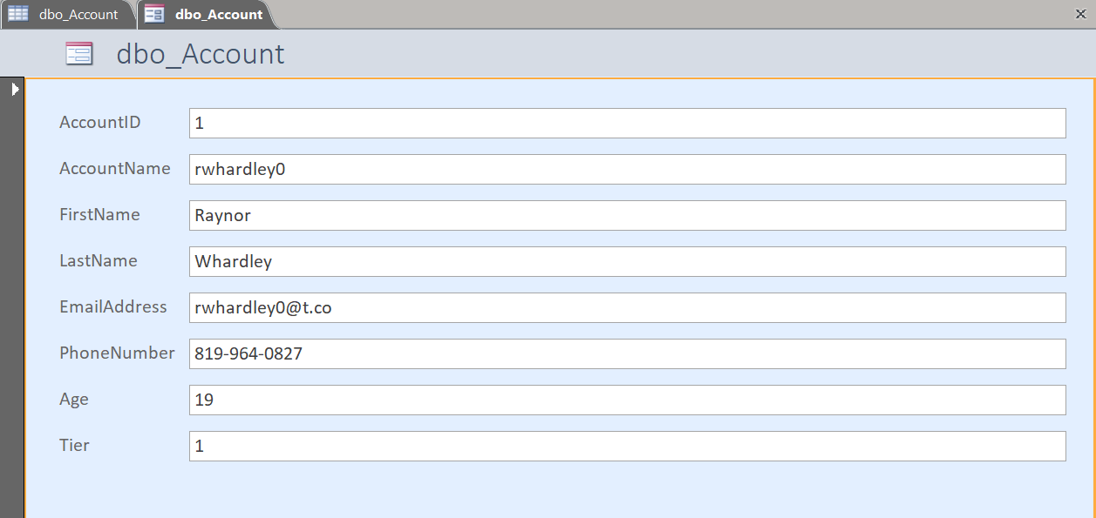

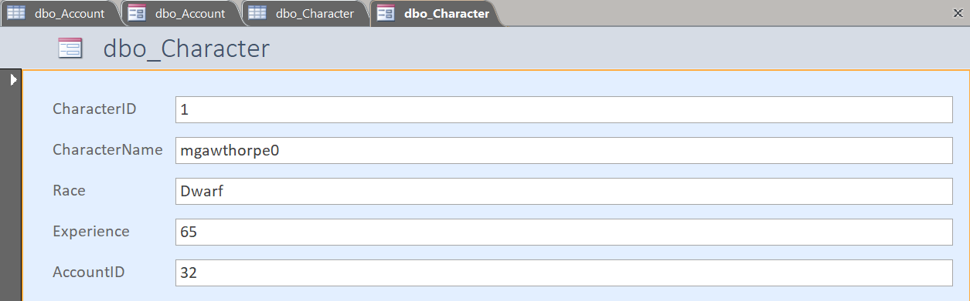

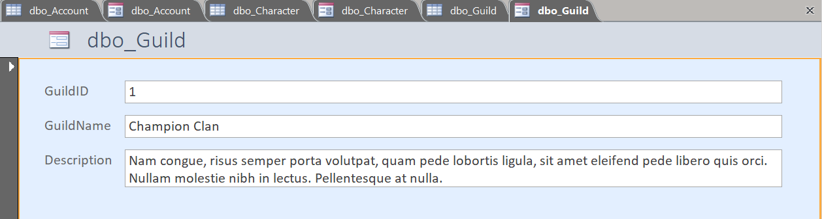

**Reflection**

I can say with confidence that the asynchronous course material alongside the assigned labs were essential to my success in completing this project. These materials allowed me to work through an initially overwhelming series of tasks and procedures in a steadily paced week-by-week fashion. After going through the process of creating and querying a database, I now have a better understanding of my strengths and shortcomings when approaching database design.

For instance, I had little to no issue coding and working in a SQL environment. My prior programming experience gave me a slight leg-up when learning and executing the necessary SQL commands for the first time. Contrastingly, I initially found it difficult to conceptualize my database design into diagrams (especially when it came time to establish relationships between each table).

Overall, I am happy with the final database as well as the answers to my data questions. I hope to push my SQL capabilities even further in future endeavors by designing more and more complex database systems.