Project Members:

1. Nguyễn Thế Tùng
2. Vũ Hoàng Việt
3. Nguyễn Thị Thương

**I, DOCUMENT PURPOSE**

In today's world, the internet plays an important role in people's lives. As people's living standards rise, their expectations for life's quality and efficiency rise as well. As a result, the traditional bookstore's inconvenient nature progressively emerges, and the online bookshop has steadily been more widely used. The online bookstore is a book industry revolution. Because the time, location, and space available to traditional bookstores are limited, the types of books and books available are limited.However, the online bookstore disrupted the traditional bookstore's management model; as long as you have a computer, you can buy a book from anywhere, saving time and effort and effectively shortening the book selection link time. The online bookshop system is built on the premise of providing consumers with convenience and service.

The scope for this project is to help people easier to get the book they want. And this project also provides some information about the book as people viewing them on the website.

This project includes modules such as:

1. **Admin:**

* Admin Login
* User Management:
* Book Management:
* Author Management
* Category Management
* Publisher Management
* Order Management

1. **Client:**
   * User Login and Registration
   * Update Address
   * Update Payment Method
   * Add Product To Cart
   * Checkout Order
   * User View Order

**II, MODULE USE CASES**

1. **Admin:**

**1.1, Admin Login**

In Admin login module, the Admin Login page is available to access from the website by following required ,

* Username
* Password

Noted that only admin account can access to the main page of admin page. If admin input incorrect account, there will be a notification reminding admin to input the right one.

**1.2, User Management:**

In User Management module, Admin can create a new admin account by the following required details,

* User name
* Name
* Password
* Confirm(Re) Password
* Mobile Number
* Email
* Day of birth

After creating new account, new assigned admin can use that account to log into the admin page.

**1.3, Book Management:**

In book managing page, admin can create, edit, view detail of selected book and delete book(s) from the database.

In creating and editing book, admin can add new information for book by the following required details,

* + Book Title
  + Edition
  + Author
  + Category
  + Publisher
  + Publisher Date
  + Image
  + Quantity In Stock
  + Price

After created, new added book will present in the table list of book on the main book management page and there will be a notification for successfully added/edited book.

* + In viewing detail of book, information of book will be shown by the following details,
  + Book Title
  + Edition
  + Author
  + Category
  + Publisher
  + Publisher Date
  + Image
  + Quantity In Stock
  + Price

**1.4, Author Management**

In this module, admin can also create a new author, edit existed one, view details and also delete author.

In creating or editing detial, admin can add new information by the following required

details,

* + Author name
  + Birth Year
  + Active Status
  + Image
  + Description

Noted that Image is not required because the image of author might not be found in time, but it can be added as editing author later on. After successfully added a new author, there will be a notification and the author name can be choose when creating/editing book.

* + In viewing detail, all the detals of author will be shown,
  + Author name
  + Birth Year
  + Active Status
  + Image
  + Description

**1.5, Category Management**

The process for this module is similar to Author Management, admin can create, edit and delete a category

In creating/editing a category, admin will only have to provide require information like,

* + Category name

After created/edited, there will be a notification for successfully action and the category can be choose for creating/editing book later on.

**1.6, Publisher Management**

In this module, admin can create new publisher, editing as well as view detail and delete an existing publisher.

When creating/editing a publisher, admin will have to provide some required information such as,

* + Publisher Name
  + Established Year
  + Image
  + Description

Noted that Image is not required since the image of publisher might not be found. After creating/editing a publisher, there will be a notification for successfully action and the name of publisher can be used later on when creating/editing book.

**1.7, Order Management**

In this module, admin can view order details as well as editing order’s status after checking the order detail.

In editing order status, there will be fields to display the quantity of book that remain in stock and a checking message in order to help admin easier to check. For example, if the quantity of book in stock is 5 and the quantity in order is 6, there will be a message “Out of Stock” displayed so that admin can look and check for it. After finishing checking, admin will change Order Status to “Shipping” if the order is acceptable, or change to “Cancel” if the order is denied due to “Out of Stock”

**1.8, Logout**

This module ends the session, if the current admin user wishes to end the login session. After that, it navigates to admin login page.

1. **Client**

**2.1, User login and registration**

In User login and registration module, the User Login and Registration page is available to access from the website. If user hasn’t registration yet, they can fill in the form by required details

* + Name
  + Username
  + Password
  + Confirm(Re) Password
  + Mobile Number
  + Email
  + Date of birth

After finishing registration, user will be automatically logged in to the webpage.

**2.2, Update address**

In this module, user can go into the address list to create new billing address or edit existing address. To add/edit an address, user will have to fill into a form by required details,

* + Address detail (Resident number, street name)
  + District
  + City
  + Postal Code

One user can have more than one address in address book.

**2.3, Update Payment Card**

In this module, user can add new payment card, edit existing one by providing required information like,

* + Card Number
  + Card Type
  + From Date (Valid from)
  + To Date (Good through)

One user can have more than one payment card.

**2.4, Add to cart**

In this module, user can choose item that they want and click “Add to cart” to add new item into cart. In “Cart” page, there will be information shown as,

* Book Name
* Quantity in stock (Optional)
* Quantity in cart
* Price

There will be an “Update” button to update price if user change their item’s quantity. If user remove an item, the information of cart will be refresh right after that.

**2.5, Checkout**

After finishing adding items to cart, user click checkout to go to the checkout page. In this page , user will have to provide information for the order such as,

* Address
* Payment method
* Note

User can choose either existing address that been registered before or right a new one, which is not save to the user’s address book.

There will also be 2 option for payment, paid by cash or by card that also been registered. If user choose “Paid by cash”, the payment status will be “Unpaid”. If user choose “By Card”, the payment status will be “Paid”.

There will a Note field for user to input some note for the order. This field is optional/ not required to fill.

**2.6, User View Order**

In this module, user can view their past orders. User can also view detail of the order and cancel the order.

**2.7, Logout**

This module ends the session, if the current user wishes to end the login session. After that, it navigates to login page.

**III, Design and Implement Constraint**

1. Database: The system shall use the MS SQL Server Database, which is open source and free.

2. Operating System: The Development environment shall be Window 10

3. Web-based: The system shall be a Web-based application ASP.NET

**IV, System Analysis**

System analysis is the first and foremost step performed in developing the software to solve a particular problem. In the analysis part, a software developer examines the requirements. Carrying out preliminary investigation identifies these requirements

* Analysis consists of two sub phases:

1. Planning
2. Requirement definition

During planning phase, work schedules will be planned. Requirement definition is a specification that describes the processing environment, the required software functions, performance constraints (Size, Speed, Machine Configuration) and exception handling.

**V, Schema Diagram**

**VI, Usecase Diagram**

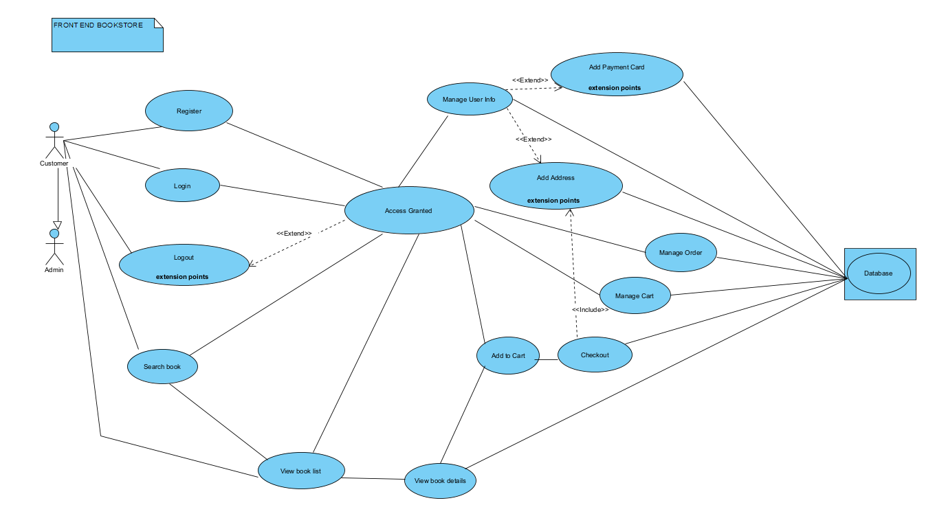

**VII, Technical**

1. HTML 5

2. CSS

3. BOOTSTRAP v4

4. AJAX

5. JQUERY

6. SQL

7. MVC

8. Validation

9. Session

**IX, Role for team member**

Tung: Create sql database, designed admin login and home page

Viet: Designed client home page, user login and detail page

Thuong: Designed cart, checkout and view order detail

**X, Conclusion**