**Project:** Book Shop API

**Perform By:** Ha Van Tung (TungHV7)

**Completed Date:** 20/10/2021

**I. About this project**

- The project is named Book Shop API, which built base on .NET Core 3.1, Entity Framework Core and SQL Server database.

- The project structure has 5 parts:

* BookShopBE.API
* This is where the controllers and config files for the project are located.
* BookShopBE.Common
* This is where the foundation code files are located.
* BookShopBE.Core
* This is where the repositories and services are located.
* BookShopBE.Data
* This is where the entity models, DTO models and data context are located.
* BookShopBE.Database
* This is where the SQL script files are located.

- There are 6 controllers of this project:

* AuthenticationController: manage actions related to registration, login, logout, user authentication.
* BookController: Manage actions related to the store's book inventory.
* CartController: Operations with shopping cart.
* FeedbackController: Product feedback operations.
* OrderController: Manage order activities.
* UserController: User management.

**II. How to run project**

**1. Create Database**

- Open SQL Server and using Windows Authentication to connect SQL Server:

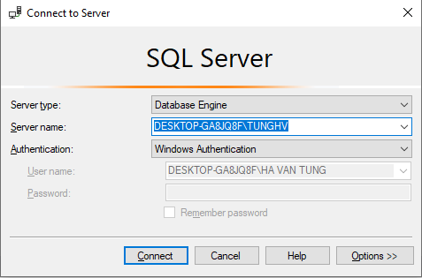

- Create new database with the name “BookShopDB”:

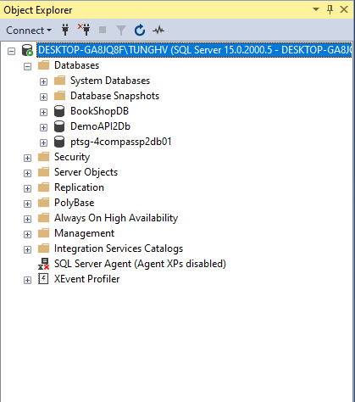

- Open BookShopBE project by Visual Studio, find Solution Explorer, open file appsettings.json in **BookShopBE.API** and fill your connection string to BookShopDB in “DefaultConnection”:



- Next, open Package Manager Console windows and run command: Add-Migration CreateDb

After that, run command: Update-Database

- Open **BookShopBE.Database**:

+ Copy two scripts **Get_Author_Id.sql** and **Get_Book_Id.sql** in **Sql_Functions** folder, run theses scripts in SQL Server.

+ Next, copy scripts **InitDB.sql** in Sql_InitDB folder, run this scripts in SQL Server.

**2. Run project**

- Press  or press F5 to open Swagger UI.

- Register account:

+ Click Register in Authentication.

+ Click Try it out.

+ Add values to form. Note that the **Password** must have at least 6 characters; starting with a capital letter; including letters, numbers and 1 special character such as @, …

+ Click EXECUTE.

- Login:

+ Click Try it out, enter your Username and Password which you have been registered.

+ Click EXECUTE.

+ Copy the values of key “jwToken” in response body:

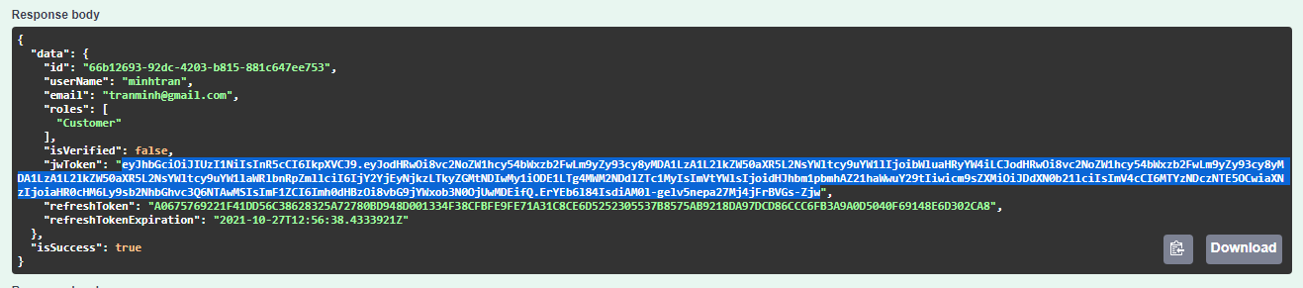

+ Click Authorize button and enter “Bearer ”, paste the values of key “jwToken” and click Authorize. After that, click Close. Now, you are logined.