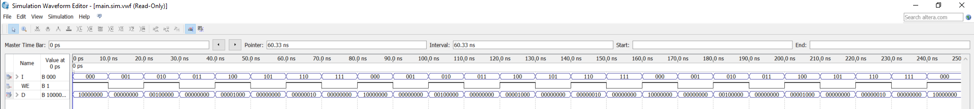

Figure : decoder 3_8

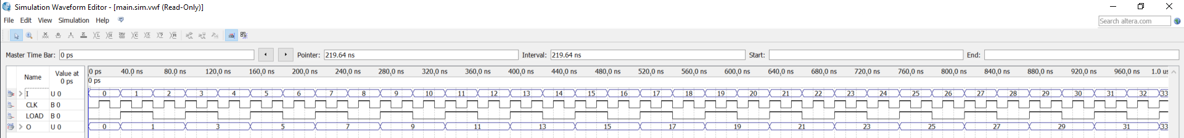

Figure : reg_16bit

Figure : mux8_16bit

Figure : RegFile