電腦網路作業—wireshark

A1035531 蔡東霖

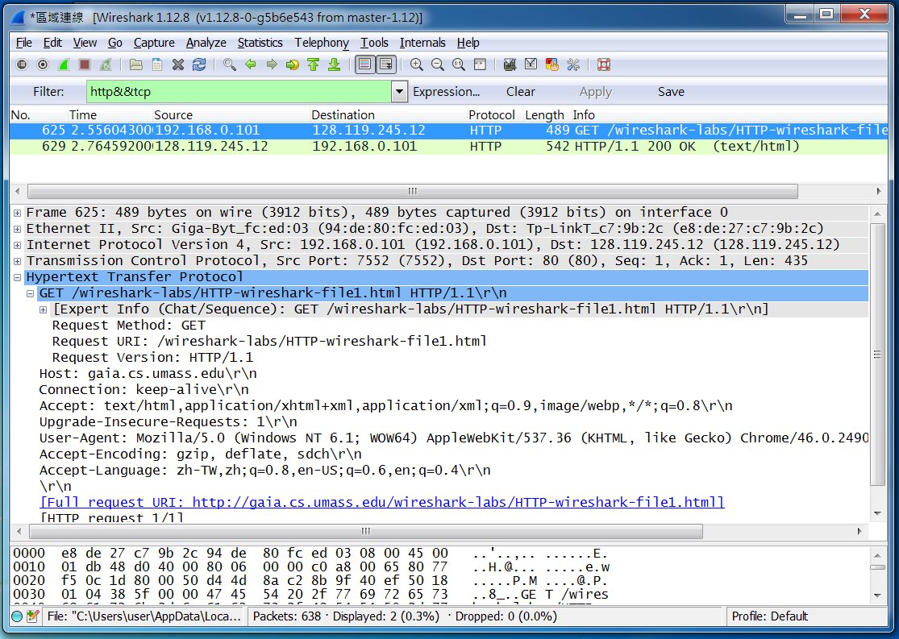

1. Is your browser running HTTP version 1.0 or 1.1? What version of HTTP is the

server running?

Ans: 都是1.1

2. What languages (if any) does your browser indicate that it can accept to the

server?

Ans: zh-TW,zh;q=0.8,en-US;q=0.6,en;q=0.4

3. What is the IP address of your computer? Of the gaia.cs.umass.edu server?

Ans: my:192.168.0.101 server:128.119.245.12

4. What is the status code returned from the server to your browser?

Ans: 200

5. When was the HTML file that you are retrieving last modified at the server?

Ans: Last-Modified: Wed, 18 Nov 2015 06:59:01 GMT

6. How many bytes of content are being returned to your browser?

Ans: Content-Length: 128

7. By inspecting the raw data in the packet content window, do you see any headers within the data that are not displayed in the packet-listing window? If so, name one.

Ans: can not find

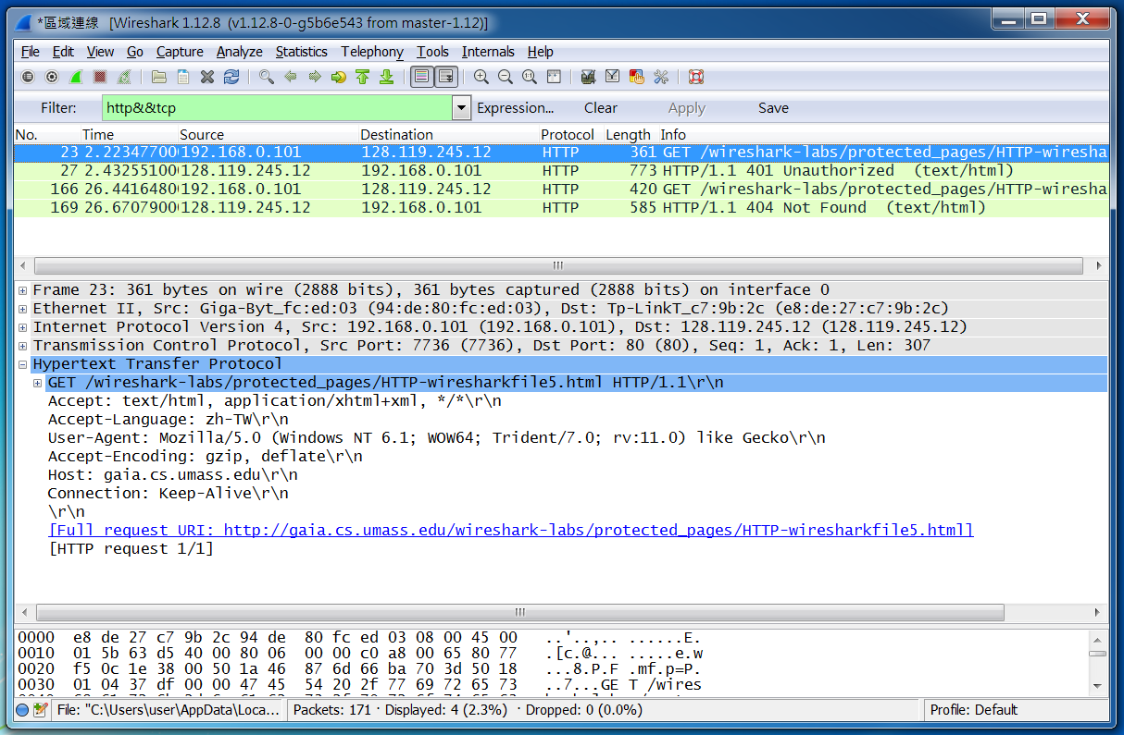

18. What is the server’s response (status code and phrase) in response to the initial

HTTP GET message from your browser?

Ans: Status Code: 401 Response Phrase: Unauthorized

19. When your browser’s sends the HTTP GET message for the second time, what

new field is included in the HTTP GET message?

Ans: Status Code: 404 Response Phrase: Not Found

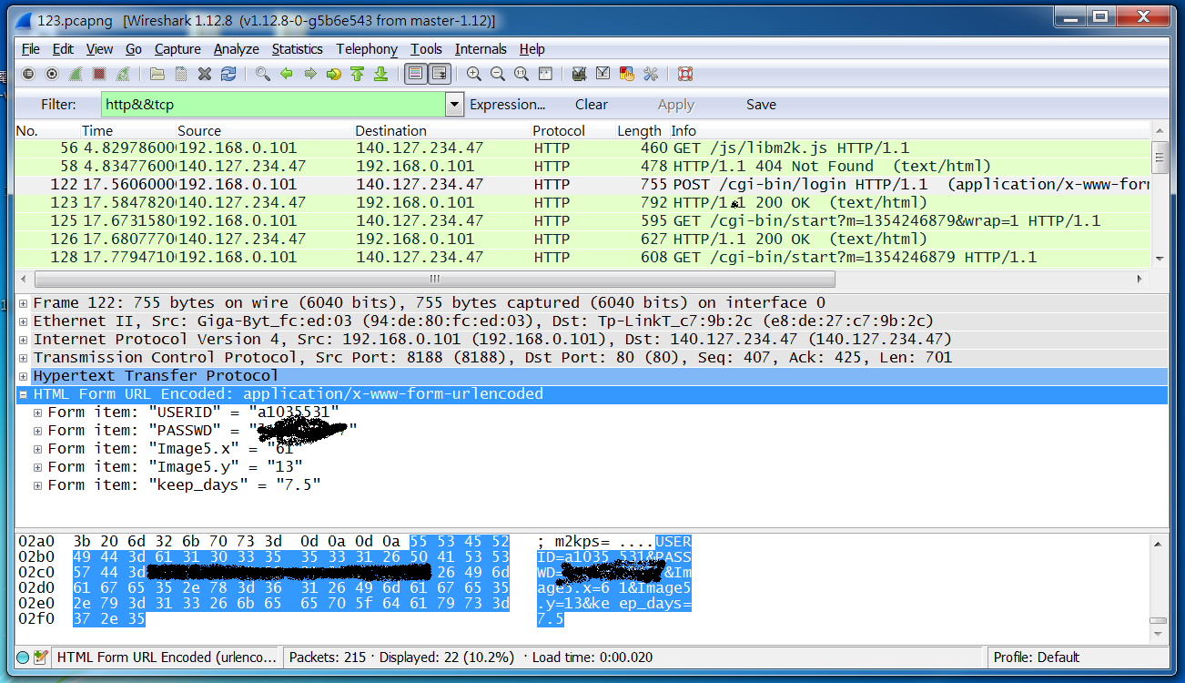

在”post”前與網站mail.nuk.edu.tw取得連結，“Post”則是含有帳密的封包，而post下面的”HTTP”封包回傳並執行set-cookie，其他封包為要求及回傳網站物件。