|  |
| --- |
| aSSIGNMENT 1  COMPUTER SYSTEM |
| Nguyen Nam Tung  Student ID: 103181157  Unit code: COS10004  Lab: THU-08:30-BA405 |



# Table of content

1. Table of content 2

2. Circuit description 2

3. Outline of the design 4

3.1. The minute circuit 4

3.2. The hour circuit 5

3.3. The standard clock circuit 6

3.4. Alarm minute circuit 7

3.5. Alarm hour circuit 7

3.6. Alarm clock circuit 8

3.7. The full clock circuit 9

3.8. The compare circuit 10

4. Unresolved problems 10

# Circuit description

To create the complete clock, the following circuits must be utilized:

There are two clocks that must be used: the standard clock, which operates the normal clock procedure, AM/PM and set time modes, and the alarm clock, which operates the set alarm mode. The full clock combines two clocks and is utilized to toggle between normal mode and set time mode. The compare circuit is then applied to compare the bits of the standard clock and alarm clock. The alarm and standard clock have minute and hour circuits that are distinct.

The main_clock circuit will include both the main interface and functionality of the clock. Here is how it looks like:

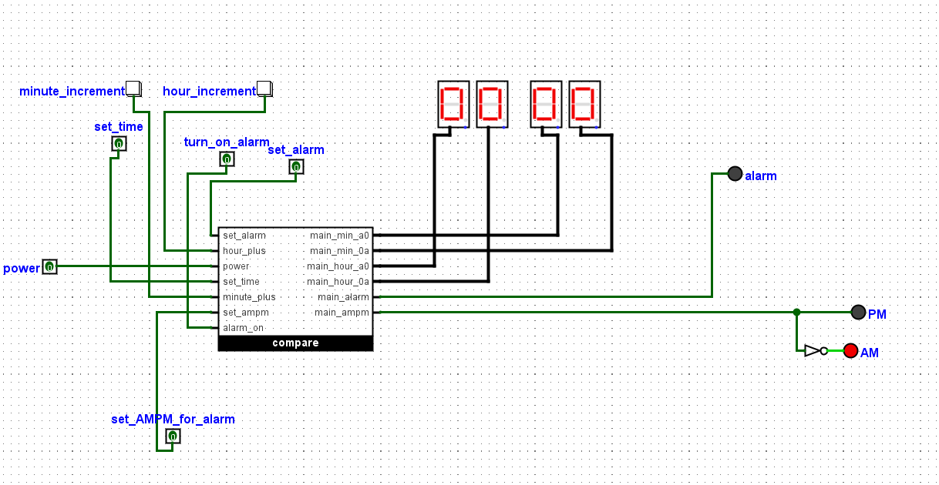

To use the clock, several steps that need to be done:

* Turn on the power pin and enable the Auto-Tick Mode to start the clock from 00:00.
* The AM/PM pair of LEDs show the state (day/night) of the clock.
* When the set time pin is enabled, the clock is stopped, and the minute increment and hour increment buttons (h+ and m+) can be used to adjust the time.
* When the set alarm pin is enabled, the set alarm mode is activated. In this mode, minute increment and hour increment can be used to set the desired time, and the set AMPM for alarm pin determines whether the alarm goes on during the day or night. Then, the turn on alarm pin must also be activated to power up the alarm. Using the turn_on_alarm pin, the LED of the alarm can be turned off when it is operated.

# Outline of the design

## The minute circuit

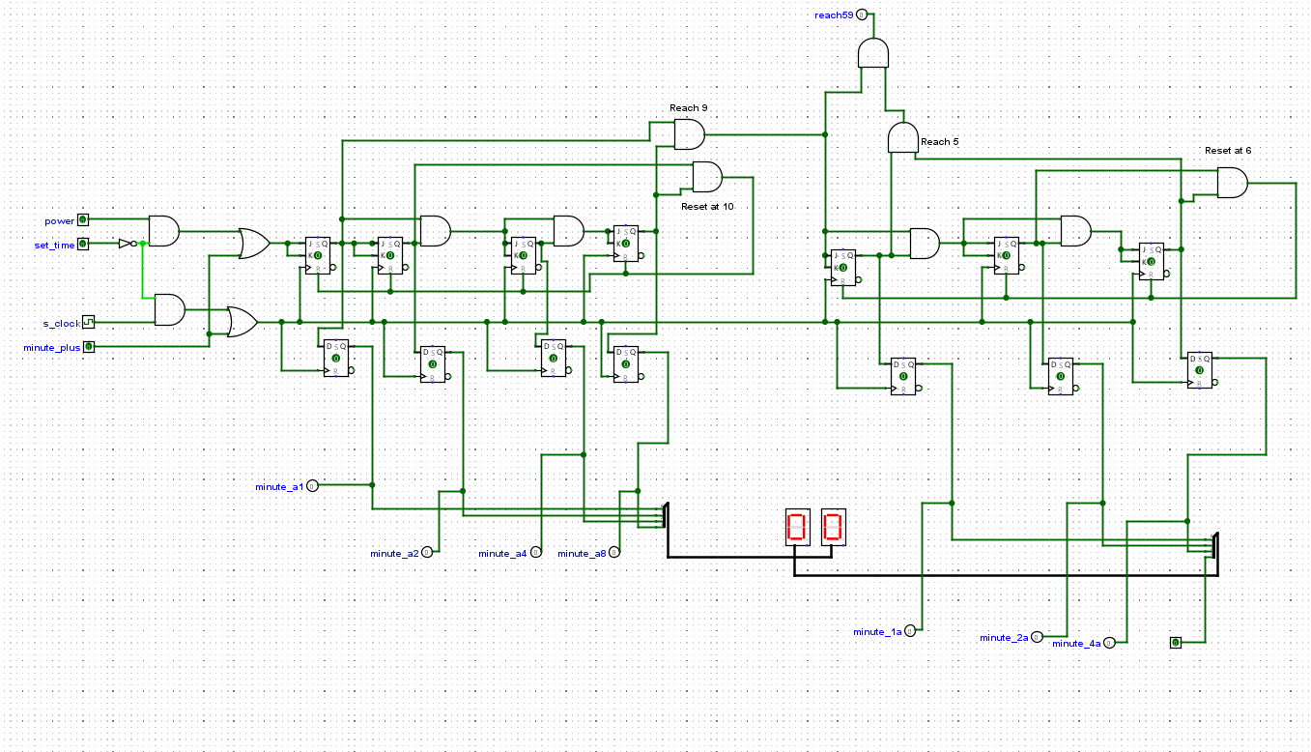

Two counters are required to create the minute circuit: one that counts from 0 to 9 and another that counts from 0 to 5. JK Flip-Flops are used to operate the counters, whereas D Flip-Flops are employed for synchronization and to avoid illegal states. The output of an AND gate resets the counter from 0 to 9 to 0 when the output reaches 10. When the output of the preceding counter is nine, it is fed into the input of the counter from zero to five. This counter functions identically to the previous one, as its output of 10 resets the counter to 0. When the combined value of the two counters equals 59, the data is transferred to the hour circuit. When the set time pin is enabled, the data of the input pin and the clock are stopped, and the minute plus pin functions as both a clock pulse and an input, which increases the value of the clock display.

## The hour circuit

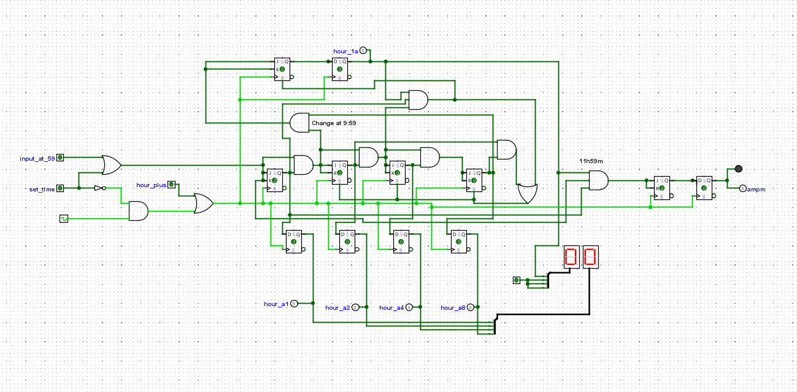

When the output of the minute circuit is 59, it is fed to the hour circuit's input. Moreover, two counters, one counting from 0 to 9 and the other from 0 to 1, are necessary. Both counters have the same features as those in the minute circuits. The output of the counter from 0 to 9 is fed into the input of the counter from 1 to 2 when the output reaches 9. D This circuit also employs flip-flops to circumvent the illegal state. When either the output value is 13 or the value of the counter from 0 to 9 is 10, the circuit will reset to 01. When the outputs of the hour circuit and the minute circuit represent 11:59, the ampm output will change and the state will be maintained until the next 11:59. This section of the circuit controls AM/PM shifting:

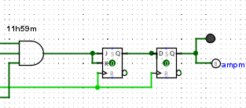

The set time mode functions identically in the minute circuit.

## The standard clock circuit

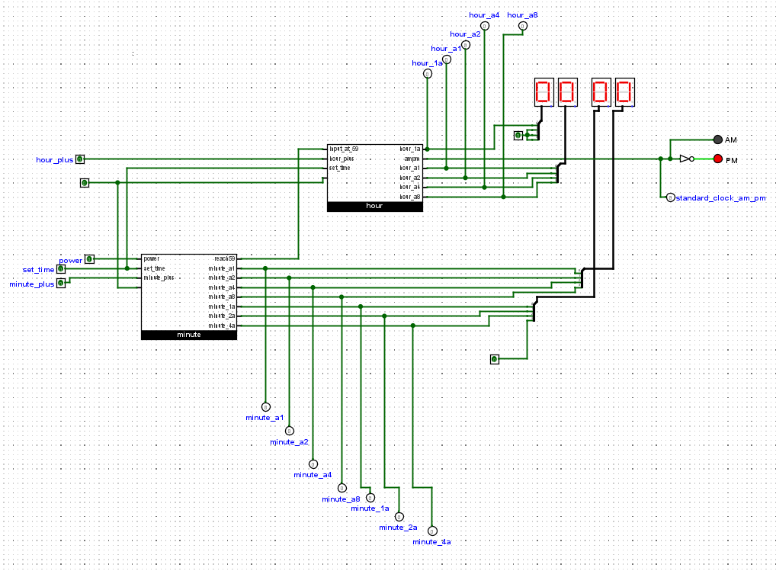

The standard clock circuit is comprised of both the minute and hour circuits. There are pins to activate the power, set the time mode, and increment the minutes and hours. The clock's outputs are also labelled accordingly. Minute_a1 represents the bit 1 output in the unit column of the minute circuit, whereas minute_1a represents the bit 1 output in the tens column. The day and night status of the clock are indicated by two LEDs.

## Alarm minute circuit

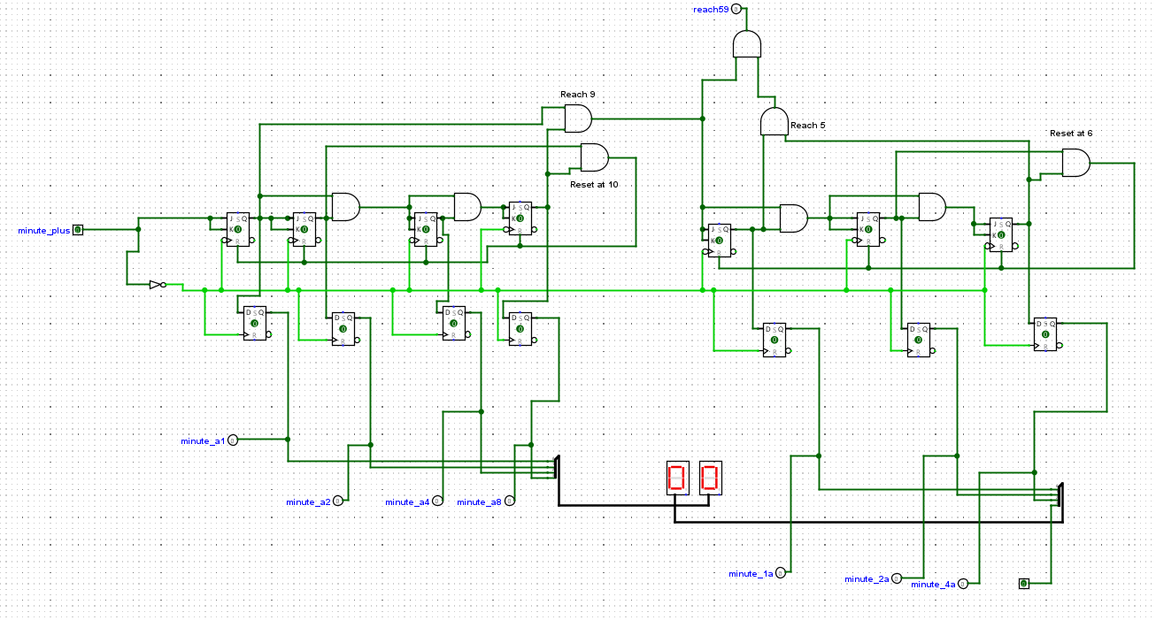

The alarm minute circuit is identical to the alarm clock minute circuit, with the minute_plus pin and a NOT gate representing both input and clock pulse.

## Alarm hour circuit

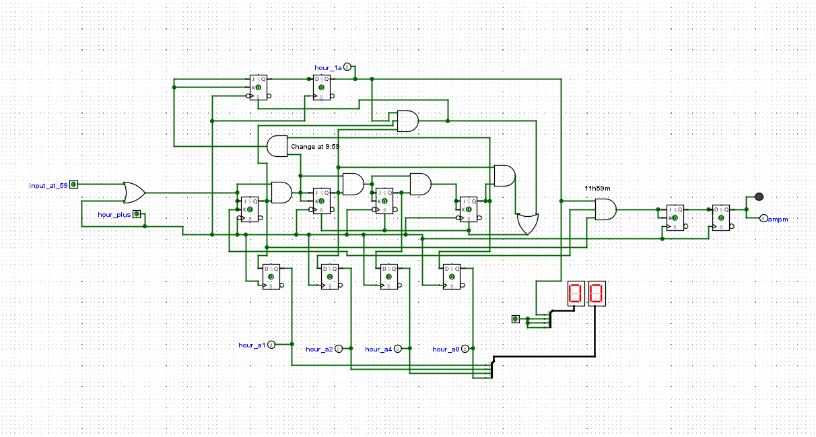

The alarm hour works the same as the standard hour circuit, with the hour_plus pin increasing the value of the clock display.

## Alarm clock circuit

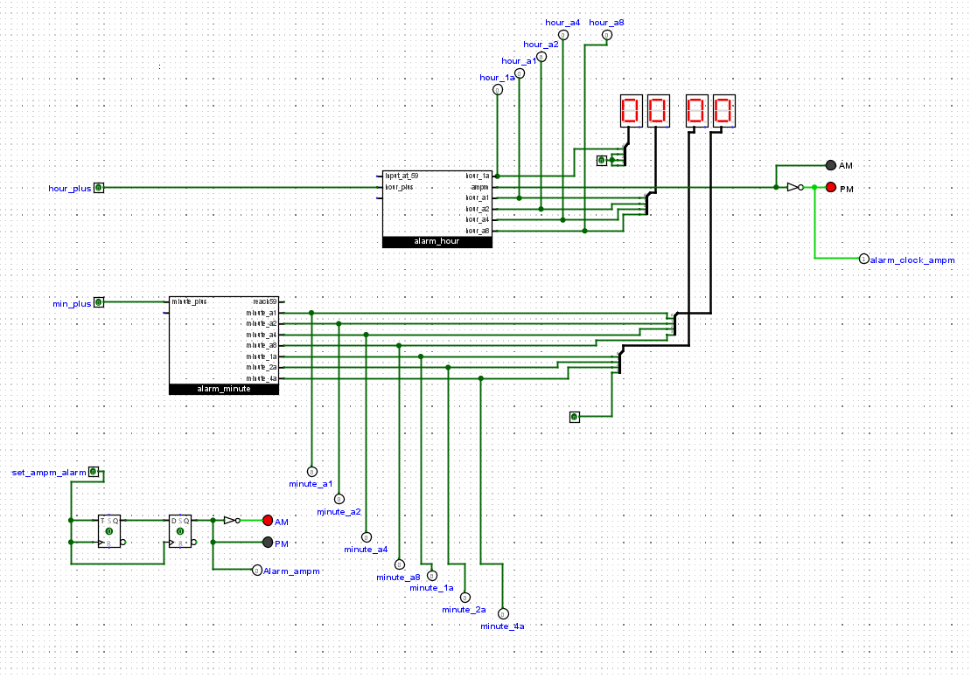

The alarm clock is a duplicate of the standard clock with the Set AMPM section added. Similar to the hour circuit, the state of it will be maintained until the same input is received.

## The full clock circuit

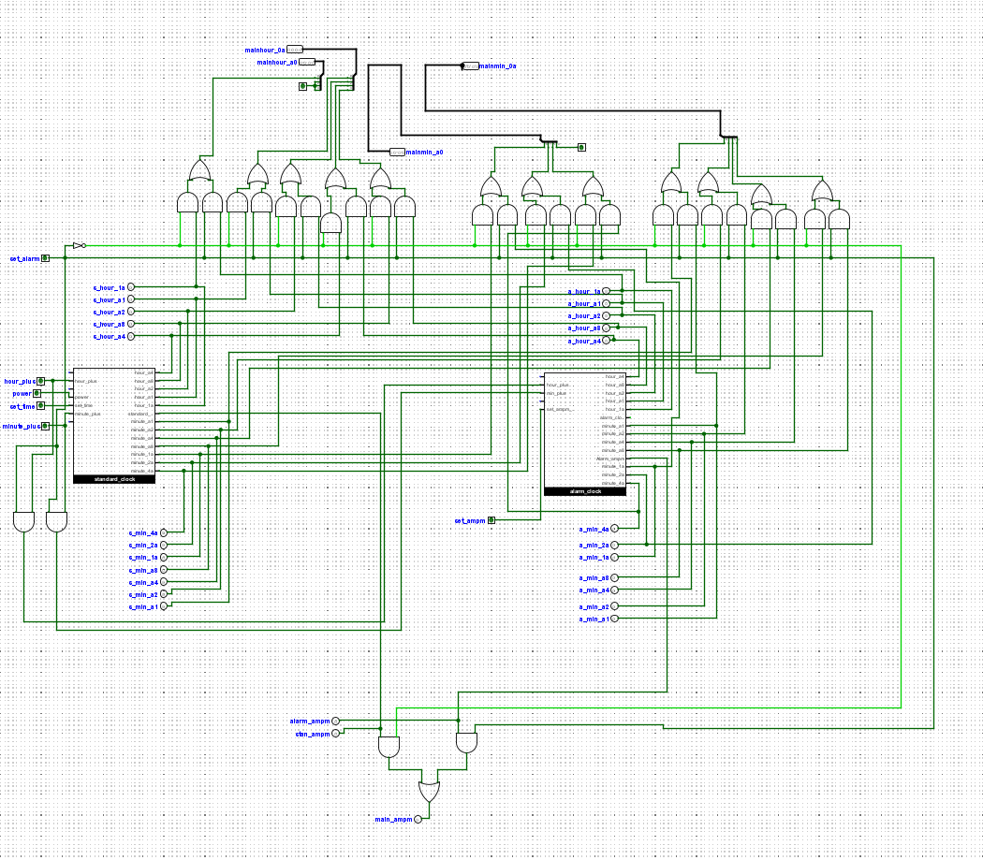

This full clock circuit modifies the main clock's display based on the state of the set alarm pin. If the set alarm pin is activated, the display is from the alarm clock, whereas if it is deactivated, the display is from the standard clock. Numerous AND and OR gates are used for this state transition.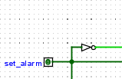

## The compare circuit

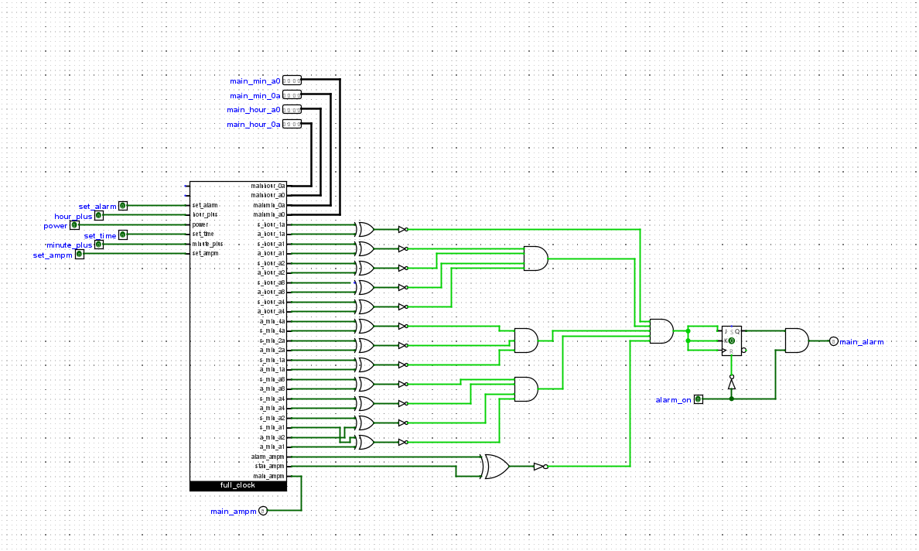

This circuit compares the clock's bits with the standard clock's bits. The minute and hour bits of the two clocks will be compared using numerous gates; if all bits are similar, the main alarm LEDs will be activated. The alarm is reset using the alarm_on pin.

# Unresolved problems

Although the function of the clock appears to be perfect, there is still an issue with the set time mode. Specifically, when the h+ button is pressed and the clock is resumed, an additional hour is displayed. For example, I want to change 03:39 to 04:49:

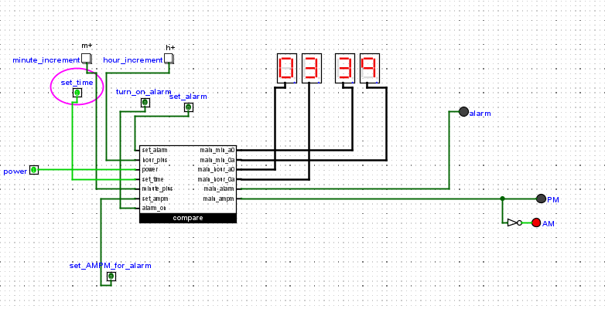

The hour increment button is pressed:

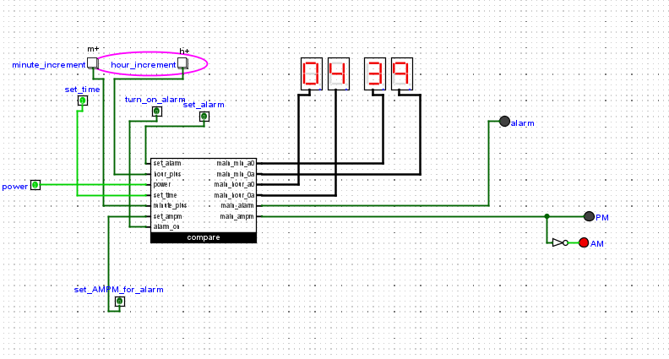

This is the clock's display after the set time mode has been deactivated and reactivated after a few seconds.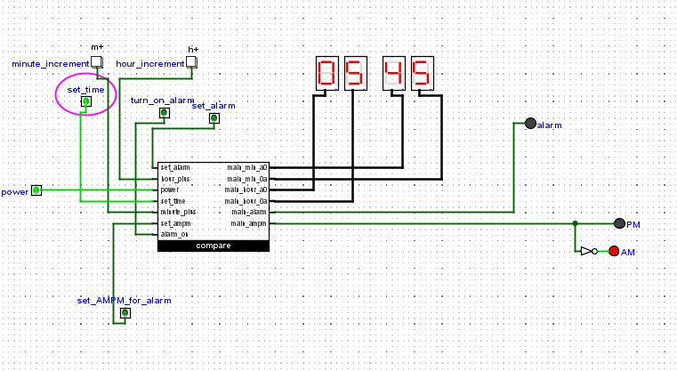

This issue also sometimes appears in the set alarm mode. This is the issue that I must address in future projects. Even though the clock may not function properly, completing this task requires a great deal of time and effort as I want the clock to function as effectively as possible. So, I hope that the errors do not significantly impact the outcome of the overall performance of the clock.