

|  |
| --- |
| ASSIGNMENT 2  2022 |
|  |
| Nguyen Nam Tung  103181157  Lab Session: Thursday BA405 8h30  COS10004 Computer Systems |

# Table of content

1. Table of content 2

2. Design outline 2

2.1. Stage 1 3

2.2. Stage 2 4

2.3. Stage 3 5

2.4. Stage 4 6

2.5. Stage 5 7

3. Unresolved problems 9

4. Conclusion 9

# Design outline

For the design outline of my program, I have submitted a total of 6 code files for each stage from stage 1 to stage 5a, and a full code program file (similar to the stage5a)

## Stage 1

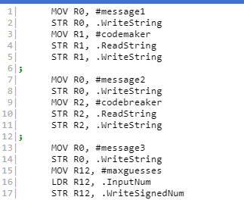

I stored the required strings: , ,  to variables (message1, message2, message3) and then I stored the input of the user into 3 variables: codemaker, codebreaker, maxguesses. Here is an example of the output:



## Stage 2

In this stage, I created a function call getcode to get the input code from the codemaker. The function behind this is to loop through all the index in the input string of the user and then compare the character in the string to the color string such as r, g. After a character is checked if the character is not valid, invalid message will show up. If it is valid, the next character in the string will be checked and the index of the loop will be incremented by 1 until all 4 characters are checked. If there is another character, an invalid message will also show up.

## Stage 3

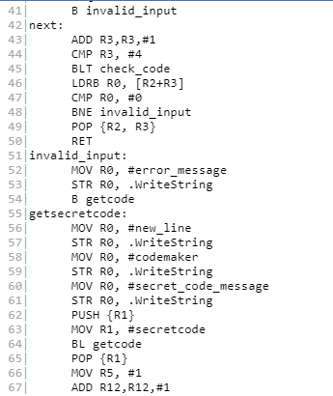

I get the input string code from the user, check if it satisfies all the requirements, then store it into the #secretcode array.

At this point, R12 is currently used to store my maximum number of guesses, while R5 would be used to store the current guess number (I added 1 to R12 in line 67, since a BLT method would be used later to check if the user has reached the maximum guess number or not in the latter stage).

## Stage 4

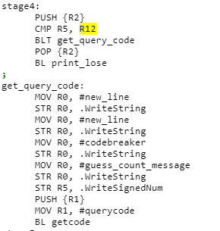

In this stage, I will keep asking for the input of the user until the maximum number of guesses has been reached. This is possible due to the (cmp R5, R12/ BLT get_query_code) functions I used in line 70 and 71. The user input will be stored into the #querycode array to be compared later.

## Stage 5

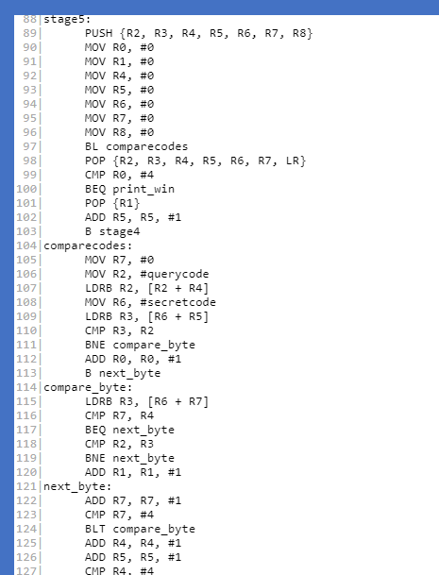

The comparecodes function is used to compare the position of the each character between the querycode and the secretcode array. The compare_bytes function is used when the position do not match: The program will then loop through the other components in the querycode array to find any matching bytes (or matching colors).

After comparing, the #win message will be printed out if the user got the secretcode before reaching the guess limit (matching positions equals to 4), and the #lose message will be printed out if the user is not able to do the above (by using print_win and print_lose methods respectively).

Sample screenshots:



# Unresolved problems

I have only finished the assignment from stage 1 to stage 5a. I still have not completed stage 5b and stage 6 of the assignment (which has graphic display of the pegs).

# Conclusion

In conclusion, I believe that this assignment 2 is a great way of showing the application of ARM Assembly programming.