

|  |
| --- |
| Project and Group Reflection |
|  |
| 28 May 2023  Student Name: Nguyen Nam Tung  Student ID: 103181157  Unit: COS30045 – Data Visualization  Word Count: 2851 |

# Table of Content

Table of Content 1

1. Introduction 3

2. My Learning Journey 3

2.1. Data Visualization Concepts 3

2.2. Data Programming Concepts 8

3. Group Reflection 14

3.1. Role of the team members 14

3.2. Strategies 15

3.3. Reflection 17

4. Conclusion 18

Reference 19

# Introduction

This report provides an insightful overview of my learning journey throughout this unit, showcasing the valuable knowledge gained and its practical application in our group project, World Refugees Migration. Our project aims to create compelling data visualizations that effectively communicate the gravity of the global refugee migration crisis, with the primary objective of generating public awareness and fostering the involvement of researchers and policymakers. By actively engaging these key stakeholders, we aspire to collectively devise innovative solutions that can aid these vulnerable migrants and ultimately alleviate this pressing humanitarian challenge.

# My Learning Journey

## Data Visualization Concepts

**Design Guideline and Graphical Integrity**

In the second week of our unit, I delved into the fundamental design guidelines put forth by Tufte and Munzner, which play a crucial role in ensuring the effectiveness and efficiency of visualizations. Tufte's design principles place a strong emphasis on graphical integrity, maximizing the data-to-ink ratio, and increasing data density (Tufte, 1983). On the other hand, Munzner emphasizes the significance of employing appropriate visual encodings (Munzner, 2015). In our visualization project, I am confident that we have successfully and skillfully applied these two design principles.

By adhering to Tufte's principles, we have ensured that our visualizations maintain graphical integrity, meaning that they accurately represent the underlying data without distorting or misinterpreting it. We have also strived to maximize the data-to-ink ratio, eliminating any unnecessary or redundant elements from our visualizations, and focusing solely on conveying the most relevant information. Additionally, we have successfully achieved higher data density, efficiently presenting a larger amount of information within a limited visual space.

Building upon Munzner's guidelines, we have employed appropriate visual encodings to enhance the clarity and comprehensibility of our visualizations. By thoughtfully selecting visual variables, we have effectively encoded the data attributes, enabling users to discern patterns, trends, and relationships effortlessly.

**Data Abstraction**

In the unit, I was also introduced to the concept of data abstraction. From my understanding, data abstraction refers to the process of simplifying and representing complex datasets in a more understandable and intuitive manner. It involves selecting and presenting relevant information while hiding unnecessary details, allowing users to focus on the key aspects of the data. In my project, I transformed the dataset on refugees into visual elements like Heatmaps and Sankey diagrams. This transformation allows for a more accessible and simple representation of the data.

**Marks and Channels**

Marks in data visualizations are graphical elements that represent individual connections or values (Munzner, 2015). In our project, we utilized a diverse range of marks to effectively convey information. For instance, in the Interactive Heatmap, the marks were represented by polygons, capturing the shape of countries on the map, as well as areas and lines that illustrated data values across categorical or continuous axes of the area chart. The pie chart employed marks in the form of slices, representing distinct data categories. In the Sankey Diagram, marks were visualized as flows of data between nodes, illustrating connections and relationships.

Channels, on the other hand, are visual properties that influence the appearance of marks (Munzner, 2015). In our project, we strategically employed various channels to enhance visual encoding. For example, the color channel was leveraged in the Heatmap to differentiate and highlight different values. The position along an axis was utilized in the area chart to represent data values in relation to the independent variable. The size of each slice in the Pie chart was used to indicate proportions or magnitudes. Additionally, the width of nodes and links in the Sankey Diagram served to convey the magnitude of data flow between different entities.

**Psychological Principle**

In the fourth week of the course, I delved into several fundamental psychological principles that play a crucial role in data visualization. Here are the key principles I explored:

* Sensation and Perception: Understanding how our senses perceive and interpret visual stimuli is fundamental in designing effective visualizations. By considering factors such as brightness, contrast, and visual acuity, we can create visuals that are easy to perceive and interpret accurately.
* Attention: Capturing and maintaining the viewer's attention is vital in data visualization. By leveraging techniques such as visual hierarchy, focal points, and strategic use of color and motion, we can direct attention to important elements and facilitate the exploration of data patterns.
* Color: The use of color in data visualization is a powerful tool for encoding information. By carefully selecting color dimensions (hue, saturation, luminance) and following the color guidelines, we can enhance the legibility and clarity of our visualizations.
* Gestalt: The Gestalt principles describe how humans naturally perceive and organize visual elements. Principles such as proximity, similarity, closure, and continuity help us understand how viewers group and interpret visual components. By leveraging these principles, we can design visuals that facilitate quick comprehension and reveal meaningful patterns.

By incorporating these psychological principles into our data visualization project, we have created compelling and impactful visuals that effectively communicate information and engage viewers' attention.

**Design Process**

In the fifth week of the unit, I gained valuable knowledge on various aspects of the design process, including the Munzner Level of Design and the practice of design sketching. These concepts played a pivotal role in our project as we acknowledged the significance of sketching as a powerful tool for constructing and exploring our project ‘s visualization ideas. By putting our ideas on paper or using digital sketching tools, we could quickly iterate through different concepts, refine our approach, and visualize the potential layout and composition of our visualizations. Here are some examples of our draft sketches showcasing the evolution of our design ideas:

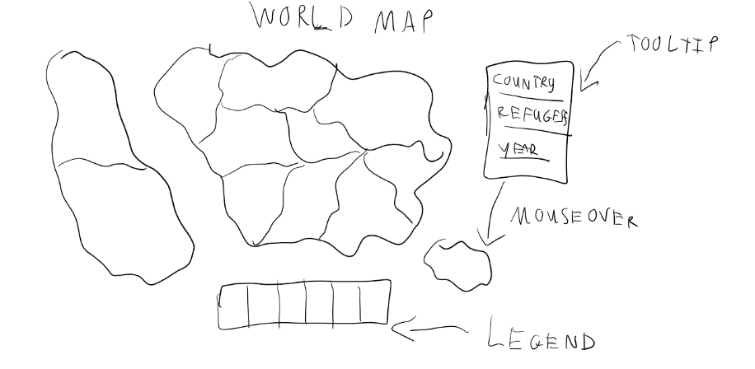

Figure 1: Heatmap Sketch 1

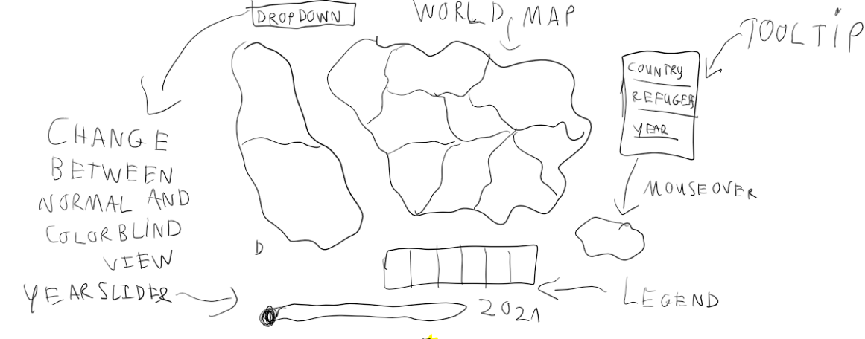

Figure 2: Heatmap Sketch 2

Figure 3: Final Design: Interactive Heatmap

**Interaction**

Interaction plays a crucial role in our data visualization project, as it enhances user engagement and facilitates a deeper exploration of the data. We have incorporated various interactive elements that allow users to interact with and manipulate the visualizations to gain valuable insights. Some examples of the interactions we have implemented in the project include:

* Mouse over effect for the heatmap (tooltips, displaying the pie and the area chart)
* Change the displayed year of the heatmap
* Change the view of the heatmap (color-blind view and normal view)
* Mouse over effect for the Sankey diagram
* Dragging feature of the Sankey

**Storytelling with data**

Storytelling is an essential aspect of our data visualizations as it ensures that our message is effectively delivered to the target audience. In the project, we had to employ storytelling techniques to ensure that our visualization effectively conveyed our message:

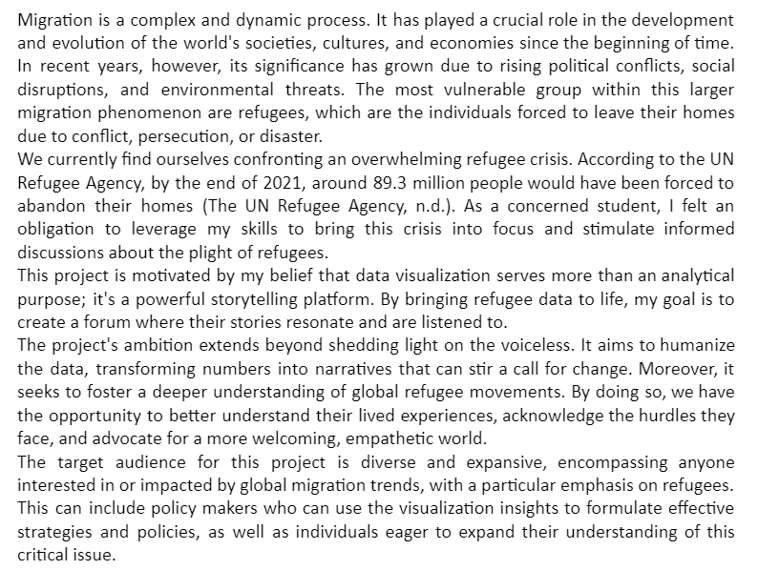

Figure 4: Utilizing storytelling technique in our project (taken in our process book)

## Data Programming Concepts

**Basic HTML, CSS, and JavaScript**

In week 1, I had the opportunity to delve into fundamental programming concepts such as HTML, CSS, and JavaScript, all of which serve as the building blocks for our project.

**Data Binding, Data Loading**

During the second week, I acquired essential skills that serve as the foundation for creating graphs and charts using d3.js. One key concept I grasped was the ability to bind a data element to a visual element. This technique is crucial for dynamically representing data visually and is pivotal in the creation of interactive and data-driven visualizations.

Furthermore, I delved into the process of reading external files, such as CSV files, into my program. This skill became particularly significant for our project, as our team needed to read a GeoJSON file to draw a map and match and load data from a CSV file. This capability enabled us to seamlessly integrate and visualize location-based data with the corresponding information from the CSV file.

Figure 5: Loading files

**Drawing Charts with Data**

Throughout the units, I was able to learn how to make different types of charts, such as a scatter plot, a bar chart, and a choropleth. Initially, I encountered some challenges and found it difficult to draw charts accurately. However, I soon recognized that to create effective visualizations, I needed a comprehensive understanding of the graph's components and how they were encoded.

By gaining a deeper insight into the elements comprising a chart, I was able to overcome these obstacles and successfully complete the project. I harnessed my newfound knowledge to create visually compelling illustrations that effectively conveyed the intended information. Below, you can find a selection of these illustrations, showcasing the successful implementation of different types of charts within our project:

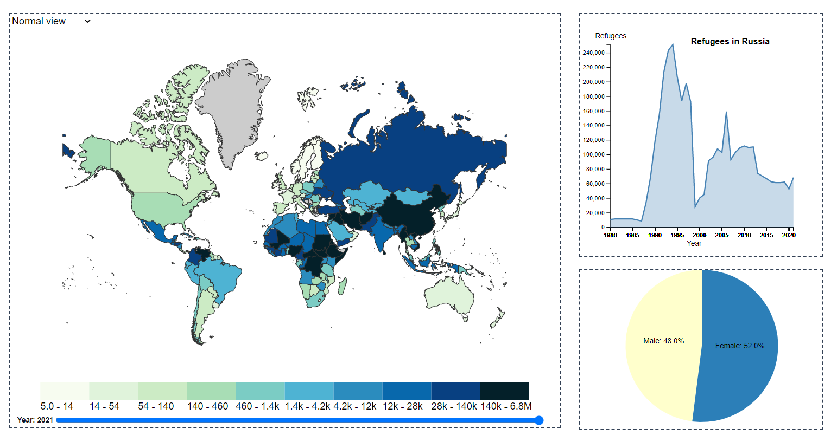

Figure 6: Project Visualization 1: Interactive Heatmap

Figure 7: Project Visualization 2: Sankey Diagram

**Scaling**

Scaling is a programming concept that plays a vital role in displaying datasets. By mapping input values to output values, scaling ensures that the data is appropriately represented. In our project, scaling was extensively employed to guarantee accurate and meaningful visualizations.

For example, in the area chart, we utilized the scaleLinear function to map the time and the number of refugees to the size of the canvas (Figure 8). This allowed us to proportionally represent the data, providing a clear understanding of the trends and patterns over time. By applying scaling techniques, we were able to dynamically adjust the size of the chart based on the dataset, ensuring optimal visualization.

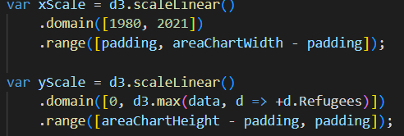

Figure 8: scaleLinear function

Similarly, in the choropleth map, we employed the scaleQuantile function to map the number of refugees to a color scale. This technique allowed us to represent varying levels of refugee populations across different regions with distinct colors, enabling users to grasp the intensity and distribution of the data effectively (Figure 9).

Figure 9: scaleQuantile function

**Transitions**

Transitions are also invaluable tools that allow for seamless and visually appealing animations when transitioning between different chart states. In our project, we utilized transitions to achieve smooth and captivating effects, specifically when interacting with the heatmap by mouseover and mouseout events.

Figure 10: Mouseover effect

Figure 11: Mouseout effect

**Data Updating**

During the fifth week of our unit, I acquired valuable knowledge regarding updating, adding, and removing values from datasets. This understanding proved particularly valuable in our visualization project, where we implemented an interactive heatmap.

In our project, we designed a year slider located at the bottom of the heatmap. By manipulating this slider and changing the selected year value, the data displayed in the heatmap dynamically updated accordingly. This functionality allowed us to showcase the evolution and variation of the data over different years, enabling users to gain insights and observe trends specific to each year.



Figure 12: Year slider feature

**Mouse Over Effect**

The implementation of mouseover effects played a crucial role in enhancing our visualizations, allowing users to access detailed information about the elements they interacted with. By leveraging the mouseover effect, we were able to create tooltips that provided users with a closer look at specific countries within our visualizations.

When users hover their cursor over a country, a tooltip would appear, highlighting the selected country and displaying relevant details. This interactive feature allowed users to gain insights into the specific attributes of each country, while also displaying supplementary visualizations related to that country such as the pie chart and the area chart (see Figure 12).

Figure 13: Interactive features

# Group Reflection

## Role of the team members

Initially, our team had assigned separate roles to each team member. I took on the responsibility of dataset cleaning and visualization coding, while my project teammate Bill focused on researching topics related to migration, designing the visualization website, and writing the process book. We followed a sequential approach, completing our individual tasks and planning to merge our work two weeks before the deadlines. The final two weeks were allocated for finalizing the project.

However, we soon realized that this approach was not as effective as we had expected. We identified the need for a more collaborative and integrated approach to maximize our team's productivity. As a result, our roles grew to incorporate a wider variety of responsibilities. I not only focused on coding the visualization and data cleaning but also actively participated in the process book and designing the website. Similarly, Bill's role also evolved significantly. In addition to designing the website and styling the visualizations, he also took on the responsibility of writing the process book and coding the visualizations.

By adapting our roles to better align with the project's requirements and leveraging our individual strengths, we were able to effectively complete our assigned tasks and contribute to the project's overall success. The expanded roles allowed us to collaborate more closely, exchange ideas, and leverage our collective expertise. This dynamic shift in responsibilities resulted in a more cohesive and comprehensive final product.

Through this experience, we recognized the importance of flexibility and adaptability within a team. By adjusting our roles and embracing a collaborative mindset, we were able to optimize our workflow and ensure the successful completion of the project.

## Strategies

One of the key strategies that greatly contributed to our team's success was maintaining clear and regular communication channels. In addition to our tutorial meetings at the lab on Mondays, we implemented a practice of holding offline meetings every weekend. These meetings served as dedicated time for us to discuss project updates, brainstorm ideas, and ensure that our efforts were aligned. By having periodic meetings between team members, we were able to track individual progress, address any issues, and maintain accountability throughout the project.

Another crucial aspect of our strategy was establishing a clear goal. Having a well-defined goal helped us maintain focus and direction, minimizing confusion, overlaps, and conflicts in our team's work. With a shared understanding of our objectives, we were able to work cohesively and efficiently toward achieving our desired outcomes.

Last but not least, effective time and task management were also key factors in our strategy. We established clear timelines, prioritized tasks, and closely monitored progress to ensure that we stayed on track. This proactive approach allowed us to be organized, allocate resources effectively, and complete important deadlines. Here is an example of our goal and deadline setup (see Figure 13 and Figure 14):

Figure 14 : Example of our deadline setup 1

Figure 15 : Example of our deadline setup 2

By combining regular communication, a clear goal, and effective time and task management, we were able to maintain an efficient and productive workflow throughout the project. These strategies fostered a collaborative environment, minimized roadblocks, and enabled us to achieve our objectives successfully.

## Reflection

Our team members demonstrated strong collaboration and respect for each other's ideas and opinions. During meetings, everyone actively contributed and listened attentively to one another. This fostered a positive and inclusive environment where each member felt valued and encouraged to share their perspectives. Additionally, we ensured that the proposed objectives, deadlines, and strategies were strictly followed This dedication ensured that our team remained focused and driven, enabling us to produce the highest quality project work possible.

In our project, despite the overall efficiency and high quality of our data visualization work throughout the semester, we encountered several challenges along the way. One major issue was the process of finalizing our ideas and sketches. With multiple ideas competing for inclusion, we encountered difficulties in selecting the most suitable concept, which resulted in confusion and hindered our progress.

To address this challenge, we implemented a more iterative approach to idea development and sketch finalization. We allocated dedicated time for brainstorming sessions, where each team member could share their ideas and provide feedback on the sketches. As a result, we could identify common themes and refined our ideas to align with the project's objectives.

Additionally, another problem we encountered was the presence of bugs in our programs. Around week 10, we faced several technical issues with unexpected errors, causing us to feel stressed and worried that we may not be able to resolve them.

To address this problem, we engaged in extensive troubleshooting and research. We thoroughly analyzed the code, reviewed documentation, and sought assistance from online resources and forums. This process required perseverance and patience, as we had to navigate through complex issues and consider various possible solutions. Through collaborative efforts and effective communication, we were able to identify the causes of the bugs and implement appropriate fixes

# Conclusion

In conclusion, the completion of this unit and the data visualization project has provided me with valuable knowledge and skills. I have learned to effectively apply design principles and programming concepts to create visually compelling and informative visualizations. Moreover, I have gained insights into effective teamwork, collaboration, and task management skills, which will be valuable in my future projects.

# Reference

Munzner, T. (2015). *Visualization analysis & design*. Crc Press, Taylor & Francis Group.

Tufte, E.R. (1983). *The visual display of quantitative information*. Cheshire, Conn.: Graphics Press.