Boon Solution Technical Document

Project: Gitlab API Extraction

Name: Nguyen Nam Tung

Email: [nguyennamtung123@gmail.com](mailto:nguyennamtung123@gmail.com)

Phone Number: 0405335420

# Table of Content

**Table of Content 2**

**Introduction 3**

**Project Structure 3**

**Project Outcome 4**

**Requirements Fulfillment 6**

Use of requirements.txt 7

Readme.md 7

Use of logger library 7

Error handling (try, catch) 8

Use of database 9

Database record management (CRUD) 10

Code commentary 10

Code quality 11

Secure coding 11

Use of SQL Alchemy 12

Use of OpenAPI library 13

**Additional Implementation: Airflow 14**

**Future Implementation and Improvement 19**

# Introduction

This document outlines the development process for the assignment submitted for the Graduate Developer role at Boon Solutions. It highlights what I have learned throughout the project, including an additional automation feature demonstrating how to set up an automated workflow using Apache Airflow.

Additionally, I will share alternative approaches and recommendations on how the system can be further enhanced for a more complete and scalable solution. Due to time constraints, I was unable to implement all the additional features; however, this document provides an overview of potential improvements and technologies that could be integrated in future iterations.

# Project Structure

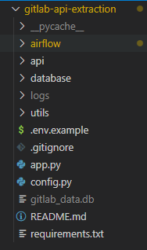

For the main part of this project, we will not be using any components from the airflow/ directory. The airflow/ directory is dedicated to the implementation of an automated data pipeline using Astronomer and Apache Airflow, which is covered separately as an additional automation feature. Therefore, this section will focus solely on the core project structure and functionality, excluding the Airflow automation setup.

Below is a table that outlines the main folders and files in the project, along with their purpose:

| **File / Folder** | **Purpose** |
| --- | --- |
| airflow | Airflow project |
| api | GitLab API client and request handlers |
| database | SQLAlchemy models, DB sessions, queries |
| logs | Logs for debugging |
| utils | Utility functions |
| .env.example | Example environment variables for configuration |
| README.md | Project documentation |
| requirements.txt | Dependencies to run the app and Airflow |
| app.py | Core logic to fetch and store projects |
| config.py | Configuration and secrets loader |

# Project Outcome



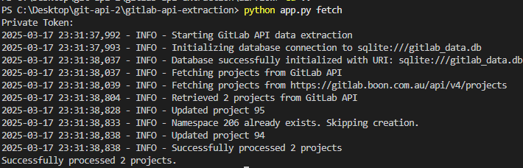

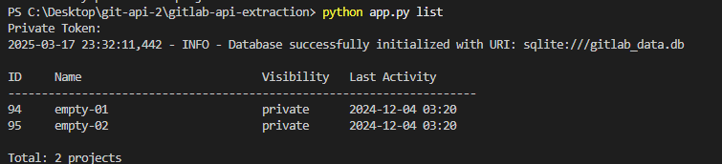

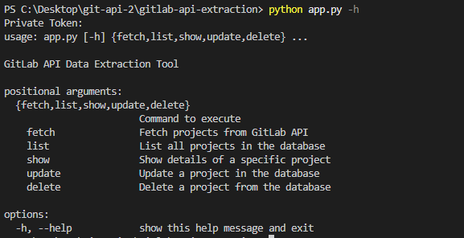

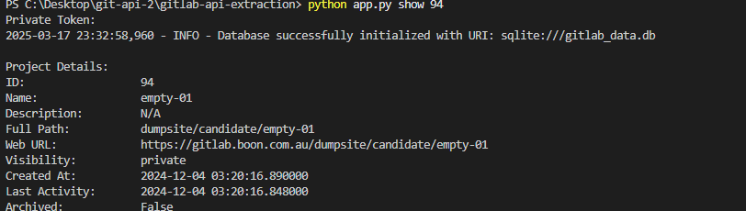

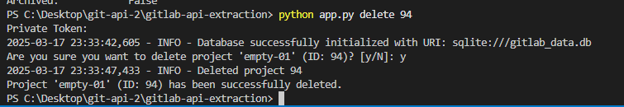

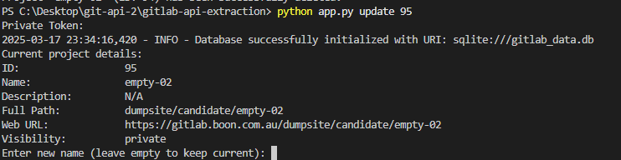

# Requirements Fulfillment

In this section, I will outline all the requirements specified for the assignment and explain the methods and techniques I used to satisfy each of them. Each requirement is addressed with a clear implementation strategy to demonstrate how the project fulfills the objectives

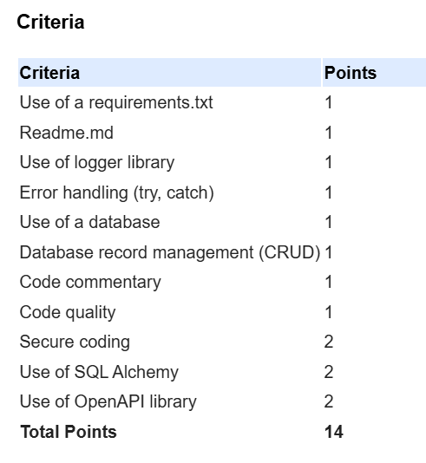

## Use of requirements.txt

The project includes a comprehensive requirements.txt file that lists all necessary Python dependencies required to run the application. This ensures a smooth and consistent setup of the development environment, allowing for easy installation of all libraries and packages through a single command.

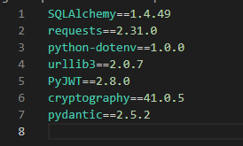

## Readme.md

This README.md provides comprehensive documentation, including the following sections:

* **Project Overview and Description**: A brief introduction to the purpose, functionality, and objectives of the project.
* **Installation Instructions:** Step-by-step guidance on how to set up and install the project dependencies.
* **Usage Examples:** Detailed examples demonstrating how to use the project's features and run the application.
* **Project Structure Explanation:** A breakdown of the project's folder and file organization with explanations of their purposes.
* **Security Considerations:** An overview of the security practices implemented, such as environment variable usage and sensitive data handling.
* **Development Notes:** Additional notes and recommendations for future improvements, as well as insights gained during the development process.

## Use of logger library

The project includes a robust custom logging system implemented in utils/logger.py, providing enhanced visibility and traceability throughout the application. Key features of the logging system include:

* **Configurable Log Levels:** Log levels can be easily configured via environment variables, allowing flexibility between development and production environments.
* **Dual Output Logging:** Supports both console and file-based logging to ensure logs are accessible during runtime and persisted for future analysis.
* **Structured Log Format:** Each log entry includes timestamps, log levels, and source file information for improved readability and debugging efficiency.
* **Log File Rotation:** Automatically rotates log files and appends timestamps to maintain organized log archives and prevent files from growing too large.
* **Context-Specific Logging:** Logging is implemented throughout the application in a context-aware manner, providing meaningful insights and aiding in troubleshooting.

## Error handling (try, catch)

The application implements comprehensive error handling throughout the codebase to ensure stability, reliability, and ease of troubleshooting. Key aspects of the error handling strategy include:

* **Robust Database Error Handling:** All database operations are wrapped in try/except blocks to gracefully handle potential issues such as connection failures or query errors.
* **API Request Error Handling:** API calls include exception handling for network-related issues, timeouts, and invalid or unexpected responses from the GitLab API.
* **Command Execution Safeguards:** Critical command executions are protected with appropriate exception handling to prevent unexpected crashes and ensure smooth execution.
* **Detailed Exception Logging:** All caught exceptions are logged with comprehensive contextual information, including error details and the specific part of the code where the exception occurred.
* **User-Friendly Console Feedback:** Clear and informative error messages are displayed in the console, ensuring that users are aware of issues without exposing sensitive technical details.

Example from api/client.py:

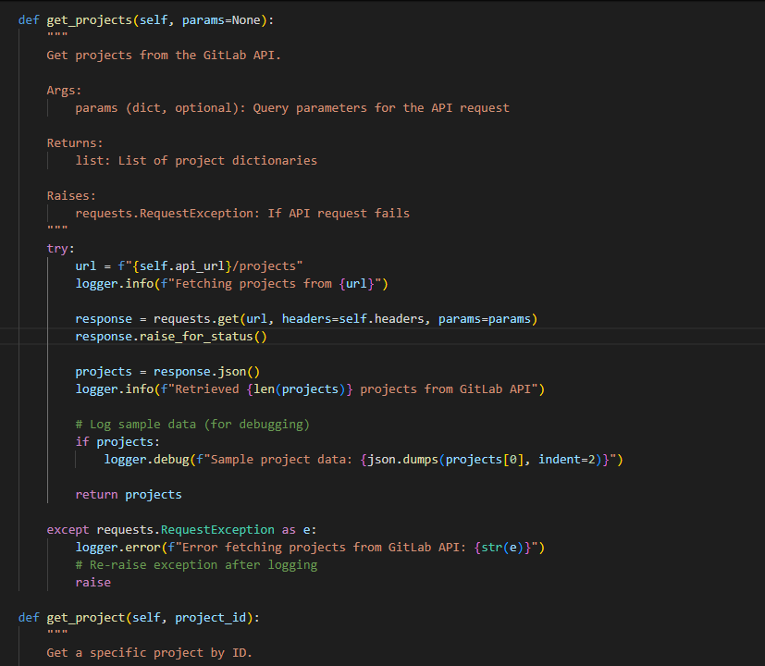

## Use of database

The project features a well-structured and efficient database solution, designed to ensure reliable and persistent data storage. The key components of the database implementation include:

* **SQLite Database for Persistent Storage:** A lightweight, file-based SQLite database is used to persistently store GitLab project data, suitable for local development and testing environments.
* **Well-Defined Schema and Relationships:** The database schema is thoughtfully designed, incorporating appropriate relationships and constraints to maintain data integrity and consistency.
* **Configurable Database URI:** The database connection URI is configurable via environment variables, enabling easy transitions between development, testing, and production environments.
* **Database Initialization and Connection Management:** The system includes proper database initialization routines and efficient connection management, ensuring stable and consistent access to the database.

Here is the database Structure Overview:

* **Project Table:** Stores detailed information about GitLab projects, including project names, descriptions, creation dates, and other relevant metadata.
* **Namespace Table:** Manages namespace information associated with GitLab projects and includes foreign key relationships to maintain referential integrity with the Project table.
* **Data Types and Constraints:** Each table field is defined with appropriate data types and constraints to enforce data validity and consistency.

## Database record management (CRUD)

The project implements complete CRUD (Create, Read, Update, Delete) operations through the ProjectRepository class, providing a clean and organized interface for managing project data within the database.

**CRUD Method Overview:**

Create:

create_project() adds new project records to the database.

Read:

get_project_by_id() retrieves a specific project by its ID.

get_all_projects() fetches all project records from the database.

Update:

update_project() modifies existing project details based on specified parameters.

Delete:

delete_project() removes a project record from the database by ID.

Each CRUD operation is implemented with:

* **Proper error handling:** Ensures exceptions are caught and logged appropriately.
* **Transaction management:** Guarantees data consistency by committing or rolling back transactions as needed.
* **Input validation:** Verifies input data before performing operations to maintain data integrity.

## Code commentary

The project maintains clear and comprehensive source code documentation to ensure readability, maintainability, and ease of understanding for future developers. The documentation strategy includes the following key practices:

* **Module-Level Docstrings:** Each module begins with a detailed docstring that explains its overall purpose, functionality, and how it fits into the project structure.
* **Class and Method Docstrings:** Every class and method includes descriptive docstrings outlining their purpose, expected parameters, return values, and any exceptions that may be raised during execution.
* **Inline Comments for Complex Logic:** Complex or non-obvious code logic is accompanied by concise inline comments to clarify implementation details and reasoning.
* **Consistent and Standardized Formatting:** All docstrings follow standard Python documentation conventions (PEP 257), ensuring consistency in formatting and structure across the entire codebase.

## Code quality

The project follows high-quality coding standards to ensure readability, maintainability, and scalability. Key practices and principles implemented include:

* **Adherence to PEP 8:** The entire codebase follows Python's official PEP 8 style guidelines, ensuring consistency in formatting and readability.
* **Consistent Naming Conventions:** Variables, functions, classes, and modules are named consistently and descriptively, following Python naming standards.
* **Proper Code Organization and Module Structure:** The project is structured logically into well-defined modules, each with a clear purpose and responsibility.
* **DRY (Don't Repeat Yourself) Principle:** Code duplication is minimized by extracting reusable logic into shared functions or classes, promoting efficiency and reducing maintenance overhead.
* **Single Responsibility Principle (SRP):** Each class and function is designed to perform a single, well-defined task, improving modularity and simplifying testing.
* **Appropriate Use of Python Idioms**: Modern and efficient Python idioms and constructs are used throughout the project to write clear, concise, and pythonic code.
* **Clear and Maintainable Code Structure:** The project emphasizes clarity and maintainability, making it easy for future developers to understand and extend the codebase.

## Secure coding

1. Credential Management

* **Secure API Token Handling:** API tokens are never hardcoded in the source code. Instead, they are stored in environment variables and loaded securely at runtime.
* **Environment Configuration:** Sensitive credentials are managed through .env files, with an .env.example template provided to guide setup without exposing actual secrets.

2. Input Validation and Sanitization

* **API Data Validation:** All incoming data from API requests is thoroughly validated before processing to ensure it meets expected formats and structures.
* **Database Input Filtering:** Data inputs for database operations are filtered to allow only permitted fields, reducing the risk of unexpected or malicious data insertion.

3. SQL Injection Prevention

* **Use of SQLAlchemy ORM:** All database interactions are performed through SQLAlchemy’s Object Relational Mapper (ORM), which automatically uses parameterized queries to prevent SQL injection.
* **No Raw SQL Execution:** The application avoids using raw SQL statements, eliminating risks associated with manual query building.

4. Secure Error Handling

* **Detailed Logging Without Sensitive Exposure:** Logs capture sufficient detail for debugging but avoid revealing sensitive data such as API tokens or internal system details.
* **User-Friendly Error Messages:** Errors presented to end-users are concise and do not expose internal implementation or configuration information, preventing leakage of system details.

5. Database Security

* **Connection Pooling with Pre-Ping Validation:** Ensures that database connections are valid before use, reducing the risk of unexpected connection failures.
* **Transaction Management:** All database operations are wrapped in transactions with proper commit/rollback handling to ensure data consistency and integrity.

6. Secure Defaults

* **Minimal Logging in Production:** Logging verbosity is reduced in production environments to avoid unnecessary data exposure while maintaining sufficient operational insight.
* **Secure Configuration Defaults:** Default settings prioritize security, such as enabling pre-ping for database connections and disabling debugging features in production.

## Use of SQL Alchemy

The project takes full advantage of SQLAlchemy’s capabilities to manage database interactions efficiently and maintain a well-structured, scalable data model. Below is an overview of how SQLAlchemy is utilized in the project:

1. ORM Models

* **Declarative Base Models:** The database schema is defined using SQLAlchemy’s declarative base system, enabling a clean and concise representation of the database structure through Python classes.
* **Proper Model Relationships:** A many-to-one relationship is established between the Project and Namespace models, where multiple projects are associated with a single namespace.
* **Appropriate Column Types and Constraints:** Each table column is explicitly defined with appropriate data types (e.g., Integer, String), constraints (e.g., nullable=False), and default values to ensure data integrity and consistency.

2. Session Management

* **Proper Session Initialization and Lifecycle Handling:** Sessions are created and managed in a centralized manner, ensuring they are properly committed, rolled back on error, and closed after each operation.
* **Connection Pooling and Configuration:** The application benefits from SQLAlchemy’s connection pooling to optimize database performance and manage resource usage efficiently. Connection health checks (e.g., pre-ping) are also enabled to maintain stability.

3. Query Operations

* **ORM-Based Queries:** All data retrieval and manipulation operations are performed through SQLAlchemy’s ORM query interface, promoting safety, readability, and maintainability.
* **Filtering, Relationship Traversal, and Joins:** The system performs complex queries that include filtering, joining tables, and traversing relationships between models, all using SQLAlchemy’s expressive ORM API.

4. Relationships

* **Foreign Key Constraints:** Referential integrity is enforced through foreign key constraints, ensuring that each Project is correctly associated with a valid Namespace.
* **Cascading Deletes:** Cascade behavior is configured so that deleting a Namespace will automatically delete all associated Project records, preventing orphaned data.
* **Bidirectional Relationships with back_populates:** Relationships between Project and Namespace models are bidirectional, allowing for easy navigation and querying from either side of the relationship.

## Use of OpenAPI library

The project leverages the OpenAPI specification and tooling to streamline API integration, ensure type safety, and improve maintainability. Below are the key areas where OpenAPI is utilized:

1. Client Generation

* **Automated Client Generation:** The project uses openapi-generator-cli to generate a Python client from GitLab's official OpenAPI specification.
* **Simplified API Handling:** The generated client code manages request formatting, authentication, and response parsing, reducing manual effort and potential errors.

2. API Integration

* **Custom API Client:** A custom client, implemented in api/client.py, extends and works alongside the OpenAPI-generated client to provide additional functionality and abstraction specific to the project’s needs.
* **Robust Error Handling:** Comprehensive error handling is implemented for all API interactions, ensuring stability and clear logging of any issues encountered during API calls.

3. Documentation

* **Instructions in README:** The project’s README.md includes step-by-step instructions for generating API clients from OpenAPI specifications using openapi-generator-cli.
* **Reference to GitLab OpenAPI Spec:** A direct link to GitLab's OpenAPI specification is provided for transparency and to enable users to regenerate or customize the client as needed.

4. Type Safety and Validation

* **Type-Safe Models:** The OpenAPI-generated models enforce type safety across API interactions, ensuring that request and response data adheres to the defined schemas.
* **Request Validation:** Request payloads are validated based on OpenAPI schemas, reducing the risk of sending invalid or malformed data to the API.

# Additional Implementation: Airflow

To automate the process of extracting and storing data from GitLab, I introduced an integration with Apache Airflow, a powerful data orchestration tool designed for automating ETL (Extract, Transform, Load) workflows. By leveraging Airflow, the extraction and storage tasks are executed on a defined schedule without the need for manual intervention.

For easier management, scalability, and deployment of Airflow, I utilized Astronomer, which provides a streamlined platform for running and managing Airflow environments. Astronomer simplifies environment configuration, version control, and monitoring, making the workflow orchestration more efficient and maintainable.

Below is a diagram illustrating the architecture and flow of the automated pipeline I have implemented:

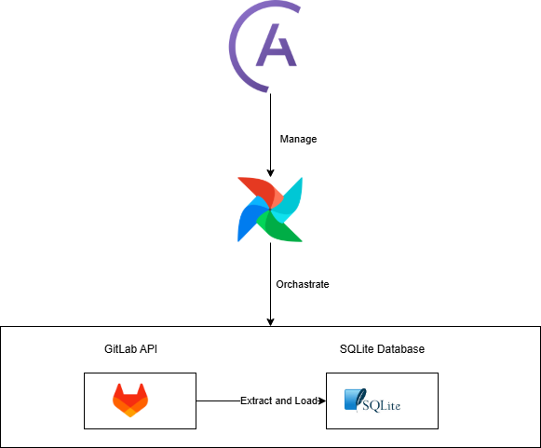

Step 1: Install Docker

Make sure Docker is installed and running on your machine. You can download Docker from Docker's official website.

Step 2: Install Astro CLI

Open PowerShell as an administrator and run the following commands to download and install the Astro CLI:

Invoke-WebRequest -UseBasicParsing https://install.astronomer.io -OutFile astro-installer.ps1

Set-ExecutionPolicy -Scope Process -ExecutionPolicy Bypass

.\astro-installer.ps1

Step 3: Verify Installation

After the installation is complete, confirm the Astro CLI is installed correctly by running:

astro version

You should see the installed version of Astro CLI displayed.

Step 4: Initialize Your Astro Project

To create a new Astro project, run the following command:

astro dev init

This will set up the necessary files and folder structure for your Astro project.

Create a DAG that imports and uses the function from app.py to fetch GitLab data. Save the DAG file in the dags folder within your project directory.

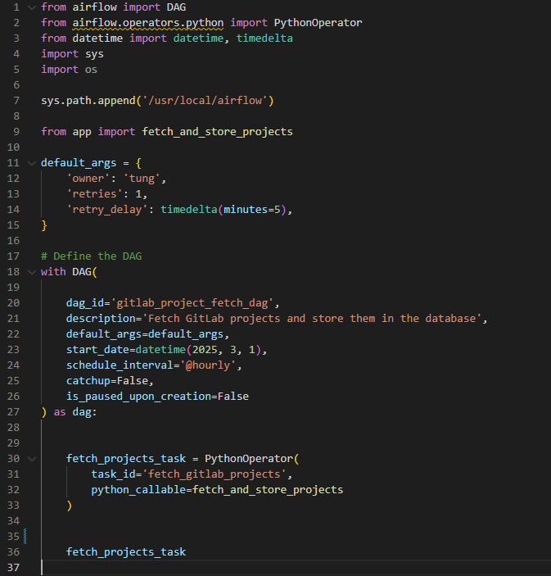

Edit the Docker file for setup and run command astro dev start to run the Airflow server on localhost:

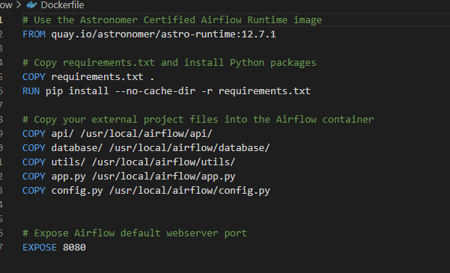

Now you can run the DAG either on a schedule or trigger it manually, on the Airflow server:

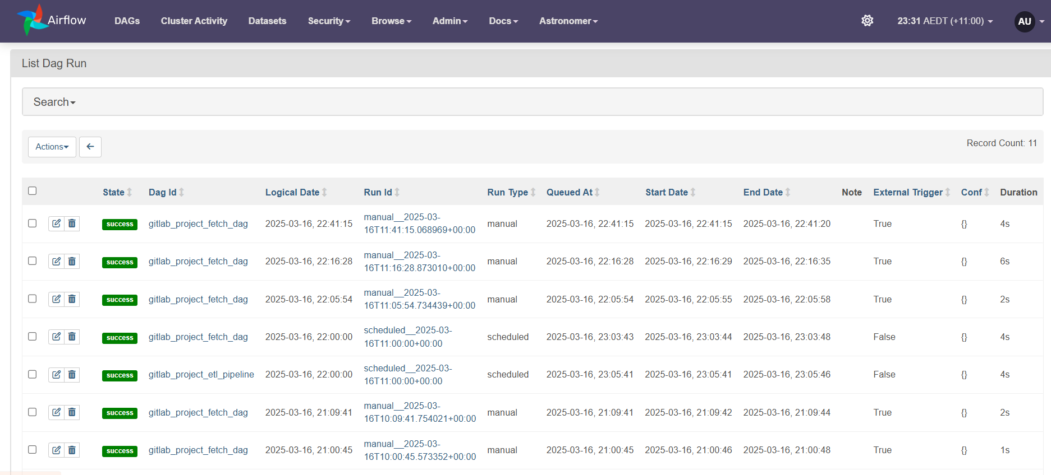

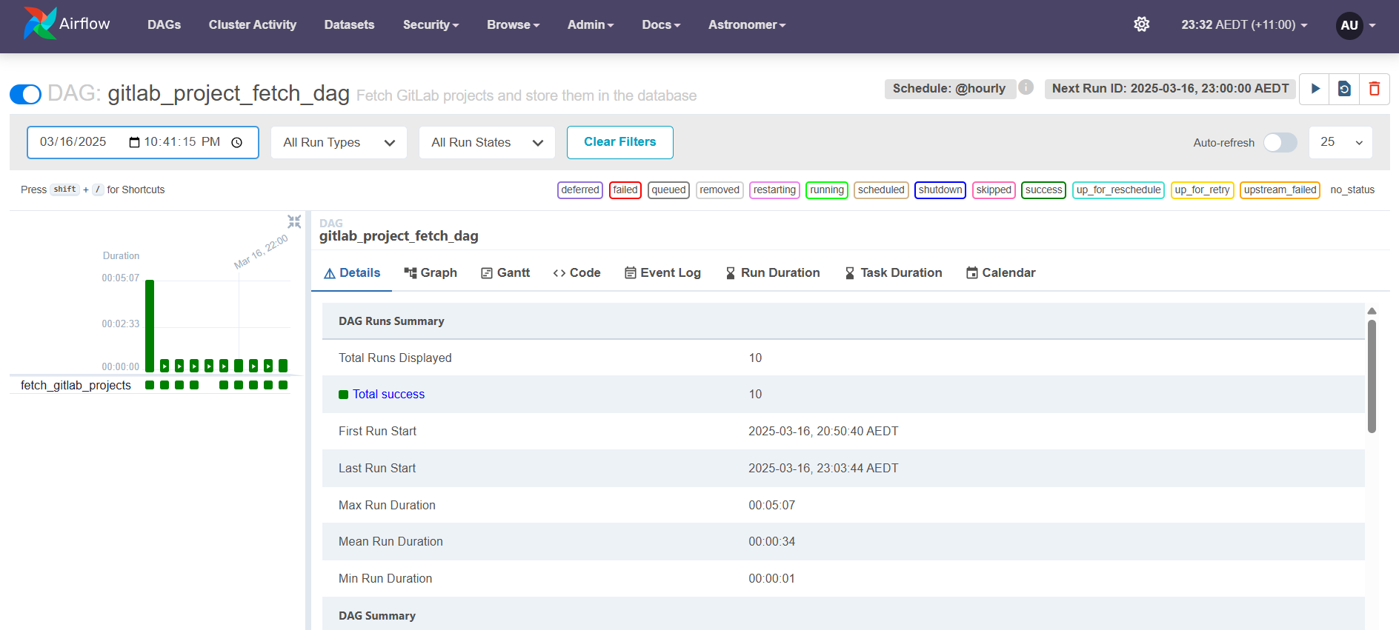

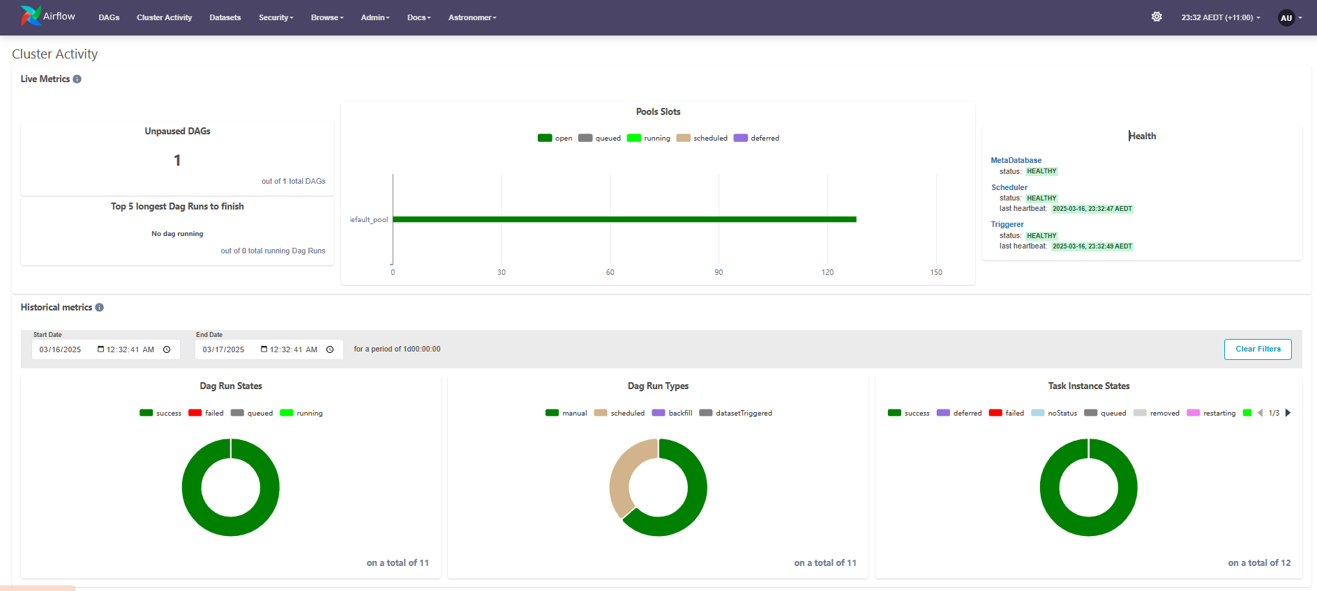



# Future Implementation and Improvement

This is a plan for a more sophisticated system that I want to implement in the future:  
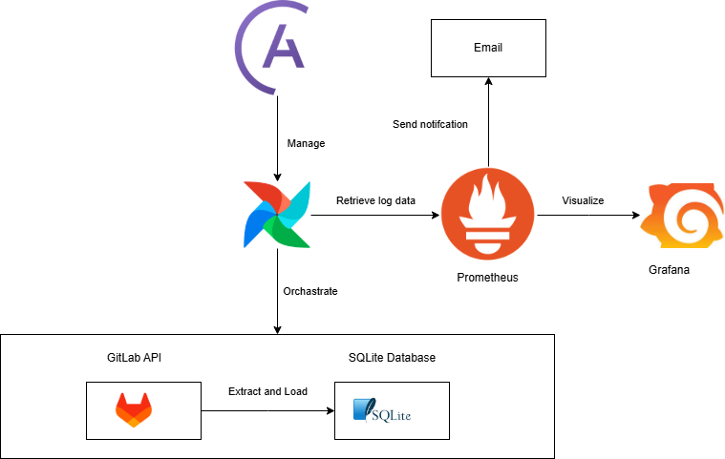

In the future, I plan to implement a more efficient and scalable system by integrating Prometheus to collect metrics and send automated email alerts to users. The system will also leverage Grafana dashboards for real-time data visualization and monitoring. To ensure security and high availability, the entire solution will be hosted on AWS within a secure cloud infrastructure.