131(<https://porto-demo13-new.myshopify.com/>)

132(<https://porto-demo13-new.myshopify.com/>)133(<https://porto-demo13-new.myshopify.com/>)134(<https://porto-demo13-new.myshopify.com/>)

135(<https://porto-demo13-new.myshopify.com/>)



136(<https://porto-demo13-new.myshopify.com/>)



137(<https://porto-demo13-new.myshopify.com/>)

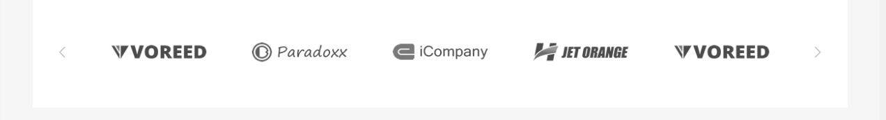

138(<https://porto-demo13-new.myshopify.com/>)



150(<https://porto-demo13-new.myshopify.com/search?q=the&type=product&product_cat=all>)

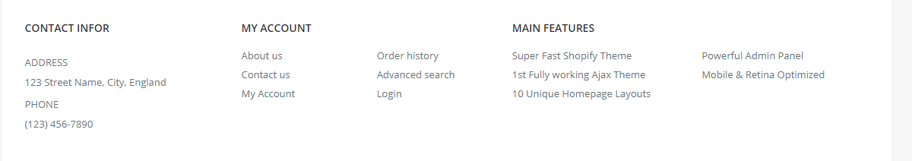

151(<https://porto-demo13-new.myshopify.com/search?q=the&type=product&product_cat=all>)



139(<https://porto-demo13-new.myshopify.com/>)



140(<https://porto-demo13-new.myshopify.com/>)



141(<https://porto-demo13-new.myshopify.com/collections/fashion/products/classic-sunglasses?variant=38627997191>)



142(<https://porto-demo13-new.myshopify.com/collections/fashion/products/classic-sunglasses?variant=38627997191>)



142(<https://porto-demo13-new.myshopify.com/collections/fashion/products/classic-sunglasses?variant=38627997191>)

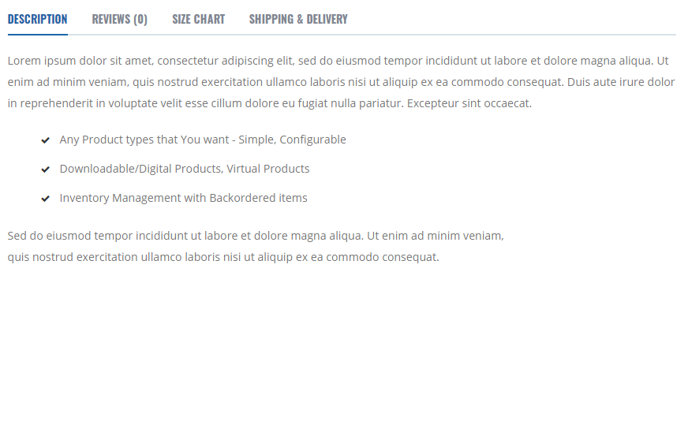

143(<https://porto-demo13-new.myshopify.com/pages/about-us>)



144(<https://porto-demo13-new.myshopify.com/pages/about-us>)



145(<https://porto-demo13-new.myshopify.com/pages/about-us>)



146 (<https://porto-demo13-new.myshopify.com/pages/contact>)



147



148(<https://porto-demo13-new.myshopify.com/products/men-ettika-leather-bracelet?variant=38627997639>)



149(<https://porto-demo13-new.myshopify.com/account/login>)

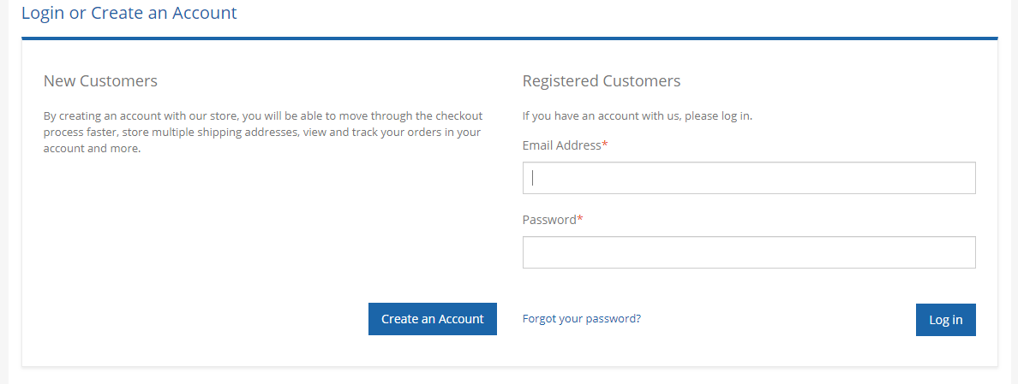

152(<https://porto-demo13-new.myshopify.com/pages/header-types>)



**153(**<https://porto-demo13-new.myshopify.com/pages/header-types>**)**

 **154(**<https://porto-demo13-new.myshopify.com/cart>**)**

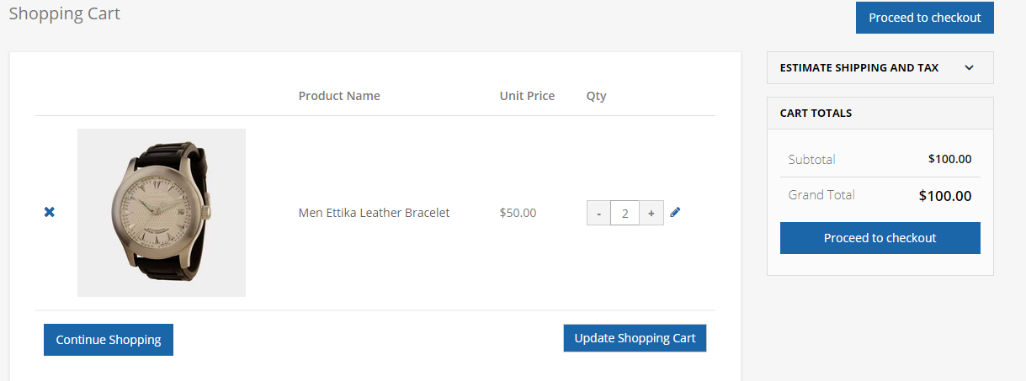

**155(**<https://porto-demo13-new.myshopify.com/17765227/checkouts/610ce41ae98af10193c57413526fe965>**)**

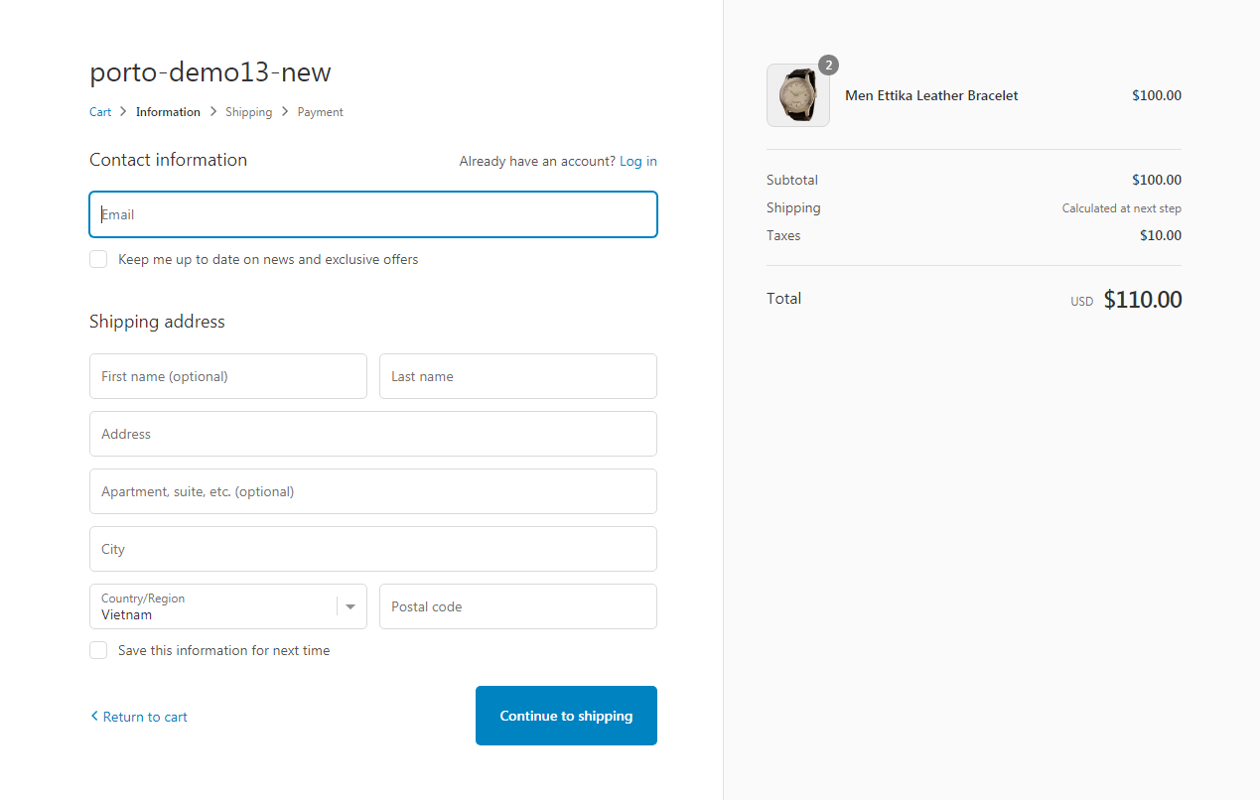

|  |  |  |  |
| --- | --- | --- | --- |
| Name | modules | Ngày phân công | Ngày kết thúc |
| Nguyễn Thị Nhựt Anh | 135 137 143 147 155 | 28/10/2019 | 2/11/2019 |
| Phan Văn Tùng | 131 136 141 146 151 | 28/10/2019 | 2/11/2019 |
| Ngô Hữu Thế | 132 138 142 148 152 | 28/10/2019 | 2/11/2019 |
| Trần Đăng Khoa | 133 139 144 149 153 | 28/10/2019 | 2/11/2019 |
| Nguyễn Chí Tân | 134 140 145 150 154 | 28/10/2019 | 2/11/2019 |