**Doc. No :TOSYM- 20200115001**

**Date : 2020. 7. 8.**

**To : Symphony Soft Co., (Tax code : 119-81-82402)**

**Attn : Mr. Ho Ik Kim / CEO.**

**Dear Sir,**

**We hereby issue the invoice for development center consignment as below,**

Unit : VND

|  |  |  |
| --- | --- | --- |
| NO. | CONTENT | AMOUNT |
| 1 | Development center consignment fee of below engineers,   1. Mr. Phan Thanh Tung (Flutter, KRW 1 MM for June 2020) | 8,500,000 |

**Please Transfer above fee to Mr. Phan Thanh Tung’s bank account below within 5 days as issuing the invoice. (Exchange currency into US dollars to wire.)**

**Bank Information to wire**

Bank : **ShinhanVietnam Bank, Tran Duy Hung branch, Hanoi, Vietnam**.

(SWIFT BIC Code : SHBKVNVXXXX)

Beneficiary : **PHAN THANH TUNG**

Account number : **700-014-521085** (USD),

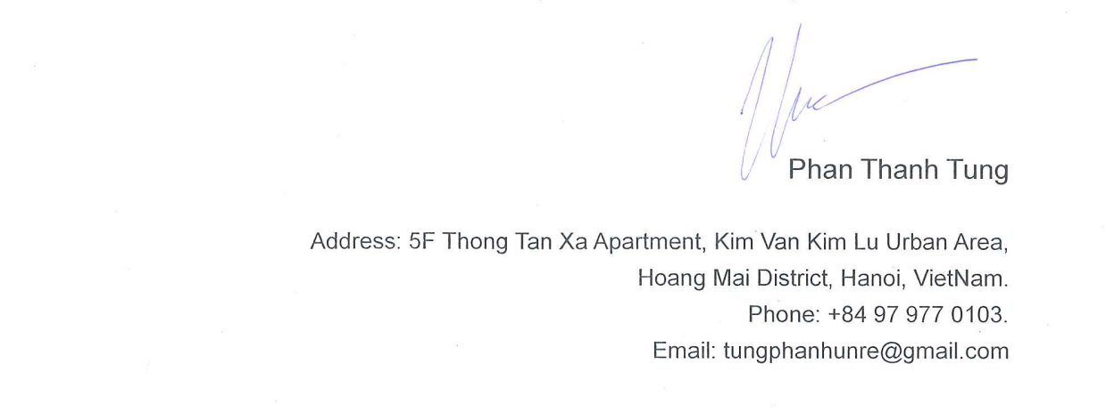**2020. 7. 8**