|  |  |
| --- | --- |
| **(Confidential)** | |
| Scope of disclosure | TSDV, SWC, TRE |
| Period of confidentiality | 7 years after release |
| Head of Information Owner | Head of Engineering Dept. |
| Handling restriction | NA |

**Software Design Specification**

**Next Generation PTE**

**Toshiba Software Development (Vietnam) Co., Ltd.**

|  |
| --- |
| Document ID: TSDV-PTE-NextGenPTE-SDS |
| Total: 93 Page No. 1 |

Revision History

|  |  |  |  |  |  |  |
| --- | --- | --- | --- | --- | --- | --- |
| Rev. No.  (X.YY) | Date (YYYY-MM-DD) | Section No. Changed | Change Description | Author | Review by | Approved by |
| 0.01 | 2017-08-14 | All | Initialize the document | DungPQ |  |  |
| 0.02 | 2017-08-17 | 5.2.3 | Update basic event of Status screen | TuanTM |  |  |
| 0.03 | 2017-08-17 | 5.2.1  5.2.2 | Add common monitoring modules  Update basic events of Graph screen | DungPQ |  |  |
| 0.04 | 2017-08-17 | 5.2.4 | Update basic events of Numeric screen | DungPQ |  |  |
| 0.05 | 2017-08-23 | 5.2  5.3  5.4 | Add the event handler of [User View] modules.  Add the event handler of [Component] module.  Add the APIs of [Service] modules. | TuanTM | TheNQ  DungPQ |  |
| 0.06 | 2017-08-31 | 7 | Add the non-function requirements. | DungPQ | LanLTM |  |
| 0.07 | 2017-09-06 | 4.3 | Add the limitation of third-party libraries and frameworks. | DungPQ |  |  |
| 1.00 | 2017-09-13 | 4.1  7 | Update the physical model.  Update the Maximum size of all opening data files. | DungPQ | Taguchi  Mitsui | KhoaLH |
| 1.01 | 2017-10-09 | 5.3 | Update drag and drop event for Graph and Numeric screen | TuanTM | DungPQ | KhoaLH |
| 1.02 | 2017-11-29 | 5  5.3  5.4  5.5 | Change the document structure  Add the system behaviors  Add description of [Browser Client] modules.  Add section of [Virtual Server] | TuanTM |  |  |
| 1.03 | 2017-12-08 | 5.5 | Add class diagram of Websocket communication  Add Start / Stop / Connect / Disconnect sequence | TuanTM | DungPQ |  |
| 1.04 | 2017-12-09 | 5.4  5.4.6  5.4.7  5.4.8 | Add the component diagram of [Browser Client]  Add the Operation component  Add the Help component  Add the Account component | TuanTM | DungPQ |  |
| 1.05 | 2017-12-16 | 5.3  5.3.7  5.4.3.3  6 | Add Figures’ caption  Add Getting file list sequence diagram  Update action of numeric again  Change refer document | TuDV |  |  |
| 1.06 | 2017-12-19 | 5.3  5.5 | Update message ID | TuanTM | DungPQ |  |
| 1.07 | 2017-12-25 | 5.5.2 | Update class name | TuanTM | DungPQ |  |
| 1.08 | 2017-12-26 | 5.1  5.4.1 | Remove section 5.1  Add class description | TuanTM | DungPQ | KhoaLH |
| 1.09 | 2018-02-19 | 5.3.2  5.3.4.4 | Add the fault list component.  Add the fault history component. | DungPQ |  |  |
| 1.10 | 2018-02-23 | 5.2.17  5.2.18  5.2.19  5.3.4.4 | Update Fault list component  Update Fault History component | TuanTM |  |  |
| 1.11 | 2018-02-27 | 5.2.13  5.2.14  5.2.15  5.2.16  5.3.5.2 | Update Fault status component | KienNH | DungPQ |  |
| 1.12 | 2018-02-27 | 5.3.4.4  5.2.19 | Update peer review defects of Event History component. | TuanTM | HienDT  (V&V) |  |
| 1.13 | 2018-03-01 | 5.2.14 | Update following V&V review | TuanTM | DungPQ | KhoaLH |
| 1.14 | 2018-04-30 | 5.3.4. | Add the saved settings when user switches screens. | DungPQ |  |  |
| 1.15 | 2018-05-21 | 5.3.1 | Update File List and Fault List component | QuocHV |  |  |
| 1.16 | 2018-05-28 |  | Move the section [WMATA Virtual Server] to the separated design document. | DungPQ |  |  |
| 1.17 | 2018-05-29 | 5.3.4  5.3.5 | Update Graph & Numeric component. | TuanTM |  |  |
| 1.18 | 2018-05-31 | 5.3.4 | Update cursor moving sequence diagram. | TuanTM |  |  |
| 1.19 | 2018-06-16 | 5.3  5.3.6 | Update design description following V&V review. | TuanTM | DungPQ | KhoaLH |
| 1.20 | 2018-07-18 | 5.2.1.5  5.3.5.4 | Add function of Undo / Redo.  Add the mechanism of [Change Language]. | DungPQ |  |  |
| 1.21 | 2018-07-18 | 5.3.4.1  5.3.4.2  5.3.4.3  5.3.4.4 | Update the time search function for Graph, Status and Numeric.  Update Fault History table function the same as File List and Fault List. | ThinhVD |  |  |
| 1.22 | 2018-08-10 | 5.2.2.7 | Add the section [Resize graph panel]. | DungPQ |  |  |
| 1.23 | 2018-08-10 | 5.2.5.2  5.3.3.2  5.3.4.2  5.3.1  5.3.2  5.3.5.2 | Update the section [Status save settings].  Save settings to a settings file.  Add warning and alarm condition for [Monitoring Status and [Fault Record Status] modules.  Add the handler of [Resize columns] for File List and Fault List.  Update the panel order to Z-order. | QuocHV |  |  |
| 1.24 | 2018-08-12 | 5.3.4.1  5.3.5.1 | Update the function Graph Comments.  Update the vertical cursor color and handler of button “Adjust View”. | TuanTM |  |  |
| 1.25 | 2018-08-12 | 5.3.5.1 | Add the sequence diagram of [Changing line positions] | LongDT |  |  |
| 1.26 | 2018-09-19 | All | Change back the layout of all pages to A4. | TuanTM | DungPQ |  |
| 1.27 | 2018-09-19 | All | Change back the layout of all pages to A4. | TuanTM | DungPQ |  |
| 1.28 | 2018-09-26 | 5.4 | Add Down sampling data algorithm | LongDT | TuanTM  DungPQ | KhoaLH |
| 1.29 | 2019-01-04 | 5.3.5.2 | Change scale and position analog signal. | ChiVN |  |  |
| 1.30 | 2019-01-09 | 5.3.5.2.1 | Add graph printing method | ChiVN |  |  |
| 5.3.5.3.1 | Add numeric printing | ChiVN |  |  |
| 5.3.4.4 | Update Filter (Date and Event name) | ChiVN |  |  |
| 5.3.7 | Add Dialog screen select signal | ChiVN |  |  |
| 5.3.6.1 | Update filter name, description | ChiVN |  |  |
| 5.3.5.1 | Right click on Y-Axis | ChiVN |  |  |
| 5.3.5.1 | Update Change line origin point | ChiVN |  |  |
| 1.31 | 2019-01-25 | 5.2.1.6 | Multiple signals selection. | ThinhVD | DungPQ | KhoaLH |
| 5.2.2.5 | [Graph] Save comments | ThinhVD |
| 5.2.2.8 | [Graph] Delete signal line. | ThinhVD |
| 1.32 | 2019-03-25 | 5.2.8 | Update the sequence of timeset | ChiVN | DungPQ | KhoaLH |

|  |  |  |  |  |  |  |
| --- | --- | --- | --- | --- | --- | --- |
| 1.33 | 2019-07-09 | 5.3.4.4  5.3.10.2 | Update fault history component regarding to WMATA add item No.13, 14, 15, 16 | ThinhVD | DungPQ |  |
| 1.34 | 2019-07-18 | 5.3.4.4 | Update after team review | ThinhVD |  | KhoaLH |
| 1.35 | 2019-08-08 | 5.2.8.1  4.3 | Update for Flexible default signal reset and related signal setting. | ThinhVD |  |  |
| 1.36 | 2019-08-12 | 5.2.8.1  4.3 | Update after team review | ThinhVD | DungPQ | KhoaLH |
| 2.00 | 2019-12-18 | 5.2.10 | Add login diagram | QuocHV |  |  |
| 2.01 | 2019-12-24 | 5.3.6.3 | Add the design of Logic Editor | DungPQ | DungPQ, HangNT, KhoeNV | KhoaLH |
| 2.02 | 2019-12-27 | 5.1.3.2  5.3.4.1  5.3.4.2  5.3.4.3  5.3.6.3 | Add design of Reset Lockout and search time absolute mode in IT8 | KhoeNV | DungPQ, HangNT, KhoeNV |  |
| 2.03 | 2019-12-27 | 2.2.2  6.5.1 | Add download diagram  Add plugins setting diagram | QuocHV | DungPQ | KhoaLH |
| 2.04 | 2020-05-26 | 5.2.8.5 | Add design for share file | ThinhVD |  |  |
| 2.05 | 2020-05-28 | 5.2.8.6 | Add design for DO Test | ThinhVD |  |  |
| 2.06 | 2020-06-01 | 5.2.8.7 | Add design for Wheel set | ThinhVD |  |  |
| 2.07 | 2020-06-01 | 5.2.6.4 | Add design for SD card | KhoeNV | HangNT | KhoaLH |
| 2.08 | 2020-08-03 | 5.5.1 | Add design of Graph Lazy Load | DungPQ | HangNT | KhoaLH |
| 2.09 | 2020-12-15 | 5.2.1 | Update design for starting application | ThinhVD | DungPQ | KhoaLH |
|  |  |  |  |  |  |  |
|  |  |  |  |  |  |  |

Content

1. Introduction 9

2. References 9

3. Definitions and Acronyms 9

4. System Overview 10

4.1. System perspective 10

4.2. Common Design rules 11

4.2.1. Low-coupling modules 11

4.2.2. CSS style 11

4.2.3. Web responsive 11

4.3. Third party technologies 11

5. Software Architecture 13

5.1. User View 13

5.1.1. Monitoring View 13

5.1.2. Fault Record View 14

5.1.3. Operation 15

5.1.4. Help 16

5.1.5. Account 16

5.2. System Behaviors 16

5.2.1. Common 16

5.2.2. Graph 20

5.2.3. File List 25

5.2.4. Numeric 26

5.2.5. Status 28

5.2.6. Fault List 32

5.2.7. Fault History 35

5.2.8. Operation 36

5.2.9. Help 40

5.2.10. Login 41

5.3. Browser Client 41

5.3.1. File List Component 46

5.3.2. Fault List Component 47

5.3.3. Monitoring Components 50

5.3.4. Fault Record 56

5.3.5. Service 63

5.3.6. Operation Component 81

5.3.7. Dialog screen select signal 84

5.3.8. Help Component 84

5.3.9. Account 85

5.3.10. Settings 86

5.3.11. Login screen 90

5.4. Down sampling large data 90

5.4.1. Purpose 90

5.4.2. Objectives of the down sampling method 91

5.4.3. Largest Triangle Three Buckets Algorithm 91

6. Client-Server interface 93

7. Appendix 93

List of Tables

Table 4‑1: Third party libraries and frameworks 11

Table 4‑2: Third party libraries and frameworks limitations 12

Table 5‑1: [Browser client] configuration information 42

Table 5‑2: [Browser Client] components, service and controllers 44

Table 5‑3: File list component event handlers 46

Table 5‑4: Fault list component event handlers 47

Table 5‑5: [Monitoring Graph Component] event handlers 50

Table 5‑6: [Monitoring Status Component] event handlers 53

Table 5‑7: [Record Graph Component] event handlers 56

Table 5‑8: [Record Status Component] event handlers 57

Table 5‑9: [Status Comment Mark] event handlers 59

Table 5‑10: [Record Numeric Component] event handlers 60

Table 5‑11: Common service modules APIs 63

Table 5‑12: Fault record + Monitoring GUI settings 66

Table 5‑13: Graph service APIs 69

Table 5‑14: Graph components event handlers 70

Table 5‑15: Status service APIs 73

Table 5‑16: Status service APIs 78

Table 5‑17: Status-monitoring component event handlers 79

Table 5‑18: Numeric service APIs 80

Table 5‑19: Numeric components event handlers 80

Table 5‑20: Print numeric 81

Table 5‑21: [Flex Controller] event handlers 81

Table 5‑22: [Time Set Controller] event handlers 82

Table 5‑23: Help components event handlers 84

Table 5‑24: Account component event handlers 85

Table 5‑25: Network component event handlers 86

List of Figures

Figure 4‑1: PTE system perspective 10

Figure 5‑1: Monitoring Status View 13

Figure 5‑2: Monitoring Graph View 13

Figure 5‑3: File List View 14

Figure 5‑4: Record Numeric View 15

Figure 5‑5: Flexible View 15

Figure 5‑6: Reset Lockout screen 16

Figure 5‑7 - Get initialize configuration 17

Figure 5‑8: File Parser sequence diagram 18

Figure 5‑9: Error Handling sequence diagram 19

Figure 5‑10: Get real time data sequence diagram 20

Figure 5‑11: Save graph settings sequence diagram 21

Figure 5‑12 - Load graph setting sequence diagram 22

Figure 5‑13: Load comments sequence diagram 23

Figure 5‑14: Getting File List sequence diagram 25

Figure 5‑15 - Numeric save settings sequence diagram 26

Figure 5‑16 - Numeric load setting sequence diagram 27

Figure 5‑17: Status load setting sequence diagram 28

Figure 5‑18 : Save status settings sequence diagram 29

Figure 5‑19: Play a record file sequence diagram 30

Figure 5‑20 : Display the real-time data sequence diagram 31

Figure 5‑21: Get fault information list 32

Figure 5‑22: [Fault List] Download a fault record file 33

Figure 5‑23: [Fault List] Acquire fault types 34

Figure 5‑24: Display the fault history list 35

Figure 5‑25: Select signals for fault history files 36

Figure 5‑26: Select signals for the real-time monitoring 37

Figure 5‑27: Select signals for fault record files 38

Figure 5‑28: Time Set screen 39

Figure 5‑29: Open Version screen 40

Figure 5‑30: Login screen 41

Figure 5‑31: [Browser Client] screen hierarchy 42

Figure 5‑32: [Browser Client] components diagram 43

Figure 5‑33: System data flow 45

Figure 5‑34: Download fault record 50

Figure 5‑34: Select and deselected signal on the control panel. Expand or collapse Analog/Digital in the Control Panel 52

Figure 5‑35: Change time mode Absolute/Relative on monitoring graph screen. 53

Figure 5‑36: Change time mode Absolute/Relative on monitoring status screen. 55

Figure 5‑37: Share and load setting 56

Figure 5‑38: Sequence search time absolute in record graph screen 57

Figure 5‑39: Add timeline comment 59

Figure 5‑40: Sequence diagram of search time absolute in record status screen 60

Figure 5‑41: Sequence diagram of search time absolute in record numeric screen 62

Figure 5‑42: Websocket auto reconnection 65

Figure 5‑43: Module diagram of Undo/Redo function 67

Figure 5‑44: Sequence diagram of Undo/Redo function 68

Figure 5‑45: Multiple signals selection. 69

Figure 5‑46: Change line positions sequence diagram 72

Figure 5‑47: Graph cursor moving 74

Figure 5‑48: Resize graph panels sequence diagram 75

Figure 5‑49: Delete signal line 76

Figure 5‑50: Align graph line automatically 77

Figure 5‑51: Add and edit comment locally 78

Figure 5‑52: Initialize Logic Editor Dialog 83

Figure 5‑53: Synchronize between logic text and logic image 83

Figure 5‑54: User click button Apply to save 84

Figure 5‑55: Login to system. 86

Figure 5‑56: Change IP address of server. 87

Figure 5‑57: Unit display setting. 88

Figure 5‑58 Format display setting. 88

Figure 5‑58 Plugin setting 89

Figure 5‑58 Login screen 90

Figure 5‑59: Line chart contains 32768 data points 91

Figure 5‑60: Down sampled data line chart 91

Figure 5‑61: Largest triangle formed across three buckets and point C being a temporary point 92

Figure 5‑62: Down sampled line chart with the Largest Triangle Three Buckets algorithm 93



# Introduction

This document introduces software architecture of the Next Generation PTE system. The main viewers are Developers. This document does not describe the detailed [User Interface Design], but describes GUI components, common modules, communication among GUI modules, and communication to [Virtual Server] to make sure that the architecture is flexible enough to adapt any future requirement changes.

# References

|  |  |  |  |  |
| --- | --- | --- | --- | --- |
| **Document ID** | **Document/Standards Name/Title** | **Source** | **Version No. /Release or Publication date** | **Brief Description/Section Reference** |
| 1 | NextgenPTE_20170525 | TRE | 2017-05-25 | PTE integration strategy and plan. |
| 2 | 次世代PTE_統合AILIST_20170622 | TRE | 2017-06-22 | Integration problem list. |
| 3 | 次世代PTE_統合開発工程_20170622 | TRE | 2017-06-22 | PTE 2017 master plan and estimation. |
| 4 | TSDV-2017A-PTU-ScreenPrototype | TSDV | 1.10 | GUI prototype specification. |
| 5 | <https://docs.angularjs.org/guide/databinding> | Internet | NA | AngularJS guideline web page. |
| 6 | TSDV-PTE-Manual.docx | TSDV | 1.03 | PTE C++ tool guideline. |
| 7 | <http://blog.softelegance.com/angularjs/angularjs-advantages-and-limitations/> | Internet | NA | Advantage and disadvantage of AngularJS. |
| 8 | <https://www.weblineindia.com/blog/angularjs-what-why-advantages-and-disadvantages/> | Internet | NA | Advantage and disadvantage of AngularJS. |
| 9 | <http://chimera.labs.oreilly.com/books/1230000000345/ch02.html#_what_it_doesn_t_do> | Internet | NA | Advantage and disadvantage of D3. |
| 10 | <http://www.htmlcenter.com/blog/the-bootstrap-framework-controversy-should-you-use-it-or-not/> | Internet | NA | Advantage and disadvantage of Bootstrap. |
| 11 | <https://docs.handsontable.com/pro/1.3.4/tutorial-known-limitations.html> | Internet | NA | Advantage and disadvantage of HandsonTable. |
| 12 | TSDV-2017B-PTE-SRS.docx | TSDV | 0.19 | PTE requirement specified |
| 13 | 171122_PTE_monitoring_3 | TRE | 2017-11-23 | GUI Design Document |
| 14 | E6MX0211_ブラウザPTE_通信インタフェース設計書.xlsx | TRE | 2017-12-18 | Message Interface document |

# Definitions and Acronyms

|  |  |  |
| --- | --- | --- |
| **No** | **Acronyms** | **Definition** |
| 1 | TSDV | Toshiba Software Development Vietnam |
| 2 | TRE | Toshiba Transport Engineering |
| 3 | PTE | Portable Test Equipment |
|  |  |  |
|  |  |  |

# System Overview

## System perspective



Figure 4‑1: PTE system perspective

 Client-side Server side

* [Browser Client] application connects to [Virtual Server] to get the real-time monitoring data and user settings. [Browser Client] reads [Local Browser Data files] from the hard disk or [Local Server data files] through [Virtual Server] to visualize data in screen as graphs, status panel and tables. User only can interact directly to the [Browser Client].
* [Virtual Server] takes charge of two jobs:
  + Connects to the [CPU board] via the COM port to read out protection records and monitor operation of the device. The [Virtual Server] sends the JSON-formatted message to the [Browser Client].
  + Takes charge of managing the data file hierarchy and support other FTP server function, because [Browser Client] cannot access directly to hard disk files without through the user operation.
* [CPU Board] is a separated device against the [PTE] device that provides the real-time value to the [Virtual Server].

## Common Design rules

This section describes design strategy and common rules of the current design. Any modification or improvement of design have to strictly follow these rules to guarantee the consistency of architecture.

### Low-coupling modules

Modules MUST NOT access directly to the internal data of other modules (Use APIs instead).

Modules SHOULD use messages to interact to each other.

Modules SHOULD NOT use directly APIs from higher-level modules (use message or callback instead).

Modules SHOULD NOT use directly APIs from plugin modules (use message or callback instead).

### CSS style

Each components MUST have a separated CSS file.

All DOM components style SHOULD be assigned by [class], not by [id].

Styles SHOULD be named by module names, sub-module names (such as *pte-graph-menu*).

### Web responsive

SHOULD define clearly the web responsive layout design (which grid cells should hide or merge, etc.).

SHOULD apply the Bootstrap style to the Web Responsive (design for mobile first).

## Third party technologies

Table 4‑1: Third party libraries and frameworks

|  |  |  |  |  |  |
| --- | --- | --- | --- | --- | --- |
| **No** | **Name** | **Type** | **Description** | **Version** | **License** |
| 1 | AngularJS | Framework | Two way data binding is the synchronization mechanism between the model and the view. | 1.6.5 | MIT |
| 2 | D3 | Library | Draw graphs | 4.9.1 | BSD3 |
| 3 | Bootstrap | Framework | Web style template | 3.3.7 | MIT |
| 4 | HandsonTable | Library | Draw tables |  | MIT |
| 5 | Draw2d | Library | Logical circuit draw |  | MIT |

Table 4‑2: Third party libraries and frameworks limitations

|  |  |  |  |
| --- | --- | --- | --- |
| **No** | **Name** | **Limitations** | **Countermeasure** |
| 1 | AngularJS | Big and complicated | Only learn and use the most basic and reliable functions (data binding). |
| Too many data watchers (2000) can cause to lag UI | Use other libraries to monitor data grid and list (For example HandsonTable). |
| 2 | D3 | Doesn't always try to support older browsers | Latest version browsers can support D3:  + IE10, IE11, Edge.  + Firefox, Google Chrome. |
| Does not handle bitmap map tiles | D3 is great with vector—SVG images or GeoJSON data in the map-drawing projects. |
| 3 | Bootstrap | Project CSS styles may be conflict to some common bootstrap styles (for example panel, button, etc.) | Follow strictly the coding rule to name CSS style. |
| 4 | HandsonTable | Not mobile-friendly yet | Define an abstraction layer of creating, updating the data table so that it can be easier to extend the module in the future. |

# Software Architecture

## User View

### Monitoring View

[Monitoring View] provides the users the visualization for real-time data. [Monitoring View] is composed by:

* [Monitoring Graph Component] view: Refer to the section 5.3.3.1.
* [Monitoring Status Component] view: Refer to the section 5.3.3.2.

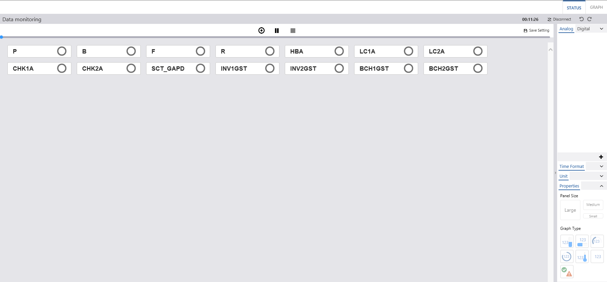

Figure 5‑1: Monitoring Status View

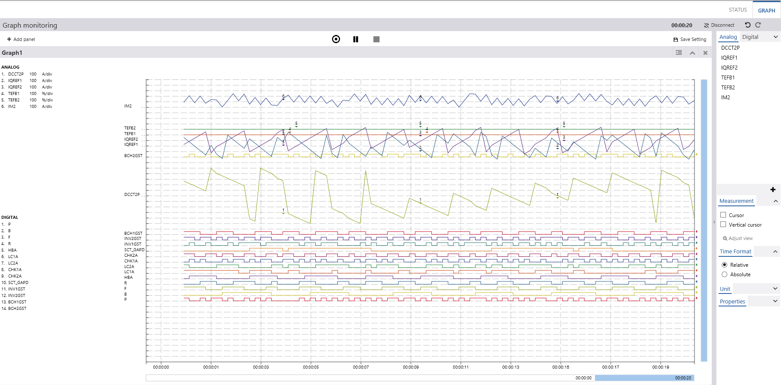

Figure 5‑2: Monitoring Graph View

### Fault Record View

[Fault Record View] provides the users the visualization for opening and loading data files. [Fault Record View] is composed by:

* [File List Component] view: Refer to the section 5.3.1.
* [Record Graph Component] view: Refer to the section 5.3.4.1.
* [Record Status Component] view: Refer to the section 5.3.4.2.
* [Record Numeric Component] view: Refer to the section 5.3.4.3.

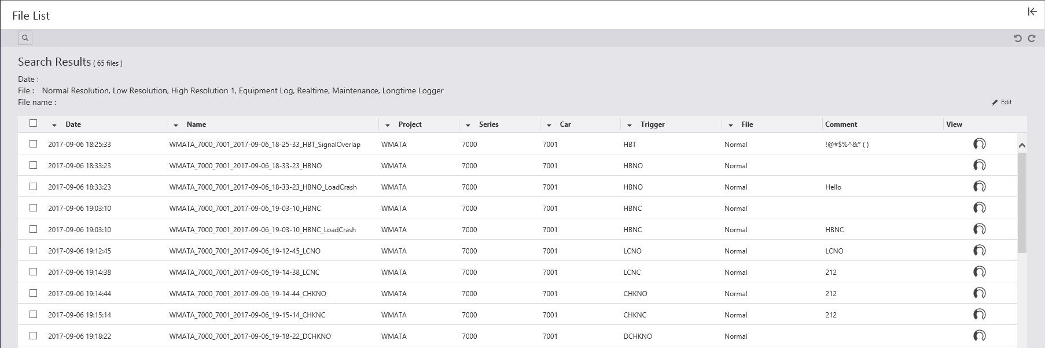

Figure 5‑3: File List View

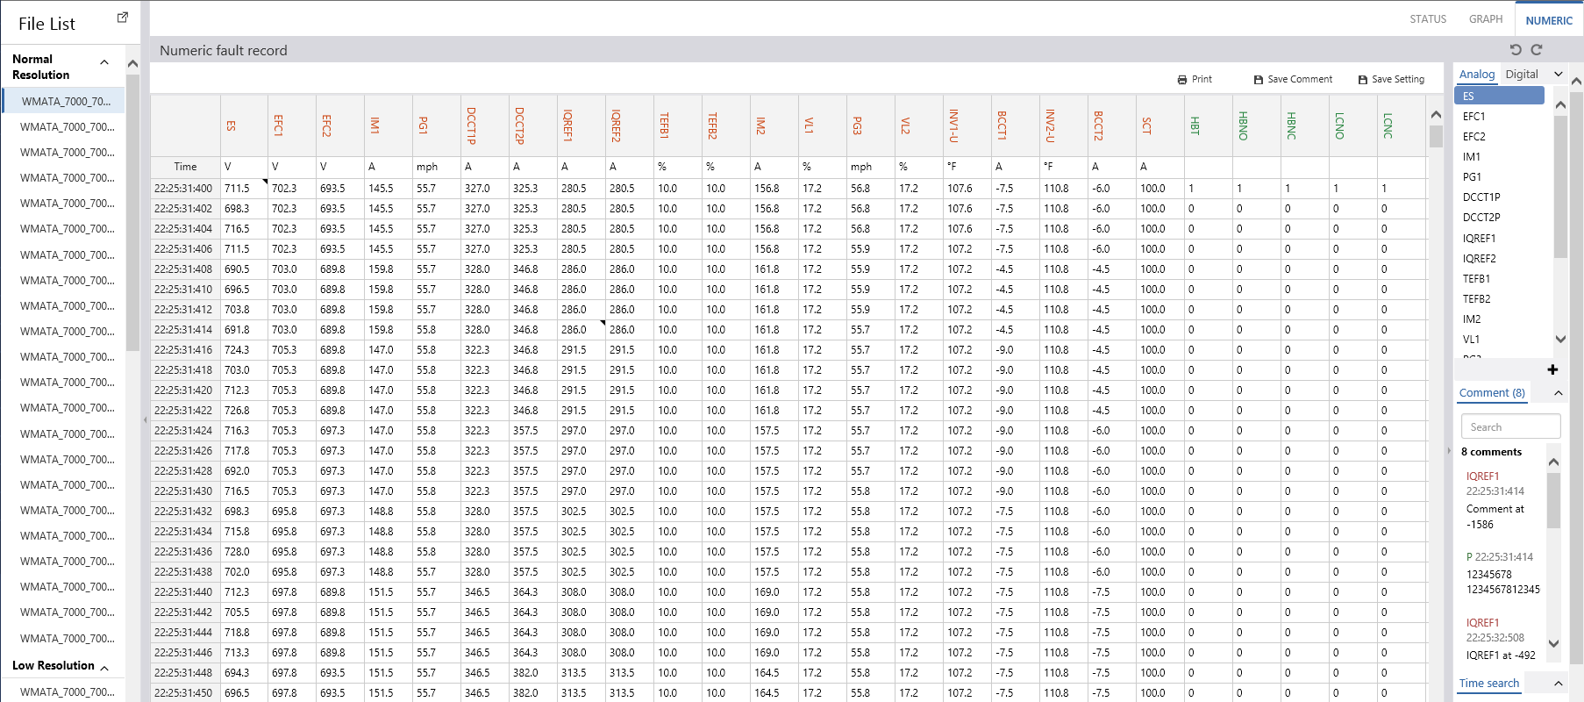

Figure 5‑4: Record Numeric View

### Operation

#### Flexible View

[Flexible View] provides the users the user setting for signal selection of each data file types.

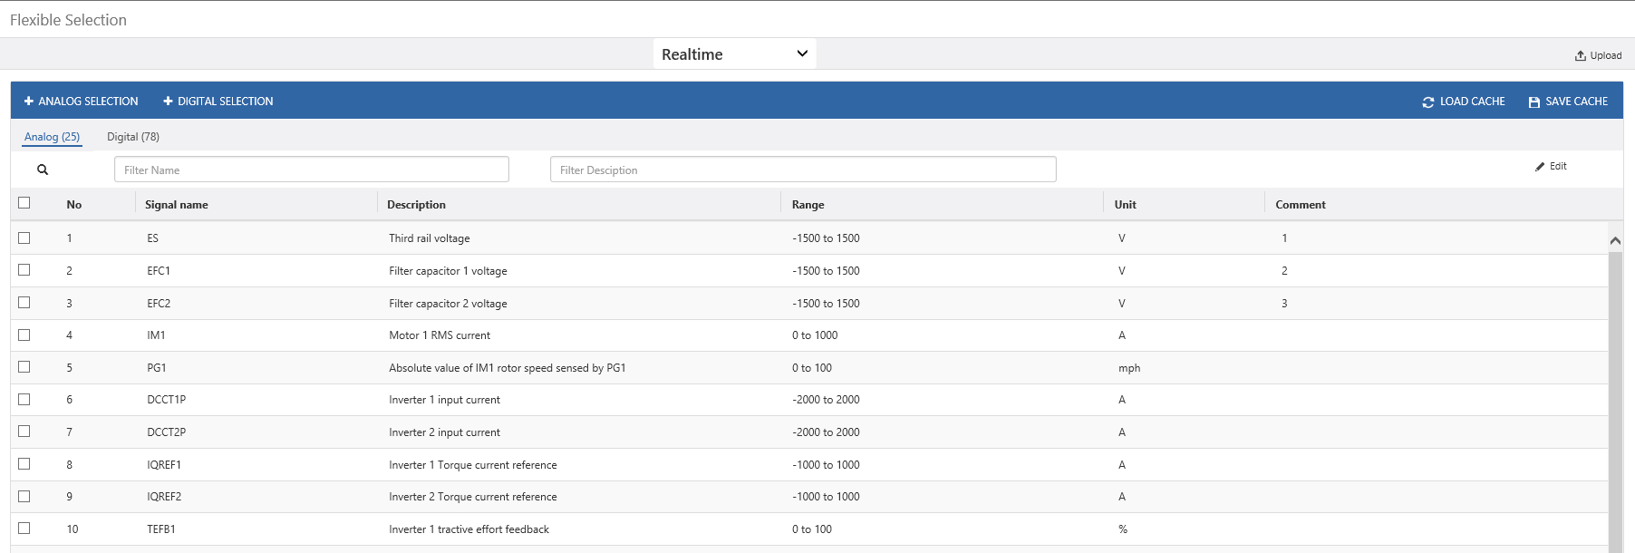

Figure 5‑5: Flexible View

#### Reset Lockout View

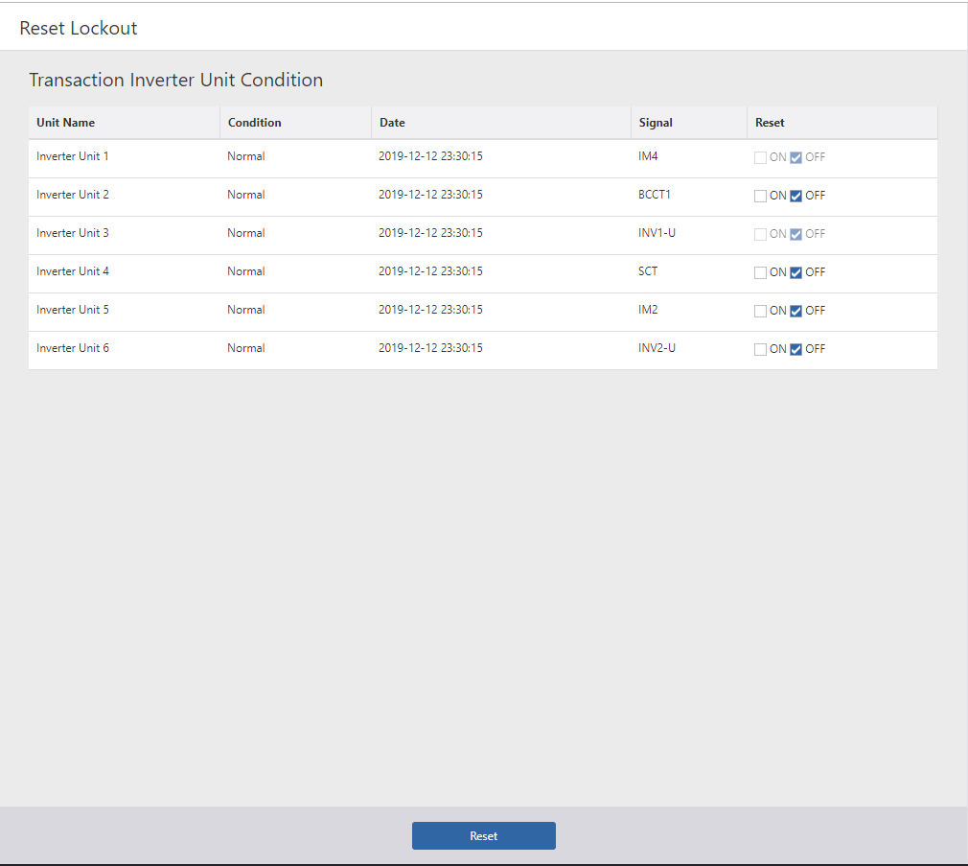

Figure 5‑6: Reset Lockout screen

### Help

NA

### Account

NA

## System Behaviors

### Common

#### Get initialize configuration

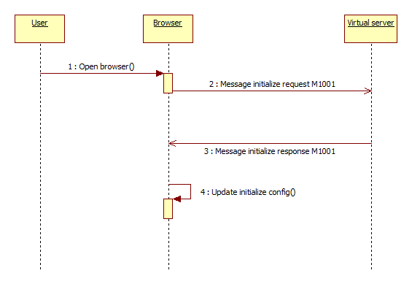

Figure 5‑7 - Get initialize configuration

#### Parse a record file

*Note: Following diagram referred from customer document ICD_BrowserPTE_Sequence_20180226.pdf

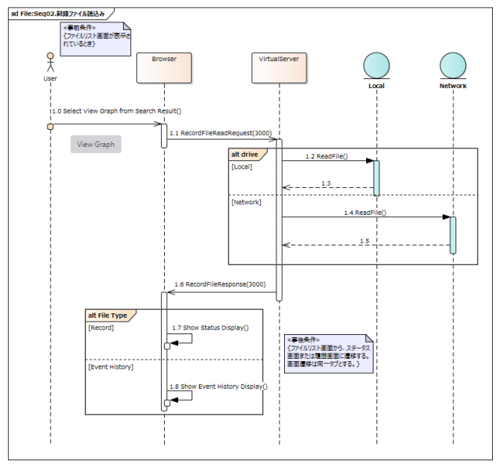

Figure 5‑8: File Parser sequence diagram

#### Error Handling

This function like an observer of client for watching and handling errors or exceptions. And every error or exception will be warning for user.

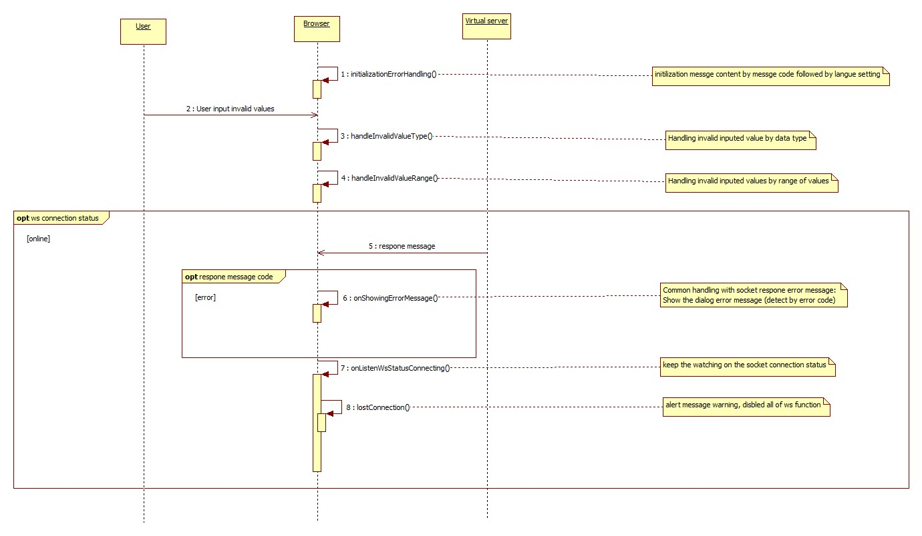

Figure 5‑9: Error Handling sequence diagram

### Graph

#### [Graph] Display the real-time data

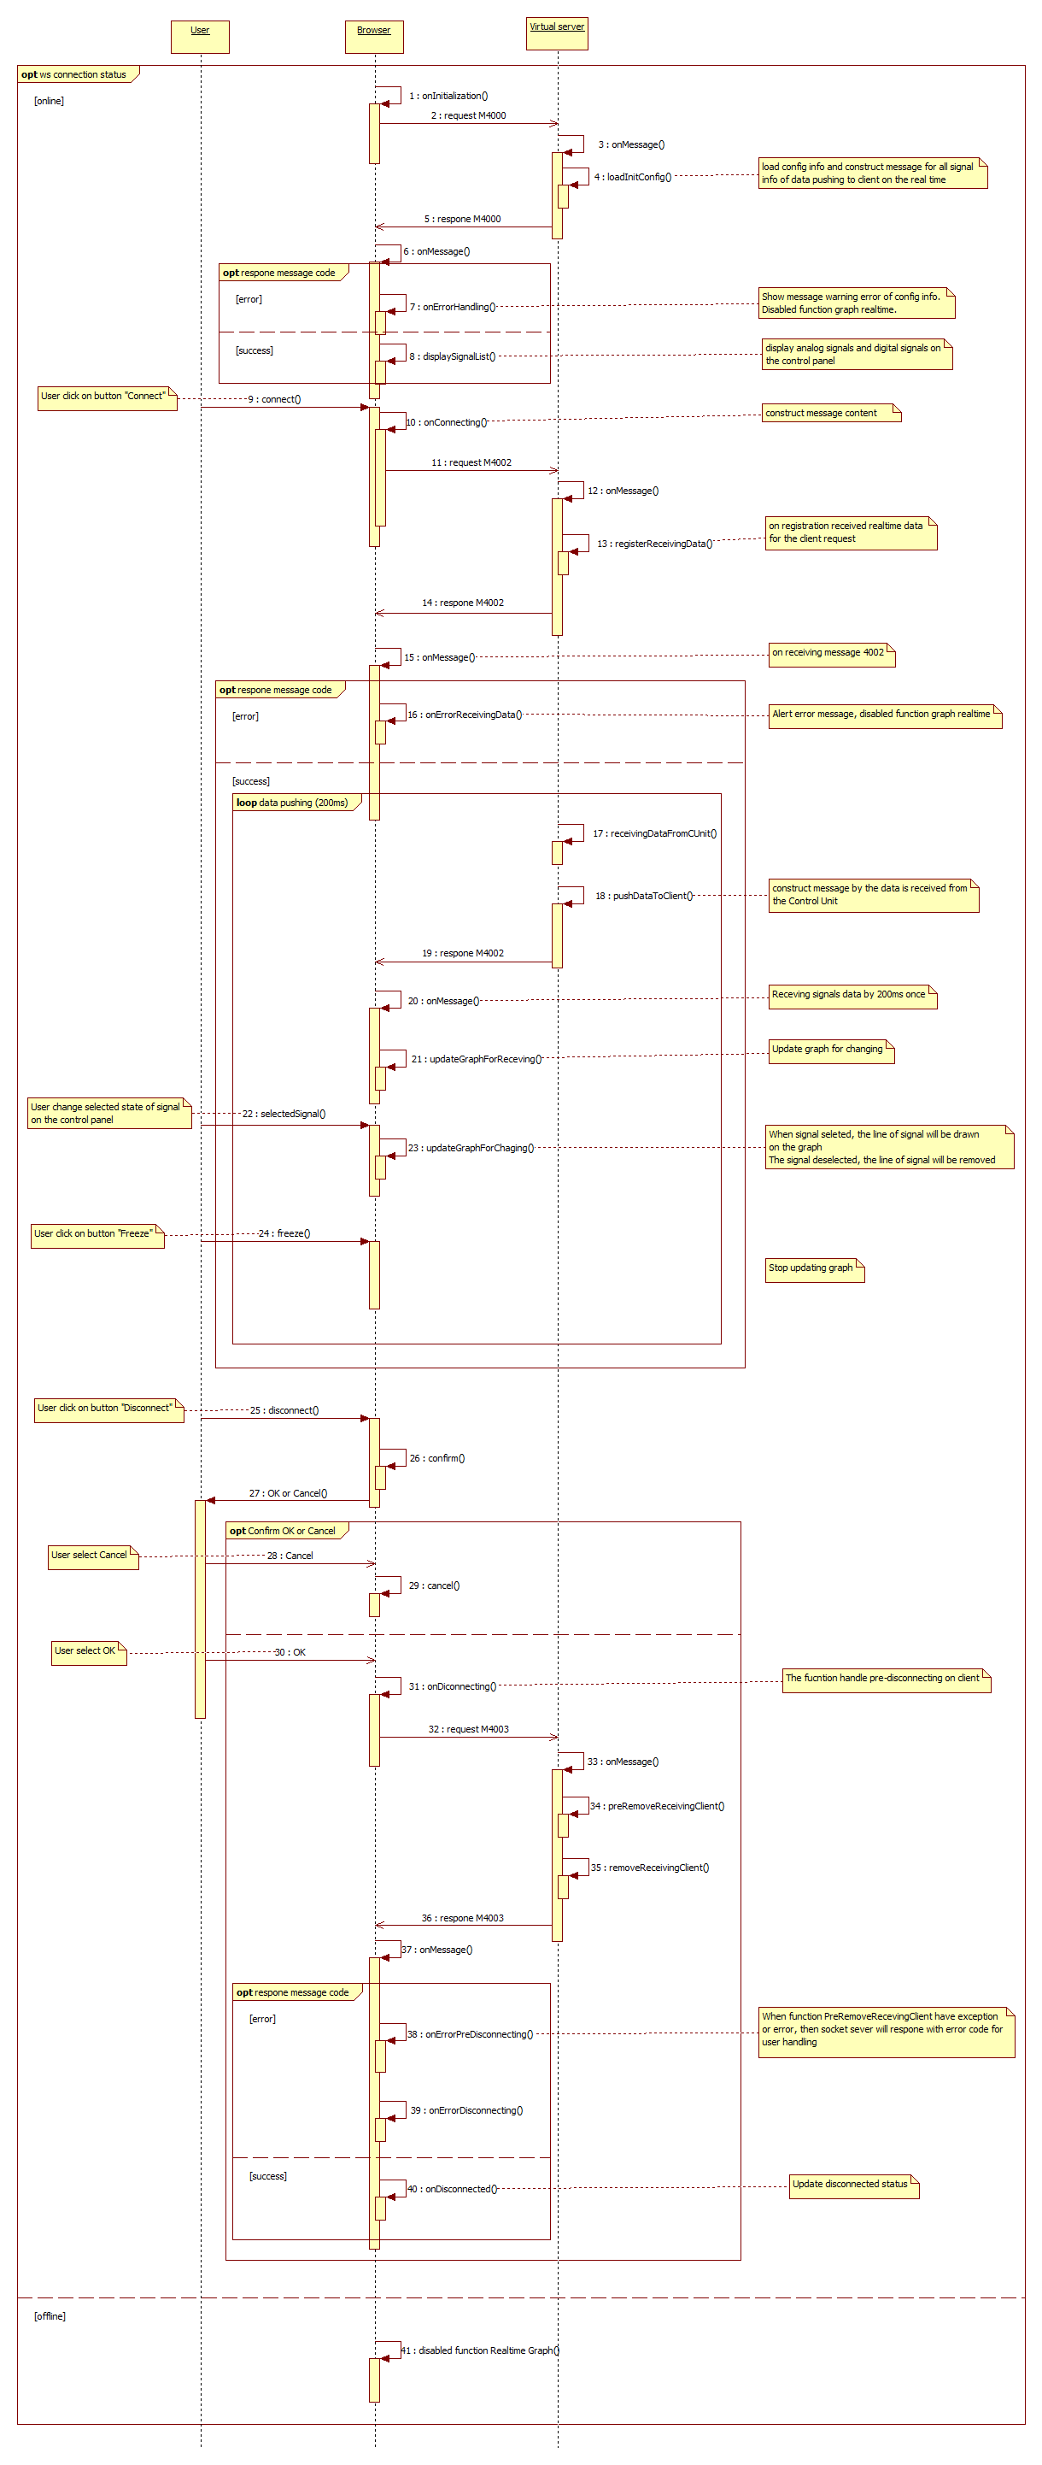

Figure 5‑10: Get real time data sequence diagram

#### [Graph] Save graph settings

This function allowed user could save the graph screen displaying information by click on button “Save Setting”. All of the screen displaying information on user pre-session will be appeared on the next-session.

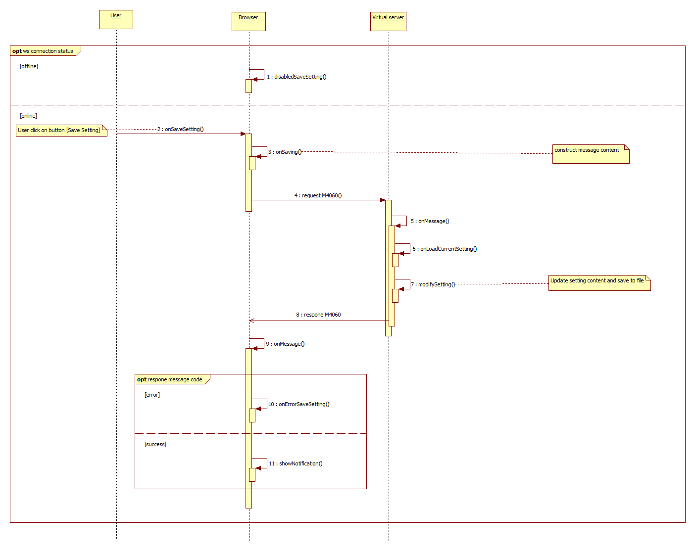

Figure 5‑11: Save graph settings sequence diagram

#### [Graph] Load graph settings

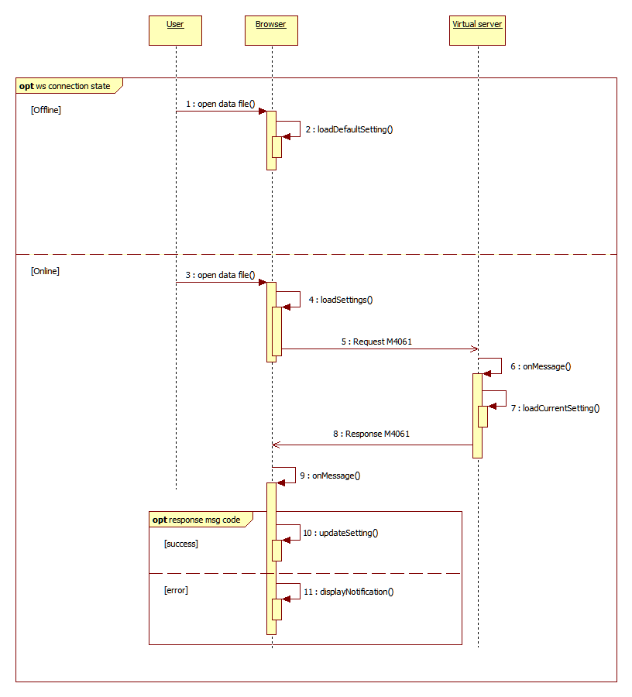

Figure 5‑12 - Load graph setting sequence diagram

#### [Graph] Save comments

Refer to the sequence diagram **Error! Reference source not found.**. If users try to close the screen without doing save comment after adding / editing comment, display a warning popup message and urge user to save the comment.

#### [Graph] Load comments

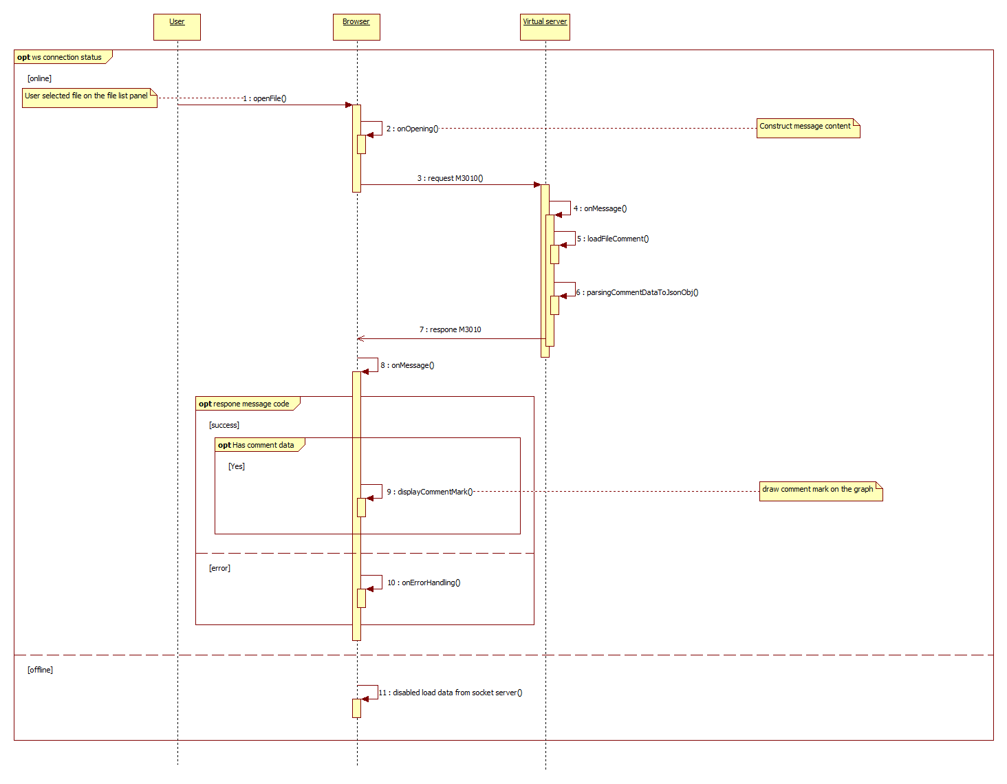

Figure 5‑13: Load comments sequence diagram

### File List

#### [File List] Get the list of files

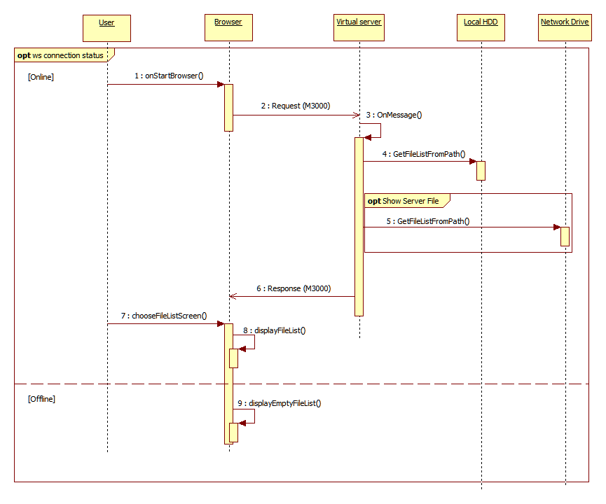

Figure 5‑14: Getting File List sequence diagram

### Numeric

#### [Numeric] Save numeric settings

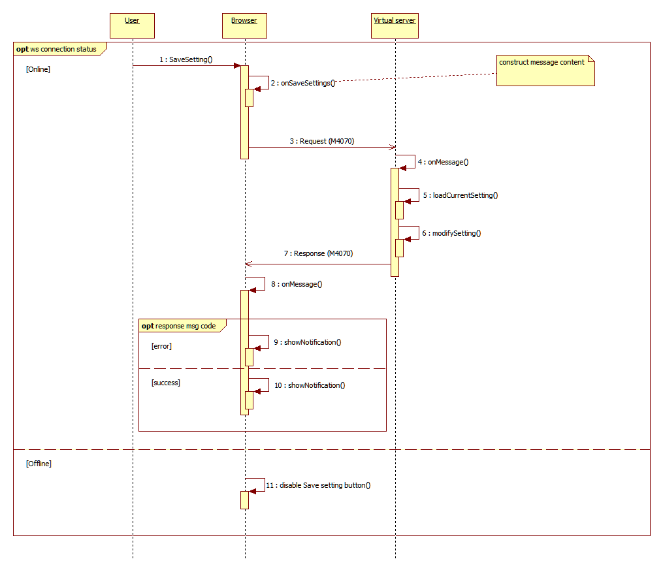

Figure 5‑15 - Numeric save settings sequence diagram

#### [Numeric] Load numeric settings

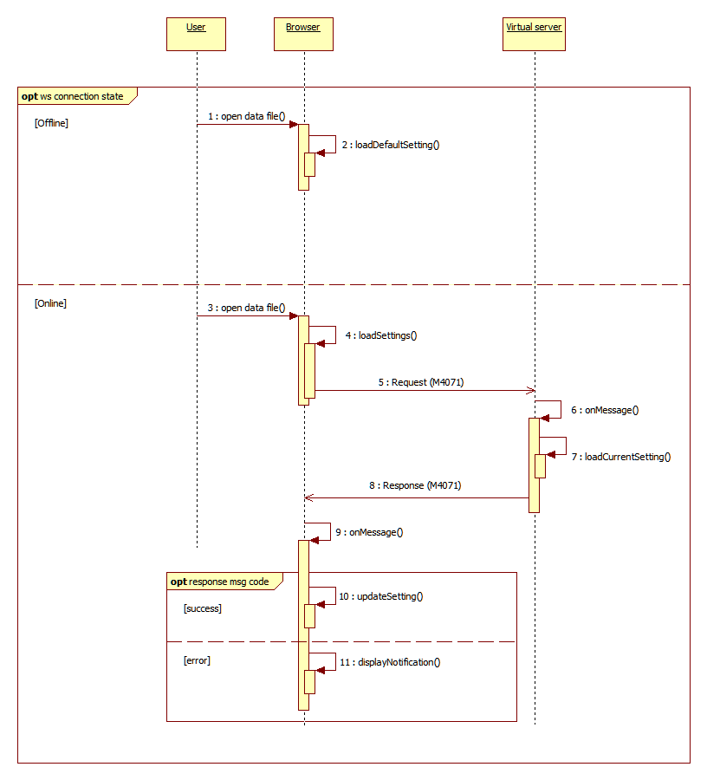

Figure 5‑16 - Numeric load setting sequence diagram

### Status

#### [Status] Load status settings

This function is used to load the displaying status screen information. The setting file is read to get the configuration information to initialize the display of status screen.

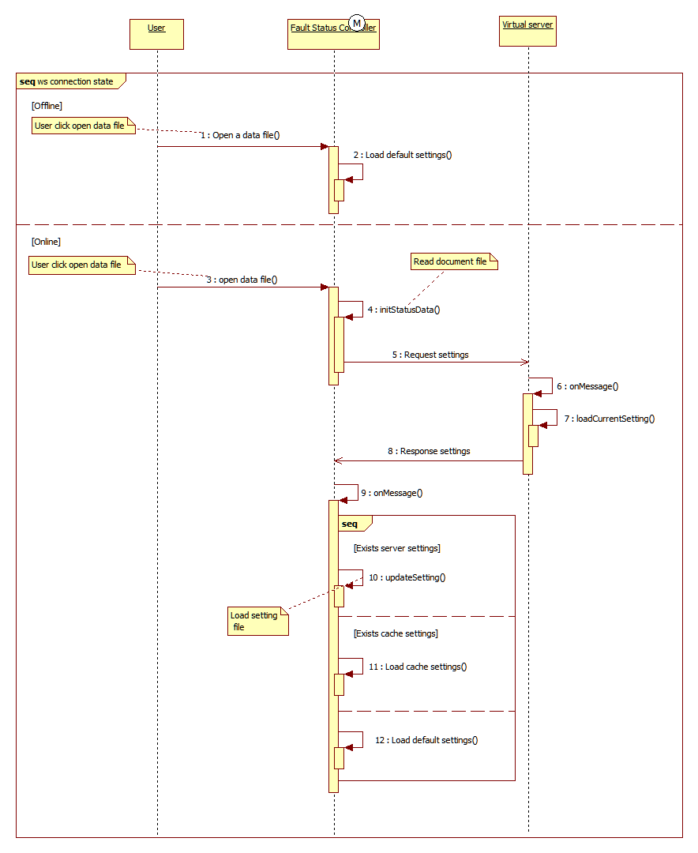

Figure 5‑17: Status load setting sequence diagram

#### [Status] Save status setting

This function is used to save the displaying status screen information. Status screen information is saved to the setting file.

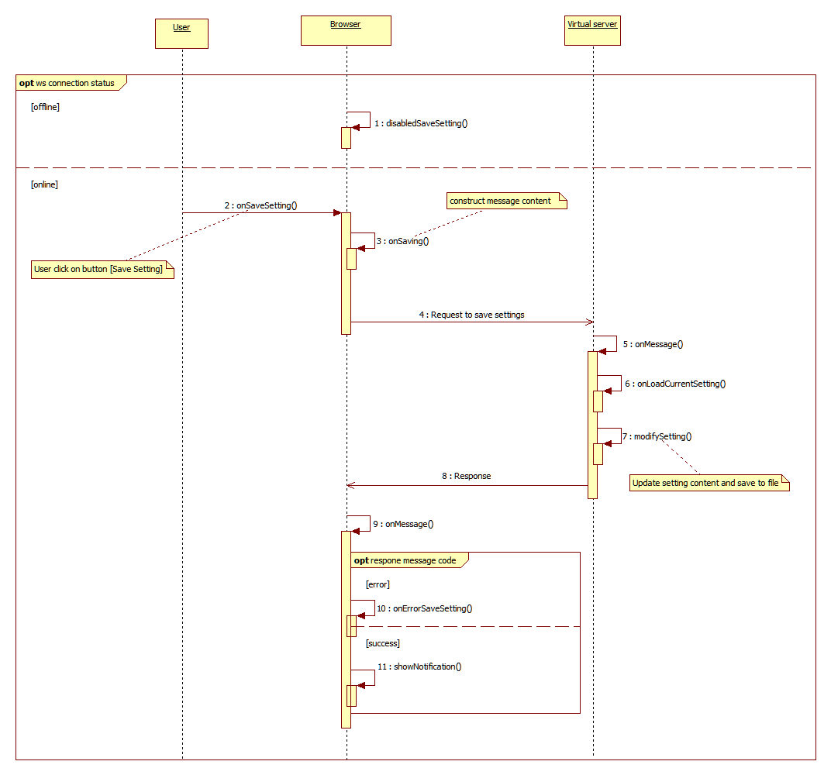

Figure 5‑18 : Save status settings sequence diagram

#### [Status] Play a record file

This function is about specifications when recording file is played on the status:

* Frame advance (1 frame, frame unit specification)
* Trigger point displayed on bar (display red triangle, click triangle then jump to).
* Button next/prev is disabled as SRS

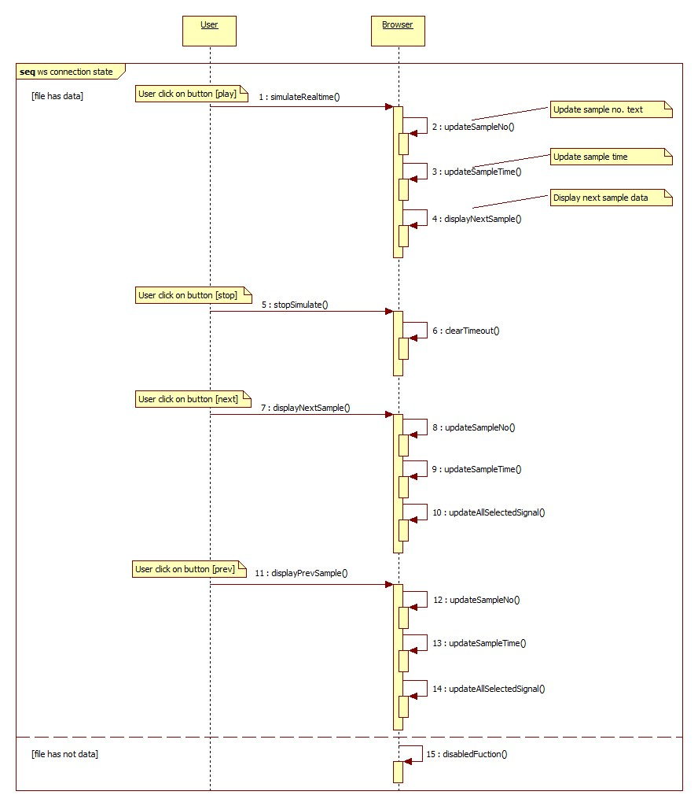

Figure 5‑19: Play a record file sequence diagram

**Remarks**: In the step 15, the buttons next/prev are disabled as SRS (section 5.7.3. Play a record file).

#### [Status] Display the real-time data

This function is about receiving real time data and drawing it on the status. The socket data is sent periodically, the socket client receive and push data to status service. The status service will handle the data and display the real-time panel which is showing on the screen. The maximum existing time of the sample is 15 minutes (about 4500 samples for each signal on the panel).

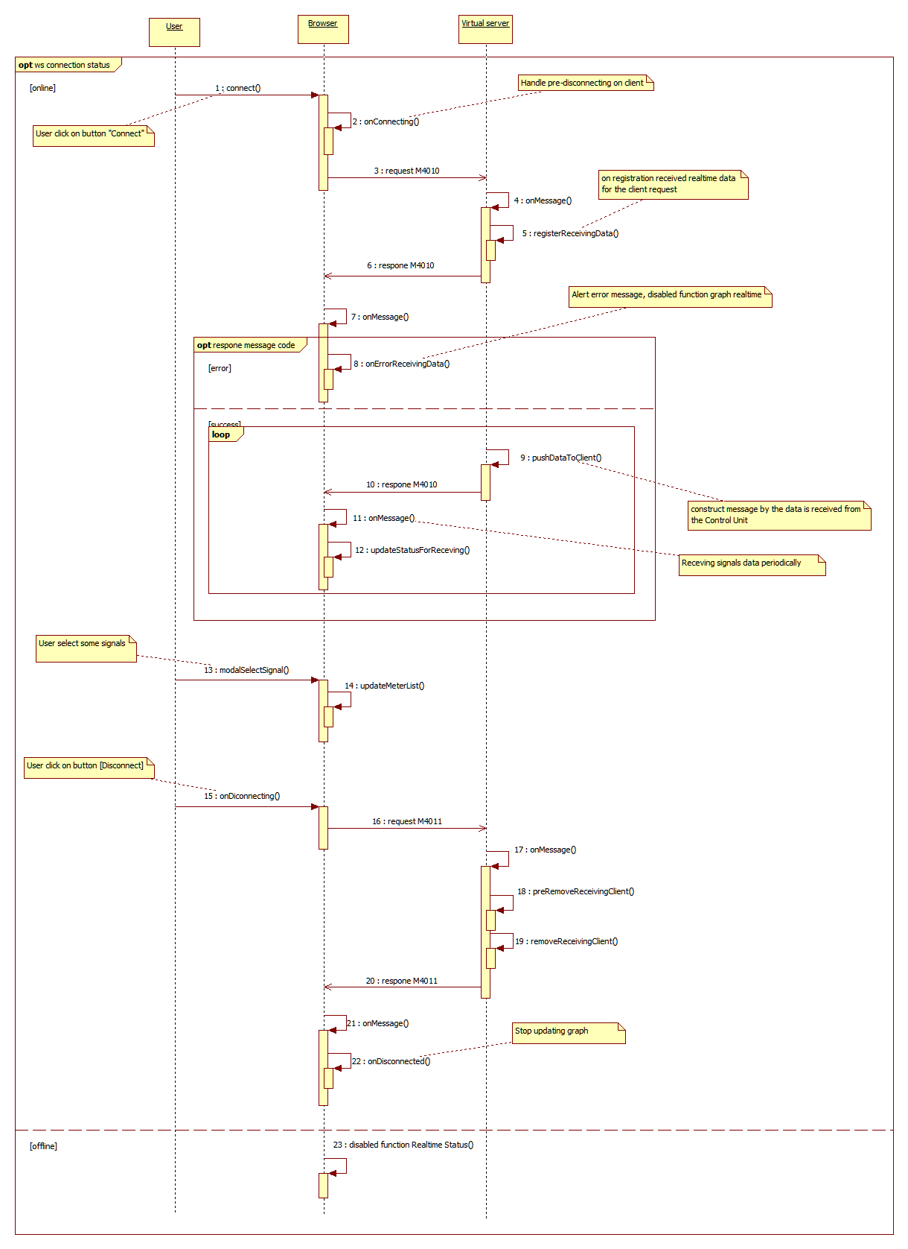

Figure 5‑20 : Display the real-time data sequence diagram

### Fault List

#### [Fault List] Get fault information list

*Note: Following diagram referred from customer document ICD_BrowserPTE_Sequence_20180226.pdf

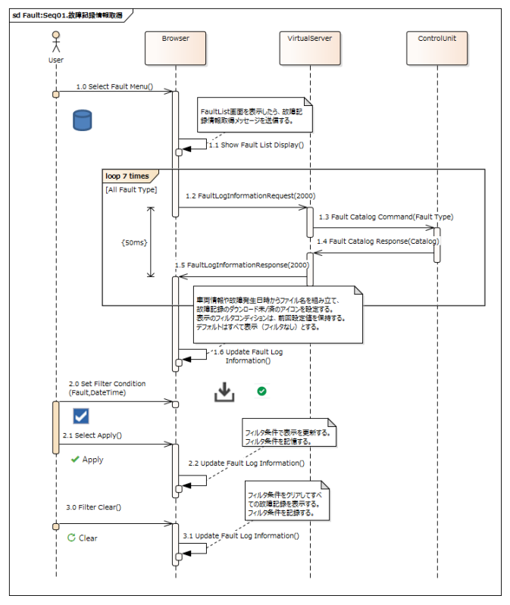

Updated: message ID 2000

Updated: message ID 2000

Figure 5‑21: Get fault information list

#### [Fault List] Download a fault record file

*Note: Following diagram referred from customer document ICD_BrowserPTE_Sequence_20180226.pdf

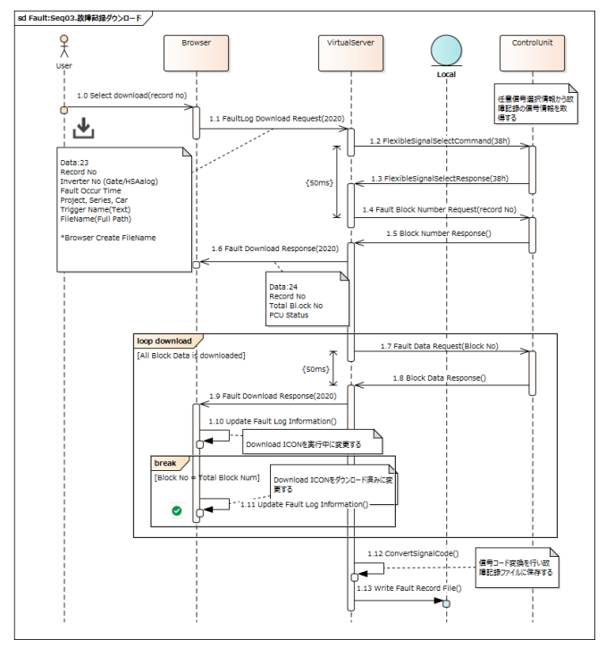

Updated: message ID 2020

Updated: message ID 2020

Figure 5‑22: [Fault List] Download a fault record file

#### [Fault List] Acquire fault types

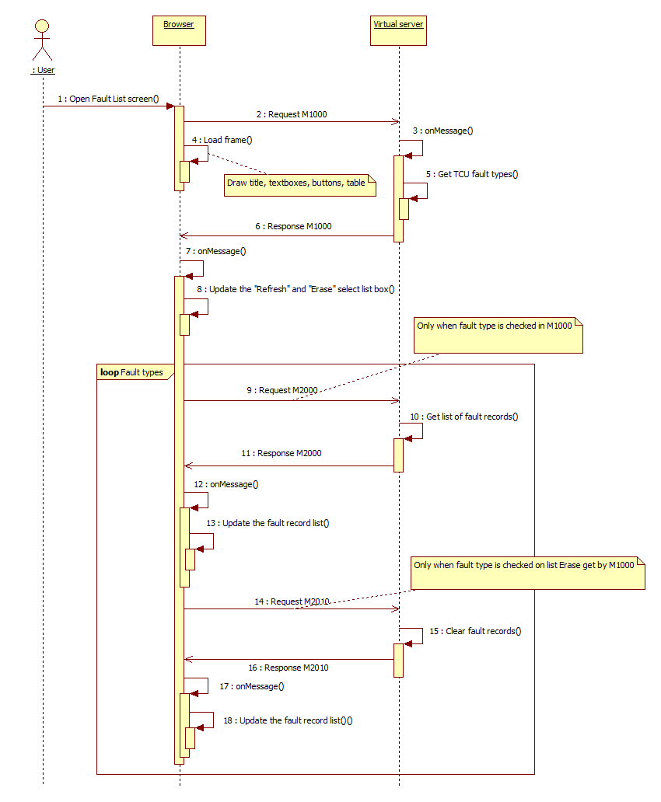

Figure 5‑23: [Fault List] Acquire fault types

※Remark: Refer to document ブラウザPTE仕様確認用資料_20190111.pptx to see more information about message M1000.

### Fault History

#### [Fault History] Display the fault history list

By default, the fault history detects and displays only the Protective Signal event. Also, at the time of starting, the events defaults to "1" are detected and displayed.

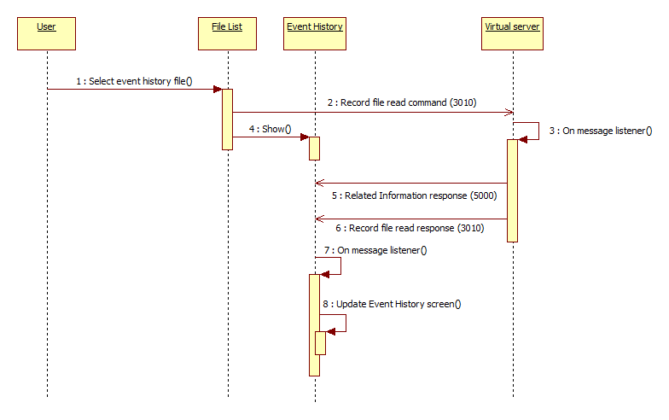

Figure 5‑24: Display the fault history list

### Operation

#### [Flexible] Select signals for fault history files

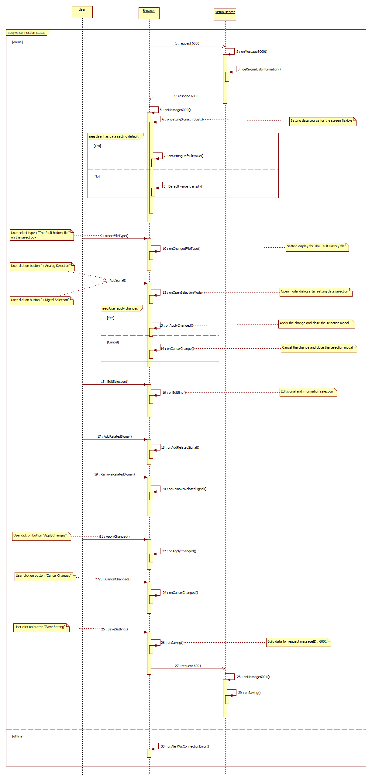

Figure 5‑25: Select signals for fault history files

#### [Flexible] Select signals for the real-time monitoring

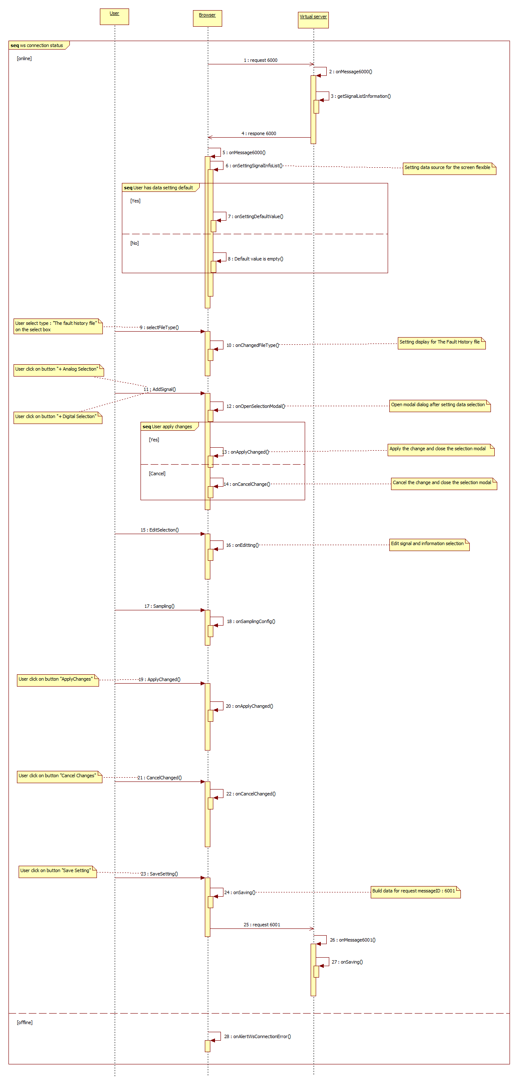

Figure 5‑26: Select signals for the real-time monitoring

#### [Flexible] Select signals for fault record files

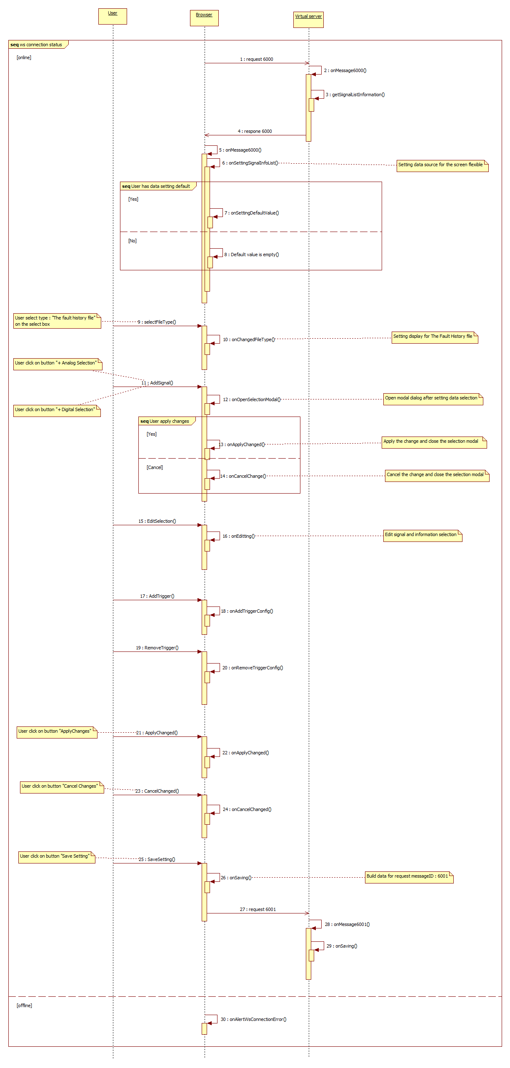

Figure 5‑27: Select signals for fault record files

#### [Operation] Time Set screen

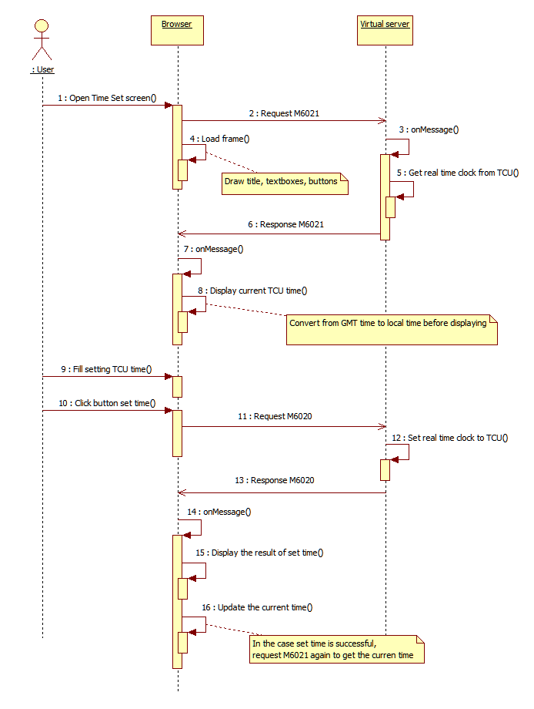

Figure 5‑28: Time Set screen

### Help

#### [Help] Version

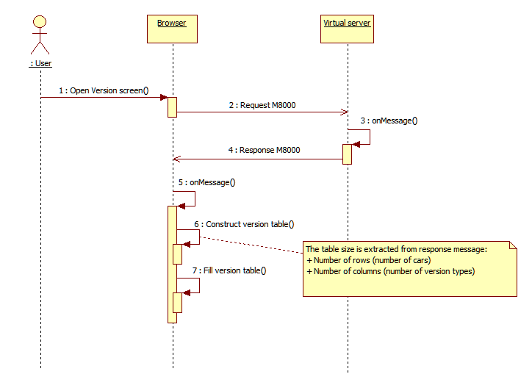

Figure 5‑29: Open Version screen

### Login

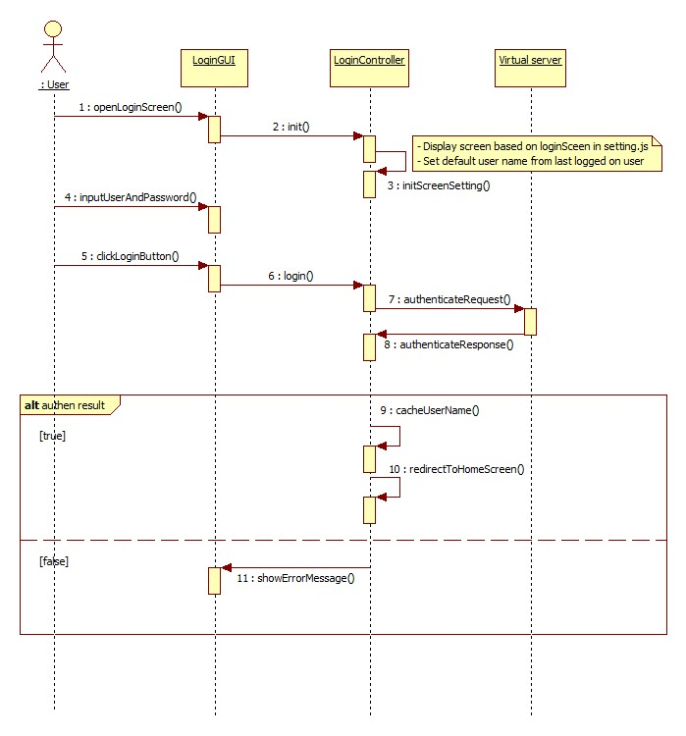

Figure 5‑30: Login screen

## Browser Client

The [Browser Client] web page hierarchy is described below. The GUI should provide a menu so that user can jump to any specified screens from any specified screens.



Figure 5‑31: [Browser Client] screen hierarchy

Table 5‑1: [Browser client] configuration information

|  |  |
| --- | --- |
| **Configuration info** | **Remark** |
| Signal Info | Signal information may be stored in JavaScript Setting Files |
| Language Setting | Support English, Japanese and Vietnamese. |



Figure 5‑32: [Browser Client] components diagram

 Outside components

 Service

 Components

In the component diagram, the architecture is divided into some layers below:

* [Component] layer
* [Service] layer
* In each components, it is compulsory to implement at least one controller to handle all events and internal data (following the AngularJS framework).

Table 5‑2: [Browser Client] components, service and controllers

|  |  |  |  |  |  |
| --- | --- | --- | --- | --- | --- |
| **No** | **Layer** | **Component** | **Common controller** | **Own controller** | **Description** |
| 1 | [Component] layer | File List Component |  | File List Controller | Basic GUI parts to construct the user full views. |
| 2 | Monitoring Graph Component | Monitoring Controller | Monitoring Graph Controller |
| 3 | Monitoring Status Component | Monitoring Status Controller |
| 4 | Record Graph Component | Recorded Controller | Record Graph Controller |
| 5 | Record Status Component | Record Status Controller |
| 6 | Record Numeric Component | Record Numeric Controller |
| 7 | Operation Component | NA | Flex Controller |  |
| 8 | Help Component | NA | NA |  |
| 9 | Account Component | NA | NA |  |
| 10 | [Service] layer | Graph service | NA | NA | Provide common functions for monitoring controllers and record controllers |
| 11 | Status service | NA | NA |
| 12 | Numeric service | NA | NA |



Figure 5‑33: System data flow

 Outside components

 Service

 Components

In the data flow diagram:

* [Configuration information] and [File List model] is retrieved from the [Virtual Server] through websocket.
* [Monitoring] components get the real-time data and update into the data model [Visualization Graph model] and [Visualization Status model].
* [Recorded] components get the file-parsing data and update into the data model [Visualization Graph model], [Visualization Status model] and [Visualization Numeric model].
* [Visualization Graph model] are the common data model of both [Monitoring] and [Recorded] components to draw graph panes in [Graph Service].
* [Visualization Status model] are the common data model of both [Monitoring] and [Recorded] components to draw status panes in [Status Service].
* [Visualization Numeric model] are used to draw numeric panes in [Numeric Service].
* [User Display Setting] include [Graph Setting], [Status Setting] and [Numeric Setting]. These displaying settings should be requested from server when related components are loaded.

### File List Component

[File List] is the common component of both [Monitoring View] and [Fault Record View]. [File List] provides user two main sub-views: [File Tree View] and [Time Line View].

Table 5‑3: File list component event handlers

|  |  |  |
| --- | --- | --- |
| **Module name** | **Event name** | **Handling description** |
| Overall | Load frame | Send a message to the server to request:  + Server file hierarchy (to use in [File Tree View]).  + List of file information (Names, types, start-times, end-times) to use in [Time Line View].  Load and display [File Tree View] pane. |
| Click on [File Tree View] button | Show [File Tree View] pane. Hide [Time Line View] pane. |
| Click on [Time Line View] button | Show [Time Line View] pane. Hide [File Tree View] pane. |
| Click on [Expand/Collapse] button | Expand or Collapse the whole [File List View] pane area. |
| File Tree View | Open a server file | Send a message to the server to request:  + The file content.  Use [File Parser] to parse the data file into the common data structure that all other plugins (Graph, Status, etc.) modules can use. |
| Open or Drag drop local files | Get the file content from local files.  Use [File Parser] to parse the data file into the common data structure that all other plugin (Graph, Status, etc.) modules can use. |
| Upload the data files. | Send a message to [Virtual Server] to execute the FTP function.  Reload the server file hierarchy that displays at the front-end.  (Because [Virtual Server] and [Browser Client] is on the same machine, the task of FPT does not take much time. |
| Download the data files. |
| Time Line View | Click on the file icon | It is the same when the user opens a server file.  In the case of many overlapped data files, display the dialog that displays the overlapped files and the related information (start-time and end-time, etc.). |
| Click on the data type icon | Show/Hide all graph icons that is corresponding to the selected data type on the timeline. |
| Select the time-scale | Update the visualization timeline following the selected scale. |
| File List Table | Check/uncheck on multiple select filter | Filter data by all selected options in all table header filters then show only rows that match filter conditions. |
| Right click on table header | Show context menu with all column name options (Date and View columns options are disabled) |
| Check/uncheck on show/hide column context menu. | When check/uncheck on show/hide column context menu option then show/hide corresponding table column. |
| Click on column name header | Clear previous sort option if exists then reorder table rows by new column name sort option (column just clicked). |
| Change date in date time filter | Update date label condition with selected from and to date.  Filter data that in from and to range then hide all rows not in from and to range, show all rows that in selected range. |
| Change text in comment input | Calculate comment text length to bytes then trim off excess characters. |
|  | Resize columns | Add the resizing handlers to the borders of each columns.  Calculating the resizable minimum and maximum size.  The resizable minimum size should depend on the length of the own column header text.  The resizable maximum size depend on the length of the beside column header text (user only can resize maximum until the beside column header text reach minimum size). |

### Fault List Component

Table 5‑4: Fault list component event handlers

|  |  |  |
| --- | --- | --- |
| **Module name** | **Event name** | **Handling description** |
| Fault List Table | Check/uncheck on multiple select filter | Filter data by all selected options in all table header filters then show only rows that match filter conditions. |
| Right click on table header | Show context menu with all column name options (Date and View columns options are disabled) |
| Check/uncheck on show/hide column context menu. | When check/uncheck on show/hide column context menu option then show/hide corresponding table column. |
| Click on column name header | Clear previous sort option if exists then reorder table rows by new column name sort option (column just clicked). |
| Change date in date time filter | Update date label condition with selected from and to date.  Filter data that in from and to range then hide all rows not in from and to range, show all rows that in selected range. |
| Change text in comment input. | Calculate comment text length to bytes then trim off excess characters. |
|  | Resize columns | Add the resizing handlers to the borders of each columns.  Calculating the resizable minimum and maximum size.  The resizable minimum size should depend on the length of the own column header text.  The resizable maximum size depend on the length of the beside column header text (user only can resize maximum until the beside column header text reach minimum size). |

#### Download

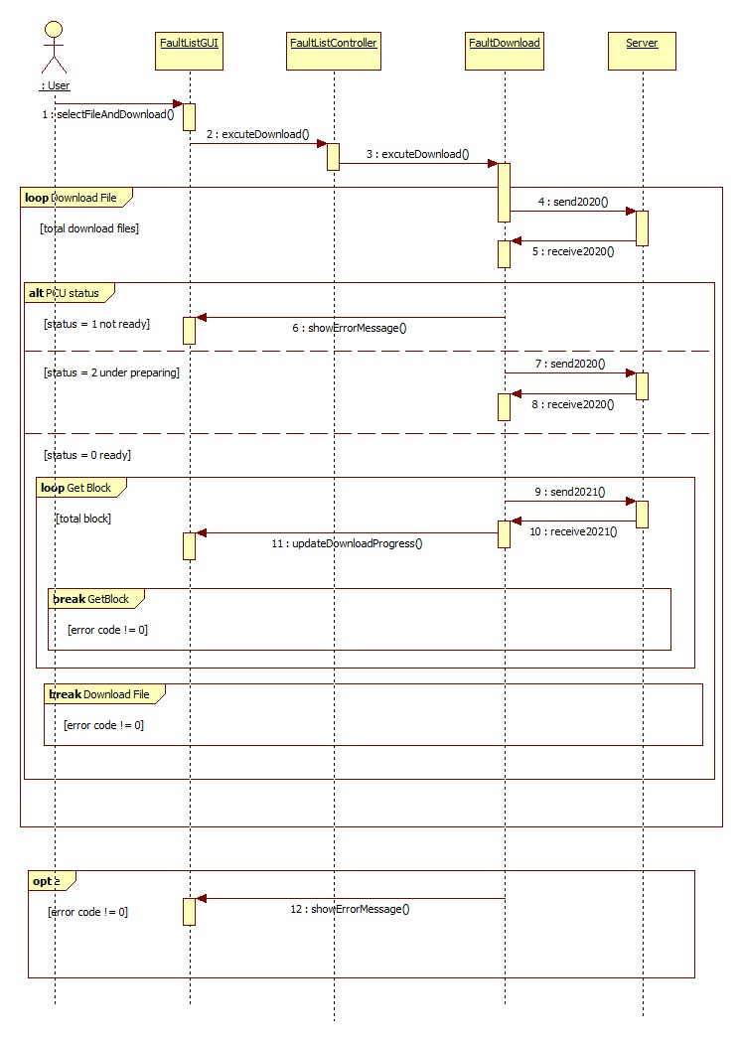

Figure 5‑34: Download fault record

### Monitoring Components

#### Monitoring Graph Component

[Monitoring Graph] invokes [Graph Service] APIs to visualize the real-time data and support some functions such as [Start Record], [Freeze Record] and [Stop Record].

Table 5‑5: [Monitoring Graph Component] event handlers

|  |  |  |  |
| --- | --- | --- | --- |
| **Module name** | | **Event name** | **Handling description** |
| Graph View |  | Load frame | Get [User Display Setting] of the current user.  Load [Set of graph panes]. |
| Real-time monitoring | Receive real time data | Parse the real-time message data.  All data from the past should be stored and updated into [Visualization Graph model].  Update the graph visualization. |
| Connect | Send message to subscribe real-time data.  Register callback function to update screen. |
| Disconnect | Send message to unsubscribe real-time data.  Register callback function to stop update screen |
| Start Record | Send message to virtual server to record data. |
| Stop Record | Send message to virtual server to stop record data then store. |
| Freeze Record | Call function to stop update screen. |
| Graph control panel | N/A | Load frame | Get [User Display Setting] of the current user.  Load the current status of [Graph control panel]. |
| Select signals | Get all values of the selected signals and add into the Visualization Graph model.  User can select all signals. |
| Deselect signals | Remove all Visualization Graph model of the selected signals.  User can de-select all signals. |
| Add Graph Pane | Add a new graph pane into the graph pane set. Maximum panes that can display on screen should be two. |
| Remove Graph Pane | Remove the graph pane from the graph pane set. |
| Expand/Collapse Signal list | Expand or Collapse the analog or digital signal list to cover the whole control panel area. |
| Change time mode | Change time mode of chart screen (absolute time or relative time).  Refer to Figure 5‑36: Change time mode Absolute/Relative on monitoring graph screen. |
| Click [Search Time] button | Open the [Search Time] dialog. User can select the timestamp for each cursor. The graph view will update the cursor position for each graph. |
|  |  | Select comment | When user select comment, the corresponding icon in graph is focused.  If the icon is out of graph display range, graph will be scrolled to display this icon.  The focused comment icon is drawn at the middle of graph display as much as possible. |
|  |  | Edit comment | When user double-clicks on a comment, browser displays the comment-editing dialog.  In the comment-editing dialog, user can edit the content of the selected comment. |
|  |  | Properties panel | This area in Control panel contains:  + Change line color.  + Change line style.  + Show/Hide graph legend.  + Change graph background color: Cursor color must be changed to white if background color is black  + Change font. |



Figure 5‑35: Select and deselected signal on the control panel. Expand or collapse Analog/Digital in the Control Panel

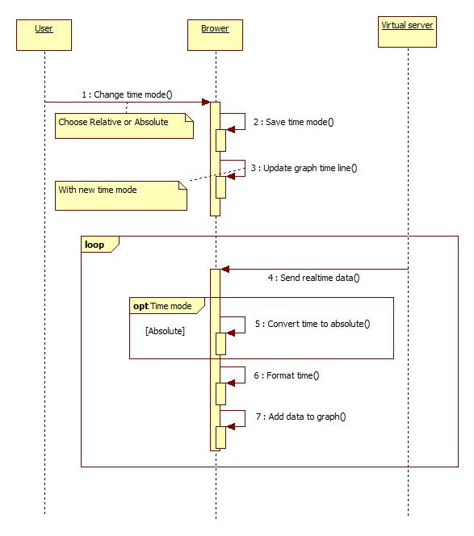

Figure 5‑36: Change time mode Absolute/Relative on monitoring graph screen.

#### Monitoring Status Component

[Monitoring Status] invokes [Graph Service] API to visualize the real-time data and support some functions such as [Start Record], [Freeze Record] and [Stop Record].

Table 5‑6: [Monitoring Status Component] event handlers

|  |  |  |  |
| --- | --- | --- | --- |
| **Module name** | | **Event name** | **Handling description** |
| Status View |  | Load frame | Get [User Display Setting] of the current user.  Draw screen title, command bar, display area.  Draw control panel.  Meters are drawn by the default size as [Large].  Request the virtual server to get the warning and alarm condition for signal meters. |
| Real-time monitoring | Connect | Send message to subscribe real-time data.  Register callback function to update screen. |
| Receive real time data | Parse the real-time message response.  All data from the past should be stored and updated into [Visualization Status model].  Update the graph visualization:  + Meter values and meter bars.  + Depending on the warning and alarm condition for each signal meters, display yellows and red meters correspondingly (alarm condition is higher priority). |
| Disconnect | Send message to unsubscribe real-time data.  Register callback function to stop update screen |
| Start Record | Send message to virtual server to record data.  Display the recording time on the left of the recording button. |
| Stop Record | Send message to virtual server to stop record data then store |
| Status control panel | N/A | Load frame | Get [User Display Setting] of the current user.  Load the current status of [Status Control Panel]. |
| Select signals | Call function to add corresponding signal |
| Deselect signals | Call function to remove corresponding signal |
| Change time mode | Change time mode of chart screen (absolute time or relative time). Refer to Figure 5‑37: Change time mode Absolute/Relative on monitoring status screen. |



Figure 5‑37: Change time mode Absolute/Relative on monitoring status screen.

### Fault Record

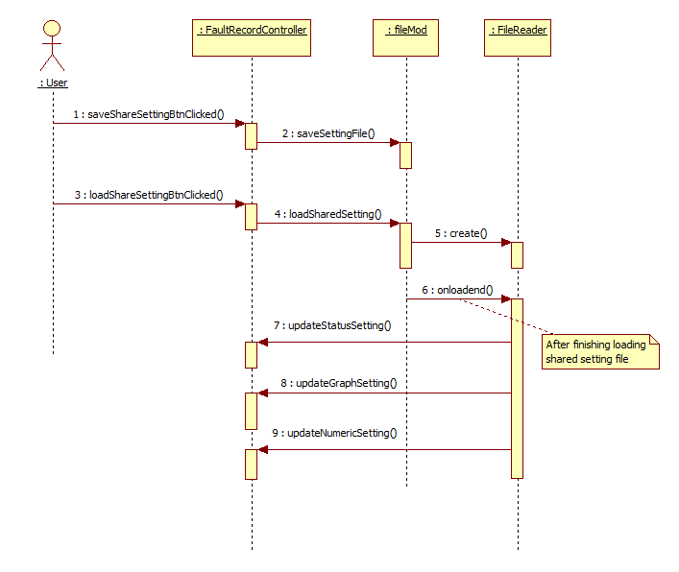

Figure 5‑38: Share and load setting

#### Record Graph

[Record Graph] invokes [Graph Service] APIs to visualize the file-parsing data.

Table 5‑7: [Record Graph Component] event handlers

|  |  |  |  |
| --- | --- | --- | --- |
| **Module name** | | **Event name** | **Handling description** |
| Graph View |  | Load frame | Get [User Display Setting] of the current user.  Load [Set of graph panes]. |
| Read file | Receive file-parsing data | Parse the file data and update into [Visualization Graph model].  Update the graph visualization. |
| Graph control panel |  | Load frame | Refer to the section 5.3.3.1. |
| Select comment |
| Edit comment |
| Properties panel |
| Time search | Click button “Search” | Get the searching-time from the searching-time textbox.  If the searching-time is valid:  + Set the cursor position by the searching time.  + Update the graph area corresponding to cursor position.  + Synchronize the current played timestamp (Status components).  The application should handle the case of the searching-time is invalid. |
| Press “Enter” |



Figure 5‑39: Sequence search time absolute in record graph screen

#### Record Status

[Record Status] invokes [Status Service] APIs to visualize the file-parsing data and support some functions of playing visualization data.

Table 5‑8: [Record Status Component] event handlers

|  |  |  |  |
| --- | --- | --- | --- |
| **Module name** | | **Event name** | **Handling description** |
| Status View |  | Load frame | Get [User Display Setting] of the current user.  Draw screen title, command bar, display area.  Draw control panel.  Meters are drawn by the default size as [Large].  Request the virtual server to get the warning and alarm condition for signal meters. |
|  | Start Play | Execute the corresponding operation the current fault record data:  + Start to play record file.  + Display the next sample.  + Display the previous sample.  + Stop to play record file.  During updating the graph visualization:  + Meter values and meter bars.  + Depending on the warning and alarm condition for each signal meters, display yellows and red meters correspondingly (alarm condition is higher priority). |
| Next |
| Previous |
| Pause Play |
| Select signals | Call function to signal selected. |
| Remove signals | Call function to remove signal selected. |
| View comment signals | Call function to show comment of signal. |
| Status control panel |  | Load frame | Get [User Display Setting] of the current user.  Load the current status of [Status Control Panel]. |
| Analog Data | Select | Call function to add corresponding signal. |
| Unselect | Call function to remove corresponding signal. |
| Digital  Data | Select | Call function to add corresponding signal. |
| Unselect | Call function to remove corresponding signal. |
| Comment | Search comment | Search and return the comments have signal name or comment content contains text input. |
| Select comment of signal | Go to show comment of signal selected. |
| Properties | Change size of signal | Change size signal selected (Large, Medium, and Small). |
| Change style of signal | Change Type signal selected ( v-bar, h-bar, volt, round, thermometer value, number-only, status ) |
| File Information | Information of file | Show information of data file select. |
|  | Time  Search | Click button “Search” | Get the searching-time from the searching-time textbox.  If the searching-time is valid:  + Set the current played timestamp by the searching time.  + Update the screen (panel value, etc.) corresponding to the current played timestamp.  + Synchronize the cursor position (Graph component)  The application should handle the case of the searching-time is invalid. |
|  | Press “Enter” |

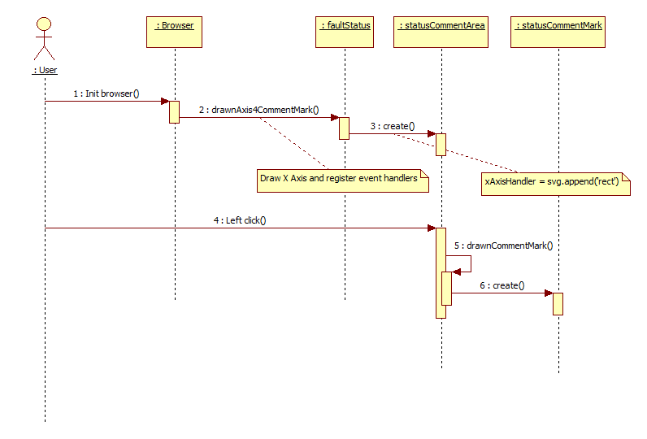

Figure 5‑40: Add timeline comment

Table 5‑9: [Status Comment Mark] event handlers

|  |  |
| --- | --- |
| **Event name** | **Handling description** |
| Left click | .on(‘click’)  Comment mark is selected. |
| Mouse down | .on(‘mousedown’)  Comment is marked to prepare to drag. |
| Double click | .on(‘dblclick’)  Show the comment editting dialog. |
| Dragging | d3.drag().on(‘drag’)  Update comment mark position. |
| Drag end | d3.drag().on(‘end’)  Update comment mark position and remove highlighting. |



Figure 5‑41: Sequence diagram of search time absolute in record status screen

#### Record Numeric

Table 5‑10: [Record Numeric Component] event handlers

|  |  |  |  |
| --- | --- | --- | --- |
| **Module name** | | **Event name** | **Handling description** |
| Numeric Pane View |  | Load frame | Get [User Display Setting] of the current user.  Draw screen title, command bar, display area. |
| Receive file-parsing data | Parse the file data and update into [Visualization Numeric model].  Update the numeric visualization. |
| Add/Edit or Delete comment | Modify or remove comment of cells |
| Vertical / Horizontal | Switch between vertical and horizontal header |
| Highlight trigger | Trigger line background color is red |
| Context menu | Context menu on table header:  + Change header orientation  Context menu on table cell  + Add comment  + Edit / Delete comment |
| Header tooltip | When hover on header, show tooltip which contains:  + Signal full description  + Signal value range |
| Numeric control panel |  | Load frame | Get [User Display Setting] of the current user.  Load the current status of [Numeric Control Panel]. |
| Analog Data | Select | Display selection dialog to select signal.  Call function show data analog on numeric table. |
| Unselect | Deselect signal by press X button of this signal  Call function to hide data analog on numeric table. |
| Digital Data | Select | Display selection dialog to select signal.  Call function show data digital on numeric table. |
| Unselect | Call function to hide data digital on numeric table. |
| Comment | Search comment | Search and return the comments have signal name or comment content contains text input. |
| Select comment | Go to corresponding cell on numeric table |
| Edit comment | User double-click on comment item to edit. Click outside to complete edit. |
| Save comment | Send JSON message to server to store comment to file.  Message format refer to E6MX0211 document. |
| Save setting |  | Send JSON message to server to store current screen setting.  Message format refer to E6MX0211 document. |
| Panel properties |  | Contains following function:  + Change header orientation  + Change font  + Change color |
|  | Time  Search | Click button “Search” | Get the searching-time from the searching-time textbox.  If the searching-time is valid:  + Jump to the searched row.  + Highlight the searched row.  The application should handle the case of the searching-time is invalid. |
|  | Press “Enter” |



Figure 5‑42: Sequence diagram of search time absolute in record numeric screen

#### Fault History

This screen display event history of fault record in a row. When select an event, details information of selected event will be displayed. It also displays fault candidate, guidance and countermeasure action.

Signal recorded in Fault history file will be compared with previous value. If change detected, this event will be displayed as a row of Event history table.

Fault related information file, Fault presumption information file, Fault presumption recovery file will be received from Virtual server.

|  |  |  |
| --- | --- | --- |
| **Module name** | **Event name** | **Handling description** |
| Fault History table | Receive data from [File Parser] | Detect value change from 0 --> 1 and from 1 --> 0 then put to table. Only Event tab and Numeric tab are shown, other tab must be hidden.  Display analog related signal’s value and unit at event time.  Display digital related signal’s value is [High] or [Low] according value [1] or [0] at the event time. |
| Search by date | Searching events which match [Date] condition from user input. Target column of searching is Date. |
| Search by date & time | Searching events which match [Date & time] condition from user input.  Target column of searching is Date.  Reflect the filter after completion of input (after filter input sub screen is closed) |
| Search by fault signal | Searching events which match [Event name] from user input. Target column of searching is Value.  Can filter multi signal by separated data with commas character.  Reflect the filter after completion of input (after filter input sub screen is closed) |
| Display detail information when select event | Display details information of event when selected |
| Check/uncheck on multiple select filter | Filter data by all selected options in all table header filters then show only rows that match filter conditions. |
| Right click on table header | Show context menu with all column name options (Date and View columns options are disabled) |
| Check/uncheck on show/hide column context menu. | When check/uncheck on show/hide column context menu option then show/hide corresponding table column. |
| Click on column name header | Clear previous sort option if exists then reorder table rows by new column name sort option (column just clicked). |
| Change date in date time filter | Update date label condition with selected from and to date.  Filter data that in from and to range then hide all rows not in from and to range, show all rows that in selected range. |
| Change text in comment input (limit 32 bytes) | Calculate comment text length to bytes then trim off excess characters. |
| Mouse hover on signal name. | Display tooltip with the value is [Description] of signal’s data receive from [File Parser]Update for add item 14 |

### Service

The service module SHOULD take inputs as input parameters, should NOT take inputs from global variables, HTML component ID, etc.

#### Common service

Table 5‑11: Common service modules APIs

|  |  |  |
| --- | --- | --- |
| **Module name** | **APIs** | **Remark** |
| Websocket | Connect to the websocket server. |  |
| Disconnect to the websocket server. |  |
| Register the callback to the server message. |  |
| Unregister the callback to the server message. |  |
| Send the message to the websocket server. |  |
| File parser | [File Parser] contains APIs to open all supported data files:   * Normal failure record file X * Normal failure record file Z * Low-speed failure record file X * Low-speed failure record file Z * Failure history record file X * Failure history record file Z * PP7 high speed record R * PP7 high speed record H * High-speed gate record type 1 * High-speed gate record type 2 * High-speed analog * Status data record | Refer to the document [TSDV-PTE-SRS.docx] (Requirement specification of 2015B) to see the data structure. |
| Error handler | Register the error information (error ID, error level, error message content, error callback). |  |
| Get the message information. |  |
| Display the error message on the screen. |  |
| Language  (※１) | Translate the static messages (Static translation). | Each static text is assigned by a specific key. Depending on the selected language, the [Language] module display the corresponding message. |
| Translate the dynamic messages (Dynamic translation). | Create the string builder to construct the correct message. Each string builders is also assigned by a specific key. |

※１: [Change Language] function is applied for modules on the Next Gen PTE:

* Home
* Fault List
* File List
* Status
* Graph
* Numeric
* Fault History
* Flexible Signal Selection

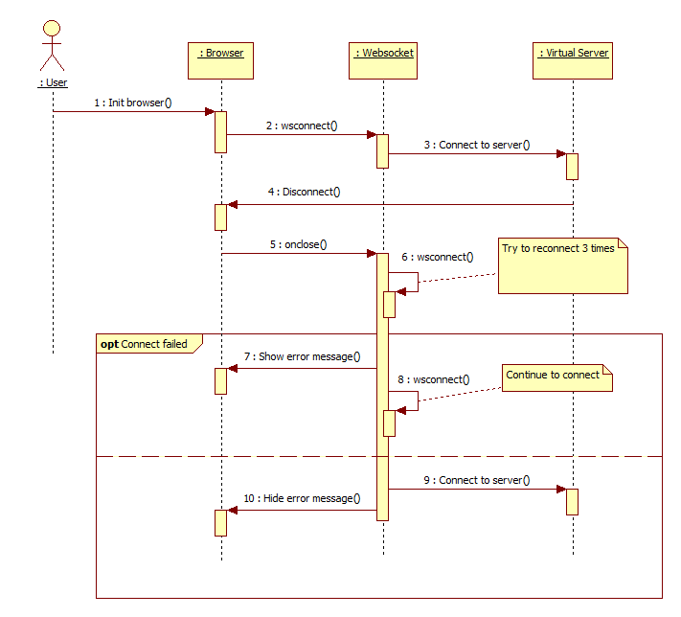

Figure 5‑43: Websocket auto reconnection

##### 5.3.5.1.1. Switch screens

When user switches fault record screens and monitoring screens, the browser saves the current displaying settings. The table below describes the need-to-save settings:

Table 5‑12: Fault record + Monitoring GUI settings

|  |  |  |  |
| --- | --- | --- | --- |
| **Section name** | **Category** | **Settings info** | **Remark** |
| Graph | Number and order of panels |  |  |
| For each panels | Panel name |  |
| Cursor + Cursor position |  |
| Vertical cursor + Cursor position |  |
| Y-axis elements | Horizontal Gridlines |
| Axis Values |
| Brush range |  |
| Time setting |  |
| Analog selected signals | Line color |
| Line weight |
| Line dash |
| Position |
| Scale |
| Digital selected signals | Line color |
| Line weight |
| Line dash |
| Position |
| Font | Font |
| Font style |
| Font size |
| Background color |  |
| Panel expand / collapse |  |
| Panel show / hide |  |
| Comments | Comment time |  |
| Analog comment info |  |
| Digital comment info |  |
| Control panel |  |  |
| Monitoring | Connect / Disconnect |  |
| Status | Selected signals | Panel style |  |
| Panel size |  |
| Panel position |  |
| Current played timestamp |  |  |
| Comments | Comment time |  |
| Analog comment info |  |
| Digital comment info |  |
| Control panel |  |  |
| Monitoring | Connect / Disconnect |  |
| Numeric | Selected signals |  |  |
| Vertical / Horizontal |  |  |
| Comments | Comment time |  |
| Analog comment info |  |
| Digital comment info |  |
| Active cells / rows / columns |  |  |
| Control panel |  |  |
| Fault List | Selected types to Get Fault Log |  |  |
| Selected types to Clear Fault Log |  |  |
| Sorting order |  |  |
| File List | Searched file name |  |  |
| Sorting order |  |  |

##### 5.3.5.1.2. Undo / Redo

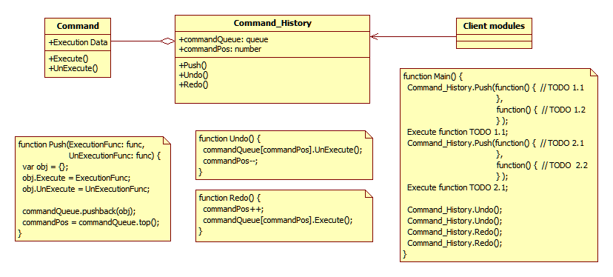

Figure 5‑44: Module diagram of Undo/Redo function

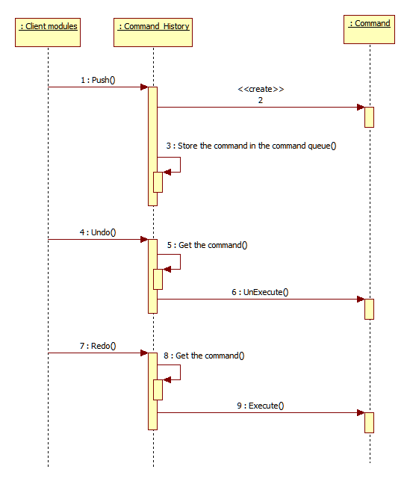

Figure 5‑45: Sequence diagram of Undo/Redo function

##### 5.3.5.1.3. Multiple signals selection

This function allow user drag over signals list to select or un-select signal. Status select or unselect depend on status of first signal. The number of selected will update during select/unselect signal. Pictures below describes behavior of multiple signals selection:

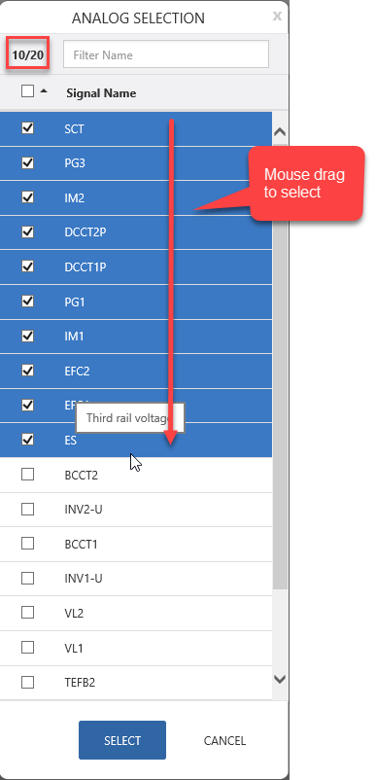

Figure 5‑46: Multiple signals selection.

#### Graph service

Table 5‑13: Graph service APIs

|  |  |
| --- | --- |
| **Module name** | **APIs** |
| Set of graph panes | Create the layout of graph panes from the user [User Display Setting].  Also attach the event handler for each graph components (Refer to the Table 5‑14: Graph components event handlers). |
| Update the graph from [Visualization Graph model]. |
|  |
| Data Sampler | With the original signals data and the zoom scale, provide the possible-to-visualize signal data. |
| Print | Create the print view from the information of selected graph panes (displayed signals, back ground color, line color, etc.). |

Table 5‑14: Graph components event handlers

|  |  |  |  |  |  |
| --- | --- | --- | --- | --- | --- |
| **Module name** | | | | **Event name** | **Handling description** |
| Set of graph panes | Overall |  |  | Load frame | Based on the [User Display Setting] (graph pane quantity, selected signals, colors, etc.):  + Draw graph panes, graph charts.  + Draw legends.  + Draw the time sliders. Zoom slider to the setting scale.  + Draw cursors. |
| Graph pane | Overall |  | Right click on X-Axis. | Open the X-Axis Context Menu, user can:  + Change X Tick.  + Toggle X Text (Turn on/off notation). |
| Right click on Y-Axis | Open the Y-Axis Context Menu, user can:  + Change Y Tick.  + Change Y Rank.  + Toggle Y Text (Turn on/off notation).  + Toggle Horizontal Gridlines  + Change scale and position analog signal.  + Move sub screen open by Y-axis menu. |
| Right click on the graph pane | Open the Graph Context Menu, user can:  + Change the background color.  + Change font.  + Change number scale line.  Default scale ratio of each signal is 100/div |
| Click [Show/ hide pane] icon | Show/hide the selected graph pane. |
| Resize panel height | When mouse over the bottom line of Graph pane, resize icon will be displayed. User can drag to resize the height of graph. |
| Graph chart |  | Change background color | Display the context menu to support user to select the background color.  Some component color should be changed to white such as:  + Cursor, vertical cursors  + Legend  + Tick value |
|  | Change line origin point | Both analog and digital lines can be changed origin points.  There are 2 ways to change line origin point:  + Open context menu by right click on Y-axis.  + Drag and drop lines to change position.  (Refer to diagram Figure 5‑47: Change line positions sequence diagram).  + Display with ▼ mark if multi line same position, click ▼ will show all signal names same position. |
| Legend |  | Load frame | Display all selected signals on the left side of graph panes. |
| Click on the graph legends | Open the Graph Line Menu, user can:  + Change the line color.  + Change the line thickness.  + Change type of line (dot, dash...) |
| Cursor | Cursor | Color of cursor | #006e00 |
| Display cursor time | Display time of current cursor position at the top of cursor.  When user drag cursor, cursor time move correspondingly. |
| Vertical cursors | Drag cursors | Display the graph values on cursor positions.  Calculate the drag-able areas of each cursors to make sure left cursor and right cursor not to cross over to each other.  Update the color of the graph area that is inside vertical cursors.  Update the color of the graph areas that are outside vertical cursors. |
| Double click at the middle | Consider two cursor position as the visualization start-time and end-time, calculate the sampling and re-draw the graphs. |
| Click button “Adjust View” |
| Color or cursor | Vertical cursor 1: #e01859  Vertical cursor 2: #1a6fe1 |
| Time Slider |  |  | Drag the slider | Calculate the visualization start-time and end-time and re-draw the graphs. |
| Scale the slider | Calculate the zoom scale, calculate the sampling and re-draw the graphs. |

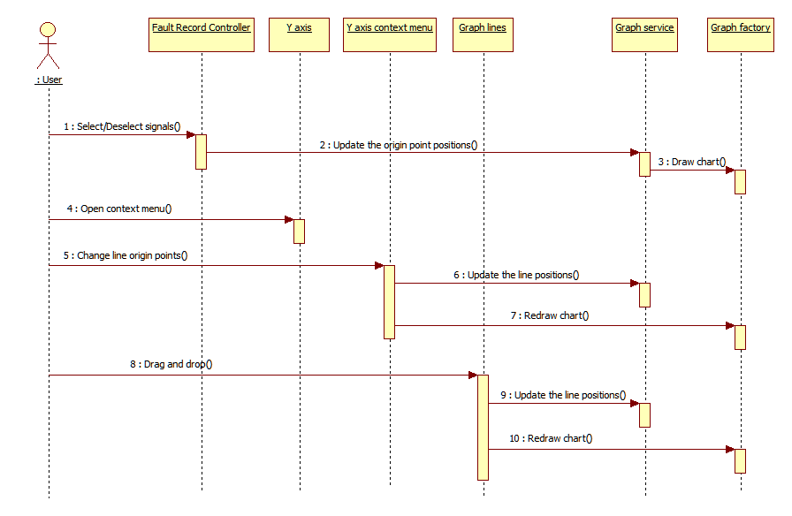

Figure 5‑47: Change line positions sequence diagram

##### 5.3.5.2.1. Graph printing method

This function is used to printing graph.

* Paper size: Tabloid, A3, A4
* Orientation: Portrait, Landscape
* Color mode: Black & White, Color

Normally two charts on a page, in special cases the user only selects one chart, displays the full page width for this chart.

Table 5‑15: Status service APIs

|  |  |  |  |
| --- | --- | --- | --- |
| **Module name** | | **Event name** | **Handling description** |
| Graph Printing | | Click on button “Print”. | Printing Dialog Open.  User can move screen dialog. |
| Select panel graph. | Select graph to print. |
| Change color | Change color select to print. |
| Change orientation | Change orientation select to print. |
| Print display | Header | Display information file | Show file type, file name, car no, date time.  Show more fault trigger with file type is “Normal”, “Low resolution”. |
| Display analog and digital signal. | Show name, scale… analog and digital signal. |
| Body | Display graph | Show graph with page size “Tabloid”, with orientation and color user selected from screen. |

##### 5.3.5.2.2. Cursor behavior

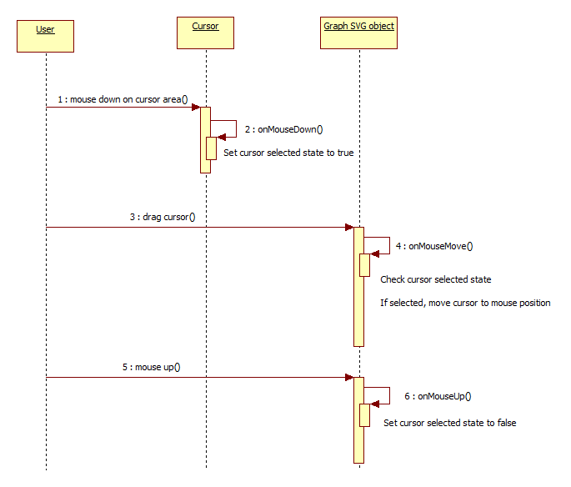

Figure 5‑48: Graph cursor moving

##### 5.3.5.2.3. Resize panels

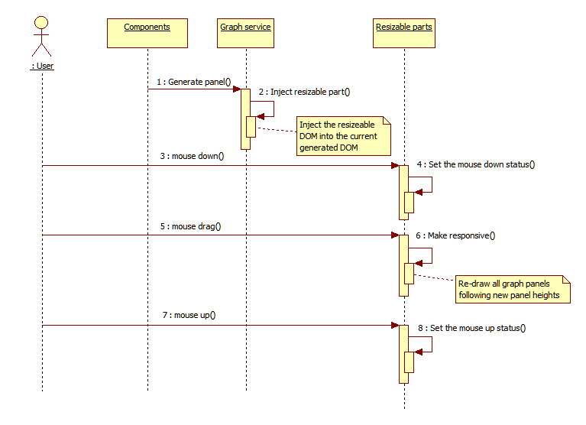

Figure 5‑49: Resize graph panels sequence diagram

##### 5.3.5.2.4. Delete signal line.

System allow user can delete signal line from graph by right click on signal line inside graph. When user right-click click on signal line inside graph, “Delete” is displayed at the top in the sub screen of the display when Vertical Cursor is turned off.

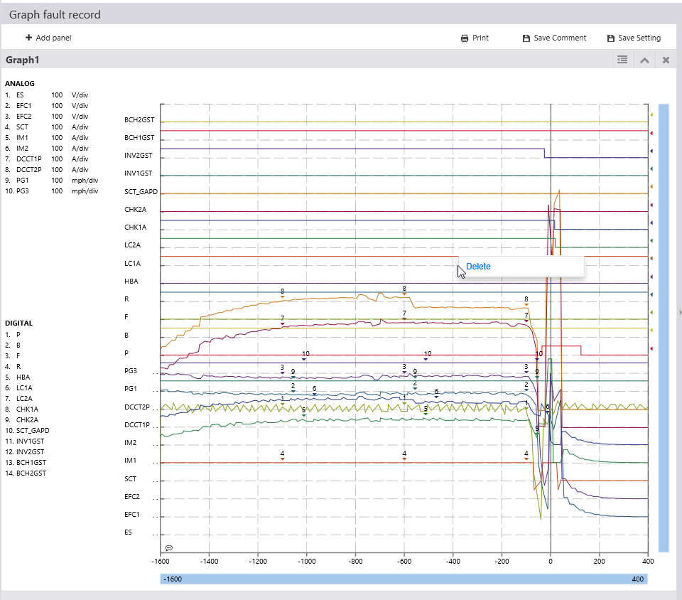

Figure 5‑50: Delete signal line

##### 5.3.5.2.5. Draw signal line evenly.

This function used to draw and align signal automatically when file doesn’t contain any setting and user doesn’t drag signal line.

* If there is only one or two signals in graph panel, signals will be aligned at the center of graph.
* If there are more than 3 signals in graph panel, signal will be aligned from position 1.
* If the number of signal is more than number of origin point, the number of origin point will be increased.
* If file has signal setting, signal will not be aligned automatically and line position setting will be kept.
* If user dragged signal, new signal will be add to the top of graph.

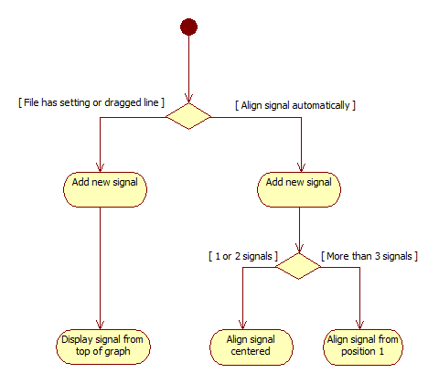

Figure 5‑51: Align graph line automatically

##### 5.3.5.2.6. [Graph] Add and edit comment

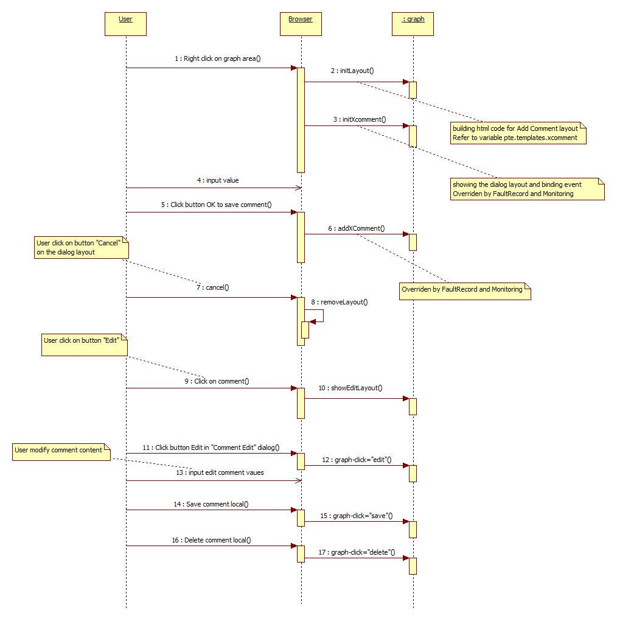

Figure 5‑52: Add and edit comment locally

#### Status service

Table 5‑16: Status service APIs

|  |  |
| --- | --- |
| **Module name** | **APIs** |
| Signal display | Create the layout of panes from [User Display Setting].  Also attach the event handler for each status-monitoring components (Refer to the Table 5‑17: Status-monitoring component event handlers). |
| Update the status-monitoring screen from [Visualization Status model]. |
| Print | Create the print view from the information of selected signals (Large or medium view, etc.). |

Table 5‑17: Status-monitoring component event handlers

|  |  |  |  |
| --- | --- | --- | --- |
| **Module name** | **Event name** | | **Handling description** |
| Signal display | Draw meter | Draw large meters | Draw screen title, command bar, display area.  Draw control panel.  Large are is selected by default. |
| Draw medium meters |
| Draw small meters |
| Change style of signal | | Change Type signal selected (Meter, Bar, Numeric, Thermometer, Pie and Counter). |
| Change size of signal | | Change size signal selected (Large, Medium, and Small). |
| Add signals | | Add new meters to monitor the added signals.  Update into the common data between [Status] and [Graph]. |
| Remove signals | | Removed the selected signal meters.  Other remaining meters will be re-ordered by Z-order.  Update into the common data between [Status] and [Graph]. |
| Start record | | Send message to the virtual server to record data. |
| Stop record | | Send message to the virtual server to stop record data then store. |

#### Numeric service

Table 5‑18: Numeric service APIs

|  |  |
| --- | --- |
| **Module name** | **APIs** |
| Numeric display | Create the layout of panes from [User Display Setting].  Also attach the event handler for each numeric components (Refer to the Table 5‑19: Numeric components event handlers). |
| Update the status-monitoring screen from [Visualization Numeric model]. |
| Print | Create the print view from the information of selected signals (horizontal or vertical view, page size, start-time, end-time etc.).  Every page should have the [Timestamp] column. |

Table 5‑19: Numeric components event handlers

|  |  |  |  |  |
| --- | --- | --- | --- | --- |
| **Module name** | | | **Event name** | **Handling description** |
| Numeric display | Time | Header | Display Horizontal | Call function to display header time column horizontal |
| Display Vertical | Call function to display header time column vertical |
| Select | Call function select column time |
| Unselect | Call function unselect column time |
| Body | Select | Call function select row |
| Unselect | Call function unselect row |
| Analog data display | Header | Display Horizontal | Call function to display header column horizontal |
| Display Vertical | Call function to display header column vertical |
| Select | Call function select column time |
| Unselect | Call function unselect column time |
| Body | Select | Call function select row |
| Unselect | Call function unselect row |
| Digital data display | Header | Display Horizontal | Call function to display header column horizontal |
| Display Vertical | Call function to display header column vertical |
| Select | Call function select column time |
| Unselect | Call function unselect column time |
| Body | Select | Call function select row |
| Unselect | Call function unselect row |
| Scroll | Horizontal scroll | Scroll | Call function render data |
| Unselect | Call function hidden data digital on numeric table |

##### 5.3.5.3.1 Numeric printing method

This function is used to printing numeric.

* Paper size: Tabloid, A3, A4
* Orientation: Portrait, Landscape
* Filter data: user input range date time filter data to printing.

Table 5‑20: Print numeric

|  |  |  |  |
| --- | --- | --- | --- |
| **Module name** | | **Event name** | **Handling description** |
| Numeric Printing | | Click on button “Print”. | Printing Dialog Open.  User can move screen dialog. |
| Change orientation | Change orientation select to print. |
| Printing area | Filter data to print. |
| Print display | Header | Display information file | Show file type, file name, car no, date time  Show more fault trigger with file type is “Normal”, “Low resolution”. |
| Body | Display data numeric | Show data numeric correct with data filter by user. |

### Operation Component

#### Flex Controller

Table 5‑21: [Flex Controller] event handlers

|  |  |  |
| --- | --- | --- |
| **Module name** | **Event name** | **Handling description** |
| Flex controller | Load frame | Get the signal list for all file types and display signals that are related to the default selected file type. |
| Users select file type on combo box | Display only signals that are related to the selected file type. |
| Users click button “Analog Selection” | Display a dialog that display all analog signals.  User can select which analog signals that are expected to add into the displaying state. |
| Users click button “Digital Selection” | Display a dialog that display all digital signals.  User can select which digital signals that are expected to add into the displaying state. |
| Users click button “Delete” | Remove signals from displaying state. |
| Users click button “Bulk Edit” | Users are allowed to change the information of signals. |
| Users click button “Apply Change” | After changing, the information are updated on the screen (not save to the virtual server yet). |
| Users click button “Cancel Change” | Revert back all signal changings. |
| Users click button “Save Setting” | Save signal settings to the virtual server. |
|  | Filter signal name | Searching signal name which match [Filter name] from user input. Reflect the filter after completion of input and user click enter.  Can filter multi signal name by separated data with commas character. |
|  | Filter description | Searching description signal which match [Filter description] from user input. Reflect the filter after completion of input and user click enter. |

#### Time Set Controller

Table 5‑22: [Time Set Controller] event handlers

|  |  |  |
| --- | --- | --- |
| **Module name** | **Event name** | **Handling description** |
| Time Set controller | Load frame | Refer to sequence diagram Figure 5‑28: Time Set screen |
| Click button Set Time |
|  |  |
|  |  |

#### Reset Lockout

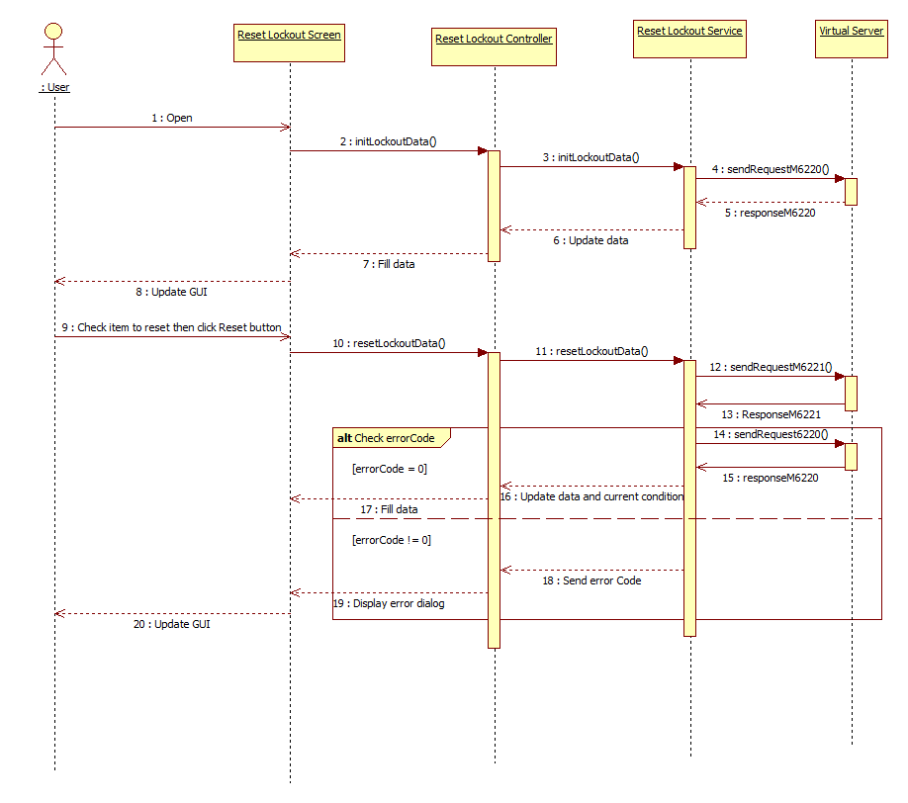

#### Logic Editor

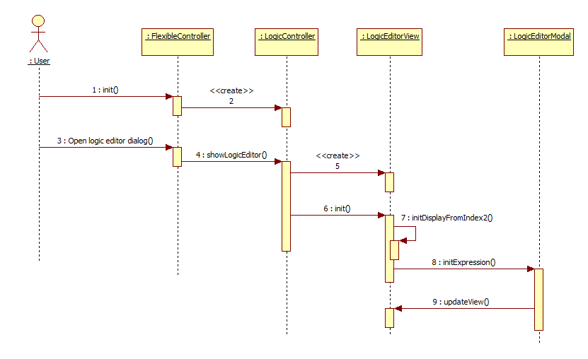

Figure 5‑53: Initialize Logic Editor Dialog

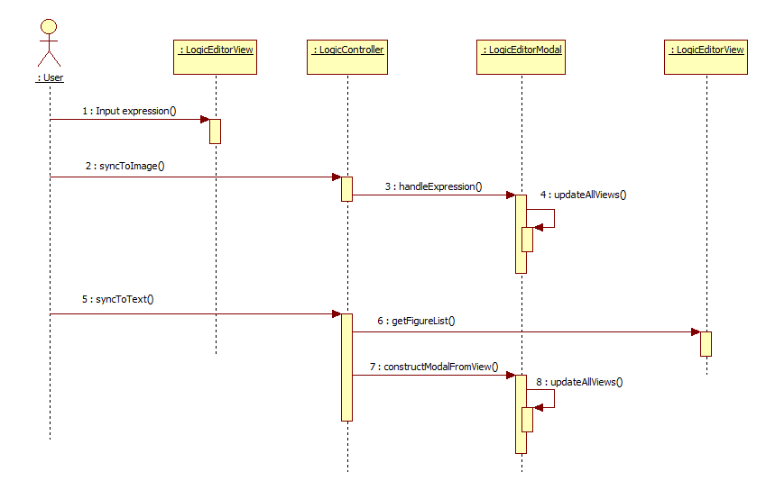

Figure 5‑54: Synchronize between logic text and logic image

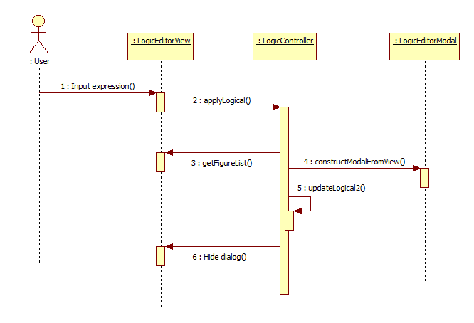

Figure 5‑55: User click button Apply to save

### Dialog screen select signal

*\*Note: All sub screens should be movable.*

Table 5-21: Dialog screen select signal

|  |  |  |
| --- | --- | --- |
| **Module name** | **Event name** | **Handling description** |
| Select signal | Load grid | Get the signal list for all file types and display signals that are related to the default selected file type. |
| Check or uncheck checkbox on header grid | If check is true all signal selected.  If check is false all signal unselect. |
| Users click button “Select” | After changing, the signal select apply to main screen. |
| Users click button “Cancel” | Not effect signal select to main screen. |
|  | Filter signal name | Searching signal name which match [Filter name] from user input. Reflect the filter after completion of input and user click enter.  Can filter multi signal name by separated data with commas character. |
|  | Move screen dialog | User can move screen. |

### Help Component

Table 5‑23: Help components event handlers

|  |  |  |
| --- | --- | --- |
| **Module name** | **Event name** | **Handling description** |
| Version | Load frame | Refer to sequence diagram Figure 5‑29: Open Version screen |
|  |  |
| Manual | T.B.D | T.B.D |

### Account

[Account] is a component of both [Login] and [Logout].

Table 5‑24: Account component event handlers

|  |  |  |
| --- | --- | --- |
| **Module name** | **Event name** | **Handling description** |
| Account | Login | Login is used to log into the system, it consists of a Username and password.   * Username is a name that uniquely identifies someone on a system and always paired with a password. * A password is a string of characters used for authenticating a user on a system.   At next login, automatically display the Username of the previous login.  Refer to Figure 5‑36: Change time mode Absolute/Relative on monitoring graph screen. |
| Logout | Logout function logs the user out of the system. |

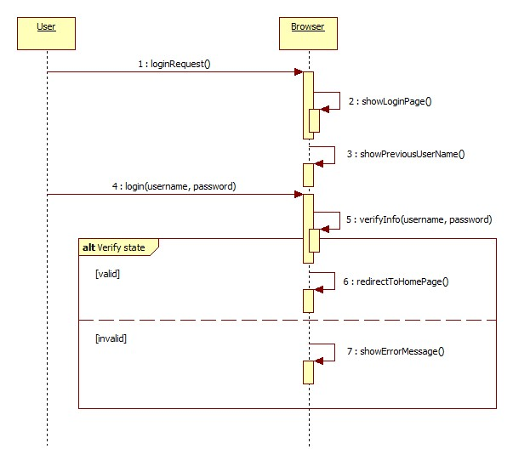

Figure 5‑56: Login to system.

### Settings

#### Network

Table 5‑25: Network component event handlers

|  |  |  |
| --- | --- | --- |
| **Module name** | **Event name** | **Handling description** |
| Network | Server address | This function is used to specify the IP address of the connection destination.  Refer to Figure 5‑57: Change IP address of server. |

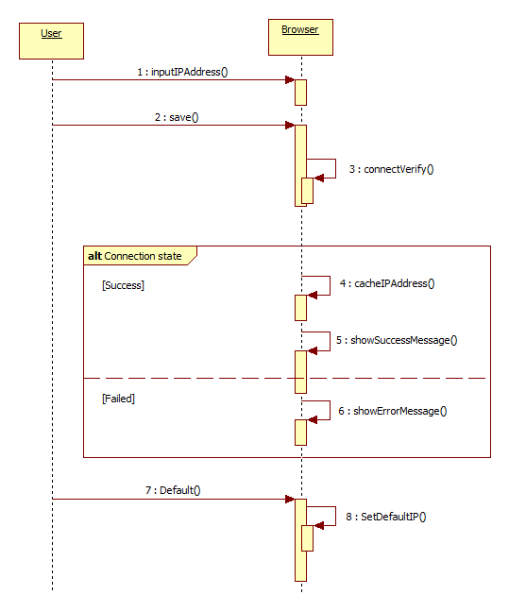

Figure 5‑57: Change IP address of server.

#### Browser Setting

* **Unit setting**: Unit setting use to setting display value for unit number receiving from server for each signal. User can change the mapping between unit number and display value in setting.js file. Browser will check and show error message if have invalid setting for unit display when initial any page.

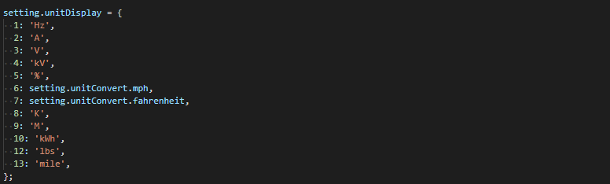

Figure 5‑58: Unit display setting.

* **Format setting**: Format setting use to setting display value for signal value number receiving from server for each signal follow C printf format. User can change the mapping between format number and display in setting.js file. Browser will check and show error message if have invalid setting for unit display when initial any page.

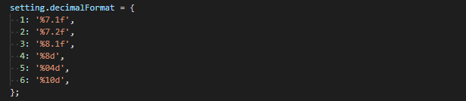

Figure 5‑59 Format display setting.

#### Plugins

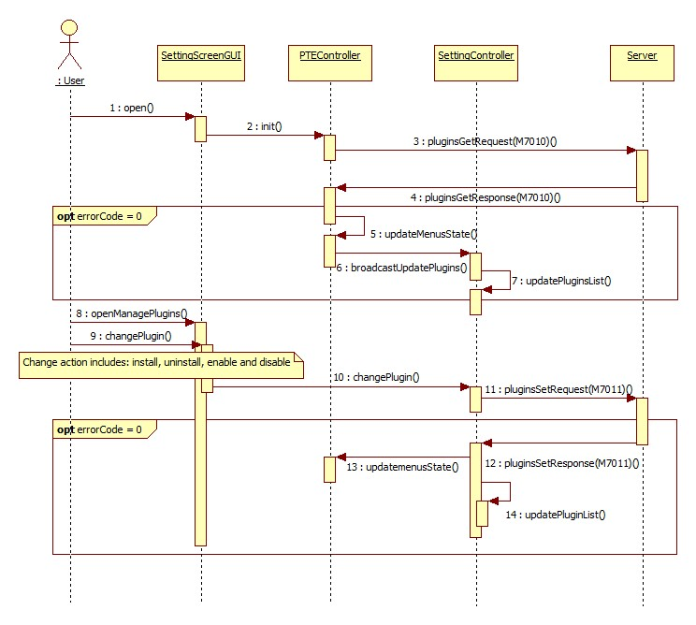

Figure 5‑60 Plugin setting

### Login screen



Figure 5‑61 Login screen

## Down sampling large data

### Purpose

The graph screen used line chart for data visualization. Generally, producing a line chart on graph is relatively easy thing to do, but if the data contains a vast number of data points, the resulting line chart may appear quite squashed. Because, such an effect is the result of rendering data containing many more points than the number of pixels for given SVG width.

For example, if total data points of the high speed file (about 32768 points) are drawn on relative small SVG, as figure 5-33, we end up with this type of squashed line chart.

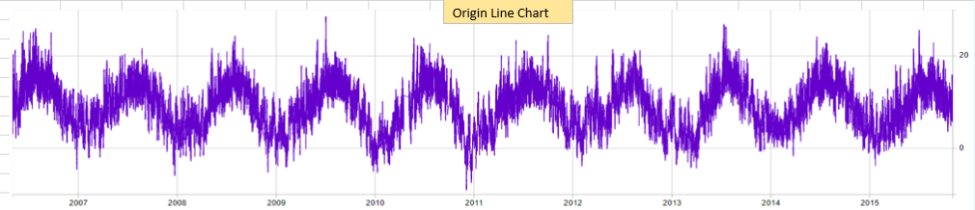

Figure 5‑62: Line chart contains 32768 data points

Some necessary steps must be taken to avoid the problems discussed before, when visualizing a large amount of data as a line chart. In this case, data points need to be thin out before visualize on screen.

### Objectives of the down sampling method

The important thing is that the down sampled data is only intended to visually represent the origin data.

And, the sampling method should be quick to process within a reasonable time for large inputs, and return a correct result.

For example, the line chart in figure 5-33, after down sampled should be seen as figure 5-34.

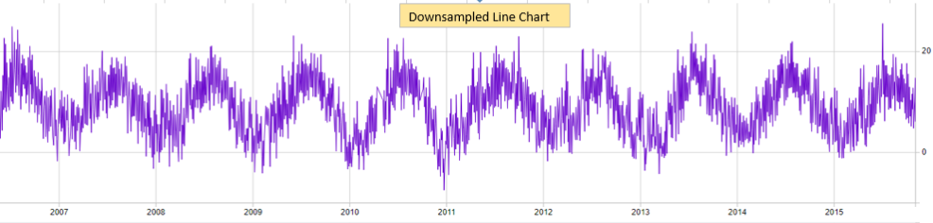

Figure 5‑63: Down sampled data line chart

### Largest Triangle Three Buckets Algorithm

The basic idea of algorithm is divide all data points into groups of approximately equal size. Then, pick up a special points in each group. All picked data point will be used to draw the down sampled line.

The first step is to divide all the data points into groups of equal size. The first and last groups will contain only the first and last data point of the original data. Therefore, first and last point will be included in the down sampled data.

The next step is go through all group from first to last and select a special point in each group. The algorithm work with three groups and loop until reach the last group. To keep the shape of graph line, we should select the most effective area (form a rectangle with largest area), which visualize in Figure 5-35. The first group only contains a single point (A point), so it will be selected to form a triangle.

The second group and third group may be contains more than one point, so we can use a brute-force approach and simply try out all the possibilities. If 2nd and 3rd group contains 100 points, the algorithm need to calculate the area of 100x100=10000 rectangle in order to find B point and C point.

To improve the performance of algorithm, we temporary pick up a C point in 3rd group. C point will be the average of all points in 3rd group. If so, we will have A point and C point fixed, the algorithm need to calculate area of only 100 rectangle in order to find B point.

After found A, B, C point, we continue to process another group to find D point, E point… until reach the last sample.

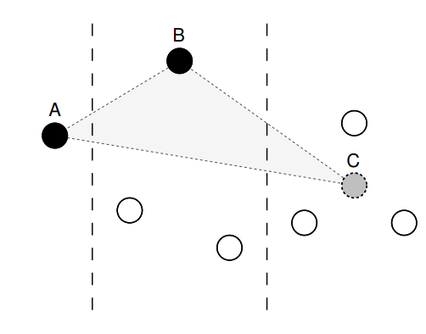

Figure 5‑64: Largest triangle formed across three buckets and point C being a temporary point

Following is the pseudo code of algorithm

**Require**: data (*the origin data*)

**Require**: threshold (*Number of thin out data points to be returned*)

1. Split the data into equal number of groups as the threshold. First group contains only the first data point and the last group contains only the last data point.
2. Select the point in the first group
3. **for** each groups except the first and last **do**
4. Rank every point in the group by calculating the area of a triangle it forms with the selected point in the previous group and the average point in the next group.
5. Select the point with the highest rank within the group.
6. **end for**
7. Select the point in the last group (*There is only one*)

**Return:** List of thin out data points

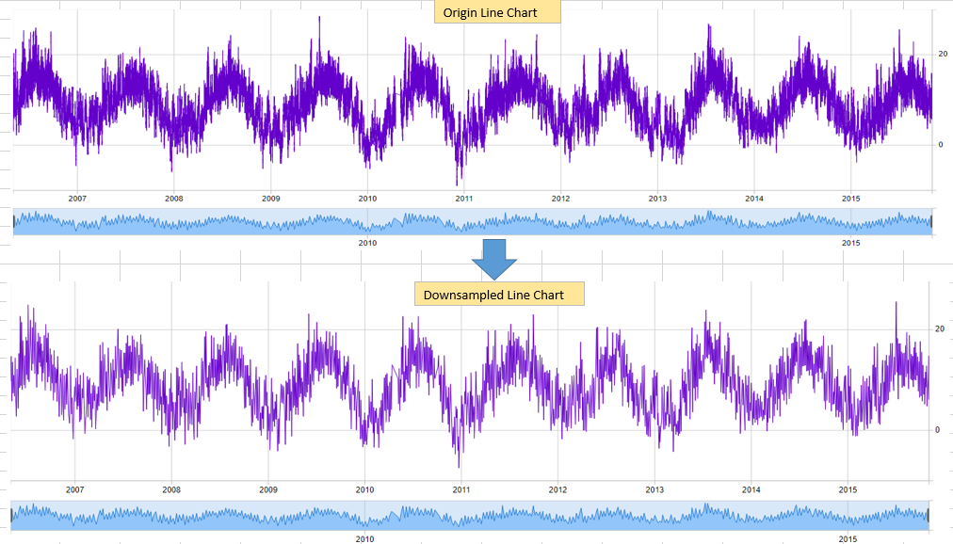

Figure 5‑65: Down sampled line chart with the Largest Triangle Three Buckets algorithm

## Lazy load

### Graph screen

|  |  |  |  |
| --- | --- | --- | --- |
| **Function** | **Sub function** |  | **Remark** |
| Print |  | Y | When users click button "Print", open the printing dialog. Users select paper size, paper orientation, graph panels and color to print the current view. |
| Add new Panel |  | N |  |
| Delete Graph Panel |  | N |  |
| Show/Hide graph by Icon at the top left of Graph |  | N |  |
| Change Horizontal time slider |  | Y | When users grab and drag the slider bar, update slider **length and timestamps.** Update the graph panel view only when users release grabbing.  Disabling sliders and loading progress is until finishing update. |
| Change Vertical bar time slider |  | Y | When users grab and drag the slider bar, update slider bar **length**. Update the graph panel view only when users release grabbing. Disabling sliders and loading progress is until finishing update. |
| Pan/Zoom function |  | Y | In progress of confirming behaviors. It is expected to be the same as “Change Horizontal/Vertical time slider”. |
| Graph Compare |  | Y | When users right-click on a panel header, open “Graph Comparison” dialog. 1) Users select “Save To Compare” to save the displaying of current panel to cache. 2) Users select “Load Compare” and select the panel to compare with. |
| Resize graph panel height |  | Y |  |
| Save Comment |  | Y | All comments on the graph view are stored at the server side. |
| Save Setting |  | Y | All settings of all graph panels are updated and stored at the server side. |
| Select Signals | Select Analog and Digital signals | Y | Add analog and digital signals to draw on a graph panel. 1) Analog signals have 3 carets at position of ¼, ½, ¾ of graph line length. 2) Digital signals are drawn as thicker lines at the value of High. |
| Share/Open Share Settings | Share file | N |  |
| Open Share file | N |  |
| Undo/Redo | Undo | Y | Undo/Redo actions: + Select Signals. + Comments (Add/Delete). + Switch tabs. |
| Redo | Y |
| Time Search | Relative | Y | Jump the cursor to the position of searching time.  Cursor should be put at the middle of panel view. |
| Absolute | Y |
| Time Format | Relative | Y | Time on graph panels are switched between Relative time and Absolute time. (Except "distance time" between vertical cursor is always Relative time). |
| Absolute | Y |
| Unit | Temperature | Y | Signal values are switched between Fahrenheit and Celsius. |
| Velocity | Y | Signal values are switched between kph and mph. |
| Measurement | Cursor | Y | When users grab and drag the cursor, update the cursor value. Update the signal values at the legend only when users release grabbing.  The loading progress is until finishing update. |
| Vertical Cursor | Y | When users grab and drag the cursor, update the cursor value.  The loading progress is not necessary. |
| Adjust View | Y | Refer to "Change Horizontal time slider". |
| Calculation |  | Y | When users right click on an analog signal (Vertical cursors are checked ON before), display the Calculation popup. |
| Line Popup |  | Y | In progress of confirming behaviors. It is expected that when users click on a graph panel, display line cursor popup to show the value of the nearest signal. |
| Comment | Add/Edit/Delete comment which don't have signal by Relative comment/ Absolute comment | Y |  |
| Add/Edit/Delete comment which have signal by Relative comment/ Absolute comment | Y |  |
| Filter Comment | N |  |
| Search Comment | Y | When user click on a comment at the Control Panel, jump the cursor to the position of comment. Cursor should be put at the middle of panel view. Selected comment is highlighted on the graph panel. |
| Change Properties | Name | N |  |
| Background color | N |  |
| Font (Size, name, style) | N |  |
| Show/Hide Legend at right panel | N |  |
| Show/Hide Legend by icon | N |  |
| Return function |  | Y |  |
| Setting Unit and Format in setting.js file |  | N |  |
| Expand and collapse Graph screen |  | N |  |
| Signal line | Signal line properties (weight, dashes, color) | N |  |
| Drag Signal line | Y | Signal lines are possible to move vertically. |
| Remove Signal line | N | When users right click on a signal line (Vertical cursors are checked OFF before), display the Delete popup. User select "Delete" to remove the signal line. |
| Y-Axis Element |  | N |  |
| X-Axis Element |  | N |  |
| Analog Y-Axis Setup |  | Y |  |
| Digital Y-Axis Setup |  | Y |  |

|  |  |  |  |
| --- | --- | --- | --- |
| **Normal Load** | | **Lazy Load** | |
| GraphRecordedController | ngfaultgraph.js | realtimeGraphRecordedController | ng-rt-faultgraph.js |
| GraphServiceCreator | graphservice.js | The same as Normal Load |  |
| faultGraphFactory | fault-graphfactory.js | The same as Normal Load |  |
| graphChart | graph-chart.js | realtimeGraphChart | rt-graph-chart.js |
| ValueCursor | value-cursor.js | RealtimeValueCursor | rt-value-cursor.js |
| VerticalCursor | vertical-cursor.js | RealtimeVerticalCursor | rt-vertical-cursor.js |
| LineCursor | line-cursor.js | RealtimeLineCursor | rt-line-cursor.js |
| GraphLegend | graph-legend.js | RealtimeGraphLegend | rt-graph-legend.js |
| DigitalStrokeLine | digital-line.js | The same as Normal Load |  |
| GraphSignalLine | graph-signal-line.js | RealtimeGraphSignalLine | rt-graph-signal-line.js |
| GraphZoom | graph-zoom.js | RealtimeGraphZoom | rt-graph-zoom.js |
| downSampler | down-sampler.js | realtimeDownSampler | rt-down-sampler.js |
| ChartPrinting | chart-printing.js | RealtimeChartPrinting | rt-chart-printing.js |
| ChartComparison | chart-comparison.js | RealtimeChartComparison | rt-chart-comparison.js |
|  |  |  |  |
|  |  |  |  |

|  |  |
| --- | --- |
| **Function name** | **Description** |
| Common | |
| + Check all bisectDate (panelTime, xPos, 1).  + In Lazy Load, index positions can be calculated by xPos / sampling time. | |
| + Write a new function getAllSignalValue(**time**) to get values of all signals at the position that is nearest to “**time**”.  + Replace all parts that use functions “findAnalogDrawingIndex” and “findDigitalDrawingIndex” by the new function above. | |
| + Check all parts that use variable “panelTime”.  + In Normal Load, “panelTime” is used to hold all record data.  + In Lazy Load, change the way of accessing “panelTime” from direct-access to server-loading. | |
| + Check all parts that use “val[”.  + Check all parts that use “.y”. | |
|  | |
| realtimeGraphRecordedController | |
|  |  |
|  |  |
|  |  |
|  | |
| GraphServiceCreator | |
|  |  |
|  |  |
|  |  |
|  | |
| faultGraphFactory | |
| drawChart | + Create the instance of the real-time graph chart. |
|  | |
| realtimeGraphChart | |
| setxAxisScale | + Do not use panelTime and bisectDate, from val [0] and val [1], round values following the sampling-time (for example 200, 400, 600, etc.) |
| findAnalogDrawingIndex | + Indexes are possible to calculated by dividing to the sampling time (for example, 200ms). |
| findDigitalDrawingIndex |
| drawSliderBar | + Do not use panelTime, from config.lajst and config.rajst, calculate the left adjusted time and right adjusted time (ms). |
| onGraphMoving | + Separate the handle of signal grabbing into new function (handleSignalGrabbing).  + In Normal Load, line cursor is always updated.  + In Lazy Load, line cursor is only updated when user click on SVG. |
| handleSignalGrabbing | + Get value of all signals at positions of ¼, ½, ¾ graph line length to draw signal carets.  + Store the y value of ¼, ½, ¾ graph line length, so that when dragging, do not have to request server again. |
| updateValueLegend | + Get value of all signals at the position that is nearest to “cursorTime”.  (Should use function getAllSignalValue(**time**)). |
| updateGraphSize | + Set domain for xAxisSliderScale by requesting server to get the overall time.  + Get value of all signals at the position that is nearest to “cursorTime” to update signal values at the legend. |
| updateGraphElementPos | + Get value of all signals at the position that is nearest to “cursorTime” to draw signal values at the legend.  + Get value of all signals at positions of ¼, ½, ¾ graph line length to draw signal carets. |
| resetAllMarkerPosition | + Get value of all signals at positions of ¼, ½, ¾ graph line length to draw signal carets. |
| rePositionLineMarker | + Get value of all signals at positions of ¼, ½, ¾ graph line length to draw signal carets. |
| updateGraphXAxisTickFormat | + Set domain for xAxisSliderScale by requesting server to get the overall time. |
| setPanelTime | Not necessary. Remove. |
| getPanelTime | Not necessary. Remove. |
| brushing | + Only update the value of time slider, do not update the graph view.  + Start loading. |
| brushEnd | + Update the graph view (same operation as function brushing of Normal Load).  + Stop loading. |
| createGraphAreaContextMenu | + Get value of all signals at the position that is nearest to mouse position to prepare for the “Add Comment” dialog. |
|  |  |
|  |  |
|  | |
| RealtimeValueCursor | |
| UpdateView | + Check all bisectDate (panelTime, xPos, 1).  + In Lazy Load, index positions can be calculated by xPos / sampling time. |
| onCursorMoving | + In Normal Load, graph view is updated when users drag cursor and mouse move.  + In Lazy Load, the updating condition is necessary to be changed, graph view is only updated when users drag cursor and mouse up. |
|  | |
| RealtimeVerticalCursor | |
| UpdateView | + Check all bisectDate (panelTime, xPos, 1).  + In Lazy Load, index positions can be calculated by xPos / sampling time. |
| onVerticalCursorMoving | + In Normal Load, graph view is updated when users drag cursor and mouse move.  + In Lazy Load, the updating condition is necessary to be changed, graph view is only updated when users drag cursor and mouse up. |
|  | |
| RealtimeLineCursor | |
| findTimeIndexFromMousePosX | + From “mousePosX”, calculate the time index position. |
| update | + Use function findTimeIndexFromMousePosX to get the time index position.  + Use function getValueAllSignalsByIndex to get value of all signals.  + Update on the view. |
| findMousePosFromAnalogTimeIndex | Not necessary. Remove. |
| findMousePosFromDigitalTimeIndex | Not necessary. Remove. |
|  | |
| RealtimeGraphLegend | |
| updateLegend | + Get value of all signals at the position that is nearest to “cursorTime” and update the signal value at the legend. |
| updateAnalogLegendValue | Not necessary. Remove. |
| updateDigitalLegendValue | Not necessary. Remove. |
| updateLegendUnit | Not necessary. Remove. |
|  | |
| RealtimeGraphSignalLine | |
| updateAnalogLinePos | + Get value of all signals at caret positions and draw carets. |
| drawGraphAnalogLine | + In the handle of signal context menu (on('contextmenu')), get the index of vertical cursors and assign to context menu modal. |
| drawGraphDigitalLine | + In the handle of signal context menu (on('contextmenu')), get the index of vertical cursors and assign to context menu modal. |
|  | |
| RealtimeGraphZoom | |
| zoomStart | + Do not allow to zoom continuously.  + Start loading. |
| zoomed | + Do not allow to zoom continuously. |
| zoomEnd | + Stop loading. |
|  | |
| realtimeDownSampler | |
| getAnalogDrawing | + Instead of processing on the whole data “orgSample”, request server to get block one by one.  + For each block, refineAnalogSignalValue and selectAnalogTrimPacket.  + Combine all trim packet of all blocks together. |
| getDigitalDrawing | + Instead of processing on the whole data “orgSample”, request server to get block one by one.  + For each block, refineDigitalSignalValue and selectAnalogTrimPacket.  + Combine all trim packet of all blocks together. |
|  | |
| RealtimeChartPrinting | |
| draw | + Recheck all parts that use val[ or panelTime. |
|  |  |
|  | |
| RealtimeChartComparison | |
| draw | + Recheck all parts that use val[ or panelTime. |
|  |  |
|  |  |

# Client-Server interface

Refer to the document [E6MX0211_ブラウザPTE_通信インタフェース設計書.xlsx] to see the latest interface between the PTU Browser and the Virtual Server.

# Appendix