

**Software Requirements Specification**

Version 1.0

Mobile World JSC

Group 4

Mock Project

**1.0. Introduction**

***1.1. Purpose***

The purpose of this document is to present a detailed description of the Mobile World Store System. It will explain the purpose and features of the system, its interfaces, what the system will do, the constraints under which it must operate, and how the system will respond to external stimuli. This document is intended for both stakeholders and developers of the system and will be recommended to potential customers for approval.

***1.2. Scope of the project***

This product is a product introduction website for customers to buy online.

***1.3. Glossary***

| ***Term*** | ***Definition*** |
| --- | --- |
| Administrator | User as admin can log in to update website data |
| Customer | Users can view products on the web, find and purchase items |

**2.0. Overall Description**

***2.1. System Environment***

End users can be project managers, the quality assurance team, and other project members.

***2.2. Functional Requirements Specification***

**USE CASE DIAGRAM**

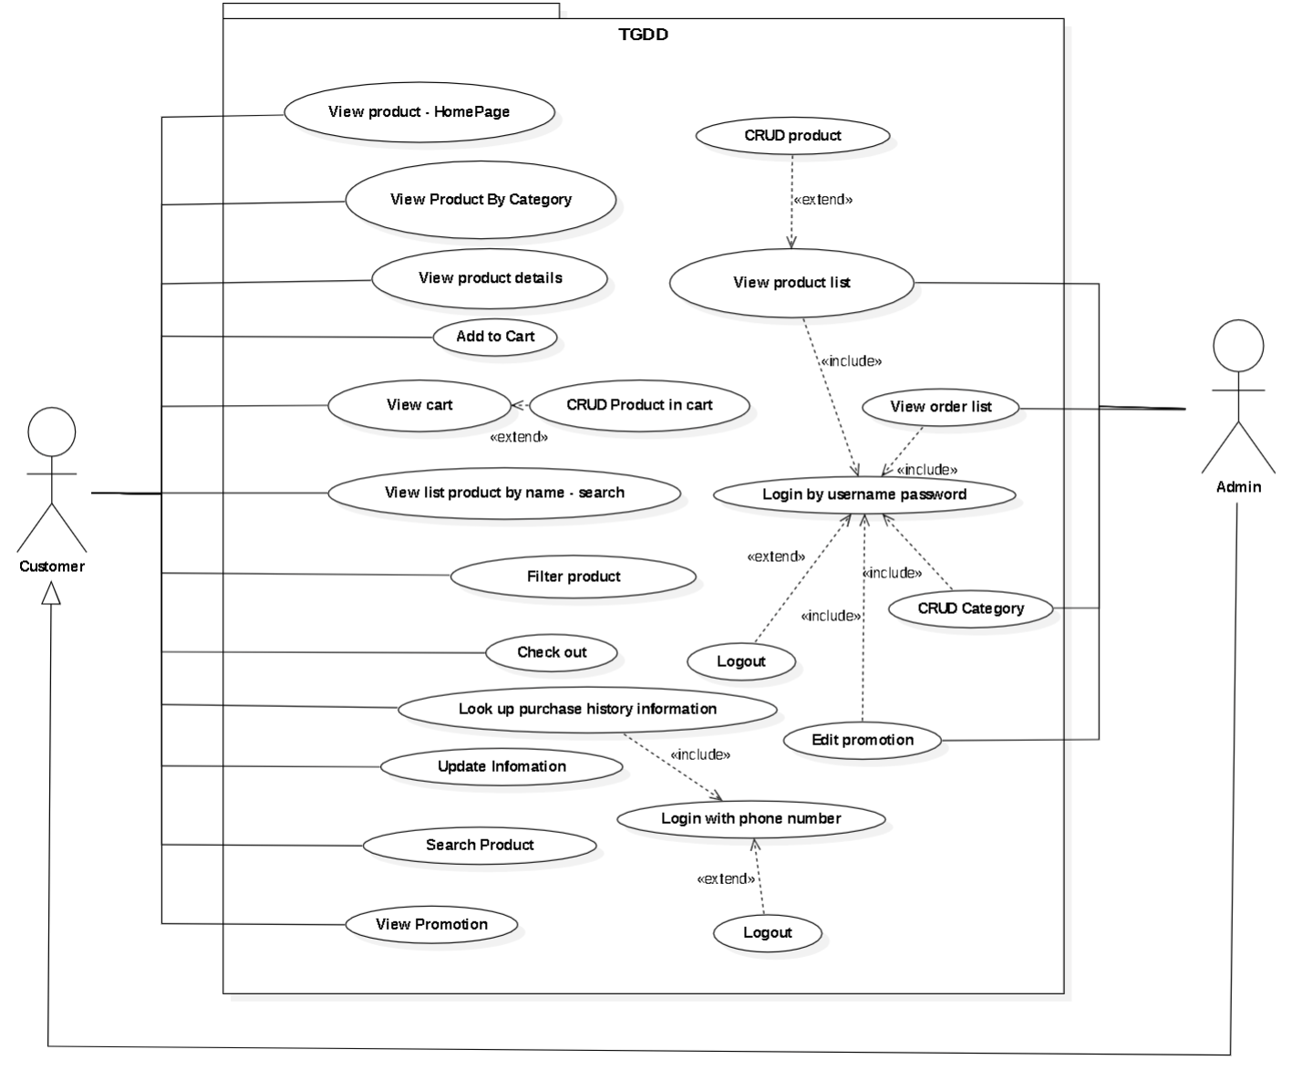

**Figure 1 – Mobile World JSC System Use Case Diagram**

***2.3. Function Requirements***

***2.3.1 Actor:***

* **Administrator:** Manage web.
* **Customer:** Includes all web visitors.

***2.3.2 Mobile World Customer Use Case***

**Diagram: *Customer View Products***

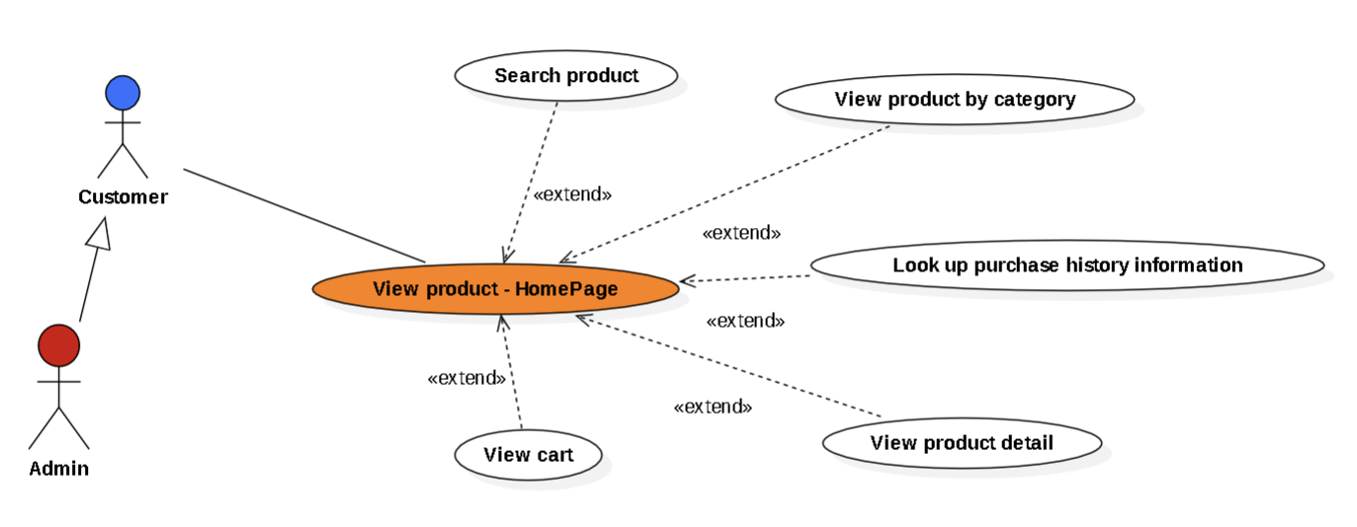

|  |  |
| --- | --- |
| **Use Case** | **Customer View Products** |
| **Short description** | The customer accesses the Mobile World web to view products. |
| **Precondition** |  |
| **Postcondition** |  |
| **Main flow description** | To be able to start using this function, the user must visit the mobile world website.   1. Customers visit the homepage. 2. The website will display products, product types, ..... 3. The website allows users to perform other functions. |
| **Alternative Paths** | **None** |
| **Exception Paths** | **None** |
| **Other** | **None** |

**Diagram: *Customer View Detail Products***

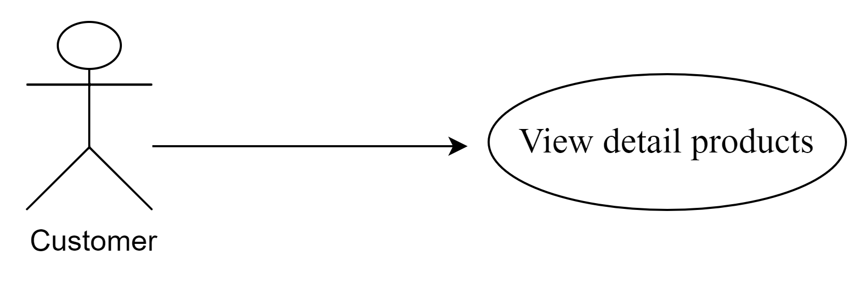

|  |  |
| --- | --- |
| **Use Case** | **Customer View Details Products** |
| **Short description** | Customers visit the mobile world web to view product details. |
| **Precondition** | The customer selects a product to view detail. |
| **Postcondition** |  |
| **Main flow description** | To be able to start using this function, the user must visit the mobile world website.   1. Customers visit the homepage. 2. The website will display products, product types, ..... 3. Select the product you want to see detailed information about. 4. The system redirects to a product detail page. |
| **Alternative Paths** | **None** |
| **Exception Paths** | **None** |
| **Other** | **None** |

**Diagram: *Customer View Products By Categories***

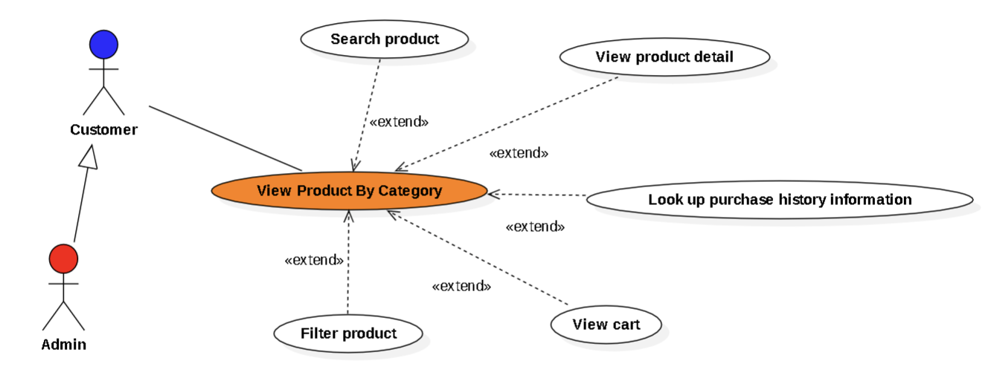

|  |  |
| --- | --- |
| **Use Case** | **Customer View Products By Categories** |
| **Short description** | Customers visit the mobile world web to view products by categories. |
| **Precondition** | Customers choose a category of products on the homepage to see products of the same type or brand,..... |
| **Postcondition** |  |
| **Main flow description** | To be able to start using this function, the user must visit the mobile world website.   1. Customers visit the homepage. 2. The website will display products, product types, ..... 3. Choose a category of products you want to see products of the same type or brand,..... 4. The system redirects to the page listing products of the same category. |
| **Alternative Paths** | **None** |
| **Exception Paths** | **None** |
| **Other** | **None** |

**Diagram: *Customer Search Products By Name or Character***

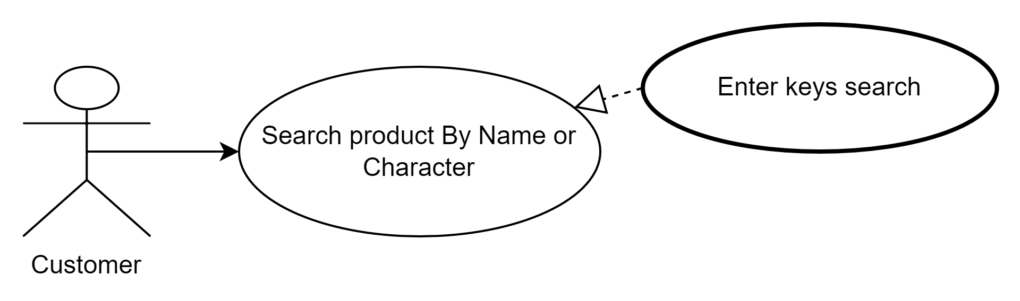

|  |  |
| --- | --- |
| **Use Case** | **Customer Search Products By Name or Character** |
| **Short description** | Customers visit the mobile world web to search for products. |
| **Precondition** | Customers click on the search line and then enter the characters to search for products. |
| **Postcondition** |  |
| **Main flow description** | To be able to start using this function, the user must visit the mobile world website.   1. Customers visit the homepage. 2. The website will display products, product types, ..... 3. Click on the search line and then enter the characters to search products. 4. The system redirects to the page with the product the customer is looking for. 5. If the product is not found, the website will notify you.   For more accurate results, please:   * Check the spelling of the entered keyword * Try again with another keyword * Try again with more general keywords * Try again with shorter keywords |
| **Alternative Paths** | **None** |
| **Exception Paths** | **None** |
| **Other** | **None** |

**Diagram: Customer add product to cart.**

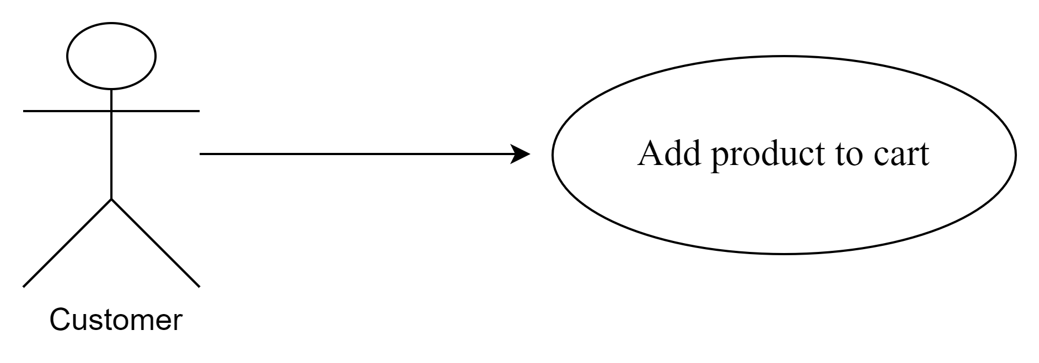

|  |  |
| --- | --- |
| **Use Case** | **Customer add product to cart** |
| **Short description** | Customer access details product page to add product to cart. |
| **Precondition** | The system exist product and the customer must click on “Order now” button |
| **Postcondition** | The system shows success message and the number beside icon cart increase |
| **Main flow description** | To be able to start using this function, the user accesses the mobile store website:   1. The customer visits the homepage. 2. The customer clicks button order now on each product (list all products page or detail product page). 3. The system adds selected products to the cart. 4. The system allows the customer to perform other activities. |
| **Alternative Paths** | **None** |
| **Exception Paths** | **None** |
| **Other** | **None** |

**Diagram: Customers view cart.**

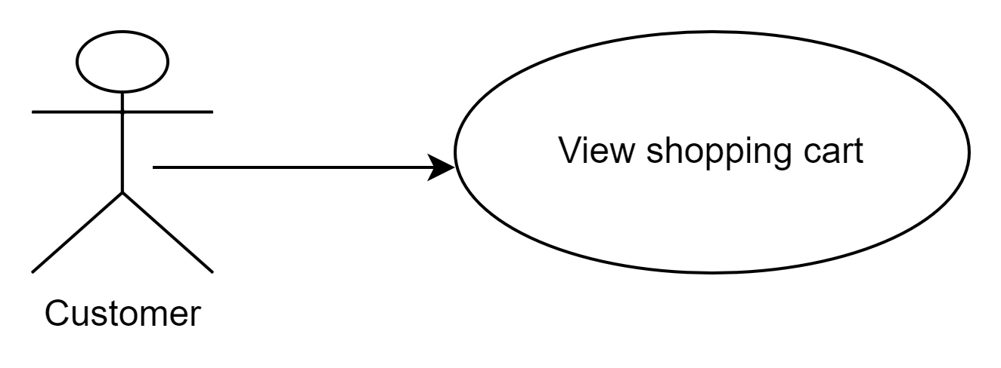

|  |  |
| --- | --- |
| **Use Case** | **Customer View their Shopping Cart** |
| **Short description** | Customers visit the shopping cart to see which products they choose. |
| **Precondition** | The customer clicks on the button “Shopping Cart”. |
| **Postcondition** |  |
| **Main flow description** | To be able to start using this function, the user must visit the cart.   1. Customers visit the homepage. 2. Customers visit the shopping cart. 3. If the cart is empty, the website shows the message “You don’t have any product in the cart.”. |
| **Alternative Paths** | **None** |
| **Exception Paths** | **None** |
| **Other** | **None** |

**Diagram: Customers update products in the shopping cart.**

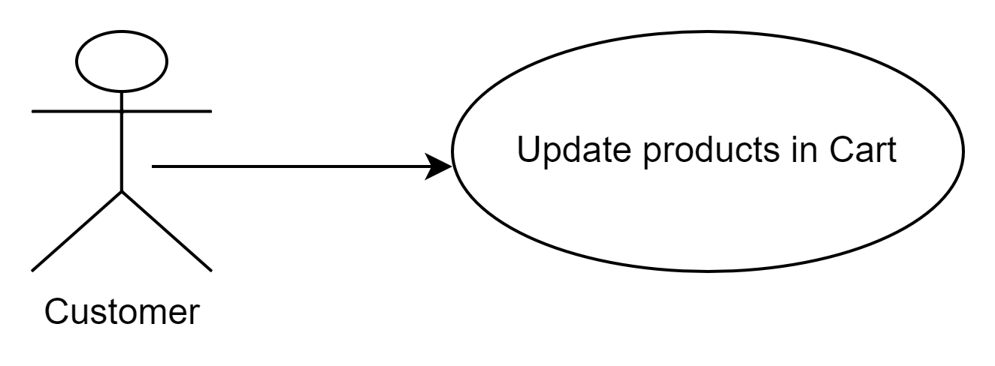

|  |  |
| --- | --- |
| **Use Case** | **Customer Update Products in Cart** |
| **Short description** | Customers visit the cart to update the quantity of products they want to buy more. |
| **Precondition** | The customer selects a product to update. |
| **Postcondition** |  |
| **Main flow description** | To be able to start using this function, the user must visit the cart.   1. Customers visit the homepage. 2. Customers visit the shopping cart. 3. If the cart is empty, the website shows the message “You don’t have any product in the cart.” 4. If the cart has products. Users select products they want to buy more. Choose the exact amount they want 5. Click on the button “Update”. 6. The system will update the quantity that matches the selected customer. |
| **Alternative Paths** | **None** |
| **Exception Paths** | **None** |
| **Other** | **None** |

**Diagram: Customers delete products in the shopping cart.** 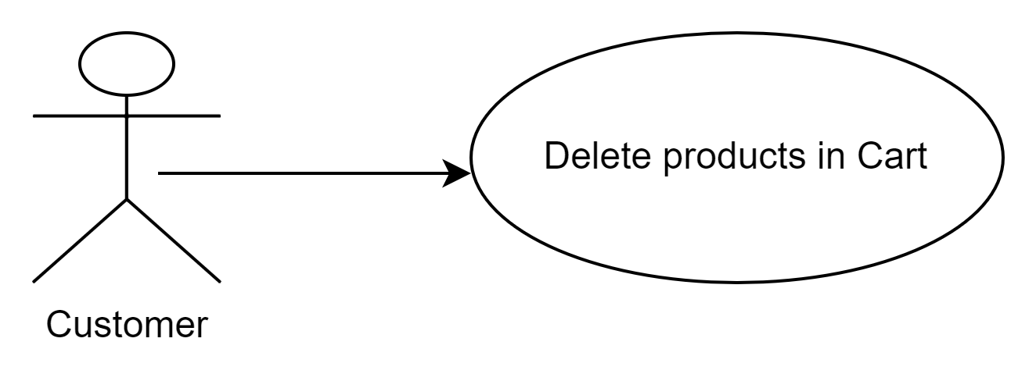

|  |  |
| --- | --- |
| **Use Case** | **Customer Delete Products in Cart** |
| **Short description** | Customers visit carts to delete products they don’t want to buy anymore. |
| **Precondition** | The customer selects a product to delete. |
| **Postcondition** |  |
| **Main flow description** | To be able to start using this function, the user must visit the cart.   1. Customers visit the homepage. 2. Customers visit the cart. 3. If the cart is empty, the website shows the message “You don’t have any product in the cart.” 4. If the cart has products. Users select products they don’t want anymore. 5. Click on the button “Delete” and select “Yes” to make sure they want to put the product out. If they change their mind, select “No”. 6. The system deletes that product out of the cart then redirects the shopping cart. |
| **Alternative Paths** | **None** |
| **Exception Paths** | **None** |
| **Other** | **None** |

**Diagram: Check out and create order.**

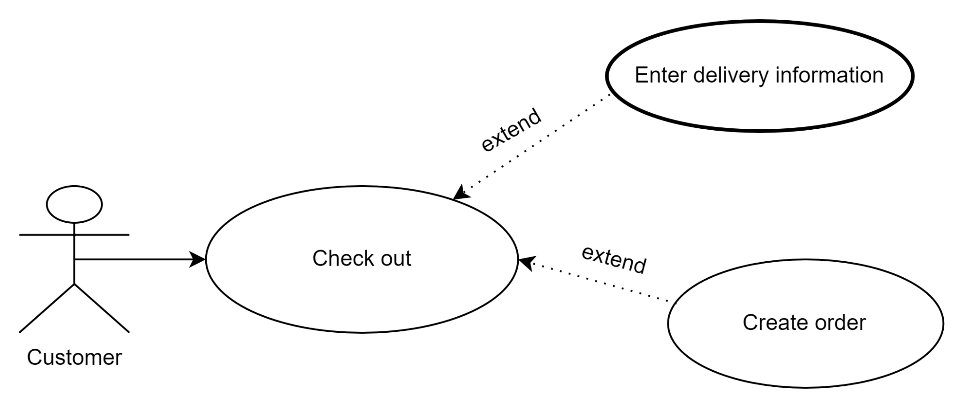

|  |  |
| --- | --- |
| **Use Case** | **Customer click check out and create order** |
| **Short description** | Customer view product in cart and click check out then create order. |
| **Precondition** | The cart exist product and the customer must click on button “Check out”. |
| **Postcondition** | The system shows success message. |
| **Main flow description** | To be able to start using this function, the user accesses the mobile store website:   1. The customer visits the View cart page. 2. The customer clicks on button “Check out” and direct to page “Check out”. 3. The customer fills in order form to create order then click button “Create order”. 4. The system shows success message and allows the customer to perform other activities. |
| **Alternative Paths** | **None** |
| **Exception Paths** | **None** |
| **Other** | **None** |

**Diagram: Customers look up the purchase history**

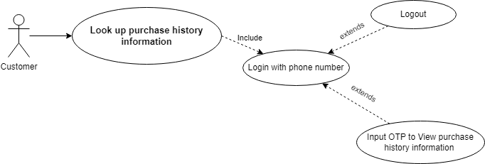

|  |  |
| --- | --- |
| **Use Case** | **Customer look up purchase history information** |
| **Short description** | Customers search to see their order. |
| **Precondition** | The customer clicks on the button “Find orders”. |
| **Postcondition** |  |
| **Main flow description** | To be able to start using this function, the user accesses the mobile store website:   1. The customer visits the homepage. 2. The customer selects the order history button. 3. The customer enters the phone number for the website to confirm. 4. The website will send the OTP code to the customer's phone. 5. Customers enter the OTP code, click continue. 6. The website will redirect to order history. |
| **Alternative Paths** | **None** |
| **Exception Paths** | **None** |
| **Other** | **None** |

**Diagram: Customer update delivery information.**

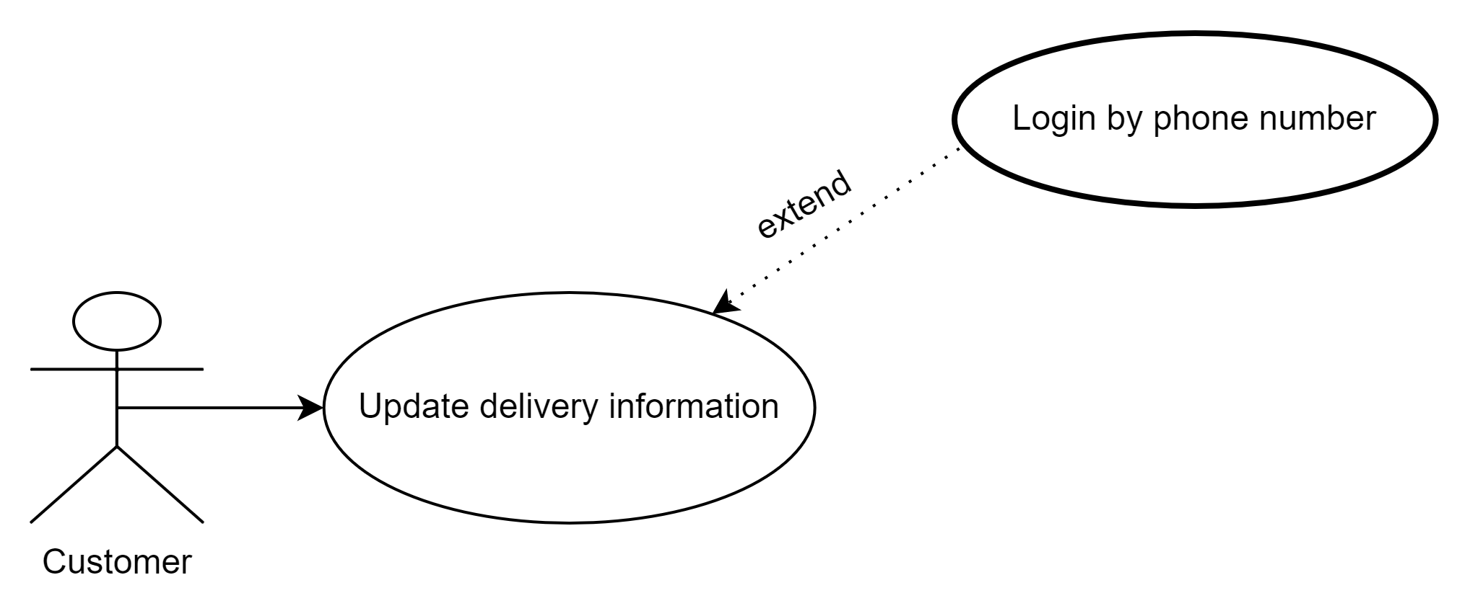

|  |  |
| --- | --- |
| **Use Case** | **Customer update delivery information.** |
| **Short description** | Customers update their delivery information. |
| **Precondition** | The customer searches for an order and clicks on the button “Update delivery information”. |
| **Postcondition** |  |
| **Main flow description** | To be able to start using this function, the user accesses the mobile store website:   1. The customer visits the homepage. 2. The customer clicks on the button “find order”. 3. The customer searches for an order by their phone number. 4. The customer clicks on the button “update delivery information”. 5. The customer input the correct information then submit. 6. System update order and show success message. |
| **Alternative Paths** | **None** |
| **Exception Paths** | **None** |
| **Other** | **None** |

**Diagram: Customer filter products.**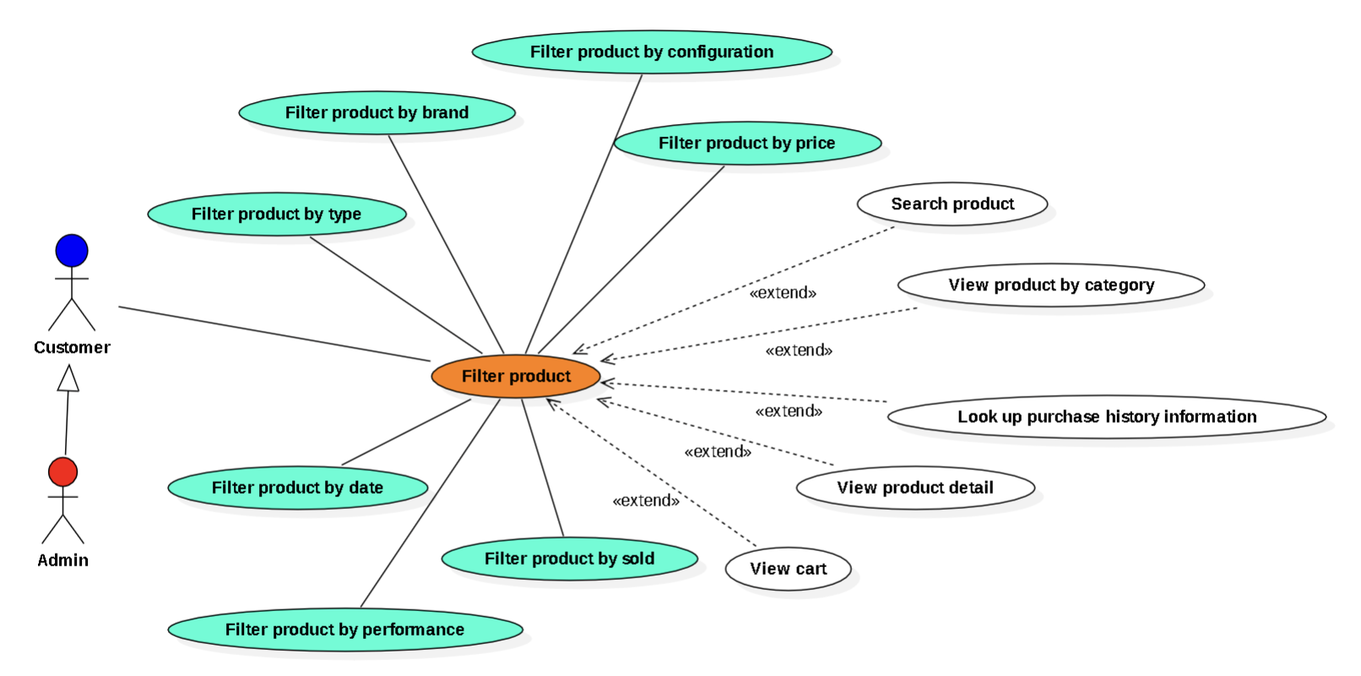

|  |  |
| --- | --- |
| **Use Case** | **Customer filter products.** |
| **Short description** | Customer filter product |
| **Precondition** | Customer is on the product view page by category or product search results page. |
| **Postcondition** | The website must display a list of products that match the criteria the user has selected, or show a not found message . |
| **Main flow description** | To be able to start using this function, the user must visit the product view page by category or product search results page.   1. The customer access home page. 2. The customer visit the view product by category page or search product result page. 3. The customer choose filter criteria such as brand, price, specifications… 4. The website displays a list of products filtered by the criteria that the user has selected. |
| **Alternative Paths** | **None** |
| **Exception Paths** | **None** |
| **Other** | **None** |

**Diagram: Customer view list promotions.**

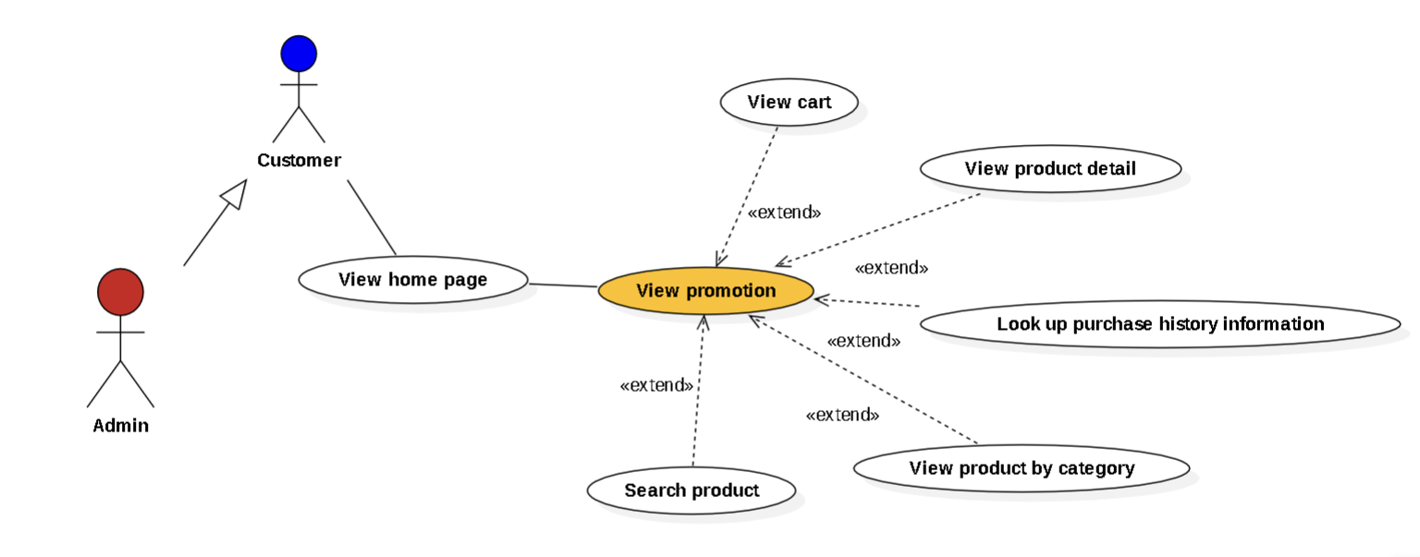

|  |  |
| --- | --- |
| **Use Case** | **Customer view list promotions.** |
| **Short description** | Customer view promotions available. |
| **Precondition** | Customers find discounts. |
| **Postcondition** |  |
| **Main flow description** | To be able to start using this function, the user must visit the mobile store website:   1. The customer accesses the home page. 2. The system displays a list of discount codes available. 3. If there is no discount code that day, the system shows a message “Discount code is currently not applicable. Wishing you a happy shopping”. |
| **Alternative Paths** | **None** |
| **Exception Paths** | **None** |
| **Other** | **None** |

***2.3.3 Mobile World Admin Use Case***

**Diagram: Admin Login.**

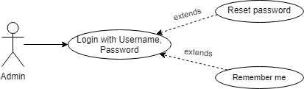

|  |  |
| --- | --- |
| **Use Case** | **Admin login.** |
| **Short description** | Admin can log in to the website to manage product |
| **Precondition** | User has to input on link /admin to access the admin page |
| **Postcondition** |  |
| **Main flow description** | To be able to start using this function:   1. Input on link localhost:8080/loginAdmin. 2. The user must enter the available username and password. 3. Click the button Login. |
| **Alternative Paths** | Users can click the reset password button to clear text.  Users click on the check box remember me to not need to log in for the next time. |
| **Exception Paths** |  |
| **Other** |  |

**Diagram: Admin view product list.**

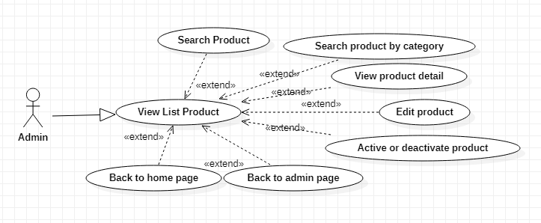

|  |  |
| --- | --- |
| **Use Case** | **Admin to view the products list.** |
| **Short description** | Admin visits products page to see all product |
| **Precondition** | Admin click on the button “View Product” |
| **Postcondition** |  |
| **Main flow description** | To be able to use this function, Admin must accesses the mobile store website:   1. Admin must login to mobile store website 2. Go to Admin page management 3. Click on button “View Product” 4. The website will redirect list off previously added product |
| **Alternative Paths** | **None** |
| **Exception Paths** | **None** |
| **Other** | **None** |

**Diagram: Admin view order list.**

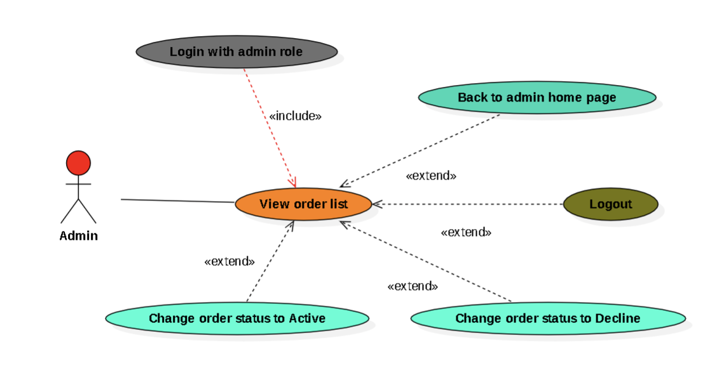

|  |  |
| --- | --- |
| **Use Case** | **Admin view orders list.** |
| **Short description** | Admin visit order management page to view all order and and edit the order status(accept or decline). |
| **Precondition** | Must be login with admin role |
| **Postcondition** |  |
| **Main flow description** | To be able to use this function, Admin must access the mobile store website with admin role:   1. Admin must login to mobile store website. 2. Admin go to order management page by on button “View Order”. 3. The system show all order. 4. Admin can check the box to change order status.   4.1. Default status is “Pending”  4.2. Declined order can't be changed status. |
| **Alternative Paths** | **None** |
| **Exception Paths** | **None** |
| **Other** | **None** |

**Diagram: Admin delete products.**

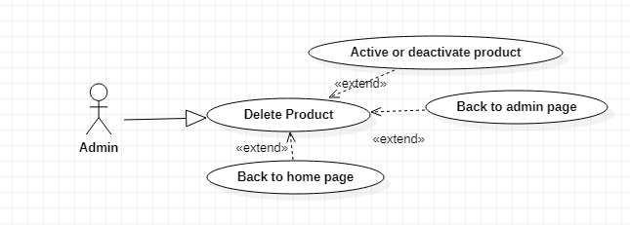

|  |  |
| --- | --- |
| **Use Case** | **Admin delete products.** |
| **Short description** | Admin disable product |
| **Precondition** | Must be login with admin role |
| **Postcondition** |  |
| **Main flow description** | To be able to use this function, Admin must accesses the mobile store website:   1. Admin must login to mobile store website 2. Go to Admin page management 3. Click on button “View Product” 4. Uncheck in Active button 5. Save to complete |
| **Alternative Paths** | **none** |
| **Exception Paths** | **none** |
| **Other** | **none** |

**Diagram: Admin update products.**

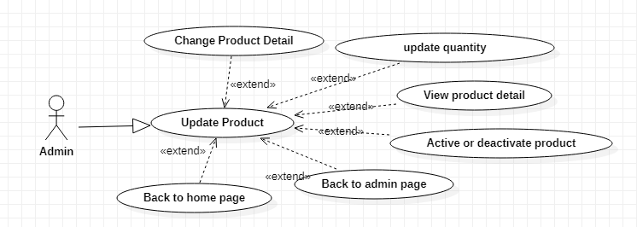

|  |  |
| --- | --- |
| **Use Case** | **Admin update products.** |
| **Short description** | Admin edit detail of product |
| **Precondition** | Must be login with admin role |
| **Postcondition** |  |
| **Main flow description** | To be able to use this function, Admin must accesses the mobile store website:   1. Admin must login to mobile store website 2. Go to Admin page management 3. Click on button “View Product” 4. Click on Edit button 5. Edit detail of product then press “comfirm” button to complete. If they change their mind, select “cancel” |
| **Alternative Paths** | **none** |
| **Exception Paths** | **none** |
| **Other** | **none** |

**Diagram: Admin insert products.**

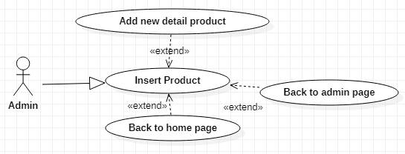

|  |  |
| --- | --- |
| **Use Case** | **Admin insert products.** |
| **Short description** | Admin add new product to store |
| **Precondition** | Must be login with admin role |
| **Postcondition** |  |
| **Main flow description** | To be able to use this function, Admin must accesses the mobile store website:   1. Admin must login to mobile store website 2. Go to Admin page management 3. Click on button “View Product” 4. Click on button “+” 5. Fill out new product information then press “confirm” to complete or “cancel” to cancel. 6. Page will auto send direct to Admin page |
| **Alternative Paths** | **None** |
| **Exception Paths** | **None** |
| **Other** | **None** |

**Diagram: Admin insert category.**

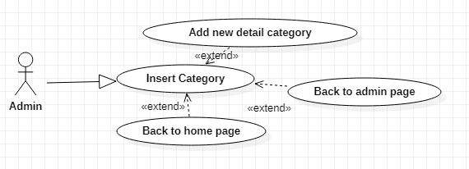

|  |  |
| --- | --- |
| **Use Case** | **Admin insert category.** |
| **Short description** | Admin add new category to store |
| **Precondition** | Must be login with admin role |
| **Postcondition** |  |
| **Main flow description** | To be able to use this function, Admin must accesses the mobile store website:   1. Admin must login to mobile store website 2. Go to Admin page management 3. Click on button “Category management” 4. Click on button “+” 5. Fill out new category information then press “confirm” to complete or “cancel” to cancel. 6. Page will auto send direct to Admin page |
| **Alternative Paths** | **None** |
| **Exception Paths** | **None** |
| **Other** | **None** |

**Diagram: Admin update category.**

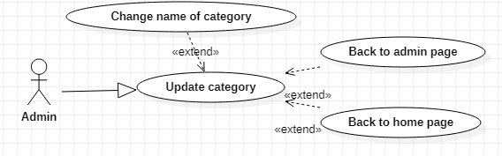

|  |  |
| --- | --- |
| **Use Case** | **Admin update category.** |
| **Short description** | Admin can change name or status of category |
| **Precondition** | Must log in with admin role |
| **Postcondition** |  |
| **Main flow description** | To be able to use this function, Admin must access the mobile store website:   1. Admin must log in to mobile store website 2. Go to Admin page management 3. Click on the button “Category management” 4. Click on the button “Edit” 5. Change name of category then press “confirm” to complete or “cancel” to cancel. 6. Page will auto send direct to Admin page |
| **Alternative Paths** | **None** |
| **Exception Paths** | **None** |
| **Other** | **None** |

**Diagram: Admin delete category.**

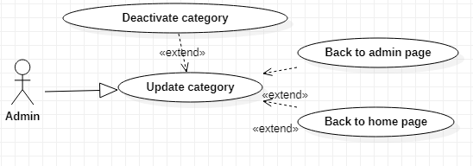

|  |  |
| --- | --- |
| **Use Case** | **Admin delete category.** |
| **Short description** | Admin deactivated category |
| **Precondition** | Must be login with admin role |
| **Postcondition** |  |
| **Main flow description** | To be able to use this function, Admin must accesses the mobile store website:   1. Admin must login to mobile store website 2. Go to Admin page management 3. Click on button “Category management” 4. Uncheck in activated box 5. Press save to confirm 6. Page will auto send direct to Admin page |
| **Alternative Paths** |  |
| **Exception Paths** |  |
| **Other** |  |

**Diagram: Admin edit promotions.**

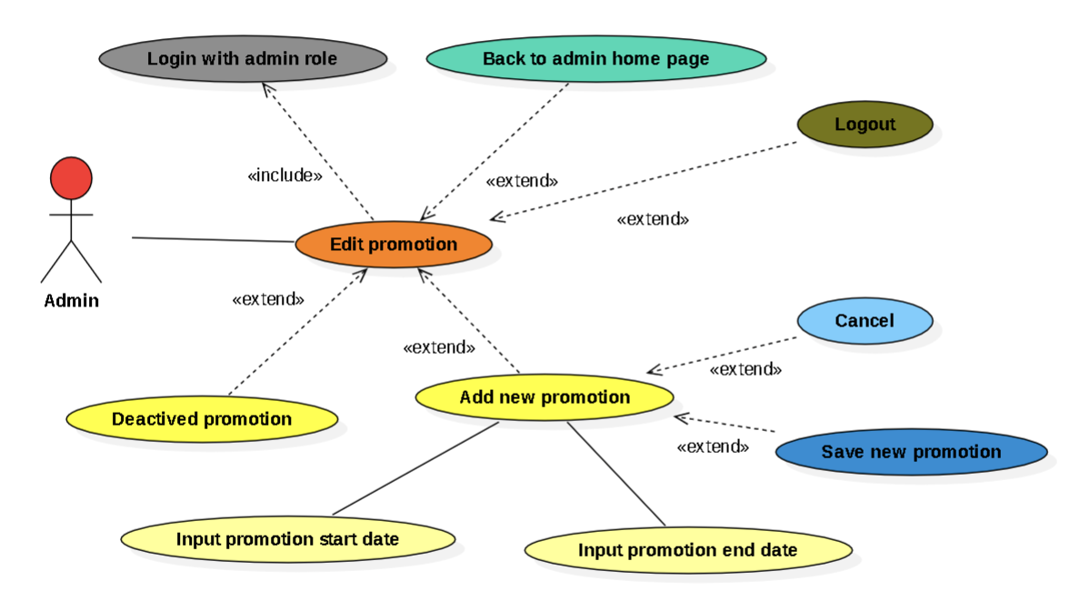

|  |  |
| --- | --- |
| **Use Case** | **Admin edit promotions.** |
| **Short description** | Admin visit promotions management page to edit promotion. |
| **Precondition** | Must be login with admin role |
| **Postcondition** |  |
| **Main flow description** | To be able to use this function, Admin must access the mobile store website with admin role:   1. Admin must login to mobile store website. 2. Admin go to promotion management page by on button “View Promotions”. 3. The system show all promotions 4. Admin can edit promotion   4.1. Admin can click the box “Deactived” to deactivated an actived promotion.  4.2. Admin can click “+” button to add new promotion:  4.2.1. Admin input start day, end day and promotion banner.  4.2.2. Admin click save to save new promotion or click cancel to return the promotions management page. |
| **Alternative Paths** | **None** |
| **Exception Paths** | **None** |
| **Other** | **None** |

**Diagram: Admin logout.**

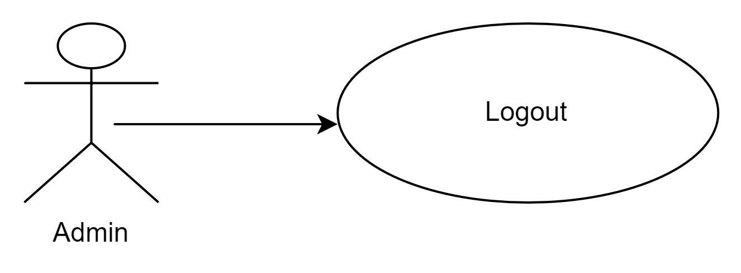

|  |  |
| --- | --- |
| **Use Case** | **Admin logout.** |
| **Short description** | Users can log out to exit the current login account |
| **Precondition** | User must access the admin website. |
| **Postcondition** | The website will return the login page. |
| **Main flow description** | To be able to use this function, the user must access the admin site and then click the logout button. |
| **Alternative Paths** |  |
| **Exception Paths** |  |
| **Other** |  |

**3.0. Entity Relationship Diagram(ERD)**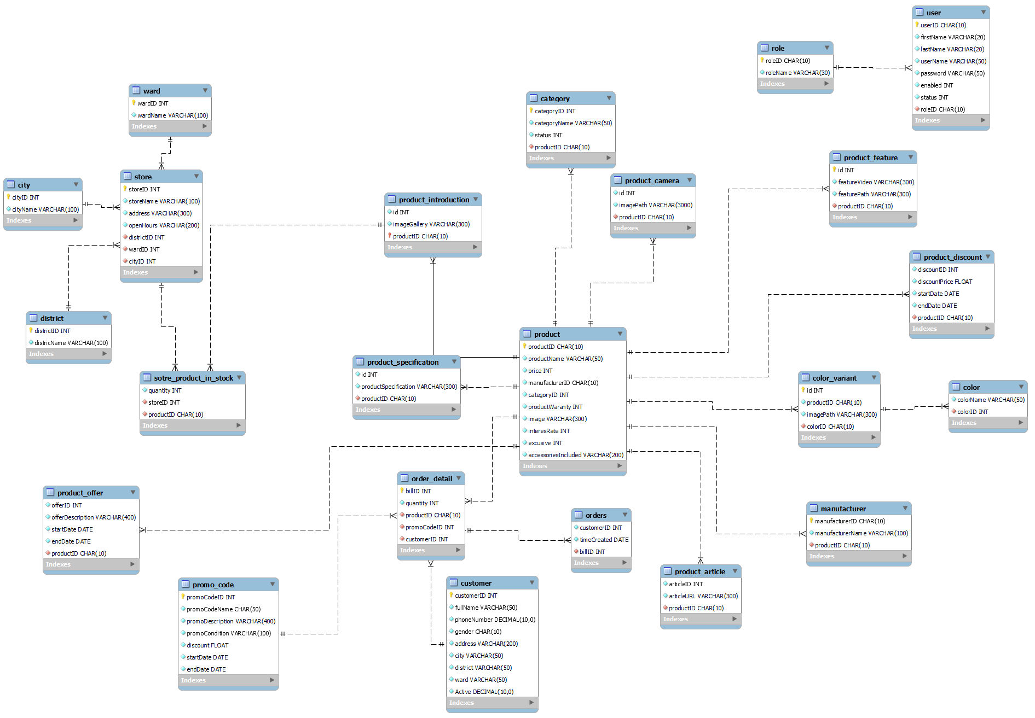

**4.0. Screenflow Diagram**

