Utilize Vietnam Rice Hush Ash For Sustainable Development

Pham Trung Kien*¹⁾, Nguyen Van Tam²⁾, Hirofumi Hinode³⁾
¹⁾Faculty of Materials Technology, Ho Chi Minh City University of Technology (HCMUT)
²⁾R&D Saigon Hi-tech Park (SHTP)
³⁾ Faculty of international development engineering, Tokyo Institute of Technology,
* Corresponding author’s email address: phamtrungkien@hcmut.edu.vn
Keywords: calcium silicate, rice hush ash, hydrothermal treatment, ceramic
Introduction
Vietnam is an agriculture country, in which produce lot of rice and its by product is rice husk ash (RHA). The RHA is consider as waste of agriculture industry, and treated by burn in the open air. This process cause air pollution, thus attracted researcher to find alternative method to reduce the impact of rice husk ash to environment [1-3]. The research group in Department of Ceramic Materials aim to reuse rice husk ash as source of Silica (SiO2) [4-5]. This research present the use of rice hush ash for sustainable development.
Material and Methods
Prepation of Vietnam Rice Husk Ash (VRH): Rice husk is burn at 600ºC with the heating rate of 10ºC/min (Naberthem 1400, Nabertherm, Germany), then soaking at 2 hour for complete burning.
Preparation of CaO: CaO is used from the commercial without purified (Xilong Chemical, China). The phase composition of commercialized CaO using XRD.
Hydrothermal treatment the mixture of VRHA and CaO: The mixture of VRHA and CaO is mixed with the Ca/P molar ratio of 1.0 with the moisture of 10% (weight percent) then pressing at 30 MPa to form the compact disk with diameter of 9mm. The compacted cylinder is hydrothermal treated at 110ºC, 130ºC, 150ºC and 180ºC for 24 hours to obtain calcium silicate and xonotlite.
Results and Conclusions
We can obtain the Xonotlite when burning over 150ºC for 18 hours, as shown on the Figure 1. This Xonotlite with the interlock crystal can be used as thermal insulator.
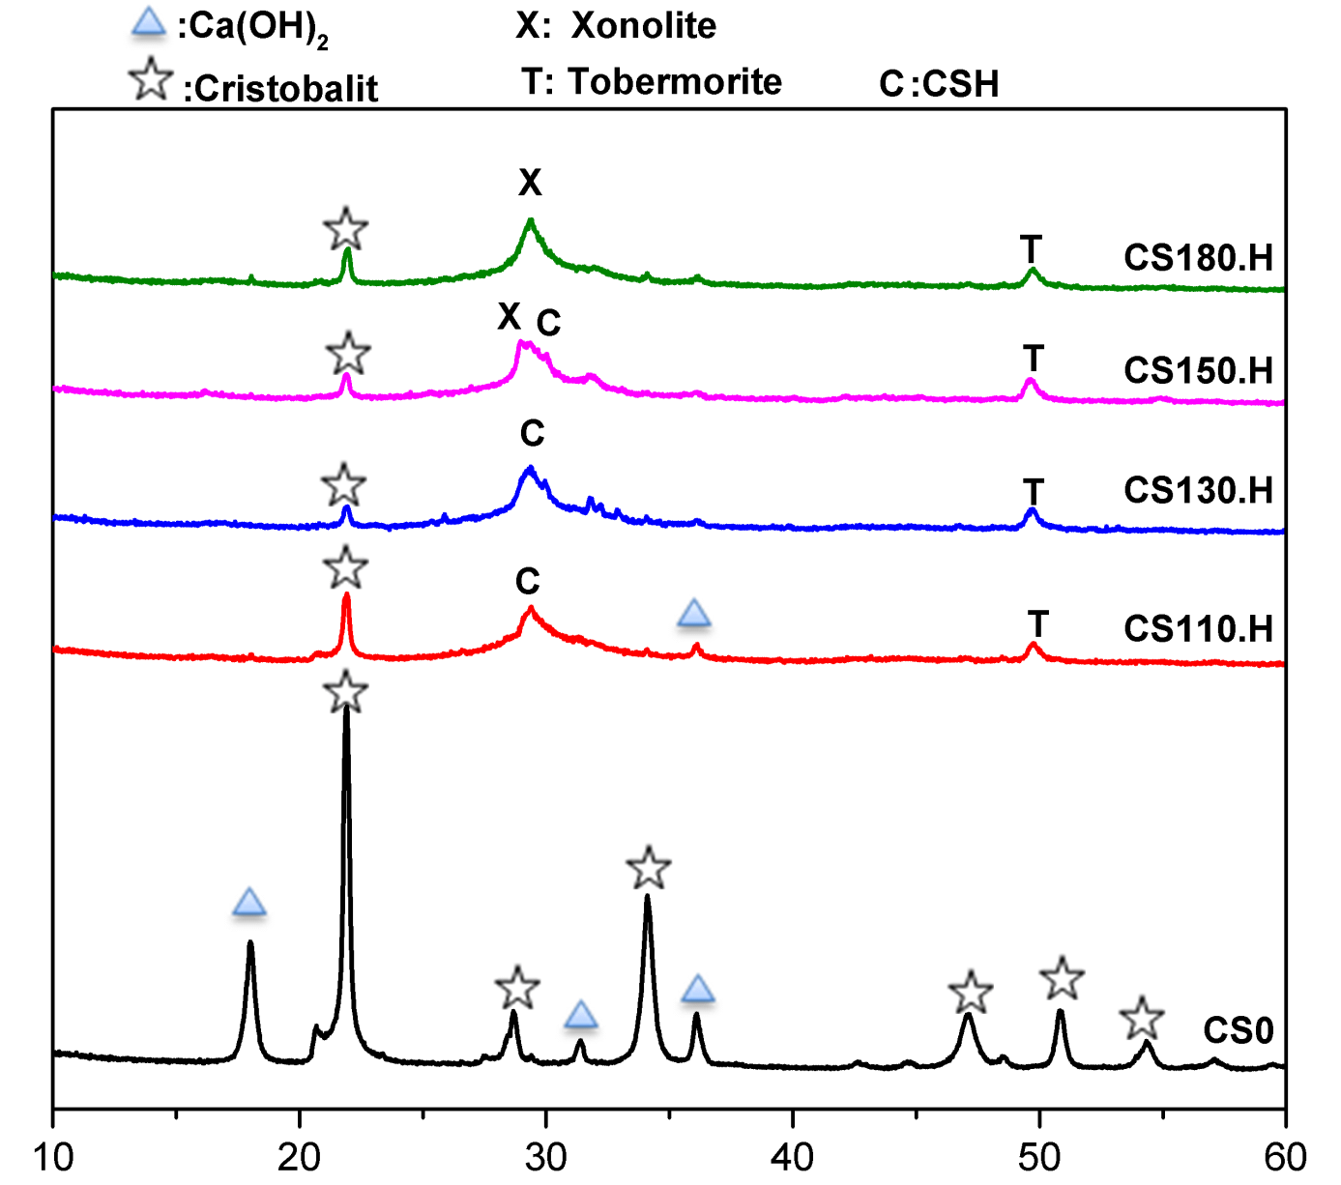
Figure 1. XRD pattern of mixture of VRHA/CaO before and after hydrothermal treatment at different temperature: (a) before; (b) 110ºC; (c) 130ºC; (d) 150ºC and (e) 180ºC. Xonotlite can be obtained when hydrothermal treated at 150ºC for 18 hours.

References
- S. Saadaldin, A. Rizkalla. Synthesis and characterization of wollastonite glass–ceramics for dental implant applications. Dental materials, vol. 30, pp. 364-371, 2014.
- Pham Trung Kien, Nguyen Hoc Thang, Do Quang Minh, Do Minh Hien, S. M. Gallardo, F. T. Bacani, Hirofumi Hinode, Michael Angelo B. Promentilla. Properties and microstructure of geopolymer from red mud, rice husk ash and diatomite. Journal of Science and Technology, vol. 53 (2B), pp. 215-221, 2015.
- Michael Angelo B. Promentilla , Nguyen Hoc Thang, Pham Trung Kien, Hirofumi Hinode, Florinda T. Bacani, Susan M. Gallardo. Optimizing Ternary-blended Geopolymers with Multi-response Surface Analysis. Waste and Biomass Valorization, vol. 7(29), pp. 1-11, 2016.
- Pham TK, Kieu DTK, Do QM, Nguyen HT, Ly HA, Pham TTT. Research on wasted glass as non-firing brick using hydrothermal method. Journal of Science and Technology, vol. 52(4A): 198-204, 2014.
- Pham Trung Kien, Do Minh Hien, Nguyen Hoc Thang, Pham Thi Lan Thanh. Innovation to recycle SiO2-sourced solid waste in Glass and Rice Ash Industry and Society. The 8th Regional Conference on Chemical Engineering in conjunction with The 7th Vietnam National Chemical Congress and The 2nd Vietnam National Chemical Engineering Congress. Ha Noi, Vietnam. 29 Nov – 01 Dec 2015, pp. 304-305.

