Mitigation of methane emission from tropical landfill using different waste cover materials

Rathborey Chan¹⁾, Chart Chiemchaisri*¹⁾, Wilai Chiemchaisri¹⁾
¹⁾Department of Environmental Engineering, Faculty of Engineering, Kasetsart University, Bangkok 10900, Thailand
* fengccc@ku.ac.th
Keywords: Compost; landfill cover; methane oxidation; methanotrophs; stabilized wastes
Introduction

Landfill is unavoidably used for municipal solid waste disposal in most countries. Deposition of solid wastes containing high organic content could create adverse environmental impacts such as leachate and gas production. Methane (CH₄) and carbon dioxide (CO₂) are the major landfill gases producing from landfills and their emissions could accelerate global warming problem. Among them, CH₄ is a greenhouse gas with an infrared activity 25 times that of CO₂ for 100- year time horizon (IPCC, 2007). Landfill is one of the major anthropogenic sources of CH₄. One tone of solid waste could generate approximately from 160 to 250 m³ of landfill gases (Humer and Lechner 1999) consisting of 50-60% CH₄ and 40-50% CO₂.
Among several techniques used for mitigating greenhouse gas emission from landfill, biological methane oxidation is one of the promising methods due to its simplicity in operation and low cost association. Nevertheless, its capacities could be varied widely depending on environmental conditions, e.g. temperature moisture content and oxygen availability. In tropical climate. high temperature could promote methanotrophic activities but the variation of rainfall between rainy and dry seasons may affect moisture and oxygen availability in cover materials for methane oxidation. There is still very limited information on methane oxidation in landfill cover in tropical climate. Thus, the aim of this study is to conducted field measurement of methane oxidation in different cover materials operated at actual solid waste disposal site in Thailand.
Material and Methods
Three lysimeters made of concrete ring with diameter 1.5 m and height of 1 m were used (Fig.1). Each lysimeter was filled with 15 cm of gravel (5 cm diameter) and 60 cm of cover material (either sandy loam, compost or stabilized wastes). The characteristics of cover materials are shown in Table 1. Landfill gas was pumped at a constant rate and supplied at the bottom of the lysimeters Gas samples were collected from different depths (0, 20, 40 and 60 cm) of cover material layer once a week and analyzed for CH₄, CO₂ and O₂ content using gas chromatography (GC 6890). Leachate was irrigated to maintain appropriate moisture content in each material (10-15 % for sandy loam and stabilized waste, 50-55 % for compost) as suggested in our previous research (Chiemchaisri et al., 2010). The leachate contained average BOD of 150 mg/l, COD of 1725 mg/l, TKN of 68 mg/l, NH₄⁺ of 4.5 mg/l, NO₃⁻ of 4.64 mg/l, NO₂⁻ of 1.64 mg/l, EC of 259 mg/l, and pH of 8.76. Fluorescence in situ hybridization (FISH) techniques were used for investigating methanotrophic microorganisms. Methane removal rate (MRR) of cover materials can be determined from following equation:
MRR (mole/m³.d) = Q[(CH₄)_{in} – (CH₄)_{out}]/V Eq.1
where Q = gas flow rate (m³/d); (CH₄)_{in} and (CH₄)_{out} = inflow and outflow methane concentration (g/m³); V = volume of cover material (m³).
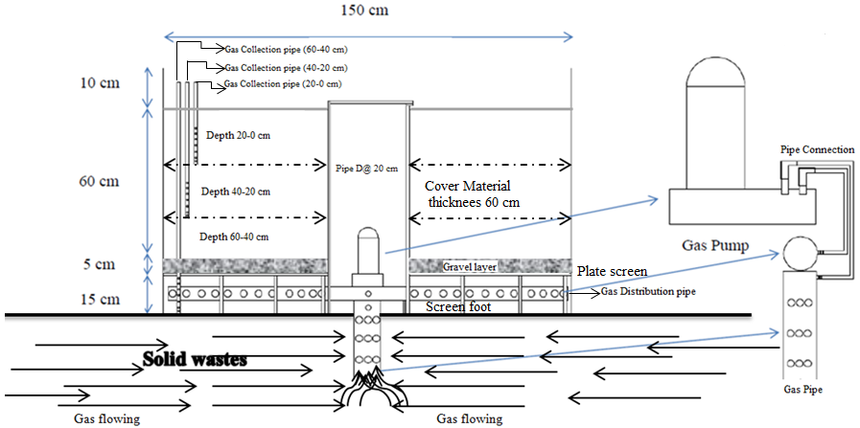
Figure 1 Schematic of experimental lysimeter

Table 1 Characteristics of cover materials
Parameters | Sandy Loam | Compost | Stabilized Waste
pH  EC (µs/cm)  Bulk density (kg/m³)  Porosity (%)  TOC (%)  NH₄⁺-N (mg/l)  NO₃⁻-N (mg/l)  PO₄⁺-P (mg/l)  TN (mg/kg) | 7.27  1,766  1,178  55.50  0.16  1.38  16.35  0.43  0.09 | 7.12  1,206  596  77.52  29.99  4.74  5.54  1.08  0.18 | 6.80  285  189  75.45  71.13  0.6  57.93  6.11  0.15
Results and Conclusions
During the experimental period, methane loading rate (MLRs) varied from 13.68±0.4 to 20.26±0.9 molCH₄/m³.d (Table 2). Average methane MRRs of all materials were greater at 60-40 cm than that of upper zone of lysimeters. Average MRRs of compost, stabilized wastes, and sandy loam at 60-40 cm depth were 10.14 ± 0.9, 7.79 ± 0.5 and 11.38 ± 0.8 molCH₄/m³_{CM}.d, equivalents to 67.2, 56.9, and 55% removals, respectively. Moreover, the remaining untreated gas was subsequently removed at the upper zone of the cover material but at much lower extent. Average MERs were 0.078±0.01, 0.075±0.01, and 0.092±0.02 mol CH₄/m³.d in compost, stabilized wastes, and sandy loam, respectively.
Table 2 Average methane loading and removal rates in each lysimeter
Sample | MLR (mol CH₄ /m³.d) |  |  | MRR (mol CH₄/m³.d)
Sample | C | SW | SL | C | SW | SL
Surface emission | - | - | - | 0.078±0.01 | 0.075±0.01 | 0.092±0.02
20-0 cm | 1.35±0.2 | 0.95±0.05 | 1.47±0.1 | 0.96±0.2 | 0.57±0.1 | 1.00±0.1
40-20 cm | 5.15±0.7 | 5.84±0.2 | 8.88±0.6 | 3.87±0.6 | 4.90±0.2 | 7.41±0.5
60-40 cm | 15.33±1.2 | 13.68±0.4 | 20.26±0.9 | 10.14±0.9 | 7.79±0.5 | 11.38±0.08

The cover material were sampled and tested for methanotrophic activities. Methane oxidation rates (MORs) were determined from CH₄ reduction against time in test vials. From the test, it was found that sandy loam had highest MOR at the top zone of lysimeter (20-0 cm) at 1.3 µmole CH₄/kg dry soil.h, while stabilized waste and compost had relatively similar activities in all depths at 0.13 to 0.2 and 2.09 to 2.49 µmole CH₄/kg dry soil.h, respectively. The results implied that methane removal could be proceeded mainly via methanotrophic activities. Methanotrophic microorganisms containing in the cover materials were analysed as shown in Table 3. It was found that methanotrophs type I which preferred oxygen-rich condition presented similarly at almost all depths of compost and sandy loam whereas methanotrophs type II which preferred methane-rich condition was mostly found at lower depth of those materials. For stabilized wastes, both types of methanotrophs were found at lower depth. Distribution profile of methanotrophic microorganisms in the lysimeter suggested higher population of methanotrophs type I and methanotrophs type II.

Table 3 Methanotrophic microorganisms (cell x 10⁶/g dry solids) presented in cover materials
Depth (cm) |  | Type I |  |  |  |  |  | Type II
 | C |  |  | SW |  | SL |  | C |  | SW | SL
0-20 |  | 24.2 | 13.3 |  | 36.1 |  | 19.9 |  | 9.7 |  | 16.9
20-40 |  | 28.7 | 13.8 |  | 35.5 |  | 24.9 |  | 14.7 |  | 17.2
40-60 |  | 24.9 | 19.6 |  | 34.6 |  | 23.6 |  | 16.9 |  | 25.1
References
Chiemchaisri C., W. Chiemchaisri, K. Chittanukul, W. Soontornlerdwanich and N.Tanthachoon (2010),.Effect of leachate irrigation on methane oxidation in tropical landfill cover soil, J. Mater. Cycles Waste Manage. 12, 161-168.
Humer M. and P. Lechner (1999), Alternative approach to the elimination of greenhouse gases from old landfills, Waste Manage Res., 17, 443-452.
IPCC (2007), Climate Change 2007: Working Group I: The Physical Science Basis, Intergovernmental Panel on Climate Change, Cambridge University Press, U.K.

