Industrial wastewater treatment in a constructed wetland utilizing Canna X Generalis

F.C. Ballesteros, Jr.* & Heidi T. Antonio
Environmental Engineering Program
University of the Philippines Diliman

* Corresponding author: fcballesteros@up.edu.ph
Keywords: natural systems; wetland; Canna X Generalis
Introduction
In view of relatively high cost of constructing wastewater treatment plants and the associated operating and maintenance cost, there is a need for a more suitable solution for treating waste in rural areas where capital is not readily available but space is not a limitation. In recent years natural treatment systems have become an increasingly popular treatment option owing to its low cost, easy maintenance and minimal requirement for technical expertise. One example of a such treatment process is a constructed wetland. In this study, wastewater from an automotive parts manufacturing plant whose wastewater is characterized by high concentration of oil and grease, COD, and TSS was studied for treatment in a constructed wetland system.
Material and Methods
Four vertical subsurface flow constructed wetlands were designed, which were composed of cylindrical plastic drums (diameter of 30 cm; height of 90 cm) that were utilized to treat industrial wastewater in parallel experiments. As shown in figure 3.2, the four CWs units had various set-ups. The porous media is composed of the following (from lower layer to upper layer): (a) layer of washed cobbles that would serve as drainage, 15cm thick (D50 = 90 mm); (b) medium washed gravel that is 10 cm thick (D50 = 25.4 mm), (c) layer of fine gravel that is 25 cm thick (D50 = 10 mm), and (d) layer of white sand that is 30 cm thick (D50 = 0.5 mm), where total thickness of 80.0 cm.
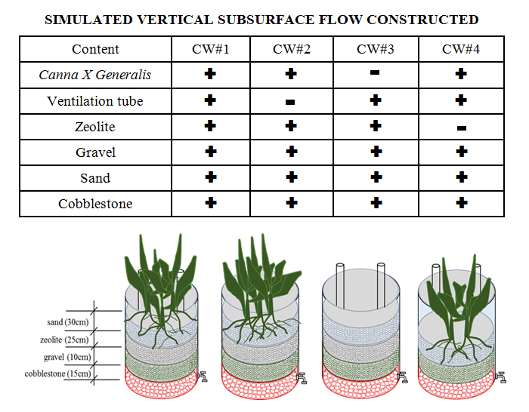

Figure 1. Experimental set-up

Results and Conclusions
This research provides some answers the effectiveness of a vertical subsurface flow CWs system in treating MRA wastewater planted with Canna X Generalis. The four constructed wetland units had various set-ups (with & without Canna X Generalis, with & without zeolite, with & without air vent) to determine the effect of the treatment efficiency are discussed below:
The presense of Canna X Generalis increased the removal efficiency of COD from 84.3% to 93.4%. TSS removal efficiency from 86.46% to 90.67%. Bioaccumulation of aluminum in Canna X Generalis was observed in its roots, shoots and leaves. Canna X generalis has several important roles in the treatment of the MRA wastewater: (1) serves as physical filter and enhances sedimentation of particulate matter and suspended solids; (2) adsorbs soluble organic contaminants; (3) serve as support for biofilm formation and niche for microbes; and (4) provides oxygen through its roots and leaves to the aerobic microbes that facilitates in the degradation of organic contaminants.
The presence of ventilation tube causes removal efficiency of COD to increase at from 86.55% to 93.35%. An increase in TSS removal from 84.46% to 90.67%. In addition, aluminum has an improved removal efficiency from 65.98% to 73.19%. The presence of ventilation tube has no significant effect on the removal of oil and grease, which was constant at 97.99%. The presence of ventilation indicates artificial aeration to the constrcuted wetland system, which indicates additional supply of oxygen as well as improved oxygen transfer. This in turn enhances the microbial biodegradation and transformation of COD and other organic matter in the wastewater.
Among the four set-up of CWs, CW#1 demonstrated the most satisfactory performance with significant removal efficiency of 93.35% for COD, 90.67% for TSS, 97% for oil and grease, and 73.19% for aluminum.

Bibliography
Adamus, Paul R, and D Ph. 2006. “Wetlands of Island County , Washington Profile of Characteristics , Functions , and Health.”
Alturkmani, Abdulrzzak. 2015. “Industrial Wastewater.” Industrial City of Hassia, Homs - Syria. Accessed February 2. doi:10.1016/S0167-9244(07)80011-4.
Bindu, T., Sylas V.P., Mahesh M., Rakesh P.S., Ramasamy E.V. 2008. "Pollutant removal from domestic wastewater with Taro (Colocasia esculenta) planted in a subsurface flow system." Ecological Engineering 33:68-82.
Carballeira, T., Ruiz, I., Soto, M. 2016. “Effect of plants and surface loading rate on the treatment efficiency of shallow subsurface constructed wetlands”. Ecological Engineering 90:203-214.

