Solid Waste Management for Boracay Island, Philippines

C. J. M. Razon*¹⁾, M. A. N. Tanchuling²⁾, initials then surnames, separated by commas
¹⁾ Environmental Engineering Program, University of the Philippines Diliman
²⁾ Environmental Engineering Program, University of the Philippines Diliman
* cjmrazon@gmail.com
Keywords: SWM; tourism; solid waste
Introduction
One of the environmental impacts of coastal tourism is the environmental degradation due to unmanaged solid wastes. This is evident in Boracay Island which is considered as one of the beach destinations in the Philippines and in the world and thus has been attracting a large number of tourists. With the growth in the tourism industry, solid wastes generated also increase. Hence, it is necessary that this is managed well to ensure sustainability in the tourism industry. The purpose of the study is to determine waste generation rates in Boracay Island, taking into account contributions of tourists. There is no study in the Philippines quantifying the waste generated by tourists. Recommendations to improve the current waste management system are also discussed. This study is useful for the many other islands in the Philippines, which have been steadily attracting tourists.
Material and Methods
Solid waste quantities are derived from waste analysis and characterization studies (WACS) as recommended by the National Solid Waste Management Commission’s national solid waste management strategy of 2012 – 2016. Activities include planning and mobilization, waste quantity analysis, waste composition study and bulk density analysis.
Results and Conclusions
An average volume of 307.88 m³/day of waste is generated by residents and tourists in the island. It must be noted that waste diversion schemes were present prior to disposal. The waste in Boracay Island is mainly composed of food waste and residual wastes. In Figure 1, over 80% of the composition is covered by the food and residual waste components. The garden waste component is made up of leaves (7%), twigs and wood (2%). The recyclable component is lowest (6%) which may be accounted to the diversion schemes before disposal. Majority of the wastes in Boracay are food wastes from restaurants, markets, and other establishments, followed by residual wastes which include used tissue paper and food packaging such as foil and film plastic. In obtaining Boracay Island’s bulk density, the volume contribution of each barangay was factored in the calculation. The island’s bulk density is 371.96 kg/m³.
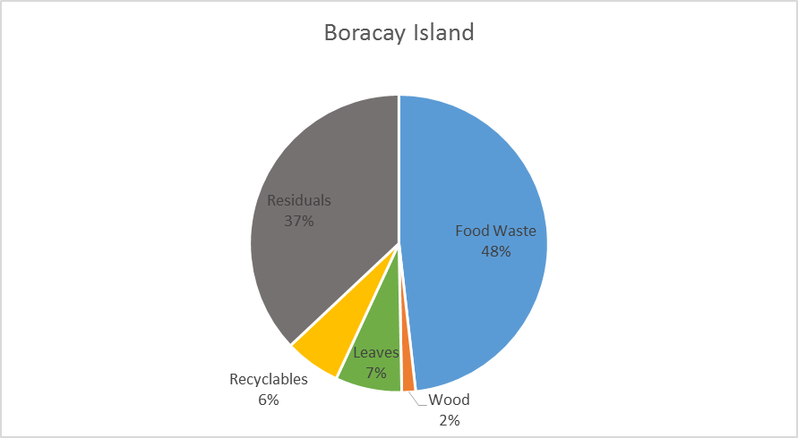
Figure 1 Waste Composition of Boracay Island accounting the weighted contribution of barangays (%wet wt.)
The density may be greatly affected by food wastes from the market, presence of coconuts, wood, and glass bottles in the area. Findings show that the average waste generation rate in Boracay Island is 1.68 kg/cap-day. Residents in Boracay produce 0.41 kg/cap-day while tourism related industries (hotels, markets and other commercial establishments) produce 4.88 kg/cap-day on the average. Waste composition of the tourism related industries compared to households are shown in Figure 2 below which suggests that most recyclables are found in tourist areas, and that majority of food wastes and biodegradable wastes are found in restaurants and households. Table 1 shows that values obtained are within range compared to other studies. Recommendations to improve the current SWM system is found in Table 2.
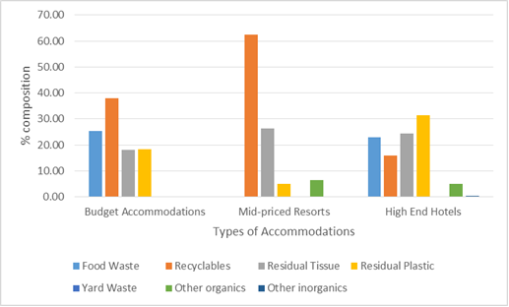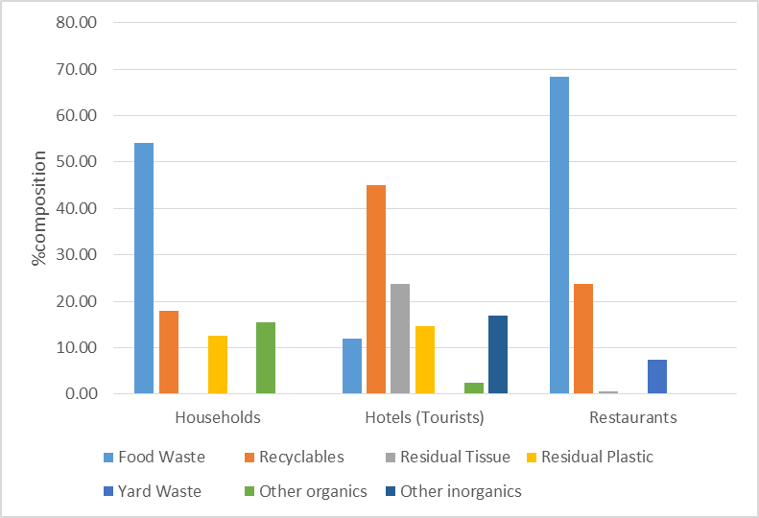
Figure 2 Comparison of waste composition for tourist waste sources and households in Boracay
Table 1. Comparison from related literature
Boracay, Philippines  (Razon et al, 2017) | Green Island, Taiwan  (Chen et al, 2004) | Menorca Island, Spain  (Mateu-Sbert, et al, 2013) | Island of Crete  (Gidarakos et al, 2005)
Locals: 0.41 kg/cap-day | Locals: 1.21 kg/cap-day (1991-2001) | Local: 1.48 kg/cap-day | Locals: 0.8 – 1.2 kg/cap-day
Tourists: 4.88 kg/cap-day | Tourists: 3.91 kg/cap-day (2000-2002) | Tourist: 1.31 kg/cap-day | Tourists: 1.2 kg/cap-day

Table 2. Issues in the current SWM in Boracay and recommended strategies
Problematic Section | Gaps and Issues | Recommended Strategies | Remarks
Collection/Monitoring | Lack of monitoring arm – mixed waste at collection points  Old trucks filled above capacity | Intensify monitoring prior to collection & provide training to SWM staff  Acquisition of new trucks to minimize risks
In-Island Disposal and Waste Management | Lack of equipment,  Poor data* recording,  Sorting on site can be improved | Acquisition of backhoe  Provide training to MRF staff
Waste Diversion | Junkshops (PET bottles and cans only, not recorded entirely)  Livestock feed (food waste, not recorded) | Increase efficiency of sorters by providing training and incentive | Minimal waste diversion means greater volume of waste STAYING in the island
Waste Utilization | Crushing of glass for pavement;  Glass bottles as non-load bearing walls;  Composting of food waste (Brgy. Balabag, unrecorded) | Minimize influx of beverages with bottles that are not saleable;  Invest in better facilities to address food waste disposal (ex. anaerobic digester); | Minimal waste utilization means greater volume of waste STAYING in the island
References
ADB, Technical Assistance Consultant’s Report: Solid Waste Management Sector Project, December 2014

Chen, MC, Ruijs,A., Wesseler, J., Solid waste management on small islands: the case of Green Island, Taiwan, Resources, Conservation and Recycling, Volume 45, Issue 1, September 2005, Pages 31-47, ISSN 0921-3449

Gidarakos, E., Havas, G., Ntzamilis, P., Municipal solid waste composition determination supporting the integrated solid waste management system in the island of Crete, Waste Management, Volume 26, Issue 6, 2006, Pages 668-679, ISSN 0956-053X

Huttche, C. M., White, A.T., Flores, M. M. 2002, Sustainable Coastal Tourism Handbook for the Philippines, Coastal Resource Management Project of the Department of Environment and Natural Resources and the Department of Tourism, Cebu City, Philippines, 144 p.

JICA, Master Plan on Solid Waste Management for Boracay Island and Municipality of Malay, 2007

Mateu-Sbert, J., Ricci-Cabello, I., Villalonga-Olives, E., Cabeza-Irigoyen, E., The impact of tourism on municipal solid waste generation: The case of Menorca Island (Spain), Waste Management, Volume 33, Issue 12, December 2013, Pages 2589-2593, ISSN 0956-053X

