Stochastic Storm Surge Modelling in the Philippine Archipelago
using ADCIRC+SWAN

J. B. Rayo, V. A. Boñgolan *
Department of Computer Science
University of the Philippines Diliman
*vabongolan@dcs.upd.edu.ph
Keywords: storm surge modelling; ADCIRC, SWAN, stochastic Navier-Stokes, typhoon Haiyan
Introduction
The Philippines is a typhoon-prone archipelago in Southeast Asia and about 20 typhoons affect it every year. Typhoon Haiyan brought devastating effects particularly in Tacloban City. More than 6,000 people are confirmed dead and 1.14 million houses damaged (Lagmay, Agaton, et. al. 2015). Unfortunately, storm surge simulations from different agencies are not completely consistent When water enters shore, the model should also consider random forces exerted by debris and in consequence this dynamical system introduces random fluctuations and turbulence.
This research aims to tailor a model for the use of the Philippines and designing it to compute fast enough and give real-time storm surge predictions around the country. To incorporate random fluctuations and external forcing on the surge and to account for errors in bathymetry and storm profile, modification of coupled ADCIRC+SWAN model is needed to give more realistic storm surge simulations. The paper published by Menaldi and Sritharan (2002) proved the existence and uniqueness of strong solutions for 2D SNS with Gaussian space-time white noise in bounded and unbounded domains. Moreover, using SNS reduces the number of physically invariant solutions of the deterministic problem. According to Flandoli (2016) additive noise is used in turbulence investigation when the energy balance is under control and the average energy injected to the system is a priori known. A weak solution of SNS satisfies a particular energy inequality. Having these recent results paved the way for pursuing this new method hoping that it will produce a more realistic model and more accurate results.
Material and Methods
Modification of the source code was necessary to include additive forcing of Gaussian random variable with variance 10^-3 as a user input. The finite element mesh of domain (Tacloban City and San Pedro Bay) was made through Battri tools (Bilgili and Smith, 2000) from SRTM30 (30 arc sec) for bathymetry data and SRTMGL1 (1 arc sec) for topography data (see figure 1). The wind profile of typhoon Haiyan was obtained from Joint Typhoon Warning Center as another input to the model. The storm surge phenomena was simulated from Nov 07 2013 18:00:00 UTM in 0.4 days. Using parallel computation the simulation time took around 330 seconds. Time series graphs will be compared with the eyewitness accounts gathered by Switzer, Villanoy, et. al. (2015) to verify the model’s correctness of the model in terms of peak elevation heights and timings when water levels rose and fall.
Results and Conclusions
FINAL REPORT for 20 stations
RMSE 1.950510
No of stations with error <= 0.50 m: 5
No of stations with error <= 1.00 m: 5
No of stations with error <= 2.00 m: 3
No of stations with error >= 2.00 m: 7

In validating the eyewitness accounts the authors obtained the following results. On all the simulated points only three agrees with the timing from eyewitness accounts. In using the stochastic model the variance of the noise should stay small O(10^-3) to make the simulation stable. Difference in water levels are in O(10^-2) compared to the deterministic case. Surface elevation contours still show coherent structures; there are no noticeable isolated patches (see Figure 2). The surface elevation curves with respect to a simulated point are still smooth because the coupled model implements an analog of predictor-corrector algorithm in computing the surface elevation (see Figure 4).

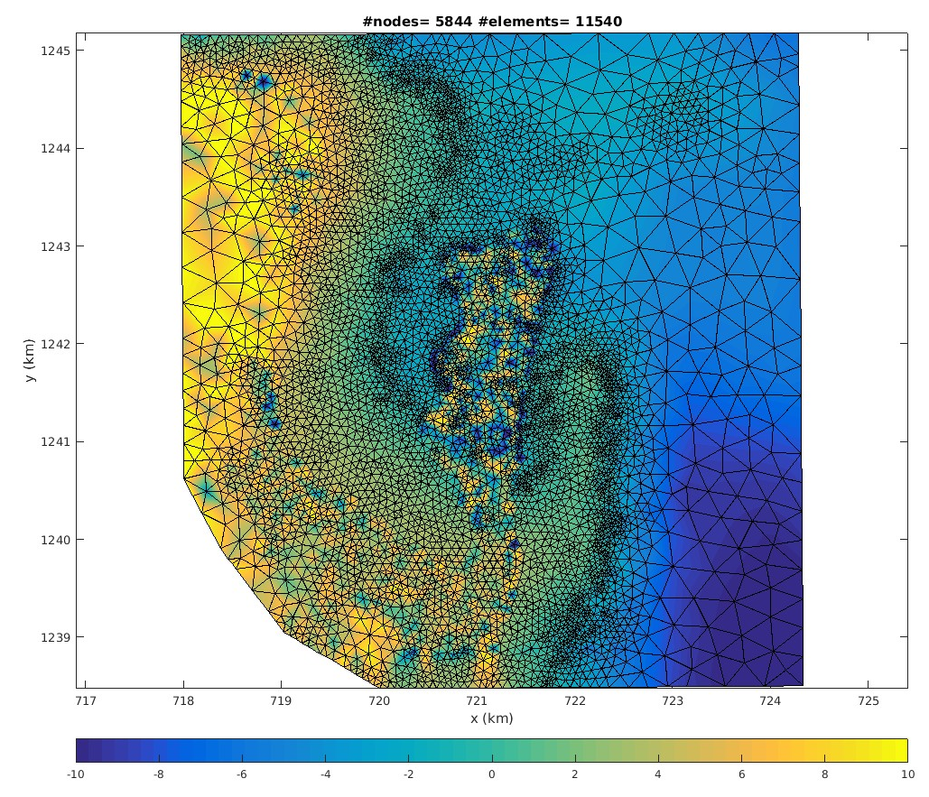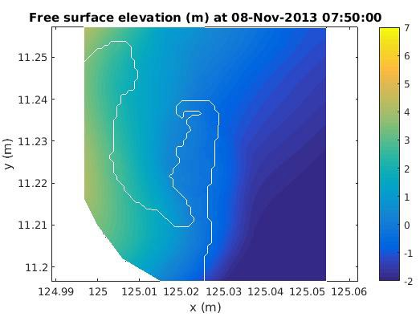
Figure 1 (left). The finite element mesh of domain. The land mass at the center represents the Tacloban Airport. The water body on the right is San Pedro Bay. Adaptive meshing makes elements smaller towards the shoreline (see Figure 2).

Figure 2 (right). The storm surge elevation heights as simulated by the stochastic model. The bathymetry is shallow and coastline curvature was almost perpendicular to the path of the storm causing water levels to increase up to 5 meters.

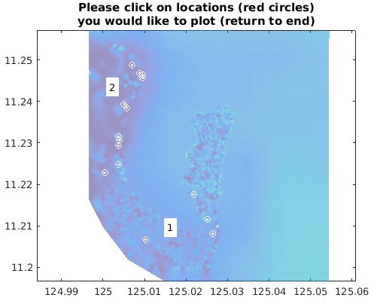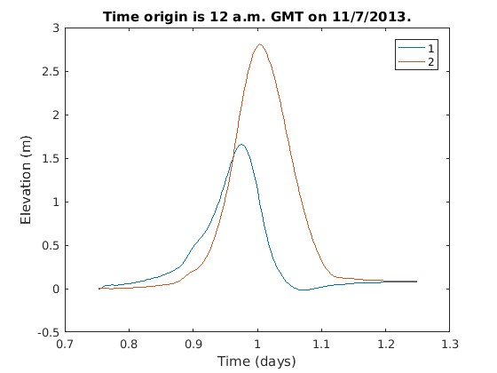
Figure 3. The surge heights as time series graphs (right) for two points chosen (left). As typhoon Haiyan moves from right to left below Tacloban city, the points on the right of land mass (see Figure 3) first experienced the maximum surge based from eyewitness accounts. The peak surge happened around Nov 8 2013 08:00 UTC+8. In this regard, the graph shows consistency with respect to eyewitness accounts.
References
Lagmay, A., Agaton, R. et. al. (2015), Devastating Storm Surges of Typhoon Haiyan. International Journal of Disaster Risk Reduction 11, 1-12.
Menaldi, J. and Sritharan, S. (2002), Stochastic 2-D Navier-Stokes Equation. Applied Mathematics & Optimization 46, 30-31.
Flandoli, F. (2016). Remarks on Stochastic Navier-Stokes Equations. Mathematical Paradigms of Climate Science 51-65.
Bilgili, A. and Smith, K. (2000). Battri 2D Triangular Grid Generator. Numerical Methods Lab, Dathmouth College.
Switzer, A., Villanoy, C., et. al. (2015). Repeat Storm Surge Disasters of Typhoon Haiyan and its 1987 Predecessor in the Philippines. American Meteorological Society 97, 31-48.

