Correspondence of a newly-developed test kits with standard methods
Thu Hien Nguyen*, Bich Thuy Ly*, Quang Diep Le*, Dung Nghiem Trung*, Hidenori Harada**, Tashuya Togo***
*Hanoi University of Science and Technology
** Graduate School of Global Environmental Studies, Kyoto University
*** Optex Co., Ltd
Keywords: Water quality; WATER it, water analysis
Introduction
For an effective environmental management, quick and accurate test is necessary for monitoring at a wide spread space and time. In this research, a comparison of Optex Company’s test kits named WATER it (WI) with standard methods (STD) has been done. The correlation between two methods is also given. Consequently, these results have proved the accuracy and adaptability of "WATER IT" for measurement of parameters such as COD, NH₄⁺, PO₄³⁻, NO₂⁻, and NO₃⁻ in water samples of Vietnam with a certain required improvement.

Material and Methods
Four sample sites, the Cau River (Thi Cau Bridge, Hoa Long, Dap Ba Da) and Nui Coc Lake had been chosen to carry the test for the correlation between COD, NH₄⁺, PO₄³⁻, NO₂⁻, NO₃⁻ obtained by the WI and STD in 8 sampling times from November 2016 to March 2017. Besides, TSS, T - N, T - P, color, UV- absorbing organic constituents (dissolved), UV- absorbing organic constituents (total) were measured by standard method for more insight explanation.
Results and Conclusions
For the samples range of 2-24/0-0.6/0.5-4.5/0.05-0.5/0.1-0.23 mg/L the correlation coefficients were 0.93/0.95/0.99/0.94/0.98 for COD, PO₄³⁻, NO₂⁻, NO₃⁻, NH₄⁺, respectively (Figure 1.1). The results used for this comparison were of samples that did not have high turbidity nor were not out of the measure range of WI. The reason that absolute values of samples measured by WI and STD were slightly different was because during this test we did not use standard to calibrate WI test kits. Therefore, a high correlation between WI and STD is the main emphasis of this research.
The repeatability of a sample measured by a Water IT device was quite good for NO₂⁻, NO₃⁻. However, for COD, NH₄⁺ and PO₄³⁻, the repeatability was unstable for some samples (two devices and one sample measured 2-3 times). For high turbidity samples, setting the machine to zero value was difficult, the machine did not receive measurement. To overcome this problem, it is necessary to filter or centrifuge samples before analysing. Therefore, the obtained results are not accurate as dissolved WI results was smaller than the STD’s one. Those primary results showed that WI has high potential to apply to measure water conditions in Vietnam even thought, some optimization of the products need to carry on for a better and larger application range of water.

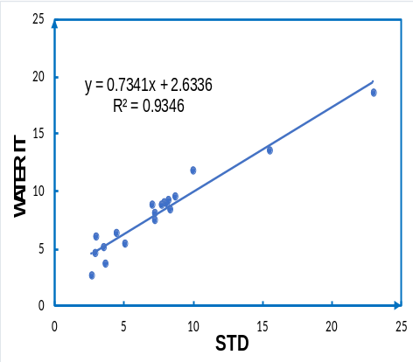 | 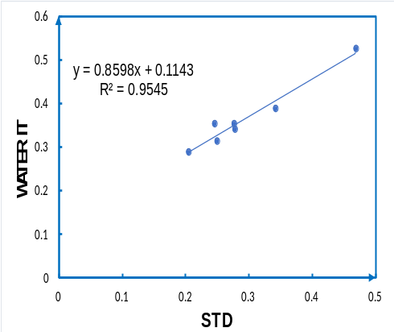
(a) | (b)
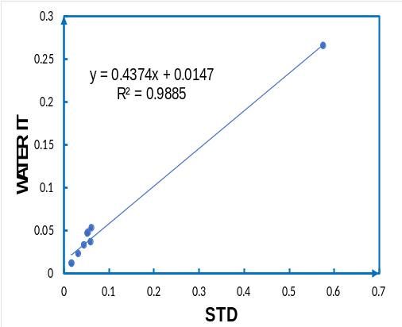 | 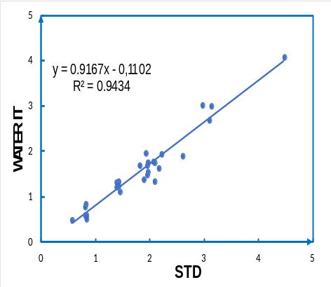
(c) | (d)
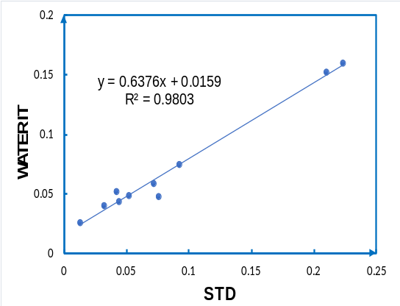
(e)

Figure 1.1. The correlation between STD and WATER it
(a): COD; (b) PO₄³⁻; (c) NO₂⁻; (d) NO₃⁻; (e) NH₄⁺, mg/L

