**Geology and engineering properties of zeolitic rock for geo-environmental application**

*Wawan Budianta*1, Luthfi Effendi1, Hirofumi Hinode2*

*1)Dept. of Geological Engineering, Universitas Gadjah Mada*

*Yogyakarta, Indonesia*

*2) Tokyo Institute of Technology, Japan*

*\*wbudianta@ugm.ac.id*

**Keywords:** zeolitic rock; geology; geotechnical

Introduction

Natural zeolites occur in different geological settings as rock-forming minerals in many locations in the world. In Tegalrejo area, Gunungkidul District, Yogyakarta Province, Indonesia. Natural zeolite in this study area has been exposed and appeared as tufaceous zeolite or zeolitic rock. The zeolitic rock in study area was investigated both in geological and geotechnical aspect. The use of natural zeolite for geoenvironmental and geotechnical application has been investigated by several reseachers (Aksoy, 2010; Ören, et al, 2013; Ören, et al, 2011)

Material and Methods

A. Field methods and laboratory work

Detailed geological map in 1:25.000 scale and stratigraphical sections were conducted. Detailed geological mapping of the study area was undertaken, concentrating on the origins of the zeolitic rock were discovered. Thicknesses of the zeolitic unit in different places have been measured in order to interpret their lateral distribution. Representative sample was taken in the study area for analysis. In this study, the zeolitic rock sample were tested to determine on mineralogical and geotechnical aspect. The zeolitic rock samples has been crushed to obtain fine grain size. Mineralogical test include X-ray powder diffraction analysis and cation exchange capacity (CEC). Geotechnical test was conducted including grain size, consistency limits and permeability test. Permeability test was conducted by using falling head method. Tap water was used as the permeant during the hydraulic conductivity tests. These geotechnical index properties could be used to help explain geotechnical engineering behavior.

B. Geological setting

The zeolitick rock in study area as part of Kebo-Butak Formation of Southern Mountain regional. This Formation is composed of conglomerates, sandstones and mudstones of marine origin. It can be subdivided into two parts which are the lower and the upper part. Previous investigators such as Van Bemmelen, 1949; Sumarso and Ismoyowati, 1975, called the lower part of this Formation as Kebo Beds. This part is composed of interbeds between sandstones, siltstones and mudstones which exhibit turbiditic characters. There are several of conglomeratic sandstones with clay clasts as major constituent. Three layers of andesitic lava are present in the middle part of this Kebo Beds. The upper part of this Formation, previously called the Butak Beds, consists of stacked interbeds of conglomeratic sandstones which vertically grade into siltstones or mudstones. A greenish color of the sandstones due to chloritic alteration product is characteristic for this upper part. The Kebo-Butak Formation as a whole attains thickness of more than 800 meters. It is interpreted that the whole column was the product of mostly lower submarine fan deposition with several interruptions of mid fan type deposition. The age of this Formation is Late Oligocene (Rahardjo, et al, 1983).

Results and Conclusions

A. Geological mapping

The resut geological map and lithological column of geological section of study area was shown in Figure 1. The study area consist of two units, interbedded sandstone - tuffacoues sandstone, which zeolitic rock located, and alluvium. The description of the unit can bee seen in figure 3, which the zeolitic rock located in tuffaceous sandstone with white-grey color, laminated structure, normal gradation, fine sand to medium sand size.

## B. Mineralogical and geotechnical characteristic

The result of microscopy analysis of the unit which the zeolitic rock located in tuffaceous sandstone. It can be observed that the sediment appear as grain supported, consist of tuff in dominant, quarts and lithic. The result of X-ray powder diffraction analysis revealed that the sample of zeolitic rock in study area consist mostly of clinoptilolite and mordenite. The cation exchange capacity (CEC) of zeolitic rock sample was 16.8 meq/100 gram respectively. One important aspect of the hydraulic barriers is the CEC of the liner material. The measured CEC values of the tested samples are lower than theoretical values reported in the literature, whereas natural zeolites have CEC values between 200 and 400 meq/100 gram (Bish and Guthrie, 1994). However, it should be noted that CEC of a zeolite can vary substantially from source to source, and it can be much lower than the theoretical CEC value. The closer the measured CEC is to the theoretical value, the more pure the zeolite and the less the cementing agents and impurities are blocking access to the zeolite pores (Allen and Andrews, 1997). The result of grain size analysis, consistency limit test and permeability test of crashed zeolitic rock were shown in table 1, 2 and 3 respectively. Table 1 show that these zeolite samples mainly contain silts/clay and with low quantities of sand or gravel. The specific gravity values are around 2.4 and these values are in good agreement with reported values in the literature for zeolites (Schultz and Cleaves, 1958; Kayabali, 1997). The liquid limit and plastic limit values of sample ie relativeli low. The shrinkage limits of the samples is similar low. The general hydraulic conductivity characteristics of compacted zeolites are different, depending on the zeolite particle size. The results showed that hydraulic conductivities of sample is relatively low. This is possibly owing to larger pores between granular zeolite particles. The pores between granular zeolite particles became further larger while running the hydraulic conductivity test. However, it should be noted that the hydraulic conductivity of the zeolitic rock can be decreased by mixing of with such as clay soil in order to meet the hydraulic conductivity regulations in landfill liner applications (Aksoy, 2010). In this study, mineralogical and geotechnical characteristics properties of two natural zeolite samples from Gunungkidul, Yogyakarta were determined for possible use of geoenvironmental applications. The tested zeolitic rock samples contain mainly clinoptilolite and mordenite. The cation exchange capacities values are under the theoretical values because of impurities in the samples. The hydraulic conductivity of the samples was relatively low which suitable for such as liner of waste disposal.

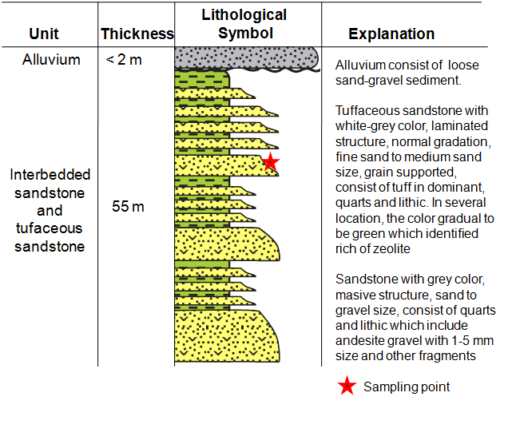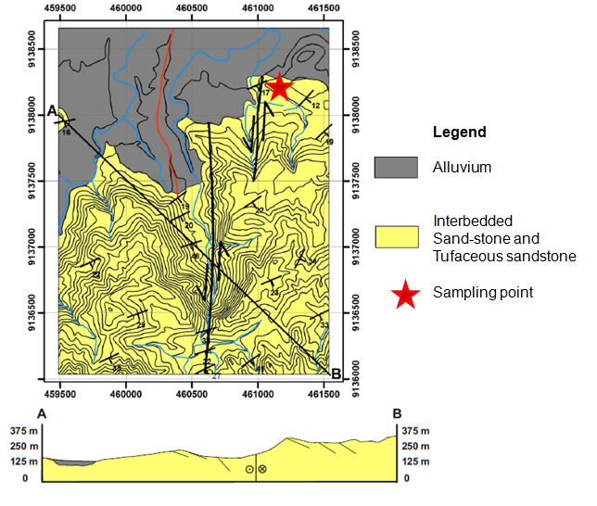

**Figure 1. Geological map and Lithological column of geological section of study area**

|  |  |  |  |  |  |  |  |  |  |  |  |  |  |  |  |  |  |  |  |  |  |  |  |  |  |
| --- | --- | --- | --- | --- | --- | --- | --- | --- | --- | --- | --- | --- | --- | --- | --- | --- | --- | --- | --- | --- | --- | --- | --- | --- | --- |
| **Table 2. Consistency limit**   |  |  | | --- | --- | | Atterberg limit | Sample | | Initial water content | 3.1 % | | Specific gravity | 2,43 | | Liquid limit | 29.9 % | | Plastic limit | 25.5 % | | Plasticity index | 4.4 % | | Shrinkage limit | 22,92 % | | **Table 1 Partricle size distribution**   |  |  |  | | --- | --- | --- | | Gravel | Sand | Silt/ Clay | | 0,00 % | 28.6 % | 71.4 % |   **Table 3 Permeability test**   |  |  | | --- | --- | | Sample | Permeability | | Zeolitic rock | 2.7 x 10-7 m/det | |

References

Aksoy, Y. Y., Characterization of two natural zeolites for geotechnical and geoenvironmental applications, Applied Clay Science 50 (2010) 130–136

Allen, E., Andrews, R. 1997. http://www.gcsaa.org/gcm /1997/may97/05zeo.html.

Bish, F., Guthrie, G.D., 1994. Clays and zeolites. In: Guthrie, G.D., Mossmann, B.T. (Eds.), Health effects of mineral dusts: Reviews in Mineralogy, 28, pp. 168–184.

Kayabali, K., 1997. Engineering aspects of a novel landfill liner material: bentoniteamended natural zeolite. Engineering Geology 45, 105–114.

Ören, A. H., and Özdamar, T., Hydraulic conductivity of compacted zeolites, 2013, Waste Management & Research, 31(6) 634–640

Ören, A. H., Kaya, A., and Kayalar, A.S, Hydraulic conductivity of zeolite–bentonite mixtures in comparison with sand–bentonite mixtures, Can. Geotech. J. 48: 1343–1353 (2011)

Rahardjo, W., 1983, Paleoenvironmental Reconstruction of The Sedimentary Sequence on The Baturagung Escarpment, Gunung Kidul Area , Central Java; Paper Presented on The 12th Annual Meeting of the Association of Indonesian Geologists, Yogyakarta, 19 p.

Sumarso dan Ismoyowati, T., 1975, Contribution to The Stratigraphy of the Jiwo Hills and Their Southern Surroundings (Central Java); Proceedings of the Indonesian Petroleum Association 4th Annual Convention, 2, p. 19-26.

Schultz, J.R., Cleaves, A.B., 1958. Geology in Engineering. John Wiley and Sons, Inc., New York.

Van Bemmelen, R.W., 1949, The Geology of Indonesia, Part 1A, General Geology; Martinus Nijhoff, The Hague.