Machine Learning for Survival Prediction in Breast Cancer: A TCGA-BRCA Gene Expression Analysis
Tungalan Ganbaatar
2026-03-27

1. Setup

1.1 Install and Load Packages
if (!requireNamespace("BiocManager", quietly = TRUE)) install.packages("BiocManager")
if (!requireNamespace("curatedTCGAData", quietly = TRUE))
BiocManager::install(c("curatedTCGAData", "MultiAssayExperiment", "TCGAutils"))
library(curatedTCGAData)
## Loading required package: MultiAssayExperiment
## Warning: package 'MultiAssayExperiment' was built under R version 4.5.3
## Loading required package: SummarizedExperiment
## Loading required package: MatrixGenerics
## Loading required package: matrixStats
##
## Attaching package: 'MatrixGenerics'
## The following objects are masked from 'package:matrixStats':
##
## colAlls, colAnyNAs, colAnys, colAvgsPerRowSet, colCollapse,
## colCounts, colCummaxs, colCummins, colCumprods, colCumsums,
## colDiffs, colIQRDiffs, colIQRs, colLogSumExps, colMadDiffs,
## colMads, colMaxs, colMeans2, colMedians, colMins, colOrderStats,
## colProds, colQuantiles, colRanges, colRanks, colSdDiffs, colSds,
## colSums2, colTabulates, colVarDiffs, colVars, colWeightedMads,
## colWeightedMeans, colWeightedMedians, colWeightedSds,
## colWeightedVars, rowAlls, rowAnyNAs, rowAnys, rowAvgsPerColSet,
## rowCollapse, rowCounts, rowCummaxs, rowCummins, rowCumprods,
## rowCumsums, rowDiffs, rowIQRDiffs, rowIQRs, rowLogSumExps,
## rowMadDiffs, rowMads, rowMaxs, rowMeans2, rowMedians, rowMins,
## rowOrderStats, rowProds, rowQuantiles, rowRanges, rowRanks,
## rowSdDiffs, rowSds, rowSums2, rowTabulates, rowVarDiffs, rowVars,
## rowWeightedMads, rowWeightedMeans, rowWeightedMedians,
## rowWeightedSds, rowWeightedVars
## Loading required package: GenomicRanges
## Loading required package: stats4
## Loading required package: BiocGenerics
## Loading required package: generics
##
## Attaching package: 'generics'
## The following objects are masked from 'package:base':
##
## as.difftime, as.factor, as.ordered, intersect, is.element, setdiff,
## setequal, union
##
## Attaching package: 'BiocGenerics'
## The following objects are masked from 'package:stats':
##
## IQR, mad, sd, var, xtabs
## The following objects are masked from 'package:base':
##
## anyDuplicated, aperm, append, as.data.frame, basename, cbind,
## colnames, dirname, do.call, duplicated, eval, evalq, Filter, Find,
## get, grep, grepl, is.unsorted, lapply, Map, mapply, match, mget,
## order, paste, pmax, pmax.int, pmin, pmin.int, Position, rank,
## rbind, Reduce, rownames, sapply, saveRDS, table, tapply, unique,
## unsplit, which.max, which.min
## Loading required package: S4Vectors
##
## Attaching package: 'S4Vectors'
## The following object is masked from 'package:utils':
##
## findMatches
## The following objects are masked from 'package:base':
##
## expand.grid, I, unname
## Loading required package: IRanges
##
## Attaching package: 'IRanges'
## The following object is masked from 'package:grDevices':
##
## windows
## Loading required package: Seqinfo
## Loading required package: Biobase
## Welcome to Bioconductor
##
## Vignettes contain introductory material; view with
## 'browseVignettes()'. To cite Bioconductor, see
## 'citation("Biobase")', and for packages 'citation("pkgname")'.
##
## Attaching package: 'Biobase'
## The following object is masked from 'package:MatrixGenerics':
##
## rowMedians
## The following objects are masked from 'package:matrixStats':
##
## anyMissing, rowMedians
library(MultiAssayExperiment)
library(TCGAutils)
library(tidyverse)
## Warning: package 'ggplot2' was built under R version 4.5.3
## Warning: package 'purrr' was built under R version 4.5.3
## Warning: package 'dplyr' was built under R version 4.5.3
## ── Attaching core tidyverse packages ──────────────────────── tidyverse 2.0.0 ──
## ✔ dplyr 1.2.1 ✔ readr 2.2.0
## ✔ forcats 1.0.1 ✔ stringr 1.6.0
## ✔ ggplot2 4.0.2 ✔ tibble 3.3.1
## ✔ lubridate 1.9.5 ✔ tidyr 1.3.2
## ✔ purrr 1.2.2
## ── Conflicts ────────────────────────────────────────── tidyverse_conflicts() ──
## ✖ lubridate::%within%() masks IRanges::%within%()
## ✖ dplyr::collapse() masks IRanges::collapse()
## ✖ dplyr::combine() masks Biobase::combine(), BiocGenerics::combine()
## ✖ dplyr::count() masks matrixStats::count()
## ✖ dplyr::desc() masks IRanges::desc()
## ✖ tidyr::expand() masks S4Vectors::expand()
## ✖ dplyr::filter() masks stats::filter()
## ✖ dplyr::first() masks S4Vectors::first()
## ✖ dplyr::lag() masks stats::lag()
## ✖ ggplot2::Position() masks BiocGenerics::Position(), base::Position()
## ✖ purrr::reduce() masks GenomicRanges::reduce(), IRanges::reduce()
## ✖ dplyr::rename() masks S4Vectors::rename()
## ✖ lubridate::second() masks S4Vectors::second()
## ✖ lubridate::second<-() masks S4Vectors::second<-()
## ✖ dplyr::slice() masks IRanges::slice()
## ℹ Use the conflicted package (<http://conflicted.r-lib.org/>) to force all conflicts to become errors
library(caret)
## Loading required package: lattice
##
## Attaching package: 'caret'
##
## The following object is masked from 'package:purrr':
##
## lift
##
## The following object is masked from 'package:generics':
##
## train
library(glmnet)
## Warning: package 'glmnet' was built under R version 4.5.3
## Loading required package: Matrix
##
## Attaching package: 'Matrix'
##
## The following objects are masked from 'package:tidyr':
##
## expand, pack, unpack
##
## The following object is masked from 'package:S4Vectors':
##
## expand
##
## Loaded glmnet 4.1-10
library(randomForest)
## randomForest 4.7-1.2
## Type rfNews() to see new features/changes/bug fixes.
##
## Attaching package: 'randomForest'
##
## The following object is masked from 'package:dplyr':
##
## combine
##
## The following object is masked from 'package:ggplot2':
##
## margin
##
## The following object is masked from 'package:Biobase':
##
## combine
##
## The following object is masked from 'package:BiocGenerics':
##
## combine
library(pROC)
## Type 'citation("pROC")' for a citation.
##
## Attaching package: 'pROC'
##
## The following objects are masked from 'package:IRanges':
##
## cov, var
##
## The following objects are masked from 'package:S4Vectors':
##
## cov, var
##
## The following object is masked from 'package:BiocGenerics':
##
## var
##
## The following objects are masked from 'package:stats':
##
## cov, smooth, var

2. Data Acquisition

2.1 Download TCGA-BRCA RNA-seq Data
Data are retrieved via curatedTCGAData, which provides pre-packaged TCGA datasets as MultiAssayExperiment objects from Bioconductor’s ExperimentHub.
brca_mae <- curatedTCGAData(
diseaseCode = "BRCA",
assays = "RNASeq2GeneNorm",
dry.run = FALSE,
version = "2.1.1"
)
## Querying and downloading: BRCA_RNASeq2GeneNorm-20160128
## see ?curatedTCGAData and browseVignettes('curatedTCGAData') for documentation
## loading from cache
## Querying and downloading: BRCA_colData-20160128
## see ?curatedTCGAData and browseVignettes('curatedTCGAData') for documentation
## loading from cache
## Querying and downloading: BRCA_sampleMap-20160128
## see ?curatedTCGAData and browseVignettes('curatedTCGAData') for documentation
## loading from cache
## Querying and downloading: BRCA_metadata-20160128
## see ?curatedTCGAData and browseVignettes('curatedTCGAData') for documentation
## loading from cache
## harmonizing input:
## removing 14373 sampleMap rows not in names(experiments)
## removing 5 colData rownames not in sampleMap 'primary'
brca_mae
## A MultiAssayExperiment object of 1 listed
## experiment with a user-defined name and respective class.
## Containing an ExperimentList class object of length 1:
## [1] BRCA_RNASeq2GeneNorm-20160128: SummarizedExperiment with 18300 rows and 1212 columns
## Functionality:
## experiments() - obtain the ExperimentList instance
## colData() - the primary/phenotype DataFrame
## sampleMap() - the sample coordination DataFrame
## `$`, `[`, `[[` - extract colData columns, subset, or experiment
## *Format() - convert into a long or wide DataFrame
## assays() - convert ExperimentList to a SimpleList of matrices
## exportClass() - save data to flat files

2.2 Extract Expression Matrix and Clinical Data
expr_mat <- assay(brca_mae[["BRCA_RNASeq2GeneNorm-20160128"]])
clin_df <- as.data.frame(colData(brca_mae))
cat("Expression matrix (genes x samples):", dim(expr_mat), "\n")
## Expression matrix (genes x samples): 18300 1212
cat("Clinical data (patients x variables):", dim(clin_df), "\n")
## Clinical data (patients x variables): 1093 2684
The RNA-seq expression matrix contains 18,300 genes measured across 1,212 tumor samples, while the clinical dataset includes 1,093 patients with associated clinical variables. The mismatch in sample counts indicates that only a subset of patients have both gene expression and clinical data, which will need to be aligned before modeling.

3. Data Preprocessing

3.1 Define 5-Year Survival Outcome
0 = death ≤5 years, 1 = survival ≥5 years Exclude censored patients with <5-year follow-up to avoid label noise
surv_df <- clin_df %>%
select(patientID, days_to_death, days_to_last_followup, vital_status) %>%
mutate(
days_to_death = as.numeric(days_to_death),
days_to_last_followup = as.numeric(days_to_last_followup),
surv_days = ifelse(vital_status == 1, days_to_death, days_to_last_followup),
surv_5yr = case_when(
vital_status == 1 & surv_days <= 365.25 * 5 ~ 0L,
surv_days >= 365.25 * 5 ~ 1L,
TRUE ~ NA_integer_
)
) %>%
filter(!is.na(surv_5yr))
cat("Retained patients:", nrow(surv_df), "\n")
## Retained patients: 351
cat("Class distribution (0 = died, 1 = survived):\n")
## Class distribution (0 = died, 1 = survived):
print(table(surv_df$surv_5yr))
##
## 0 1
## 99 252
cat("Class ratio (survived:died):",
round(sum(surv_df$surv_5yr == 1) / sum(surv_df$surv_5yr == 0), 2), "\n")
## Class ratio (survived:died): 2.55
It yields 351 patients with well-defined 5-year survival outcomes after excluding censored cases with insufficient follow-up. The class distribution is imbalanced, with more patients surviving than dying (252 vs. 99), corresponding to a survival-to-death ratio of 2.55.
surv_df %>%
mutate(Outcome = ifelse(surv_5yr == 1, "Survived (>=5 yr)", "Died (<5 yr)")) %>%
ggplot(aes(x = Outcome, fill = Outcome)) +
geom_bar(width = 0.5, show.legend = FALSE) +
geom_text(stat = "count", aes(label = after_stat(count)), vjust = -0.5, size = 4) +
scale_fill_manual(values = c("Survived (>=5 yr)" = "#2196F3", "Died (<5 yr)" = "#F44336")) +
labs(title = "5-Year Survival Outcome Distribution",
x = NULL, y = "Number of Patients") +
theme_classic(base_size = 12)
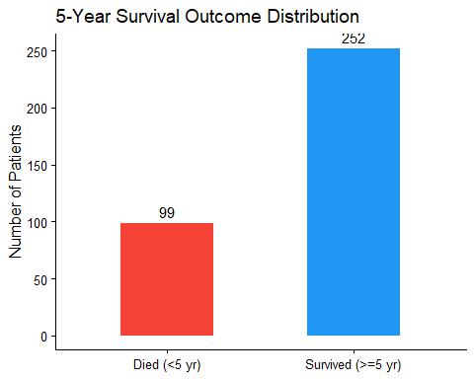
Figure 1. Class distribution of the 5-year survival outcome in the filtered TCGA-BRCA cohort.
The bar plot shows a clear class imbalance, with substantially more patients surviving at least 5 years (252) than those who died within 5 years (99). This imbalance should be considered during model evaluation, as accuracy alone may be misleading.

3.2 Filter to Primary Tumor Samples and Merge
TCGA barcodes encode sample type at positions 14-15 (01 = primary solid tumor).
primary_samples <- colnames(expr_mat)[substr(colnames(expr_mat), 14, 15) == "01"]
expr_primary <- expr_mat[, primary_samples]
colnames(expr_primary) <- substr(colnames(expr_primary), 1, 12)
expr_primary <- expr_primary[, !duplicated(colnames(expr_primary))]
common_pts <- intersect(colnames(expr_primary), surv_df$patientID)
cat("Patients with matched expression + survival data:", length(common_pts), "\n")
## Patients with matched expression + survival data: 351
expr_final <- t(expr_primary[, common_pts])
surv_final <- surv_df %>%
filter(patientID %in% common_pts) %>%
arrange(match(patientID, rownames(expr_final)))
y <- factor(surv_final$surv_5yr, levels = c(0, 1), labels = c("died", "survived"))
The gene expression data were restricted to primary tumor samples and aligned with clinical survival data using patient IDs. After matching, 351 patients with both expression and survival information were retained for downstream modeling.

3.3 Log-Transformation and Variance-Based Gene Filtering
Because p >> n (20,000+ genes, ~350 patients), we reduce dimensionality by retaining the top 500 most variable genes. Expression values are log2-transformed to stabilize variance and approximate normality.
expr_log <- log2(pmax(expr_final, 0) + 1)
expr_log[is.nan(expr_log)] <- 0
gene_vars <- apply(expr_log, 2, var)
top_genes <- names(sort(gene_vars, decreasing = TRUE)[1:500])
X <- expr_log[, top_genes]
cat("Final feature matrix (patients x genes):", dim(X), "\n")
## Final feature matrix (patients x genes): 351 500
Gene expression values were log-transformed and reduced to the 500 most variable genes to address high dimensionality and improve model stability. The final feature matrix contains 351 patients and 500 selected gene predictors for downstream modeling.
tibble(variance = gene_vars) %>%
ggplot(aes(x = variance)) +
geom_histogram(bins = 80, fill = "#607D8B", color = "white", alpha = 0.85) +
geom_vline(xintercept = min(gene_vars[top_genes]),
linetype = "dashed", color = "#F44336", linewidth = 0.8) +
annotate("text", x = min(gene_vars[top_genes]) * 1.2, y = 650,
label = "Top 500\nthreshold", color = "#F44336", hjust = 0, size = 3.5) +
scale_x_log10() +
labs(title = "Gene Expression Variance Distribution",
x = "Variance (log10 scale)", y = "Number of Genes") +
theme_classic(base_size = 12)
## Warning: Removed 4701 rows containing non-finite outside the scale range
## (`stat_bin()`).
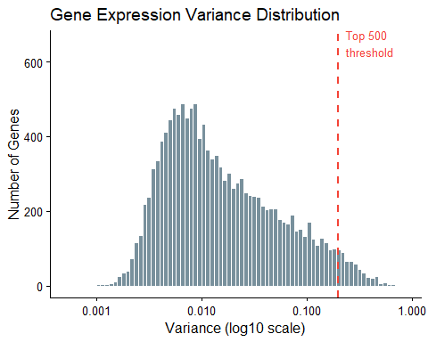
Figure 2. Distribution of per-gene variance (log10 scale). The red dashed line marks the minimum variance among the top 500 selected genes. The majority of genes fall below this threshold and are excluded.
The histogram shows that most genes have low variance, with only a small subset exhibiting high variability across samples. The red threshold line highlights the cutoff used to select the top 500 most variable genes for modeling.

4. Exploratory Data Analysis

4.1 Principal Component Analysis
PCA is applied to assess the overall structure of the data and detect potential batch effects or outliers prior to modeling.
pca_res <- prcomp(X, center = TRUE, scale. = TRUE)
pca_df <- as.data.frame(pca_res$x[, 1:2]) %>% mutate(Outcome = y)
var_exp <- round(summary(pca_res)$importance[2, 1:2] * 100, 1)
ggplot(pca_df, aes(x = PC1, y = PC2, color = Outcome)) +
geom_point(alpha = 0.55, size = 1.8) +
scale_color_manual(values = c("died" = "#F44336", "survived" = "#2196F3")) +
labs(title = "PCA of Gene Expression (Top 500 Variable Genes)",
x = paste0("PC1 (", var_exp[1], "% variance)"),
y = paste0("PC2 (", var_exp[2], "% variance)"),
color = "5-Year Outcome") +
theme_classic(base_size = 12) +
theme(legend.position = "bottom")
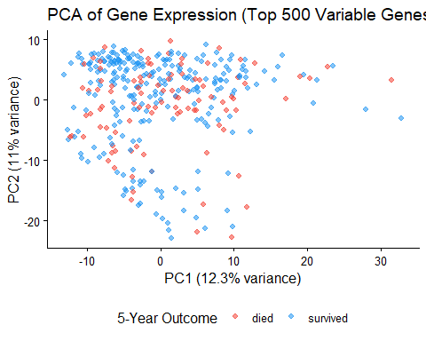 The PCA plot shows no clear separation between patients who survived and those who died within 5 years, suggesting that survival differences are not captured by simple linear combinations of the top genes. This indicates that more complex models may be needed to detect predictive patterns in the data.

5. Data Splitting Strategy

5.1 Three-Way Split: Training / Test / Validation
Train (64%) - fit models Test (16%) - model selection Validation (20%) - final unbiased evaluation It prevents overfitting to test set during model comparison
set.seed(42)
#1: Hold out 20% as validation
val_idx <- createDataPartition(y, p = 0.20, list = FALSE)
X_val <- X[val_idx, ]; y_val <- y[val_idx]
X_dev <- X[-val_idx, ]; y_dev <- y[-val_idx]
#2: Split remaining 80% into train (80%) and test (20%)
# => train = 64% of total, test = 16% of total
set.seed(42)
train_idx <- createDataPartition(y_dev, p = 0.80, list = FALSE)
X_train <- X_dev[train_idx, ]; y_train <- y_dev[train_idx]
X_test <- X_dev[-train_idx, ]; y_test <- y_dev[-train_idx]
cat("=== Data Split Summary ===\n")
## === Data Split Summary ===
cat(sprintf("Training set: %d patients | died: %d | survived: %d\n",
nrow(X_train), sum(y_train == "died"), sum(y_train == "survived")))
## Training set: 225 patients | died: 64 | survived: 161
cat(sprintf("Test set: %d patients | died: %d | survived: %d\n",
nrow(X_test), sum(y_test == "died"), sum(y_test == "survived")))
## Test set: 55 patients | died: 15 | survived: 40
cat(sprintf("Validation set: %d patients | died: %d | survived: %d\n",
nrow(X_val), sum(y_val == "died"), sum(y_val == "survived")))
## Validation set: 71 patients | died: 20 | survived: 51
split_df <- bind_rows(
tibble(Set = "Training", Outcome = y_train),
tibble(Set = "Test", Outcome = y_test),
tibble(Set = "Validation", Outcome = y_val)
) %>%
mutate(Set = factor(Set, levels = c("Training", "Test", "Validation")))
ggplot(split_df, aes(x = Set, fill = Outcome)) +
geom_bar(position = "dodge", width = 0.6) +
geom_text(stat = "count", aes(label = after_stat(count)),
position = position_dodge(width = 0.6), vjust = -0.4, size = 3.5) +
scale_fill_manual(values = c("died" = "#F44336", "survived" = "#2196F3")) +
labs(title = "Patient Allocation Across Data Partitions",
x = NULL, y = "Number of Patients", fill = "5-Year Outcome") +
theme_classic(base_size = 12) +
theme(legend.position = "bottom")
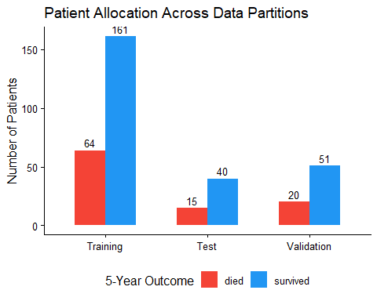
Figure 4. Patient allocation across the three data partitions, stratified by 5-year survival outcome.

6. Predictive Modeling
Hyperparameters are selected via 5-fold cross-validation within the training set only. Test set predictions are generated once per model after CV, and are used solely for model comparison.

6.1 Model 1 - Ridge-Penalized Logistic Regression
Ridge (alpha = 0) applies L2 regularization, shrinking all coefficients toward zero without eliminating any. It serves as the baseline because it handles p >> n well and retains all 500 gene predictors in a stable framework.
set.seed(42)
cv_ridge <- cv.glmnet(X_train, y_train, family = "binomial",
alpha = 0, type.measure = "auc", nfolds = 5)
pred_ridge <- predict(cv_ridge, X_test, s = "lambda.min", type = "response")
roc_ridge <- roc(y_test, as.vector(pred_ridge),
levels = c("died", "survived"), quiet = TRUE)
cat("Ridge lambda (min CV AUC):", round(cv_ridge$lambda.min, 5), "\n")
## Ridge lambda (min CV AUC): 1.17094
cat("Ridge Test AUC: ", round(auc(roc_ridge), 4), "\n")
## Ridge Test AUC: 0.6333
The ridge regression model achieves a test AUC of 0.6333, indicating modest ability to distinguish between patients who survived and those who died within 5 years. This suggests that a linear model with L2 regularization captures some signal in the data, but more flexible models may be needed for stronger predictive performance.

6.2 Model 2 - LASSO
LASSO applies L1 regularization, producing sparse solutions by setting many coefficients to exactly zero.
set.seed(42)
cv_lasso <- cv.glmnet(X_train, y_train, family = "binomial",
alpha = 1, type.measure = "auc", nfolds = 5)
pred_lasso <- predict(cv_lasso, X_test, s = "lambda.min", type = "response")
roc_lasso <- roc(y_test, as.vector(pred_lasso),
levels = c("died", "survived"), quiet = TRUE)
lasso_coefs <- coef(cv_lasso, s = "lambda.min")
n_lasso <- sum(lasso_coefs[-1] != 0)
cat("LASSO lambda (min CV AUC): ", round(cv_lasso$lambda.min, 5), "\n")
## LASSO lambda (min CV AUC): 0.01584
cat("Genes selected by LASSO: ", n_lasso, "of 500\n")
## Genes selected by LASSO: 70 of 500
cat("LASSO Test AUC: ", round(auc(roc_lasso), 4), "\n")
## LASSO Test AUC: 0.585
The LASSO model selects 70 out of 500 genes, demonstrating effective feature selection through sparsity. However, its test AUC of 0.585 indicates weaker predictive performance than ridge regression, suggesting that aggressive feature reduction may have removed useful signals.

6.3 Model 3 - Random Forest
Random Forest builds an ensemble of decision trees, each trained on a bootstrap sample with a random feature subset at each split. It captures non-linear gene interactions that linear models cannot represent. The default mtry = sqrt(p) is used.
set.seed(42)
rf_model <- randomForest(X_train, y_train, ntree = 500, importance = TRUE)
pred_rf <- predict(rf_model, X_test, type = "prob")[, "survived"]
roc_rf <- roc(y_test, pred_rf, levels = c("died", "survived"), quiet = TRUE)
cat("Random Forest Test AUC:", round(auc(roc_rf), 4), "\n")
## Random Forest Test AUC: 0.61
The random forest model achieves a test AUC of 0.61, indicating modest predictive performance comparable to ridge regression. Despite its ability to capture nonlinear relationships, it does not substantially improve prediction accuracy, suggesting limited signal in the available features.

7. Model Evaluation on Test Set

7.1 AUC Summary
results <- tibble(
Model = c("Ridge (Logistic)", "LASSO", "Random Forest"),
AUC = round(c(auc(roc_ridge), auc(roc_lasso), auc(roc_rf)), 4)
) %>% arrange(desc(AUC))
knitr::kable(results, caption = "Table 1. Test set AUC for all three models.")
Table 1. Test set AUC for all three models.
Model | AUC
Ridge (Logistic) | 0.6333
Random Forest | 0.6100
LASSO | 0.5850
Ridge-penalized logistic regression achieves the highest test AUC (0.633), outperforming both random forest (0.610) and LASSO (0.585). Overall performance across models is modest, with ridge providing the most reliable predictive signal among the approaches tested.

7.2 ROC Curves
roc_df <- bind_rows(
tibble(FPR = 1 - roc_ridge$specificities, TPR = roc_ridge$sensitivities,
Model = paste0("Ridge (AUC=", round(auc(roc_ridge), 3), ")")),
tibble(FPR = 1 - roc_lasso$specificities, TPR = roc_lasso$sensitivities,
Model = paste0("LASSO (AUC=", round(auc(roc_lasso), 3), ")")),
tibble(FPR = 1 - roc_rf$specificities, TPR = roc_rf$sensitivities,
Model = paste0("Random Forest (AUC=", round(auc(roc_rf), 3), ")"))
)
ggplot(roc_df, aes(x = FPR, y = TPR, color = Model)) +
geom_line(linewidth = 1.1) +
geom_abline(slope = 1, intercept = 0, linetype = "dashed",
color = "gray60", linewidth = 0.5) +
scale_color_manual(values = c("#E91E63", "#FF9800", "#4CAF50")) +
labs(title = "ROC Curves -- Test Set",
x = "False Positive Rate", y = "True Positive Rate", color = NULL) +
theme_classic(base_size = 12) +
theme(legend.position = c(0.63, 0.18),
legend.background = element_rect(fill = "white", color = "gray80"))
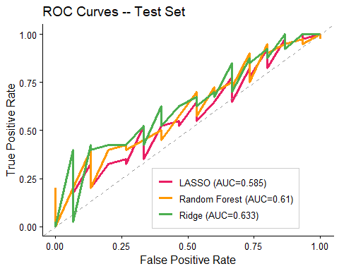 The ROC curves show that all models perform only modestly above the random baseline, with ridge regression consistently achieving the highest true positive rates across thresholds. This confirms that ridge provides the best overall discrimination among the models, though predictive performance remains limited.

8.3 Full Performance Summary
Given the class imbalance (72% survived), accuracy alone is misleading, a trivial classifier predicting “survived” for all patients achieves 72% accuracy. Balanced Accuracy (mean of sensitivity and specificity) is therefore reported alongside standard metrics.
threshold <- 0.5
cm_ridge <- confusionMatrix(
factor(ifelse(as.vector(pred_ridge) >= threshold, "survived", "died"),
levels = c("died", "survived")),
y_test, positive = "survived")
cm_lasso <- confusionMatrix(
factor(ifelse(as.vector(pred_lasso) >= threshold, "survived", "died"),
levels = c("died", "survived")),
y_test, positive = "survived")
cm_rf <- confusionMatrix(predict(rf_model, X_test), y_test, positive = "survived")
perf_df <- tibble(
Model = c("Ridge", "LASSO", "Random Forest"),
AUC = round(c(auc(roc_ridge), auc(roc_lasso), auc(roc_rf)), 3),
Accuracy = round(c(cm_ridge$overall["Accuracy"],
cm_lasso$overall["Accuracy"],
cm_rf$overall["Accuracy"]), 3),
Sensitivity = round(c(cm_ridge$byClass["Sensitivity"],
cm_lasso$byClass["Sensitivity"],
cm_rf$byClass["Sensitivity"]), 3),
Specificity = round(c(cm_ridge$byClass["Specificity"],
cm_lasso$byClass["Specificity"],
cm_rf$byClass["Specificity"]), 3),
Balanced_Accuracy = round(c(cm_ridge$byClass["Balanced Accuracy"],
cm_lasso$byClass["Balanced Accuracy"],
cm_rf$byClass["Balanced Accuracy"]), 3)
)
knitr::kable(perf_df,
caption = "Table 2. Full performance summary on the test set. Balanced Accuracy accounts for class imbalance.")
Table 2. Full performance summary on the test set. Balanced Accuracy accounts for class imbalance.
Model | AUC | Accuracy | Sensitivity | Specificity | Balanced_Accuracy
Ridge | 0.633 | 0.764 | 1.000 | 0.133 | 0.567
LASSO | 0.585 | 0.636 | 0.775 | 0.267 | 0.521
Random Forest | 0.610 | 0.727 | 0.975 | 0.067 | 0.521
Interpretation: Ridge achieves the highest AUC and balanced accuracy on the test set. Low specificity across all models reflects the difficulty of identifying the minority class (died), a clinically important limitation discussed.

8. Final Validation of Best Model
Ridge regression achieved the best test-set performance. It is applied once to the held-out validation set here, the only time the validation set is used, providing an unbiased estimate of generalization performance that is not inflated by the model selection process.
pred_val <- predict(cv_ridge, X_val, s = "lambda.min", type = "response")
roc_val <- roc(y_val, as.vector(pred_val),
levels = c("died", "survived"), quiet = TRUE)
cm_val <- confusionMatrix(
factor(ifelse(as.vector(pred_val) >= threshold, "survived", "died"),
levels = c("died", "survived")),
y_val, positive = "survived")
cat("=== Ridge -- Final Validation Set Performance ===\n")
## === Ridge -- Final Validation Set Performance ===
cat("AUC: ", round(auc(roc_val), 4), "\n")
## AUC: 0.7275
cat("Accuracy: ", round(cm_val$overall["Accuracy"], 4), "\n")
## Accuracy: 0.7324
cat("Sensitivity: ", round(cm_val$byClass["Sensitivity"], 4), "\n")
## Sensitivity: 0.9412
cat("Specificity: ", round(cm_val$byClass["Specificity"], 4), "\n")
## Specificity: 0.2
cat("Balanced Accuracy: ", round(cm_val$byClass["Balanced Accuracy"], 4), "\n")
## Balanced Accuracy: 0.5706
tibble(FPR = 1 - roc_val$specificities, TPR = roc_val$sensitivities) %>%
ggplot(aes(x = FPR, y = TPR)) +
geom_line(color = "#E91E63", linewidth = 1.2) +
geom_abline(slope = 1, intercept = 0, linetype = "dashed",
color = "gray60", linewidth = 0.5) +
annotate("text", x = 0.6, y = 0.2,
label = paste0("AUC = ", round(auc(roc_val), 3)),
size = 5, color = "#E91E63") +
labs(title = "Ridge -- Validation Set ROC Curve",
x = "False Positive Rate", y = "True Positive Rate") +
theme_classic(base_size = 12)
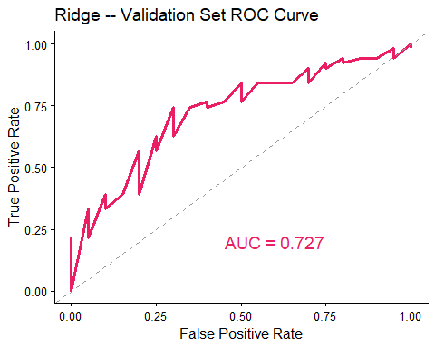 The ROC curve on the validation set shows consistent performance with an AUC of 0.727, confirming that the ridge model generalizes reasonably well to unseen data. Its clear separation from the diagonal indicates meaningful predictive ability beyond random chance.

9. Variable Importance

9.1 LASSO - Selected Genes
lasso_coef_df <- as.data.frame(as.matrix(lasso_coefs)) %>%
rownames_to_column("gene") %>%
setNames(c("gene", "coefficient")) %>%
filter(gene != "(Intercept)", coefficient != 0) %>%
mutate(abs_coef = abs(coefficient)) %>%
arrange(desc(abs_coef)) %>%
slice_head(n = 20)
ggplot(lasso_coef_df,
aes(x = reorder(gene, abs_coef), y = coefficient, fill = coefficient > 0)) +
geom_col(show.legend = FALSE) +
coord_flip() +
scale_fill_manual(values = c("TRUE" = "#2196F3", "FALSE" = "#F44336")) +
labs(title = "Top 20 LASSO-Selected Genes",
subtitle = "Blue = positive association with survival | Red = negative",
x = NULL, y = "LASSO Coefficient") +
theme_classic(base_size = 11)
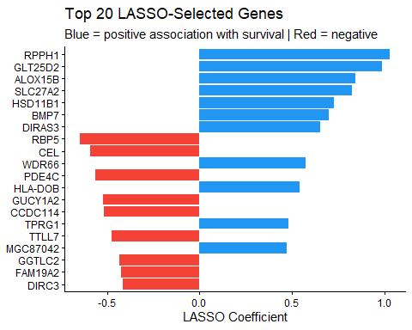 LASSO selected 70 genes at the optimal lambda. The top 20 by absolute coefficient magnitude are shown below. Positive coefficients indicate association with higher survival probability; negative coefficients indicate association with mortality.The variation in coefficient magnitudes suggests that a few key genes may contribute more strongly to prediction than others.

9.2 Random Forest - Variable Importance
rf_imp <- importance(rf_model, type = 1) %>%
as.data.frame() %>%
rownames_to_column("gene") %>%
setNames(c("gene", "MeanDecreaseAccuracy")) %>%
arrange(desc(MeanDecreaseAccuracy)) %>%
slice_head(n = 20)
ggplot(rf_imp, aes(x = reorder(gene, MeanDecreaseAccuracy), y = MeanDecreaseAccuracy)) +
geom_col(fill = "#4CAF50", alpha = 0.85) +
coord_flip() +
labs(title = "Top 20 Genes -- Random Forest Importance",
subtitle = "Mean Decrease in Accuracy (permutation importance)",
x = NULL, y = "Mean Decrease in Accuracy") +
theme_classic(base_size = 11)
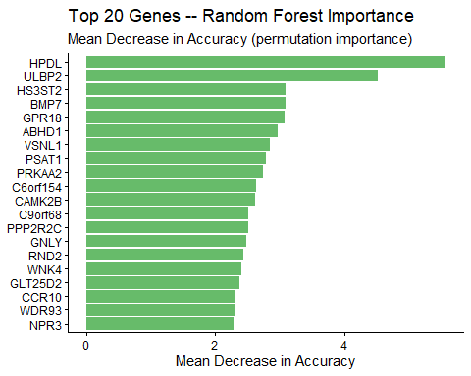 The random forest model identifies genes that contribute most to prediction, with higher mean decrease in accuracy indicating greater importance. A small subset of genes appears to drive model performance, suggesting that certain features have stronger predictive influence than others.

9.3 Consistency Across Methods
lasso_genes <- lasso_coef_df$gene
rf_genes <- rf_imp$gene
overlap <- intersect(lasso_genes, rf_genes)
cat("LASSO top 20 genes: ", length(lasso_genes), "\n")
## LASSO top 20 genes: 20
cat("Random Forest top 20 genes: ", length(rf_genes), "\n")
## Random Forest top 20 genes: 20
cat("Genes identified by both methods: ", length(overlap), "\n")
## Genes identified by both methods: 2
if (length(overlap) > 0) {
cat("Overlapping genes:", paste(overlap, collapse = ", "), "\n")
}
## Overlapping genes: GLT25D2, BMP7
Two genes (GLT25D2 and BMP7) are consistently identified by both LASSO and random forest, suggesting they may represent more robust and biologically meaningful signals. However, the limited overlap indicates that different modeling approaches capture distinct aspects of the data.

