Q1:
- (Convert to bits and bits/second)
Size text file = 1 x 1024 x 1024 x 8 (bits)
Speed ​​= 32 x 1000 (bits/second)
T (32k) = (1 x 1024 x 1024 x 8) / (32 x 1000) = 262.144 (seconds)
- (Convert to bits and bits/second)
Size text file = 1 x 1024 x 1024 x 8 (bits)
Speed = 1 x 1000 x 1000 (bits/second)
T(1M) = (1 x 1024 x 1024 x 8) / (1 x 1000 x 1000 ) = 8.38 (second)
- T(32k) = (1 x 1024 x 1024 x 8)/(32 x 1000 x 6) = 43.69 (second) if equal 10 26843.5464
T(1M) = (1 x 1024 x 1024 x 8)/(1 x 1000 x 1000 x 6) = 1.4 (second) if equal 10 858993.4592
Q2:
R = 1.5 Mbps or R = 1.5 $×{10}^{6}$Mbps, and $n_{f}$ = 250 bytes or 2000 bits (250 $×8$)
The distance that the information must trravle is the earth-to-satellite distance, or D $≈$ 36,000 km = 3,6 x ${10}^{7}$m
The speed of light c is 3 x ${10}^{8}$. We can calculate the propagation delay and processing rate as follows:
2$t_{prop}$ = $\frac{3,6 ×{10}^{7}}{3×{10}^{8}}$ = 0,12s = 120 ms
$t_{f}$= $\frac{n_{f}}{R}$ = $\frac{2000}{1,5 ×{10}^{6}}$ = 0,00133s = 1,33 ms
We can use either Go-Back-N or Selective Repeat ARQ. The default window size is N = 7 ( with a 3-bit sequence number).
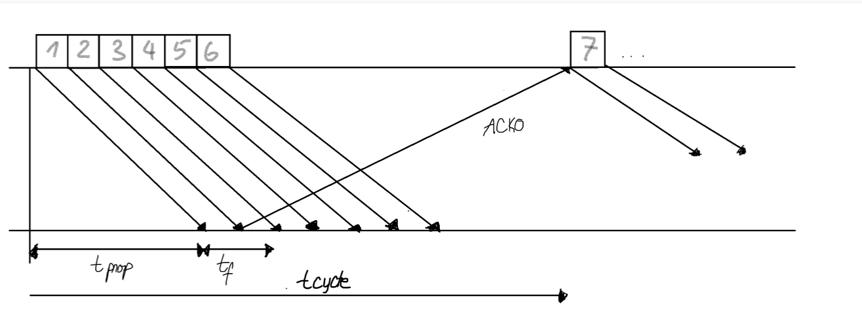
The maximum information rate is achieved with no error, and hence, no retransmission.
$t_{cycle }$ = minimum time to transmit a group of N packets
= $t_{f}$ + 2$t_{prop}$ = 1.33 + 2 x 120 = 241.31 ms
In which, $t_{cycle}$is the minimum time to transmit a group of N packets.
n = no. of bits transmitted in a cycle = N. $n_{f}$ = 7 x 2000 = 14000 bits
$R_{max}$ = $\frac{no. of bits transmitted in a cycle}{minimum cycle time}$ = $\frac{n}{t_{cycle}}$ = 58 kbps
In which, n is number of bits transmitted in a cycle, $R_{max}$ is number of bits sent in a cycle / minimum cycle time.
If the extended sequence numbering option (7-bit) is used, the maximum send window size would be N =$2^{7}$-1 = 127, and hence, the maximum information rate is:
n = N x $n_{f}$ = 127 x 2000 = 254000 bits
$R_{max}$ = $\frac{n}{t_{cycle}}$ = $\frac{254000}{241,33}$ = 1052,5 kbps = 1,0525 Mbps
Q3:
a. Message size is crucial because real-time voice communications need the delivery of a fixed packet size that can only accommodate speech signals of 20 milliseconds or less. As long as the required speech packet size can be handled, it is not as crucial how arbitrary message sizes are handled.
Sequencing is crucial as every packet must arrive in the order that it was produced. While voice transmission can withstand a certain amount of error and loss, reliability is only somewhat critical.
Pacing and flow control are less significant because it is assumed that the end systems' speeds will be same by virtue of the voice signal's synchronous nature.
Timing, for real-time voice transfer is crucial since it assists in reducing the jitter of the supplied signal through its adaption function.
Addressing is just when the connection is being set up, assuming some kind of virtual circuit packet switching technique.
Privacy, integrity, and authentication have typically not been as significant as the previously mentioned issues.
b. When the underlying network is reliable, processing at the edge is sufficient to deliver acceptable performance because the probability of error is very low. The hop-by-hop method may be required if the underlying network is unreliable. For instance, error recovery at each hop may be necessary if the probability of error is very high, as it is in a wireless channel, to enable effective communication.

Q4:
Number of subnet bits:
Original Subnet Mask: 255.255.255.0 (24 bit-1s)
New Subnet Mask: 255.255.255.248 (29 bit-1s)
Number of Subnet bits: 5 (29 - 24)

Number of subnet created:
2^{number of subnet bits} = 2⁵ = 32

Number of host bits per subnets
32 – (number of network bits) – (number of subnet bits)
= 32 – 24 – 5 = 3

Number of hosts per subnet
2^{Host bits} - 2= 2³ - 2 = 6 (-2: Network address, Broadcast address)

Network Address of this Subnet
11000000.10000111.11111010.10110100 (Host IP Address)
11111111.11111111.11111111.11111000 (New Subnet mask)
(Host IP Address) AND (New Subnet mask)
- 11000000.10000111.11111010.10110000 = 192.135.250.176

First host on this subnet
Network Address of this Subnet + 1
=192.135.250.177
Last host on this subnet
Broadcast Address on this subnet
11000000.10000111.11111010.10110100 (Host IP Address)
00000000.00000000.00000000.00000111 (New WildcardS Mask) (Negative of New Subnet mask)
(Host IP Address) OR (New Wildcard Mask)
- 11000000.10000111.11111010.10110111 = 192.135.250.183
Last host on this subnet = Broadcast Address – 1 = 192.135.250.182

Q5:
- The largest required subnet needs 50 host addresses.
- According to the question, two subnet are required for LAN-A and LAN-B and two subnets are needed to be left for future use. Therefore the total number of subnets are 4
- The /24 subnet mask in binary is prefix length
- In the network mask, the ones represent the network portion and the zeroes represent the host portion

Subnet Address | Prefix | Subnet Mask
192.168.12.0 | /26 | 255.255.255.192
192.168.12.64 | /26 | 255.255.255.192
192.168.12.128 | /26 | 255.255.255.192
192.168.12.192 | /26 | 255.255.255.192

