Graphical Abstract for Table of Contents (TOC) Use
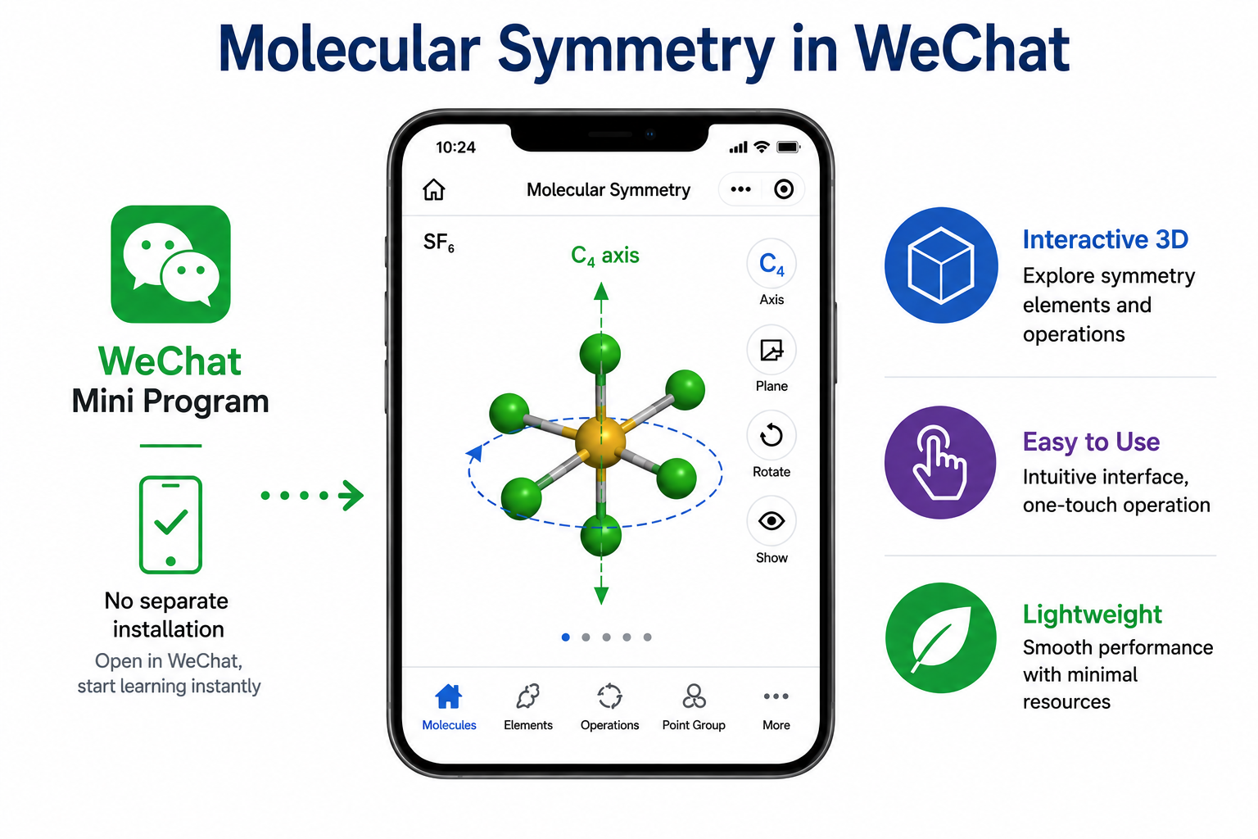

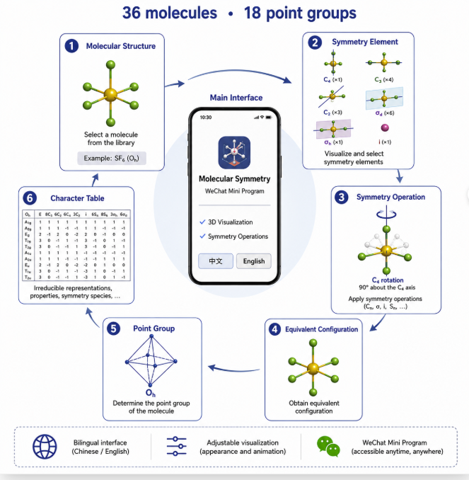
Figure 1. Overall organization and major functions of the molecular symmetry WeChat Mini Program. The interface integrates molecular selection, interactive 3D visualization, symmetry-element display, symmetry-operation animation, point-group information, and character tables within a structure → element → operation → equivalent configuration → point-group learning sequence.
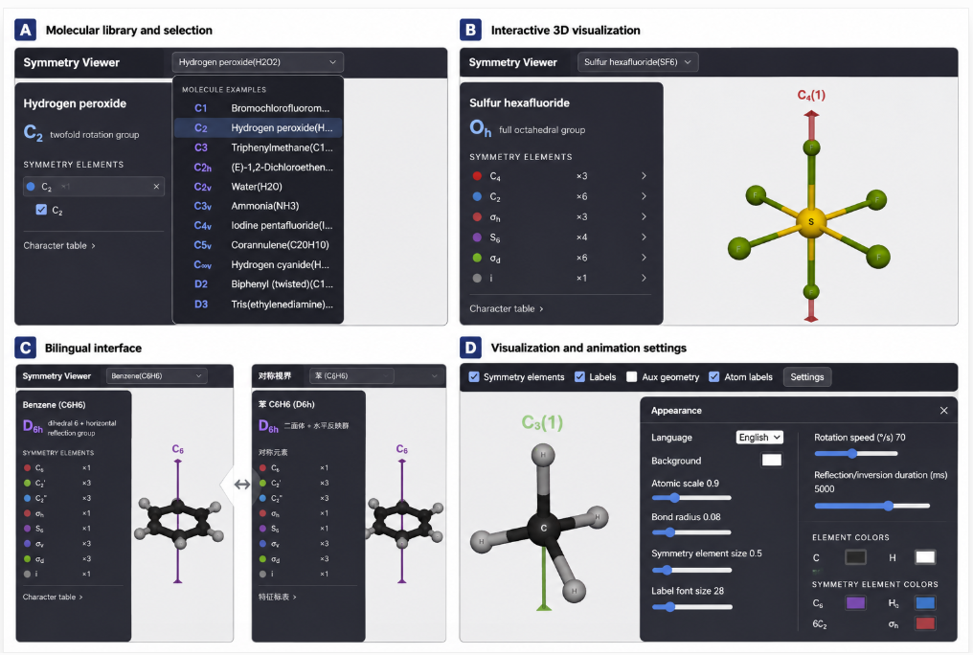

Figure 2. Interactive interface and visualization functions of the molecular symmetry WeChat Mini Program. (A) Molecular library for selecting representative molecules from different point groups. (B) Interactive 3D visualization of SF₆ (Oₕ), showing the molecular structure, symmetry-element list, and a selected C₄ axis. (C) Chinese-language interface illustrated with benzene (D₆h), demonstrating bilingual support. (D) Settings panel for adjusting molecular and symmetry-element display as well as animation parameters.

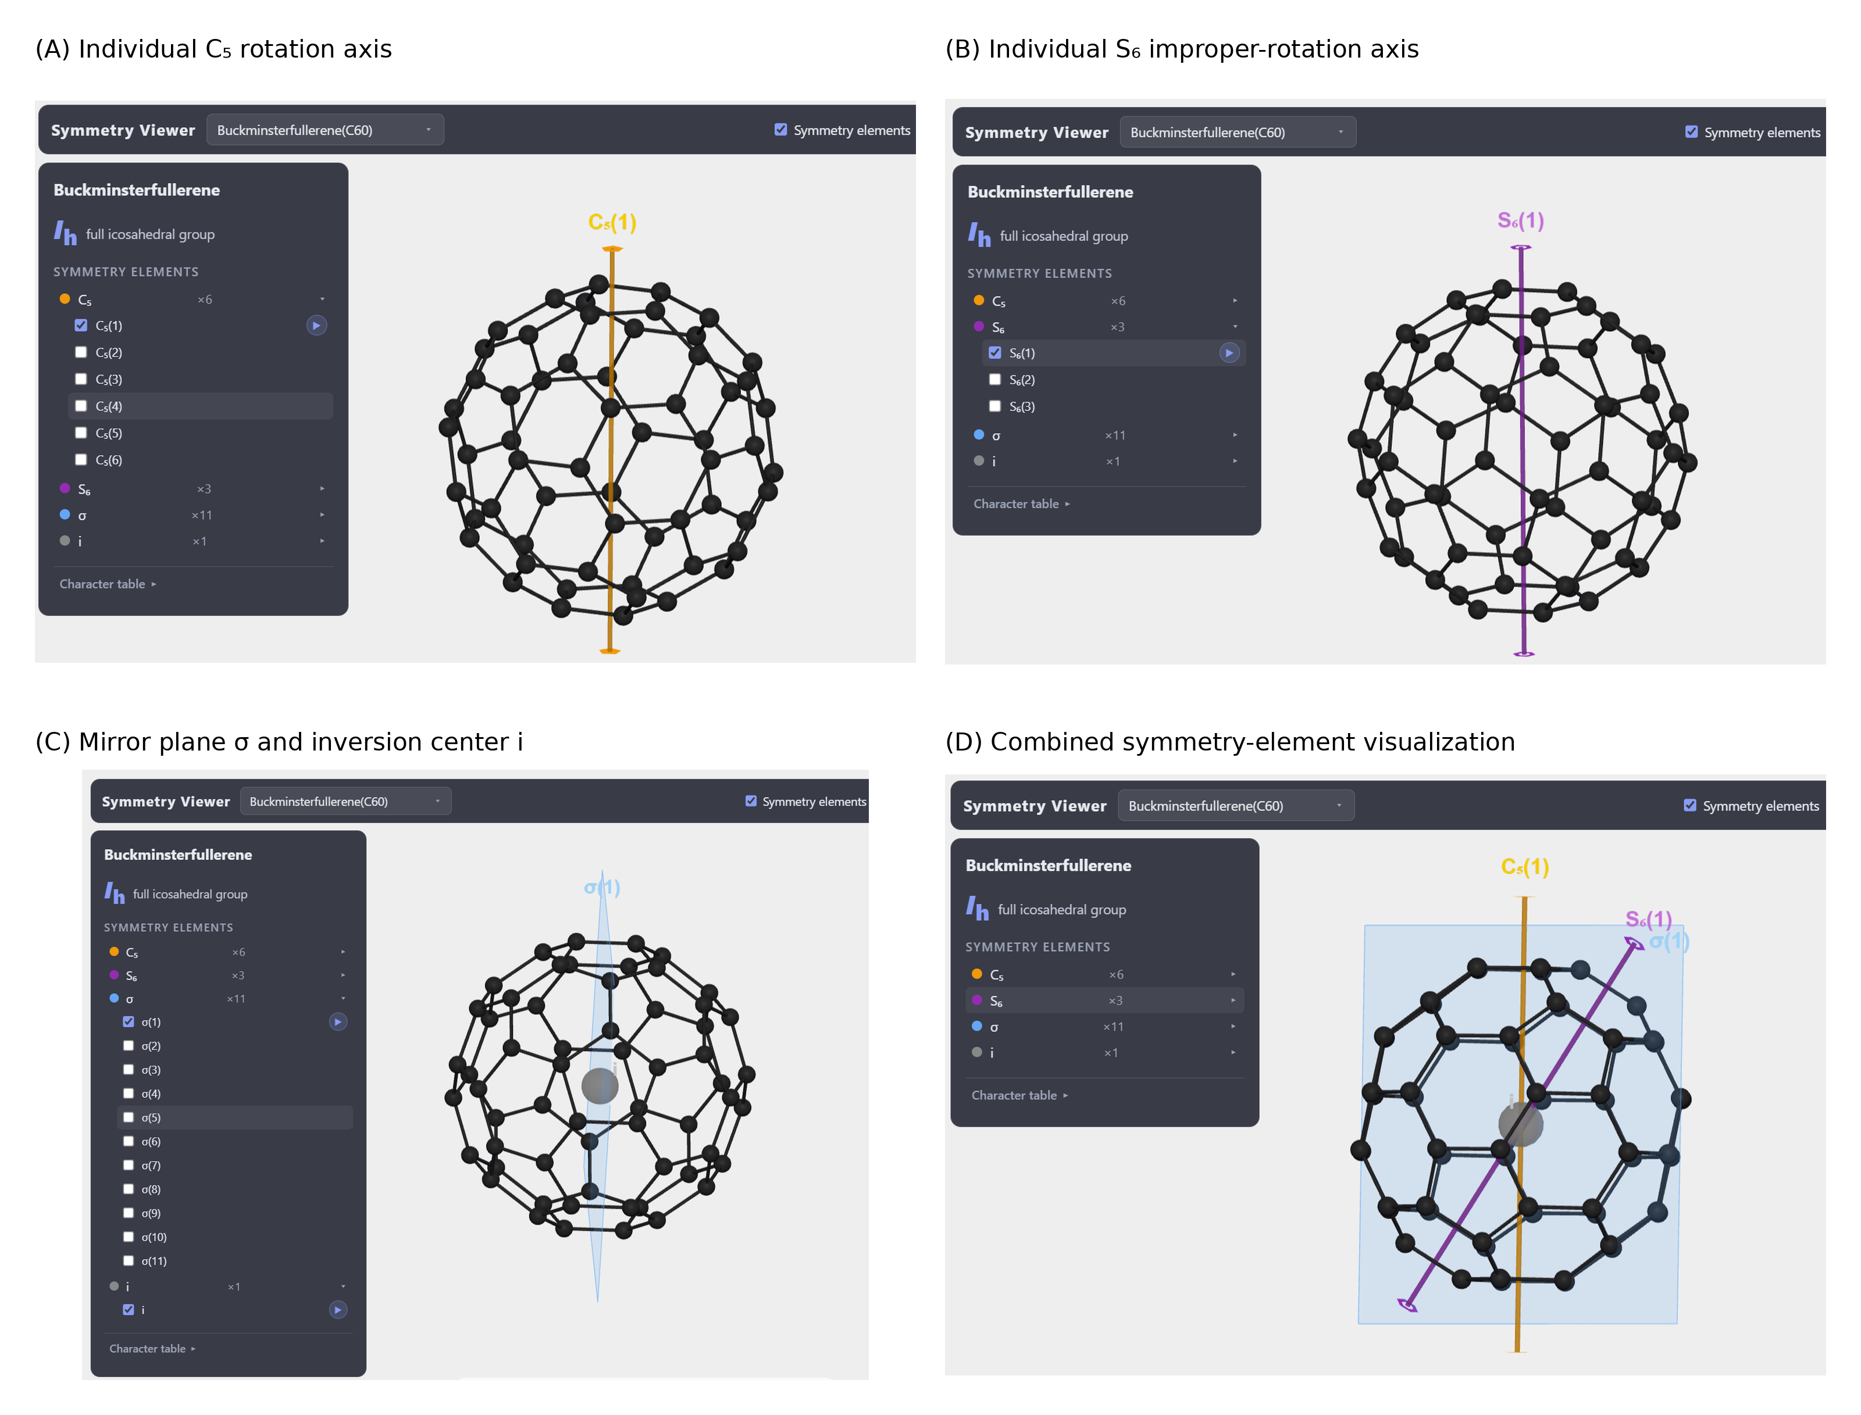
Figure 3. Selective visualization of representative molecular symmetry elements on interactive 3D molecular models. Individual symmetry elements can be displayed separately or in combination to support staged analysis of increasingly complex symmetry.
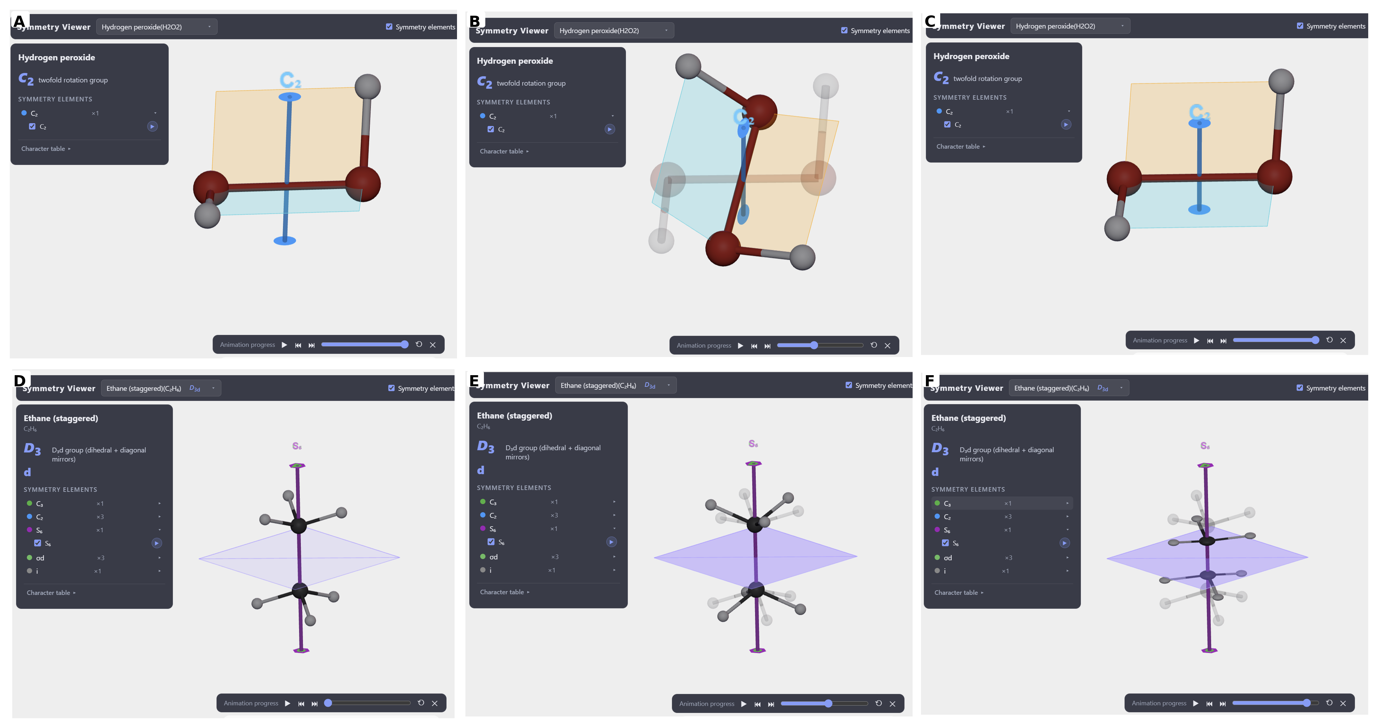
Figure 4. Animated visualization of representative symmetry operations. (A–C) Selected stages of a C₂ rotation of H₂O₂, showing the structure before, during, and after the 180° rotation. (D–F) Selected stages of an S₆ improper-rotation operation of staggered ethane, illustrating the sequential transformation relative to a semitransparent reference configuration. Animation controls allow intermediate configurations to be paused and examined.

