Họ Tên: Nguyễn Ngọc Tú

Lớp: 09_CNPM3

MSSV: 0950080079

THỰC HÀNH PHÁT TRIỂN CÔNG NGHỆ MÃ NGUỒN MỞ

Lab 1

1. Khảo sát web bán sách

Vinabook.com



Nhà sách Phương Nam



Nhà sách Fahasa:

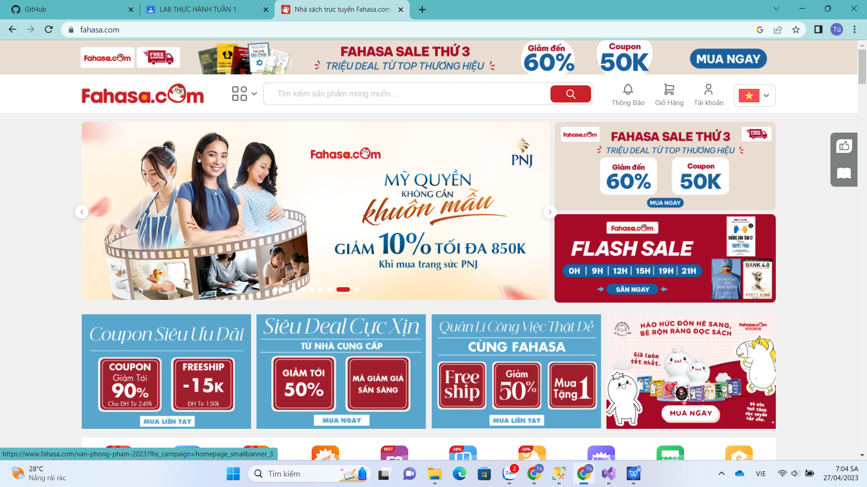

1. Cơ sở dữ liệu

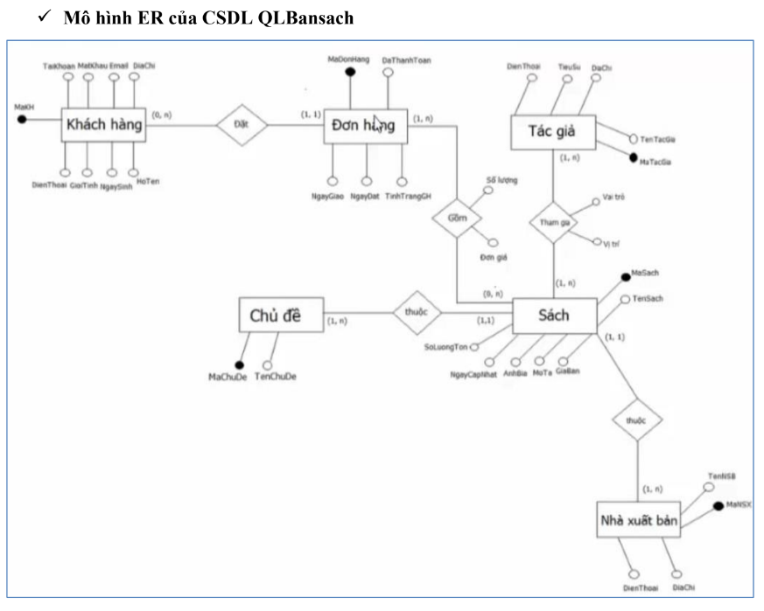

Cơ sở dữ liệu

---Xoa CSDL QLBansach neu da co

-----Tao CSDL QLBansach

create database QLBANSACH

use QLBANSACH

CREATE TABLE KHACHHANG

(

MaKH INT IDENTITY(1,1),

HoTen nVarchar(50) NOT NULL,

Taikhoan Varchar(50) UNIQUE,

Matkhau Varchar(50) NOT NULL,

Email Varchar(100) UNIQUE,

DiachiKH nVarchar(200),

DienthoaiKH Varchar(50),

Ngaysinh DATETIME

CONSTRAINT PK_Khachhang PRIMARY KEY(MaKH)

)

GO

Create Table CHUDE

(

MaCD int Identity(1,1),

TenChuDe nvarchar(50) NOT NULL,

CONSTRAINT PK_ChuDe PRIMARY KEY(MaCD)

)

GO

Create Table NHAXUATBAN

(

MaNXB int identity(1,1),

TenNXB nvarchar(50) NOT NULL,

Diachi NVARCHAR(200),

DienThoai VARCHAR(50),

CONSTRAINT PK_NhaXuatBan PRIMARY KEY(MaNXB)

)

Go

CREATE TABLE SACH

(

Masach INT IDENTITY(1,1),

Tensach NVARCHAR(100) NOT NULL,

Giaban Decimal(18,0) CHECK (Giaban>=0),

Mota NVarchar(Max),

Anhbia VARCHAR(50),

Ngaycapnhat DATETIME,

Soluongton INT,

MaCD INT,

MaNXB INT,

Constraint PK_Sach Primary Key(Masach),

Constraint FK_Chude Foreign Key(MaCD) References

CHUDE(MaCD),

Constraint FK_NhaXB Foreign Key(MaNXB)References

NHAXUATBAN(MANXB)

)

GO

CREATE TABLE TACGIA

(

MaTG INT IDENTITY(1,1),

TenTG NVARCHAR(50) NOT NULL,

Diachi NVARCHAR(100),

Tieusu nVarchar(Max),

Dienthoai VARCHAR(50),

CONSTRAINT PK_TacGia PRIMARY KEY(MaTG)

)

GO

CREATE TABLE VIETSACH

(

MaTG INT,

Masach INT,

Vaitro nVarchar(50),

Vitri nVarchar(50),

CONSTRAINT PK_VietSach PRIMARY KEY(MaTG,Masach),

Constraint FK_MaTG Foreign Key(MaTG) References TACGIA(MaTG),

Constraint FK_Masach Foreign Key(Masach) References SACH(Masach),

)

GO

CREATE TABLE DONDATHANG

(

MaDonHang INT IDENTITY(1,1),

Dathanhtoan bit,

Tinhtranggiaohang bit,

Ngaydat Datetime,

Ngaygiao Datetime,

MaKH INT,

CONSTRAINT FK_Khachhang FOREIGN KEY (MaKH) REFERENCES KHACHHANG(MaKH),

CONSTRAINT PK_DonDatHang PRIMARY KEY (MaDonHang)

)

Go

CREATE TABLE CHITIETDONTHANG

(

MaDonHang INT,

Masach INT,

Soluong Int Check(Soluong>0),

Dongia Decimal(18,0) Check(Dongia>=0),

CONSTRAINT PK_CTDatHang PRIMARY KEY(MaDonHang,Masach),

CONSTRAINT FK_Donhang FOREIGN KEY (MaDonHang) REFERENCES DONDATHANG(MaDonHang),

CONSTRAINT FK_Sach FOREIGN KEY (Masach)

REFERENCES Sach(Masach)

)

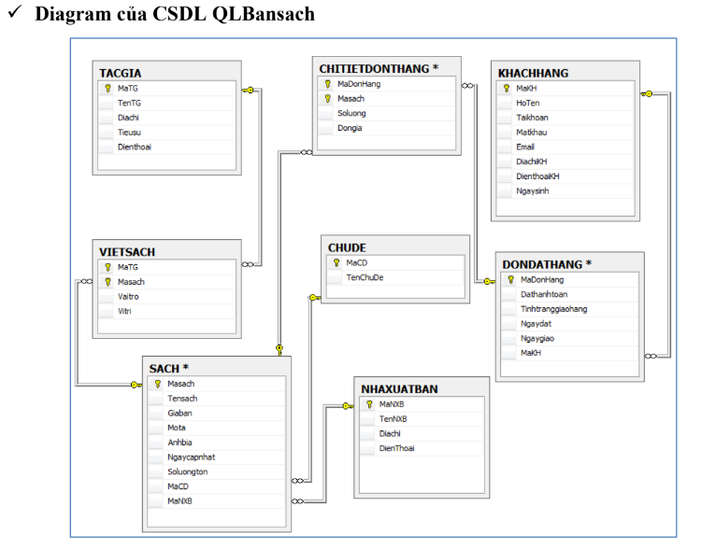

1. Layout Website template

