日期：9.28
2-16：
- #include<iostream>
- using namespace std;
- int main()
- {
- cout << "请输入一个数字" << endl;
- int a;
- cin >> a;
- cout << "您输入的数字是" << a << endl;
- return 0;
- }
Int 定义一个连，cin让用户输入，最后用cout将用户输入的数字打印出来

2-19：
- #include<iostream>
- using namespace std;
- int main()
- {
- unsigned int x;
- unsigned int y = 100;
- unsigned int z = 50;
- x = y - z;
- cout << "Difference is:" << x << endl;
- x = z - y;
- cout << "\nNow difference is:" << x << endl;
- return 0;
- }
运行结果如下：
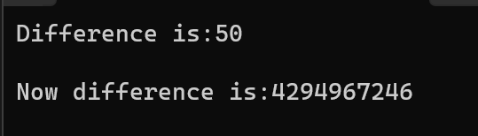
与猜想一致，如果赋值给无符号类型一个超过它表示范围的值（负数），结果是初始值对无符号类型表示数值最大值取模后的余数，而unsigned int占4个字节，则最大值是2的32次方，为4294967296。所以会出现这种情况

2-20：
- #include<iostream>
- using namespace std;
- int main()
- {
- int myAge = 39;
- int yourAge = 39;
- cout << "I am:" << myAge << "years old." << endl; //39
- cout << "You are:" << yourAge << "years old." << endl; //39
- myAge++;
- ++yourAge;
- cout << "One year passes..." << endl;
- cout << "I am:" << myAge << "years old." << endl; //40
- cout << "You are:" << yourAge << "years old." << endl; //40
- cout << "Another year passes." << endl;
- cout << "I am:" << myAge++ << "years old." << endl; //40
- cout << "You are:" << ++yourAge << "years old." << endl; //41
- cout << "Let's print it again." << endl;
- cout << "I am:" << myAge << "years old." << endl; //41
- cout << "You are:" << yourAge << "years old." << endl; //41
- return 0;
- }
运行结果如下：
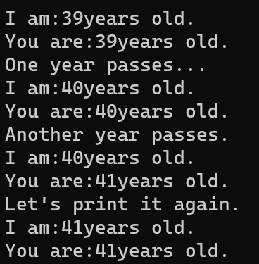
与预期结果一致，++在前就先自己+1再打印，++在后就先打印再自己+1

2-26：
- #include<iostream>
- using namespace std;
- int main()
- {
- while (1)
- {
- cout << "现在正在下雨吗？Y/N" << endl;
- char a;
- cin >> a;
- if (a == 'Y')
- {
- cout << "现在正在下雨。" << endl;
- break;
- }
- else if (a == 'N')
- {
- cout << "现在没有下雨。" << endl;
- break;
- }
- else
- {
- cout << "请用Y或N回答。" << endl;
- }
- }
- return 0;
- }
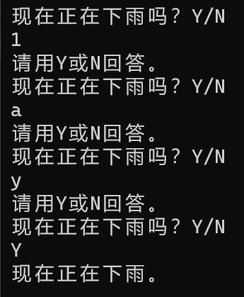运行截图
主体使用while循环，确保一直提问用户，先定义字符，让用户输入，再用if…else语句判断结果
Made by 2023217273王竞翔

