实验7
实验目的：
- 掌握类的定义和实现。
- 掌握对象创建及使用的基本方法。
实验内容：
（1）下面程序定义了一个以hours, minutes和seconds作为数据成员的Time类。设计了成员函数将两个Time对象相加（即时间相加），并进行相应的检查，查看增加的分钟数及秒数是否大于59。如果秒数大于59，则分钟数向前递增1。类似地，如果分钟数大于59，则小时数向前增1。
#include <iostream.h>

class Time
{
private:
int hours, minutes, seconds;
public:
void get_time()
{
cin>>hours>>minutes>>seconds;
}
void display_time()
{
cout<<hours<<':'<<minutes<<':'<<seconds<<endl;
}
void add_time(Time & t1, Time & t2)
{
hours=t1.hours+t2.hours;
minutes=t1.minutes+t2.minutes;
seconds=t1.seconds+t2.seconds;
if(seconds>=60)
{
seconds-=60;
minutes++;
}
if(minutes>=60)
{
minutes-=60;
hours++;
}
}
};

void main()
{
Time one, two, three;
cout<<"\nEnter the first time(hours minutes seconds):";
one.get_time();
cout<<"\nEnter the second time(hours minutes seconds):";
two.get_time();
three.add_time(one,two);
cout<<"the result is:"<<endl;
three.display_time();
}

[基本要求]
- 上机录入、调试上面程序。
- 运行程序，输入下面两组数据：
- 2 34 45
1 47 56

② 2 67 100
1 56 200
分析运行结果是否正确。
[分析与思考]
- 定义构造函数对Time类的对象进行初始化（即不用成员函数get_time）。
- 该程序要求用户输入的分钟数和秒数必须小于60，如何修改程序使得用户在输入分钟数和秒数大于等于60时，也能得到正确的结果。

（2）阅读下面的一段程序代码，代码可能有错误，请仔细分析并体会。
class Date {
public:
void Date(){};
int Date(int year,int month,int day);
void ~Date(){};
int &GetYear(){return year;}
int &GetMonth(){return month;}
int &GetDay(){return day;}
private:
int year=2000;
int month=12;
int day=31;
static bool IsLeapyear;//是否闰年
};
bool Date::IsLeapyear=true;
int Date::Date(int year,int month,int day)
{
(*this).year=year;
(*this).month=month;
(*this).day=day;
}

void main()
{
int year,month,day;
cin>>year>>month>>day;
Date mydate(year,month,day);
int &myyear=mydate.GetYear();
int &mymonth=mydate.GetMonth();
int &myday=mydate.GetDay();
cout<<myyear<<endl<<mymonth<<endl<<myday<<endl;
myyear=8888;
cout<< mydate.GetYear();
}
[基本要求]
·仔细阅读上面程序，如果有错误，请更正。
·上机录入、调试上面程序。
算法分析与设计：
程序定义了一个以hours, minutes和seconds作为数据成员的Time类。设计了成员函数将两个Time对象相加（即时间相加），并进行相应的检查，查看增加的分钟数及秒数是否大于59。如果秒数大于59，则分钟数向前递增1。类似地，如果分钟数大于59，则小时数向前增1。
源代码：
- #include <iostream>
- using namespace std;
- class Time
- {
- private:
- int hours, minutes, seconds;
- public:
- void get_time()//输入时间
- {
- cin >> hours >> minutes >> seconds;
- }
- void display_time()//展示时间
- {
- cout << hours << ':' << minutes << ':' << seconds << endl;
- }
- void add_time(Time& t1, Time& t2)
- {
- hours = t1.hours + t2.hours;
- minutes = t1.minutes + t2.minutes;
- seconds = t1.seconds + t2.seconds;
- if (seconds >= 60)
- {
- seconds -= 60;
- minutes++;
- }
- if (minutes >= 60)
- {
- minutes -= 60;
- hours++;
- }
- }
- };

- void main()
- {
- Time one, two, three;
- cout << "\nEnter the first time(hours minutes seconds):";
- one.get_time();//输入时间1
- cout << "\nEnter the second time(hours minutes seconds):";
- two.get_time();//输入时间2
- three.add_time(one, two);
- cout << "the result is:" << endl;
- three.display_time();//输出时间12之和
- }
- 测试过程和运行结果分析：
运行程序，输入下面两组数据：
- 2 34 45
1 47 56

② 2 67 100
1 56 200
第一组：
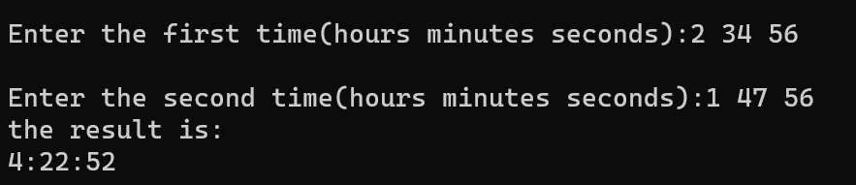
第一组符合实际
第二组：
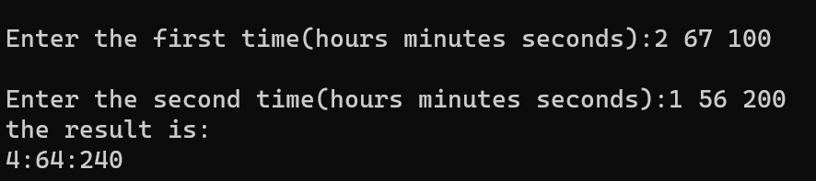
第二组明显不符合实际，因为60进1这个操作只会执行一次，对于正常的输入，只会输入0-59，所以没写循环至多执行一次，但是人为可以输入任何整数，所以要加上循环，直到秒数和分钟数都满足0-59为止
2.
源代码（改进后）：
- #include<iostream>
- using namespace std;
- class Date {
- public:
- //Date(int, int, int) {};
- Date(int year, int month, int day);
- ~Date() {};
- int GetYear() { return year; }
- int GetMonth() { return month; }
- int GetDay() { return day; }
- private:
- int year;
- int month;
- int day;
- static bool IsLeapyear;//是否闰年
- };
- bool Date::IsLeapyear = true;
- Date::Date(int year, int month, int day)
- {
- (*this).year = year;
- (*this).month = month;
- (*this).day = day;
- }

- int main()
- {
- int year, month, day;
- cin >> year >> month >> day;
- Date mydate(year, month, day);
- int myyear = mydate.GetYear();
- int mymonth = mydate.GetMonth();
- int myday = mydate.GetDay();
- cout << myyear << endl << mymonth << endl << myday << endl;
- myyear = 8888;
- cout << mydate.GetYear();
- return 0;
- }
算法分析：定义了一个Date 类，然后里面有对象年月日，通过函数提供对外的输入输出接口进行赋值操作，然后进行输出
运行结果：
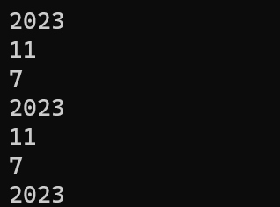
实验总结：主要学习了如何表示时间
实验8
实验目的：
- 掌握单继承程序设计的基本方法。
- 掌握多继承程序设计的基本方法。
实验内容：
(1) 下面程序定义一个vehicle类，并派生出car和truck两个派生类。
#include<iostream.h>
class vehicle
{
protected:
int wheels;
double weight;
public:
void initialize(int whls, double wght);
int get_wheels() { return wheels; }
double get_weight() { return weight; }
double wheel_loading() { return weight/wheels; }
};

class car: public vehicle
{
private:
int passenger_load;
public:
void initialize(int whls, double wght, int people =4);
int passengers() { return passenger_load; }
};

class truck: public vehicle
{
private:
int passenger_load;
double payload;
public:
void init_truck(int number =2, double max_load =24000.0);
double efficiency();
int passengers() { return passenger_load; }
};

void vehicle::initialize(int whls, double wght)
{
wheels=whls;
weight=wght;
}

void car::initialize(int whls, double wght, int people)
{
wheels=whls;
weight=wght;
passenger_load=people;
}

void truck::init_truck(int number, double max_load)
{
passenger_load=number;
payload=max_load;
}

double truck::efficiency()
{
return payload/(payload+weight);
}

void main()
{
vehicle bicycle;
bicycle.initialize(2,25);
cout<<"the bicycle has "<<bicycle.get_wheels()<<" wheels.\n";
cout<<"the bicycle weighs "<<bicycle.get_weight()<<" pounds.\n";
cout<<"the bicycle's wheel loading is "<<bicycle.wheel_loading()<<" pounds per tire.\n\n";

car audi;
audi.initialize(4,3500.0,5);
cout<<"the audi has "<<audi.get_wheels()<<" wheels.\n";
cout<<"the audi weighs "<<audi.get_weight()<<" pounds.\n";
cout<<"the audi's wheel loading is "<<audi.wheel_loading()<<" pounds per tire.\n\n";

truck jief;
jief.initialize(18,12500.0);
jief.init_truck(2,33675.0);
cout<<"the jief has "<<jief.get_wheels()<<" wheels.\n";
cout<<"the jief weighs "<<jief.get_weight()<<" pounds.\n";
cout<<"the jief's efficiency is "<<100.0*jief.efficiency()<<" percent.\n";
}

[基本要求]
- 上机录入、调试上面程序。
- 运行程序，观察运行结果是否正确且满足题意要求。
- 将class car: public vehicle和class truck: public vehicle分别改为：
class car: private vehicle和class truck: private vehicle
程序运行结果有无变化，为什么？
[分析与思考]
- 定义并实现vehicle类、car类和truck类的构造函数，完成vehicle类、car类和truck类的数据成员初始化工作。
- 将vehicle中数据成员wheels和weight改为private性质，如何修改程序以达到相同的输出结果。

（2）下面程序对应图1所示的类层次继承结构:
person

#include <iostream.h>
person

#include <iomanip.h>
#include <string.h>
graduate

teacher

class person
{
protected:
char name[20];
int birth_year;
in-service_graduate

public:
person(char *na, int year) {
strcpy(name,na);
birth_year=year;
}
int cal_age(int this_year) {
return this_year-birth_year;
}
};

class graduate :public person
{
protected:
int grade;
char specialty[20];
public:
graduate(char *na, int y, int g, char *spec):person(na,y) {
grade=g;
strcpy(specialty,spec);
}
void display(int this_year) {
cout<<" graduate age grade specialty\n";
cout<<setw(20)<<name<<setw(5)<<cal_age(this_year);
cout<<setw(7)<<grade<<setw(17)<<specialty<<endl;
}
};

class teacher :public person
{
protected:
char title[15];
char specialty[20];
public:
teacher(char *na, int y, char *ti, char *spec):person(na,y) {
strcpy(title,ti);
strcpy(specialty,spec);
}
void display(int this_year) {
cout<<" teacher age title specialty\n";
cout<<setw(20)<<name<<setw(5)<<cal_age(this_year);
cout<<setw(14)<<title<<setw(17)<<specialty<<endl;
}
};

class in_service_graduate:public teacher, public graduate
{
public:
in_service_graduate(char *na, int y, char *ti, char *spec1, int g, char *spec2):
teacher(na, y, ti, spec1), graduate(na, y, g, spec2)
{ }
void display(int this_year) {
cout<<" in_service_graduate age title work_specialty grade study_specialty\n";

}
};

void main()
{
graduate gr("zhang_ling",1978,2001,"computer");
teacher te("wang_qiang", 1976,"tutor","electronics");
in_service_graduate sg("liu_hua",1975,"lectuer","automation",2002,"computer");
gr.display(2002);
cout<<endl;
te.display(2002);
cout<<endl;
sg.display(2002);
}

[基本要求]
- 阅读程序，完成in_service_graduate类中的display()函数的程序。
- 上机录入、调试上面程序。
- 运行程序，观察运行结果是否正确且满足题意要求。
[分析与思考]
- 在上面程序中类person中的数据成员name和birth_year在in_service_graduate类中有两个副本，请使用虚基类使它们在in_service_graduate类中只有一个副本。注意同时修改程序的其他相关部分。
测试结果和运行结果分析：
（1）：
- #include<iostream>
- using namespace std;
- class vehicle
- {
- protected:
- int wheels;
- double weight;
- public:
- void initialize(int whls, double wght);
- int get_wheels() { return wheels; }
- double get_weight() { return weight; }
- double wheel_loading() { return weight / wheels; }
- };

- class car : public vehicle
- {
- private:
- int passenger_load;
- public:
- void initialize(int whls, double wght, int people = 4);
- int passengers() { return passenger_load; }
- };

- class truck : public vehicle
- {
- private:
- int passenger_load;
- double payload;
- public:
- void init_truck(int number = 2, double max_load = 24000.0);
- double efficiency();
- int passengers() { return passenger_load; }
- };

- void vehicle::initialize(int whls, double wght)
- {
- wheels = whls;
- weight = wght;
- }

- void car::initialize(int whls, double wght, int people)
- {
- wheels = whls;
- weight = wght;
- passenger_load = people;
- }

- void truck::init_truck(int number, double max_load)
- {
- passenger_load = number;
- payload = max_load;
- }

- double truck::efficiency()
- {
- return payload / (payload + weight);
- }

- void main()
- {
- vehicle bicycle;
- bicycle.initialize(2, 25);
- cout << "the bicycle has " << bicycle.get_wheels() << " wheels.\n";
- cout << "the bicycle weighs " << bicycle.get_weight() << " pounds.\n";
- cout << "the bicycle's wheel loading is " << bicycle.wheel_loading() << " pounds per tire.\n\n";

- car audi;
- audi.initialize(4, 3500.0, 5);
- cout << "the audi has " << audi.get_wheels() << " wheels.\n";
- cout << "the audi weighs " << audi.get_weight() << " pounds.\n";
- cout << "the audi's wheel loading is " << audi.wheel_loading() << " pounds per tire.\n\n";

- truck jief;
- jief.initialize(18, 12500.0);
- jief.init_truck(2, 33675.0);
- cout << "the jief has " << jief.get_wheels() << " wheels.\n";
- cout << "the jief weighs " << jief.get_weight() << " pounds.\n";
- cout << "the jief's efficiency is " << 100.0 * jief.efficiency() << " percent.\n";
- }

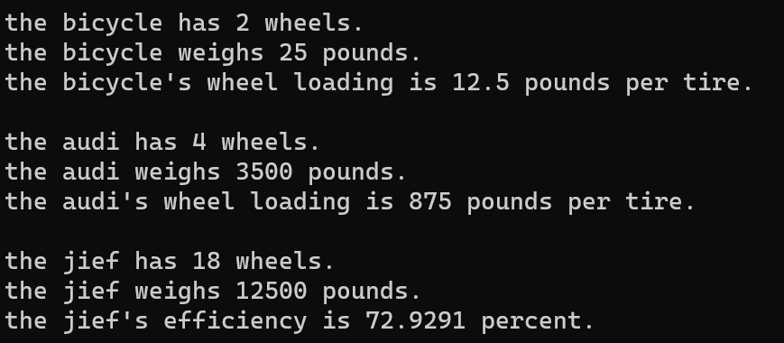
运行结果正确，符合要求
修改后：
- #include<iostream>
- using namespace std;
- class vehicle
- {
- protected:
- int wheels;
- double weight;
- public:
- void initialize(int whls, double wght);
- int get_wheels() { return wheels; }
- double get_weight() { return weight; }
- double wheel_loading() { return weight / wheels; }
- };

- class car : private vehicle
- {
- private:
- int passenger_load;
- public:
- void initialize(int whls, double wght, int people = 4);
- int passengers() { return passenger_load; }
- };

- class truck : private vehicle
- {
- private:
- int passenger_load;
- double payload;
- public:
- void init_truck(int number = 2, double max_load = 24000.0);
- double efficiency();
- int passengers() { return passenger_load; }
- };

- void vehicle::initialize(int whls, double wght)
- {
- wheels = whls;
- weight = wght;
- }

- void car::initialize(int whls, double wght, int people)
- {
- wheels = whls;
- weight = wght;
- passenger_load = people;
- }

- void truck::init_truck(int number, double max_load)
- {
- passenger_load = number;
- payload = max_load;
- }

- double truck::efficiency()
- {
- return payload / (payload + weight);
- }

- void main()
- {
- vehicle bicycle;
- bicycle.initialize(2, 25);
- cout << "the bicycle has " << bicycle.get_wheels() << " wheels.\n";
- cout << "the bicycle weighs " << bicycle.get_weight() << " pounds.\n";
- cout << "the bicycle's wheel loading is " << bicycle.wheel_loading() << " pounds per tire.\n\n";

- car audi;
- audi.initialize(4, 3500.0, 5);
- cout << "the audi has " << audi.get_wheels() << " wheels.\n";
- cout << "the audi weighs " << audi.get_weight() << " pounds.\n";
- cout << "the audi's wheel loading is " << audi.wheel_loading() << " pounds per tire.\n\n";

- truck jief;
- jief.initialize(18, 12500.0);
- jief.init_truck(2, 33675.0);
- cout << "the jief has " << jief.get_wheels() << " wheels.\n";
- cout << "the jief weighs " << jief.get_weight() << " pounds.\n";
- cout << "the jief's efficiency is " << 100.0 * jief.efficiency() << " percent.\n";
- }
这时会报错，因为继承方式为私有，car和 truck 类的成员无法调用之前的函数进行输出
（2）：
- 代码：
#include <iostream>
- #include <iomanip>
- #include <string>
- using namespace std;
- class person
- {
- protected:
- char name[20];
- int birth_year;
- public:
- person(char* na, int year) {
- strcpy(name, na);
- birth_year = year;
- }
- int cal_age(int this_year) {
- return this_year - birth_year;
- }
- };

- class graduate :public person
- {
- protected:
- int grade;
- char specialty[20];
- public:
- graduate(char* na, int y, int g, char* spec) :person(na, y)
- {
- grade = g;
- strcpy(specialty, spec);
- }
- void display(int this_year) {
- cout << " graduate age grade specialty\n";
- cout << setw(20) << name << setw(5) << cal_age(this_year);
- cout << setw(7) << grade << setw(17) << specialty << endl;
- }
- };

- class teacher :public person
- {
- protected:
- char title[15];
- char specialty[20];
- public:
- teacher(char* na, int y, char* ti, char* spec) :person(na, y) {
- strcpy(title, ti);
- strcpy(specialty, spec);
- }
- void display(int this_year) {
- cout << " teacher age title specialty\n";
- cout << setw(20) << name << setw(5) << cal_age(this_year);
- cout << setw(14) << title << setw(17) << specialty << endl;
- }
- };

- class in_service_graduate :public teacher, public graduate
- {
- public:
- in_service_graduate(char* na, int y, char* ti, char* spec1, int g, char* spec2) :
- teacher(na, y, ti, spec1), graduate(na, y, g, spec2)
- { }
- void display(int this_year) {
- cout << " in_service_graduate age title work_specialty grade study_specialty\n";

- }
- };

- void main()
- {
- graduate gr("zhang_ling", 1978, 2001, "computer");
- teacher te("wang_qiang", 1976, "tutor", "electronics");
- in_service_graduate sg("liu_hua", 1975, "lectuer", "automation", 2002, "computer");
- gr.display(2002);
- cout << endl;
- te.display(2002);
- cout << endl;
- sg.display(2002);
- }
不满足要求，没有使用虚继承，导致in-service_graduate中有两份副本
实验9
实验目的：
- 掌握虚函数定义及实现。
- 掌握具有多态性的面向对象程序设计的基本方法。
- 掌握纯虚函数与抽象类的定义、实现及应用。
实验内容：
有一个整数链表，现从此链表派生出一个整数集合类，在集合类中增加一个元素个数的数据项。集合类的插入操作与链表相似，只是不插入重复元素，并且插入后，元素个数的数据成员需增加。集合类的删除操作是在链表删除操作的基础上对元素个数做减1操作。而查找和输出操作是相同的，因此在集合类中不需要重复定义。
#include <iostream.h>
#include <conio.h>
// enum bool {false,true};
struct element { //定义链表中的结点结构
int val;
element *next;
};

class list { //定义链表类
element *elems;
public:
list() {elems=0;}
~list();
virtual bool insert(int); //此虚函数在派生类中可重新定义
virtual bool deletes(int); //此虚函数在派生类中可重新定义
bool contain(int);
void print();
};

class set:public list { //将集合类set定义为链表类list的派生类
int card;
public:
set() {card=0; }
bool insert(int); //重定义此函数
bool deletes(int); //重定义此函数
};

list::~list() //list类得析构函数定义，循环释放各元素所占的存储
{
element *tmp=elems;
for(element *elem=elems; elem!=0;)
{
tmp=elem;
elem=elem->next;
delete tmp;
}
}

bool list::insert(int val) //定义list类中插入元素的成员函数
{
element *elem=new element; //为新元素分配存储
if (elem!=0) {
elem->val=val; //将新元素插入到链表头
elem->next=elems;
elems=elem;
return true;
}
else return false;
}

bool list::deletes(int val) //定义list类中删除元素的成员函数
{
if(elems==0) return false; //若表为空，返回false
element *tmp=elems;
if(elems->val==val)
{ //若待删除的元素为表头元素
elems=elems->next;
delete tmp;
return true;
}
else
for(element *elem=elems; elem->next!=0; elem=elem->next)
if(elem->next->val==val)
{ //循环查找待删除元素
tmp=elem->next;
elem->next=tmp->next;
delete tmp;
return true;
}
return false;
}

bool list::contain(int val)
{ //判元素val在链表中是否存在
if(elems==0)return false;
if(elems->val==val) return true;
else
for(element *elem=elems; elem->next!=0; elem=elem->next)
if(elem->next->val==val)
return true;
return false;
}

void list::print() //输出链表中各元素
{
if(elems==0) return;
for(element *elem=elems; elem!=0; elem=elem->next)
cout<<elem->val<<" ";
cout<<endl;
}

bool set::insert(int val) //在set类中的insert的重定义版本
{
if( （1） )
{ //先判断此元素是否存在，然后再调用基类的此函数版本
++card;
return true;
}
return false;
}

bool set::deletes(int val) //在set类中的deletes的重定义版本
{
if(list::deletes(val)) //调用基类中的此函数版本
{ （2） ;
return true;
}
return false;
}

int main()
{
list *ptr,list1;
set set1;
ptr=&list1;
ptr->insert(30);
ptr->insert(40);
ptr->insert(543);
ptr->insert(40);
ptr->print();
ptr=&set1;
ptr->insert(23);
ptr->insert(672);
ptr->insert(456);
ptr->insert(23);
ptr->print();
getch();
return 1;
}
[基本要求]
- 阅读程序，根据题意要求在 处填上合适的内容完成程序。
- 上机录入、调试上面程序。
- 运行程序，设计测试数据，观察运行结果是否正确且满足题意要求。
源代码：
- #include <iostream>
- using namespace std;
- #include <conio.h>
- // enum bool {false,true};
- struct element { //定义链表中的结点结构
- int val;
- element* next;
- };

- class list { //定义链表类
- element* elems;
- public:
- list() { elems = 0; }
- ~list();
- virtual bool insert(int); //此虚函数在派生类中可重新定义
- virtual bool deletes(int); //此虚函数在派生类中可重新定义
- bool contain(int);
- void print();
- };

- class set :public list { //将集合类set定义为链表类list的派生类
- int card;
- public:
- set() { card = 0; }
- bool insert(int); //重定义此函数
- bool deletes(int); //重定义此函数
- };

- list::~list() //list类得析构函数定义，循环释放各元素所占的存储
- {
- element* tmp = elems;
- for (element* elem = elems; elem != 0;)
- {
- tmp = elem;
- elem = elem->next;
- delete tmp;
- }
- }

- bool list::insert(int val) //定义list类中插入元素的成员函数
- {
- element* elem = new element; //为新元素分配存储
- if (elem != 0) {
- elem->val = val; //将新元素插入到链表头
- elem->next = elems;
- elems = elem;
- return true;
- }
- else return false;
- }

- bool list::deletes(int val) //定义list类中删除元素的成员函数
- {
- if (elems == 0) return false; //若表为空，返回false
- element* tmp = elems;
- if (elems->val == val)
- { //若待删除的元素为表头元素
- elems = elems->next;
- delete tmp;
- return true;
- }
- else
- for (element* elem = elems; elem->next != 0; elem = elem->next)
- if (elem->next->val == val)
- { //循环查找待删除元素
- tmp = elem->next;
- elem->next = tmp->next;
- delete tmp;
- return true;
- }
- return false;
- }

- bool list::contain(int val)
- { //判元素val在链表中是否存在
- if (elems == 0)return false;
- if (elems->val == val) return true;
- else
- for (element* elem = elems; elem->next != 0; elem = elem->next)
- if (elem->next->val == val)
- return true;
- return false;
- }

- void list::print() //输出链表中各元素
- {
- if (elems == 0) return;
- for (element* elem = elems; elem != 0; elem = elem->next)
- cout << elem->val << " ";
- cout << endl;
- }

- bool set::insert(int val) //在set类中的insert的重定义版本
- {
- if ((contain(val))?0:list::insert(val))
- { //先判断此元素是否存在，然后再调用基类的此函数版本
- ++card;
- return true;
- }
- return false;
- }

- bool set::deletes(int val) //在set类中的deletes的重定义版本
- {
- if (list::deletes(val)) //调用基类中的此函数版本
- {
- card--;
- return true;
- }
- return false;
- }

- int main()
- {
- list* ptr, list1;
- set set1;
- ptr = &list1;
- ptr->insert(30);
- ptr->insert(40);
- ptr->insert(543);
- ptr->insert(40);
- ptr->print();
- ptr = &set1;
- ptr->insert(23);
- ptr->insert(672);
- ptr->insert(456);
- ptr->insert(23);
- ptr->print();
- getch();
- return 1;
- }
运行结果分析：首先是通过list类创建的链表list1，插入了四个元素30、40、543、40，然后输出了链表中各元素。接下来通过set类创建的集合set1，插入了四个元素23、672、456、23，但由于集合不能出现重复元素，所以第二个23并没有被插入。最后输出了集合中各元素。
输出结果：30 40 543 40 23 672 456
实验十
实验目的：
学习教材有关运算符重载的内容，对基本运算符重载及特殊运算符重载有充分的理解。对实验基本要求应在上机实验前仔细阅读，程序应事先编制完成，上机时录入调试，同时还应设计相应的测试用例集，检查程序的正确性、可靠性、完备性和容错能力。

实验内容：
（1）将一个16位二进制数表示成0和1的字符序列，即用一个字符数组来存放这个二进制数。在这个类中设置两个构造函数，一个是传递整数参数的，另一个是传递字符串参数的。因为用户在创建对象时传递的二进制数，可能是以整数形式给出，也可能是以数字串形式给出，系统应该都能接受。另外有一个类型转换函数int()，用来将类类型向整型转换。程序中的两个重载运算符“+”，“-”，用来完成两个二进制数之间的加减运算。
#include "iostream.h"
#include "string.h"
#include "conio.h"

class binary { //定义二进制类
char bits[16]; //二进制字模数组
public:
binary(char *); //字符串参数构造函数
binary(int); //整型参数构造函数
friend binary operator +(binary,binary); //重载“+”
friend binary operator -(binary,binary); //重载“-”
operator int(); //类类型转换函数
void print();
};

binary::binary(char *num)
{
int isrc=strlen(num)-1; //字符串长度-1为最低位
int idest=15;
while(isrc>=0 && idest>=0)
bits[idest--]=(num[isrc--]=='0'?'0':'1'); // 逐位赋值
while(idest>=0) bits[idest--]='0'; // 空高位值0
}

binary::binary(int num)
{
for(int i=15; i>=0;i--)
{ bits[i]=( （1） ); //求余数
num>>=1; //移位，相当于整除2
}
}

binary operator +(binary n1, binary n2)
{
unsigned carry=0;
unsigned value;
binary res="0";
for(int i=15; i>=0; i--)
{
value=(n1.bits[i]=='0'?0:1)+( （2） )+carry;
res.bits[i]=(value%2==0?'0':'1');
carry=value>>1;
}
return res;
}

binary operator -(binary n1, binary n2)
{
unsigned borrow=0;
int value;
binary res="0";
for(int i=15; i>=0; i--)
{
value=(n1.bits[i]=='0'?0:1)-(n2.bits[i]=='0'?0:1)+borrow;
res.bits[i]=(value==-1||value==1?'1':'0');
borrow=(value==-1||borrow!=0&&(value==0||value==1)?1:0);
}
return res;
}

binary::operator int()
{
unsigned value=0;
for(int i=0; i<=15; i++)
value=( （3） )+(bits[i]=='0'?0:1);
return value;
}

void binary::print()
{
char str[17];
strncpy(str,bits,16);
str[16]='\0';
cout<<str<<"\n";
}

main()
{
binary n1="1011";
binary n2=int(n1)+15;
binary n3=n1-binary(7);
n1.print();
n2.print();
n3.print();
cout<<int(n2)+5<<endl;
cout<<n2-binary(5)<<endl;
cout<<n3+binary(5)<<endl;
cout<<int(n3)-5<<endl;
getch();
return 1;
}

[基本要求]
- 阅读下列程序，根据题意要求在 处填上合适的内容完成程序。
- 上机录入、调试上面程序。
- 运行程序，纪录并分析运行结果是否正确。
测试过程和源代码：
- #include <iostream>
- #include <string>
- #include <conio>
- using namespace std;
- class binary { //定义二进制类
- char bits[16]; //二进制字模数组
- public:
- binary(char*); //字符串参数构造函数
- binary(int); //整型参数构造函数
- friend binary operator +(binary, binary); //重载“+”
- friend binary operator -(binary, binary); //重载“-”
- operator int(); //类类型转换函数
- void print();
- };

- binary::binary(char* num)
- {
- int isrc = strlen(num) - 1; //字符串长度-1为最低位
- int idest = 15;
- while (isrc >= 0 && idest >= 0)
- bits[idest--] = (num[isrc--] == '0' ? '0' : '1'); // 逐位赋值
- while (idest >= 0) bits[idest--] = '0'; // 空高位值0
- }

- binary::binary(int num)
- {
- for (int i = 15; i >= 0; i--)
- {
- bits[i] = (num % 2 == 0 ? '0' : '1'); //求余数
- num >>= 1; //移位，相当于整除2
- }
- }

- binary operator +(binary n1, binary n2)
- {
- unsigned carry = 0;
- unsigned value;
- binary res = "0";
- for (int i = 15; i >= 0; i--)
- {
- value = (n1.bits[i] == '0' ? 0 : 1) + (n2.bits[i] == '0' ? 0 : 1) + carry;
- res.bits[i] = (value % 2 == 0 ? '0' : '1');
- carry = value >> 1;
- }
- return res;
- }

- binary operator -(binary n1, binary n2)
- {
- unsigned borrow = 0;
- int value;
- binary res = "0";
- for (int i = 15; i >= 0; i--)
- {
- value = (n1.bits[i] == '0' ? 0 : 1) - (n2.bits[i] == '0' ? 0 : 1) + borrow;
- res.bits[i] = (value == -1 || value == 1 ? '1' : '0');
- borrow = (value == -1 || borrow != 0 && (value == 0 || value == 1) ? 1 : 0);
- }
- return res;
- }

- binary::operator int()
- {
- unsigned value = 0;
- for (int i = 0; i <= 15; i++)
- value = (value * 2) + (bits[i] == '0' ? 0 : 1);
- return value;
- }

- void binary::print()
- {
- char str[17];
- strncpy(str, bits, 16);
- str[16] = '\0';
- cout << str << "\n";
- }

- main()
- {
- binary n1 = "1011";
- binary n2 = int(n1) + 15;
- binary n3 = n1 - binary(7);
- n1.print();
- n2.print();
- n3.print();
- cout << int(n2) + 5 << endl;
- cout << n2 - binary(5) << endl;
- cout << n3 + binary(5) << endl;
- cout << int(n3) - 5 << endl;
- getch();
- return 1;
- }
算法分析：定义了一个名为binary的类，表示二进制数，然后重载了+ - 运算符，然后定义了一个类型转换函数，吧二进制的数转化为int类型的，主函数里，首先创建了一个二进制类的对象，1011.然后通过其转换成int并且加上15，创建一个新成员存储25，最后分别输出n2+5，n2减去binary（5），n3加上binary（5）的结果
实验十一
实验目的：
- 掌握函数模板定义、实现及应用的基本方法。
- 掌握类模板定义、实现及应用的基本方法。
- 掌握C++标准模板库STL的初步应用。
实验内容：
(1) 下面程序给出了降序气泡排序的函数模板及其应用：
#include <iostream.h>

template<class T>
void swap( ) //辅助函数：交换x和y的值
{
T temp;
temp=x;
x=y;
y=temp;
}

template <class T>
void bubblesort(T a[], int n)
{
int i,j;
int index;
i=n-1;
while(i>0)
{
index=0;
for(j=0; j<i; j++)
if(a[j+1]>a[j])
{
swap(a[j],a[j+1]);
index= ;
}
i=index;
}
}

void main()
{
int i;
int data[]={1,4,5,2,3,12,14,13,8,19,36,11,9,15,7,34,23,6,10,21};
cout<<"before sort:"<<endl;
for(i=0; i<20; i++)
cout<<data[i]<<' ';
cout<<endl;
bubblesort(data,20);
cout<<"after sorted:"<<endl;
for(i=0; i<20; i++)
cout<<data[i]<<' ';
cout<<endl;
}
[基本要求]
- 阅读程序，根据题意要求在 处填上合适的内容完成程序。
- 上机录入、调试上面程序。
- 运行程序，设计不同类型的测试数据（上面程序使用整型数组作为测试用例），观察运行结果是否正确且满足题意要求。
[分析与思考]
- 对于如下定义的指针数组：
char *strarr[]={“Fortran”, “Basic”, “pascal”, “C”, “C++”}
上面的函数模板是否可用，若不可用，程序如何修改以达到对字符串数组的排序。
(2) 下面程序定义了一个栈类模板
#include <iostream.h>
template <class T>
class Stack
{
private:
T *data;
int top, size;
int IsEmpty() { return (top<=0)?1:0; }
int IsFull() { return (top>=size)?1:0; }
public:
Stack(int n) {
data=new T[n];
size=n;
top=0;
}
~Stack() { delete []data; }
void Push( T x);
T Pop();
};

template <class T>
void Stack<T>::Push(T x)
{
if(IsFull()) {
cout<<"stack overflow.\n";
return;
}
*(data+top++)=x;
return;
}

template <class T>
T Stack<T>::Pop()
{
if(IsEmpty()) {
cout<<"stack underflow.\n";
return(-1);
}
return (*(data+--top));
}
[基本要求]
- 编写应用程序（主函数），创建不同类型的栈类对象，调试运行程序，观察运行结果是否正确且满足题意要求。
（3)下面程序是使用STL实现的对学生信息的管理操作，包括添加，删除，查找，显示等基本功能。
#include<iostream>
#include<algorithm>
#include<string>
#include<vector>
#include<stdio.h>
using namespace std;
struct student{
string no;
string name;
int age;
};

class nocmp{
string no;
public:
nocmp(string& s){no=s;}
bool operator()(student& s){ ______________________________}
};

class namecmp{
string name;
public:
namecmp(string& s){name=s;}
bool operator()(student& s){______________________________}
};
struct dump{
void operator()(student&s){
cout<<"学号: "<<s.no <<" "<<"姓名: "<<s.name<<"年龄: "<<s.age <<endl;
}
};

void ini()
{ cout<<endl;
cout<<"****************************************************************"<<endl;
cout<<" 欢迎进入学生管理系统，请选择相应的功能，如 按 1 键，进行添加操作"<<endl;
cout<<" 1 ：添加 "<<" "<<"2 ：删徐 "<<endl;
cout<<" 3 ：查找"<<" "<<"4 ：显示 "<<endl;
cout<<" q ：退出"<<endl;
cout<<"****************************************************************"<<endl;
cout<<"请选择：";
}

void display(vector<student>& v){
for_each(______________________________);
}

void add(vector<student>& v){
char ch;
string s;
do{
cin.get();
student stu;
cout<<"学号: ";
getline(cin,stu.no,'\n');
cout<<"姓名: ";
getline(cin,stu.name,'\n');
cout<<"年龄: ";
cin>>stu.age ;
______________________________
cout<<"要继续添加吗？按y键继续:";
cin>>ch;
}
while(ch=='y');
}

void del(vector<student>& v){
string no;
cout<<"请输入要删除的学生的学号：";
cin>>no;
vector<student>::iterator p=______________________________;
v.erase (p);

}

void find(vector<student>& v){
string name,s;
cin.get();
cout<<"请输入要查找的学生的姓名：";
getline(cin,name);
int i=count_if(v.begin (),v.end (),namecmp(name));
if(i==0)
cout<<"查无此人"<<endl;
else
{ vector<student>::iterator p;
p=find_if(v.begin(),v.end (),namecmp(name));
cout<<" 学号: "<<p->no<<" 姓名: "<<p->name <<"年龄: "<<p->age <<endl;
}
}
void main(){
vector<student> v;
char ch;
ini();
cin>>ch;
while(ch!='q'&&ch!='Q')
{
switch( ch)
{
case '1': add(v); break;
case '2': del(v); break;
case '3': find(v);break;
case '4': display(v);break;
case 'q':exit(0);
}
ini();
cin>>ch;
}
}

[基本要求]
·阅读上面程序，根据题意要求在 处填上合适的内容完成程序。
·上机录入、调试、运行上面程序。
[分析与思考]
·上面程序能否找到具有相同姓名的所有学生，如果不能，怎样修改才能符合要求。
·给上面程序添加修改学生信息的功能。
（1）：代码：
- #include <iostream>
- using namespace std;
- template<class T>
- void swap(T& x, T& y) //辅助函数：交换x和y的值
- {
- T temp;
- temp = x;
- x = y;
- y = temp;
- }

- template <class T>
- void bubblesort(T a[], int n)
- {
- int i, j;
- int index;
- i = n - 1;
- while (i > 0)
- {
- index = 0;
- for (j = 0; j < i; j++)
- if (a[j + 1] > a[j])
- {
- swap(a[j], a[j + 1]);
- index = j;
- }
- i = index;
- }
- }

- int main()
- {
- int i;
- int data[] = { 1,4,5,2,3,12,14,13,8,19,36,11,9,15,7,34,23,6,10,21 };
- cout << "before sort:" << endl;
- for (i = 0; i < 20; i++)
- cout << data[i] << ' ';
- cout << endl;
- bubblesort(data, 20);
- cout << "after sorted:" << endl;
- for (i = 0; i < 20; i++)
- cout << data[i] << ' ';
- cout << endl;
- return 0;
- }
没问题。
（2）：代码：
- #include <iostream>
- using namespace std;
- template <class T>
- class Stack
- {
- private:
- T* data;
- int top, size;
- int IsEmpty() { return (top <= 0) ? 1 : 0; }
- int IsFull() { return (top >= size) ? 1 : 0; }
- public:
- Stack(int n) {
- data = new T[n];
- size = n;
- top = 0;
- }
- ~Stack() { delete[]data; }
- void Push(T x);
- T Pop();
- };

- template <class T>
- void Stack<T>::Push(T x)
- {
- if (IsFull()) {
- cout << "stack overflow.\n";
- return;
- }
- *(data + top++) = x;
- return;
- }

- template <class T>
- T Stack<T>::Pop()
- {
- if (IsEmpty()) {
- cout << "stack underflow.\n";
- return(-1);
- }
- return (*(data + --top));
- }

- int main()
- {
- Stack<int>s(10);
- for (int i = 1; i <= 5; i++)
- {
- s.Push(i);//插入元素
- }
- cout << "栈顶：" << s.Pop() << endl;//10
- return 0;
- }
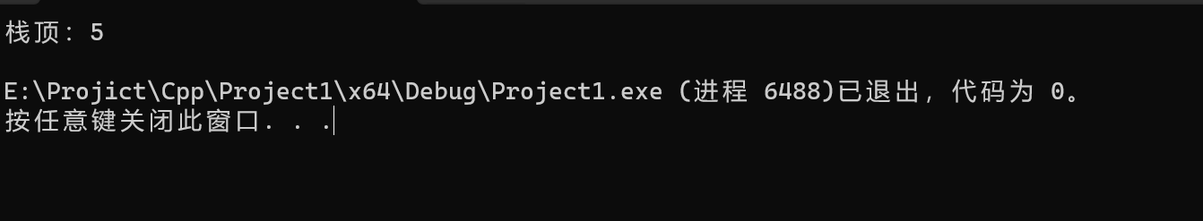
栈顶是5，符合预期
（ 3 ）：代码
- #include<iostream>
- #include<algorithm>
- #include<string>
- #include<vector>
- #include<stdio.h>
- using namespace std;
- struct student {
- string no;
- string name;
- int age;
- };

- class nocmp {
- string no;
- public:
- nocmp(string& s) { no = s; }
- bool operator()(student& s) {
- if (s.no == no) { return 1; }return 0;
- }
- };

- class namecmp {
- string name;
- public:
- namecmp(string& s) { name = s; }
- bool operator()(student& s)
- {
- if (s.name == name) { return 1; }return 0;
- }
- };
- struct dump {
- void operator()(student& s) {
- cout << "学号: " << s.no << " " << "姓名: " << s.name << "年龄: " << s.age << endl;
- }
- };

- void ini()
- {
- cout << endl;
- cout << "****************************************************************" << endl;
- cout << " 欢迎进入学生管理系统，请选择相应的功能，如 按 1 键，进行添加操作" << endl;
- cout << " 1 ：添加 " << " " << "2 ：删徐 " << endl;
- cout << " 3 ：查找" << " " << "4 ：显示 " << endl;
- cout << " q ：退出" << endl;
- cout << "****************************************************************" << endl;
- cout << "请选择：";
- }

- void display(vector<student>& v) {
- for_each(v.begin(),v.end(),dump());
- }

- void add(vector<student>& v) {
- char ch;
- string s;
- do {
- cin.get();
- student stu;
- cout << "学号: ";
- getline(cin, stu.no, '\n');
- cout << "姓名: ";
- getline(cin, stu.name, '\n');
- cout << "年龄: ";
- cin >> stu.age;
- v.push_back(stu);
- cout << "要继续添加吗？按y键继续:";
- cin >> ch;
- } while (ch == 'y');
- }

- void del(vector<student>& v) {
- string no;
- cout << "请输入要删除的学生的学号：";
- cin >> no;
- vector<student>::iterator p = find_if(v.begin(),v.end(),nocmp(no));
- v.erase(p);

- }

- void find(vector<student>& v) {
- string name, s;
- cin.get();
- cout << "请输入要查找的学生的姓名：";
- getline(cin, name);
- int i = count_if(v.begin(), v.end(), namecmp(name));
- if (i == 0)
- cout << "查无此人" << endl;
- else
- {
- vector<student>::iterator p;
- p = find_if(v.begin(), v.end(), namecmp(name));
- cout << " 学号: " << p->no << " 姓名: " << p->name << "年龄: " << p->age << endl;
- }
- }
- void main() {
- vector<student> v;
- char ch;
- ini();
- cin >> ch;
- while (ch != 'q' && ch != 'Q')
- {
- switch (ch)
- {
- case '1': add(v); break;
- case '2': del(v); break;
- case '3': find(v); break;
- case '4': display(v); break;
- case 'q':exit(0);
- }
- ini();
- cin >> ch;
- }
- }
调试代码：
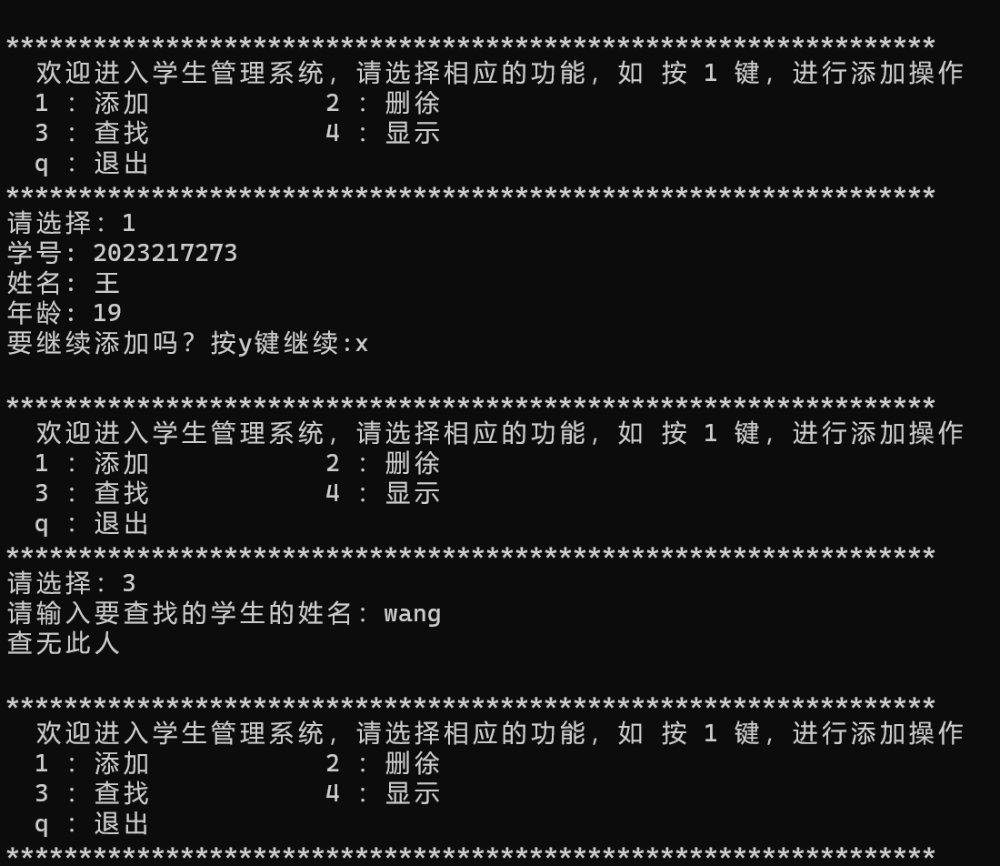
实验十二
实验目的：
- 掌握异常处理的概念，理解异常处理的意义。
- 掌握异常处理的实现机制和方法。
实验内容：
- 下面程序显示了数学运算中除数为零时的异常处理过程。
#include<iostream>
using std::cout;
using std::cin;
using std::endl;
#include<exception>
using std::exception;

class DivideByZeroException : public exception
{
public:
DivideByZeroException();
};

DivideByZeroException::DivideByZeroException():exception(“attempted to divide by zero”)
{ }

double quotient(int numerator,int denominator)
{
if(denominator= =0)
throw DivideByZeroException( );
return static_cast<double>(numerator)/denominator;
}

int main()
{
int number1;
int number2;
double result;
cout<<”Enter two integers(end-of-file to end):”;
while(cin>>number1>>number2){
try {
result=quotient(number1,number2);
cout<<”The quotient is “<<result<<endl;
}
catch(DivideByZeroException & divideByZeroException){
cout<<”Exception occurred: “<< divideByZeroException.what( )<<endl;
}
cout<<”Enter two integers(end-of-file to end):”;
}
cout<<endl;
return 0;
}

[基本要求]
·上机录入、调试上面程序。
·运行程序，输入下面两组数据：
① 5 10
② 6 0
分析运行结果是否正确，指出异常处理的过程。
[分析和思考]
·如果在程序中catch语句所俘获的异常类型与抛出的异常不符，情况将会怎样？将catch语句的俘获类型改为int类型，然后再次运行程序，分析运行结果。
·如果quotient函数没有抛出异常，结果又会怎样？试着运行，分析运行结果。
- 下面程序显示了异常处理过程中的重抛和堆栈解退问题。
#include<iostream>
using std::cout;
using std::cin;
using std::endl;
#include<exception>
#include<stdexcept>

using std::exception;
using std:: runtime_error;

void function3()
{
throw runtime_error(”runtime_error in function3”);
}
void function2()
{
function3();
}
void function1()
{
function2();
}
void throwException()
{
try {
cout<<”Function throwException throws an exception\n”;
throw ;
}
catch(exception & caughtException){
cout<<”Exception handled in function throwException”
<<”\nfunction throwException rethrows exception”;
;
}
cout<<”This is also should not print\n”;
}

int main()
{
try {
cout<<”\nmain invokes function theowException\n”;
throwException( );
cout<<”This should not print\n”;
}
catch( & caughtException){
cout<<”\n\nException handled in function main\n”;
}
try {
function1();
}
catch(runtime_error & error){
cout<<”Exception occurred:”<<error.what()<<endl;
}

cout<<”Program control continues after the catch in main\n”;

return 0;
}

[基本要求]
·阅读上面程序，根据题意要求在 处填上合适的内容完成程序。
·上机录入、调试上面程序。
·运行程序，分析运行结果是否正确，指出异常处理的过程。
[分析和思考]
·分析重抛和堆栈解退体现在程序的那些地方？
·如果将main函数中的两个try语句合并，结果又会怎样？试着运行，分析运行结果。
（1）代码：
- #include<iostream>
- using std::cout;
- using std::cin;
- using std::endl;
- #include<exception>
- using std::exception;

- class DivideByZeroException : public exception
- {
- public:
- DivideByZeroException();
- };

- DivideByZeroException::DivideByZeroException() :exception("attempted to divide by zero")
- { }

- double quotient(int numerator, int denominator)
- {
- if (denominator == 0)
- throw DivideByZeroException();
- return static_cast<double>(numerator) / denominator;
- }

- int main()
- {
- int number1;
- int number2;
- double result;
- cout << "Enter two integers(end - of - file to end) :";
- while (cin >> number1 >> number2) {
- try {
- result = quotient(number1, number2);
- cout << "The quotient is " << result << endl;
- }
- catch (DivideByZeroException& divideByZeroException) {
- cout << "Exception occurred : " << divideByZeroException.what() << endl;
- }
- cout << "Enter two integers(end - of - file to end) :";
- }
- cout << endl;
- return 0;
- }
运行：
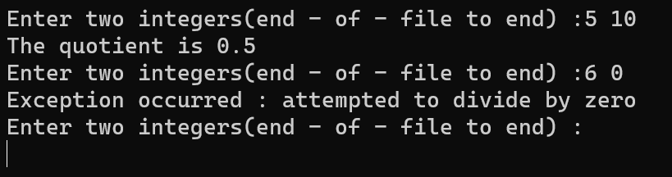
结果正确，定义了一个函数，当除数为0时会终止计算并输出出书为0的报错
（2）：代码：
- #include<iostream>
- using std::cout;
- using std::cin;
- using std::endl;
- #include<exception>
- #include<stdexcept>

- using std::exception;
- using std::runtime_error;

- void function3()
- {
- throw runtime_error("runtime_error in function3");
- }
- void function2()
- {
- function3();
- }
- void function1()
- {
- function2();
- }
- void throwException()
- {
- try {
- cout << "Function throwException throws an exception\n";
- throw runtime_error("Exception thrown in throwException");
- }
- catch (exception& caughtException) {
- cout << "Exception handled in function throwException"
- << "\nfunction throwException rethrows exception";
- throw; // 在此处填写 throw 关键字
- }
- cout << "This should not print\n";
- }

- int main()
- {
- try {
- cout << "\nmain invokes function throwException\n";
- throwException();
- cout << "This should not print\n";
- }
- catch (exception& caughtException) {
- cout << "\n\nException handled in function main\n";
- }
- try {
- function1();
- }
- catch (runtime_error& error) {
- cout << "Exception occurred: " << error.what() << endl;
- }

- cout << "Program control continues after the catch in main\n";

- return 0;
- }
运行：
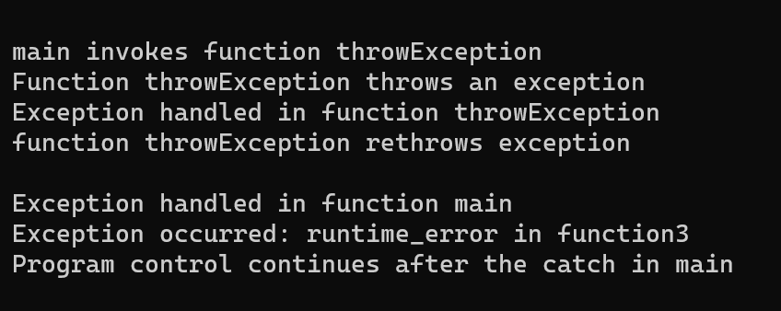
（ 3 ）：
- #include <iostream>
- #include <fstream>
- #include <conio.h>
- using namespace std;
- const int n = 40;

- int line_out(ifstream& f) //从文件f中读一行字符并显示，返回此行字符的个数
- {
- char ch;
- int len = 0;
- while (f.get(ch) && ch != '\n')
- {
- cout << ch;
- len++;
- }
- return len;
- }

- int main()
- {
- char filename1[15], filename2[15];
- int length;
- cout << "Input the file names\n";
- cin >> filename1 >> filename2;
- ifstream f1(filename1), f2(filename2);
- while (!f1.eof() && !f2.eof())
- {
- length = line_out(f1);
- if (length < n)
- for (int i = 0; i < n - length; i++)
- cout << ' ';
- line_out(f2);
- cout << endl;
- }
- while (!f1.eof())
- {
- line_out(f1);
- cout << endl;
- }
- while (!f2.eof())
- {
- for (int i = 0; i < n; i++)
- {
- if (line_out(f1) == 0)
- break;
- cout << endl;
- }
- line_out(f2);
- cout << endl;
- }
- getch();
- }

