

CONTENTS

Data-Driven Testing and Using the Page Object Model

FPT Software

|  |  |  |  |  |  |  |
| --- | --- | --- | --- | --- | --- | --- |
| # | Author | Changes Made | Date | Version | Reviewer | Approver |
| 1 | LamNS3 | docs: create template file | 18/01/2019 | 1.0.0 |  |  |

Table of Contents

Exercise 01 3

Exercise 02 3

Exercise 03 4

Exercise 04 5

Exercise 05 6

Exercise 06 7

|  |  |  |
| --- | --- | --- |
| FA Logo | Lab Code/Course Code | Duration in Minutes |

# Exercise 01

Writing a file using POI is very simple and involve following steps:

1. Create a workbook
2. Create a sheet in workbook
3. Create a row in sheet
4. Add cells in sheet
5. Repeat step 3 and 4 to write more data

Excel template:

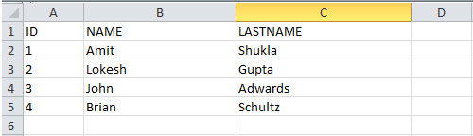

# Exercise 02

Reading an excel file using POI is also very simple if we divide this in steps.

1. Create workbook instance from excel sheet
2. Get to the desired sheet
3. Increment row number
4. iterate over all cells in a row
5. repeat step 3 and 4 until all data is read

Excel template:



# Exercise 03

Create Data Driven Framework in Selenium WebDriver Using Apache POI to verify product title with scenario as below:

1. Open Chrome browser
2. Maximize the browser window
3. Navigate to [**www.amazon.com**](http://www.amazon.com/) webpage.
4. Select “**Books**” from search category dropdown
5. Enter search key: “**Selenium**”
6. Click “Go” button
7. Click the first search result item title
8. Verify that product title is correct

Excel file data:

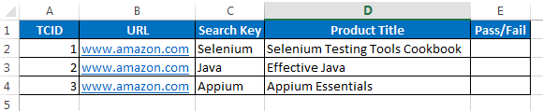

# Exercise 04

Create Data Driven Framework in Selenium WebDriver Using Apache POI with scenario as below:

1. Open Chrome browser
2. Maximize the browser window
3. Navigate to http://automationpractice.com/index.php webpage.
4. Enter search key: “**Faded Short Sleeve T-shirts**”
5. Click “**Search**” button
6. Click the first search result item title
7. Verify that product title is correct
8. Verify that product price is correct
9. Click Add to cart button
10. Verify confirmation test appears: “1 item added to Cart”
11. Navigate to Cart page from main menu
12. Verify item is displayed on Shopping Cart list

Excel file data:

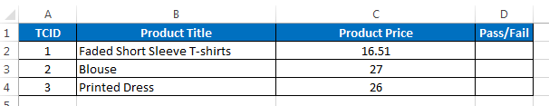

# Exercise 05

URL: <http://automationpractice.com/index.php?controller=authentication>

Please create automation scripts for test case Check Login Functionality as below:

Test case 1: Check results on entering valid Email address& Password

Test case 2: Check results on entering Invalid Email address& Password

Test case 3: Check response when an Email address is Empty & Sign in Button is pressed, and many more

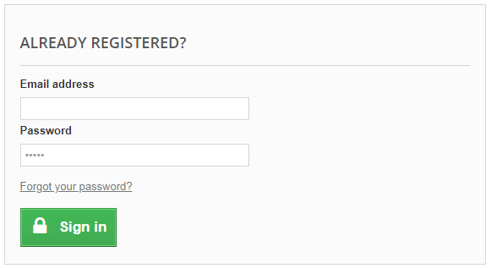

# Exercise 06

URL: <http://automationpractice.com/index.php?controller=authentication>

Please create automation scripts for test case check Email address as below:

Test case 1: Check results on entering valid Email address

Test case 2: Check results on entering invalid Email address

Test case 4: Check results on entering blank Email address

Test case 5: Check results on entering email address has already been registered

