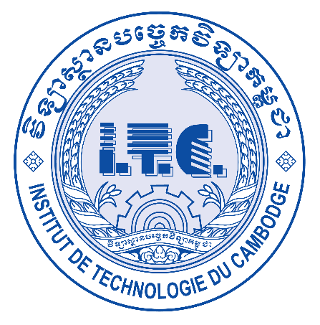

**វិទ្យាស្ថានបច្ចេកវិទ្យាកម្ពុជា**

**INSTITUTE OF TECHNOLOGY OF CAMBODIA**

**TP01**

**Lecturer : HOK Tin**

**Group : I4-GIC(C)**

**Student : TUON Sreynit**

**ID : e20191215**

**2022-2023**

Tuon Sreynit

tuonsreynit83@gmail.com

**TP01**

Ex1:

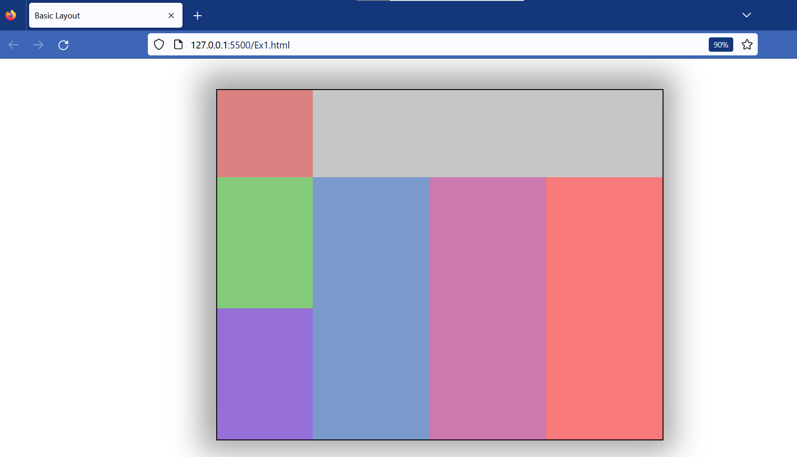

Ex2:

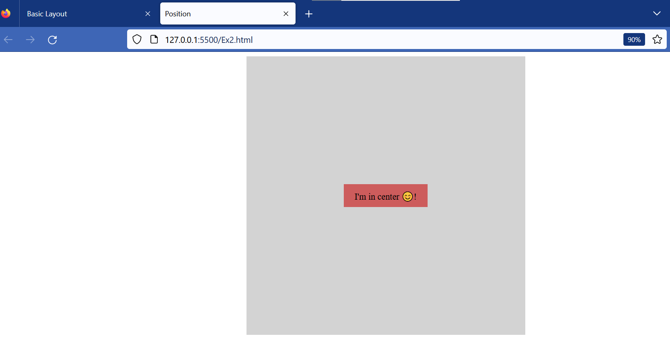

Ex3:

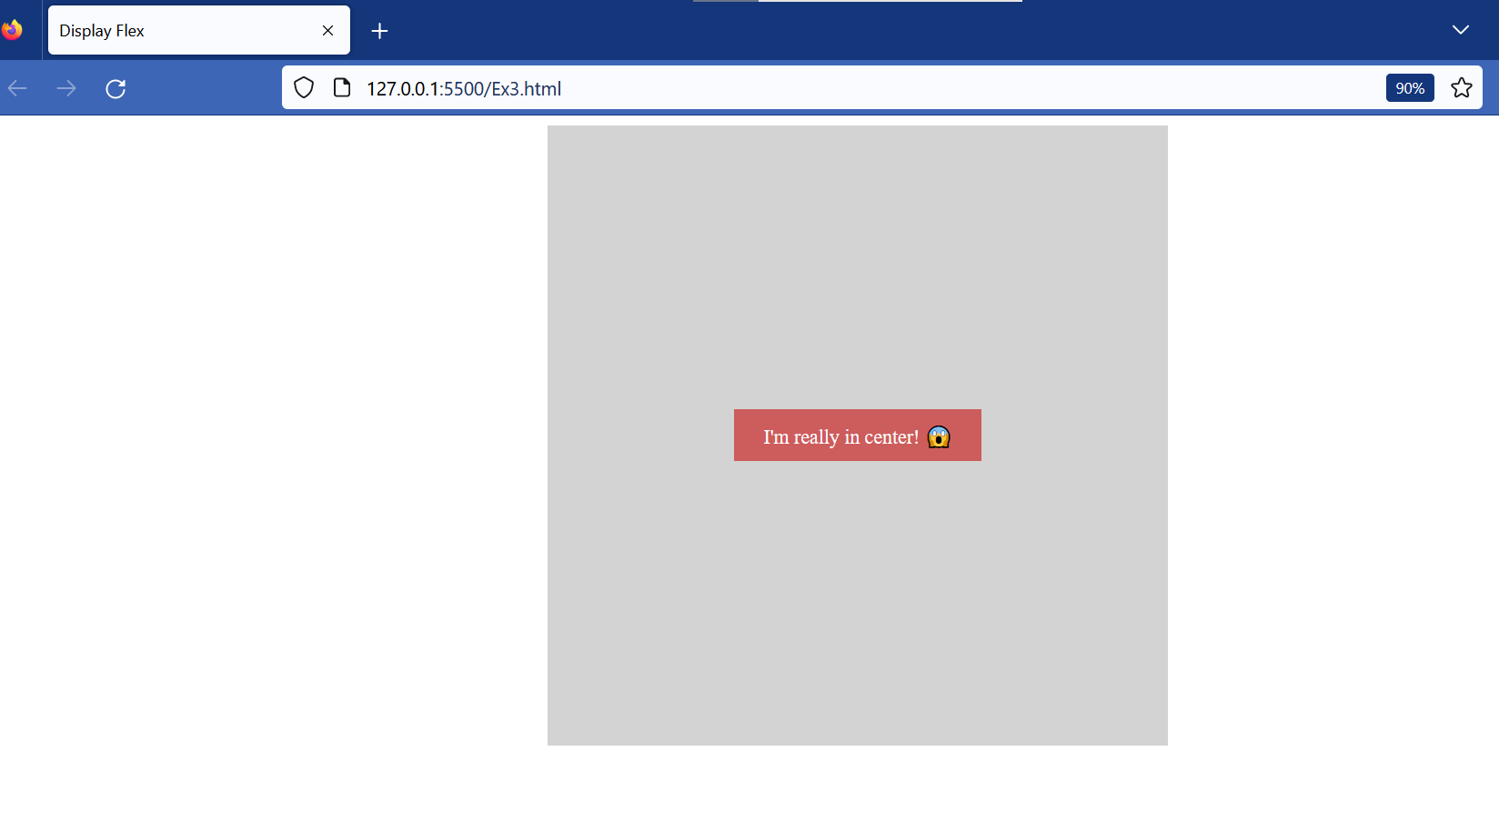

Ex4:

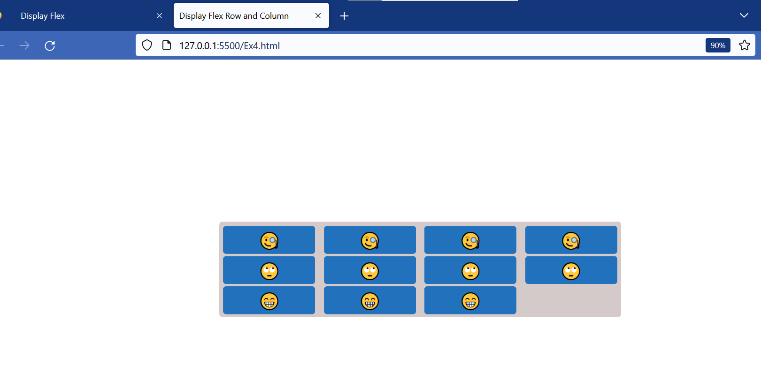

Ex5:

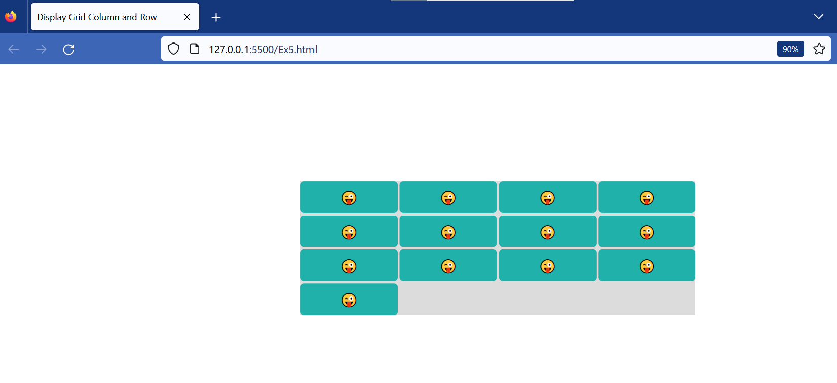

Ex6:

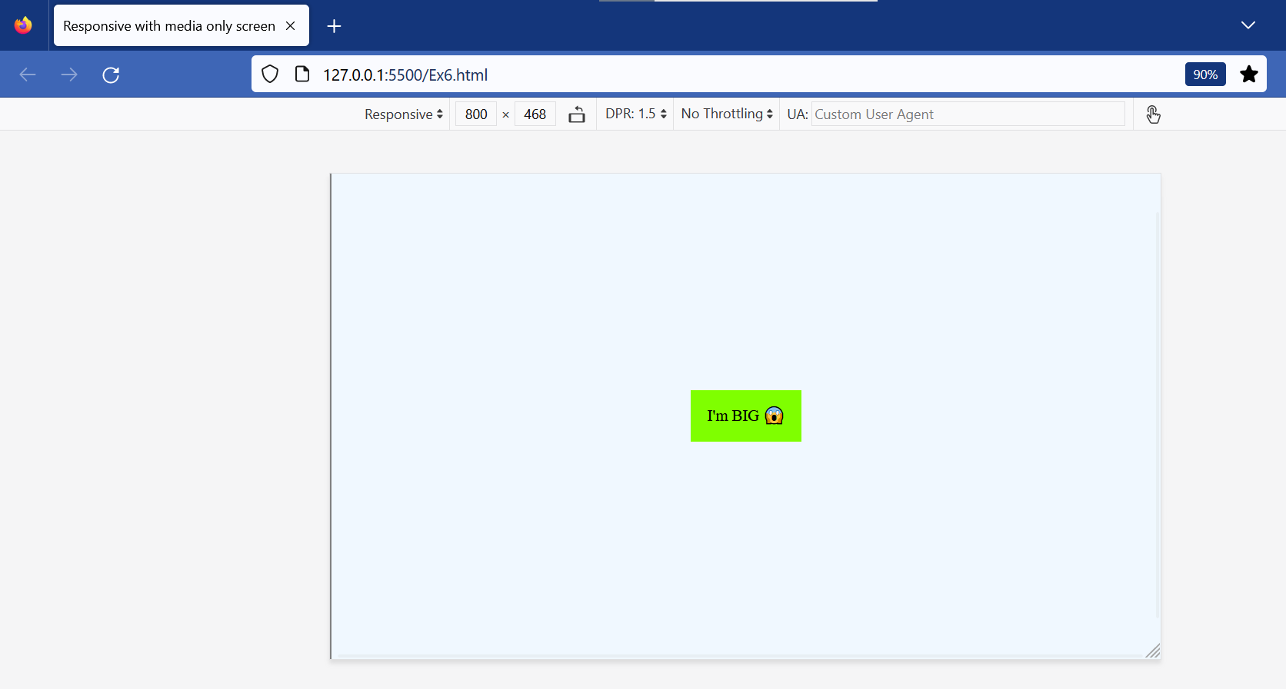

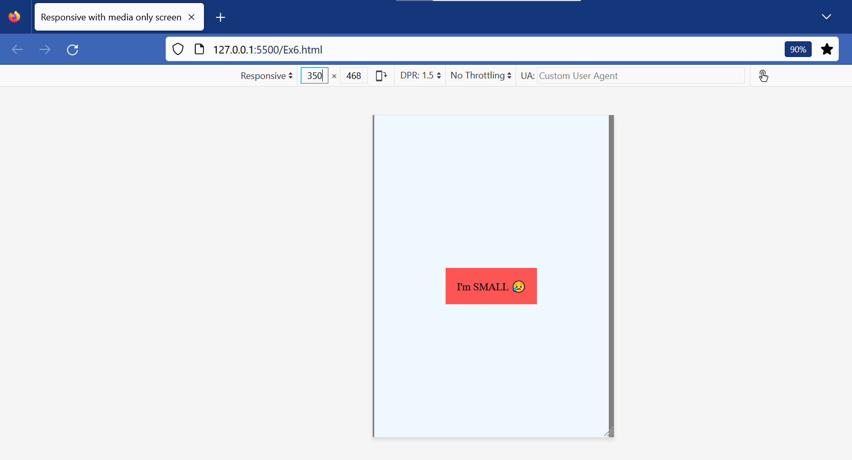

Ex7:

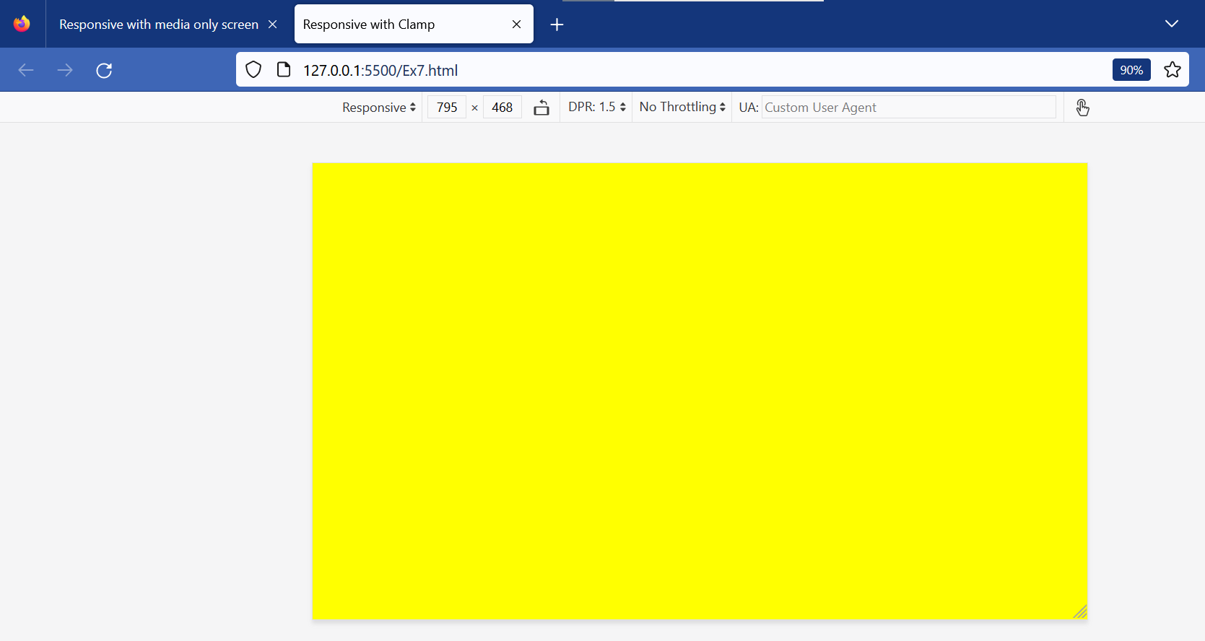

Ex8:

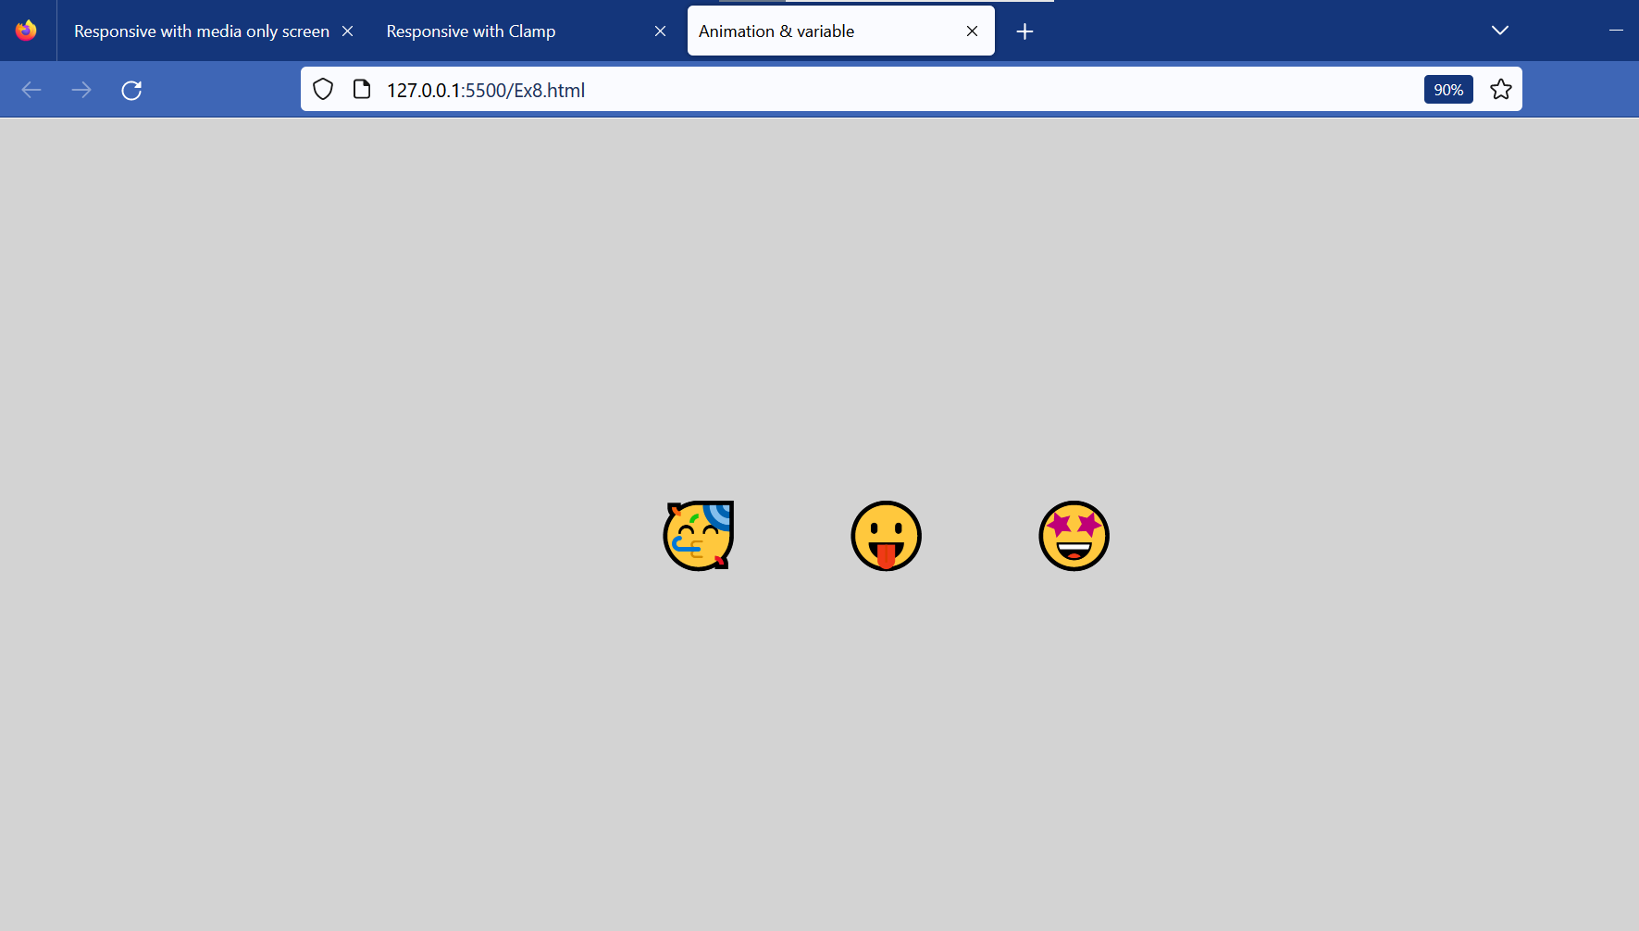

Ex9:

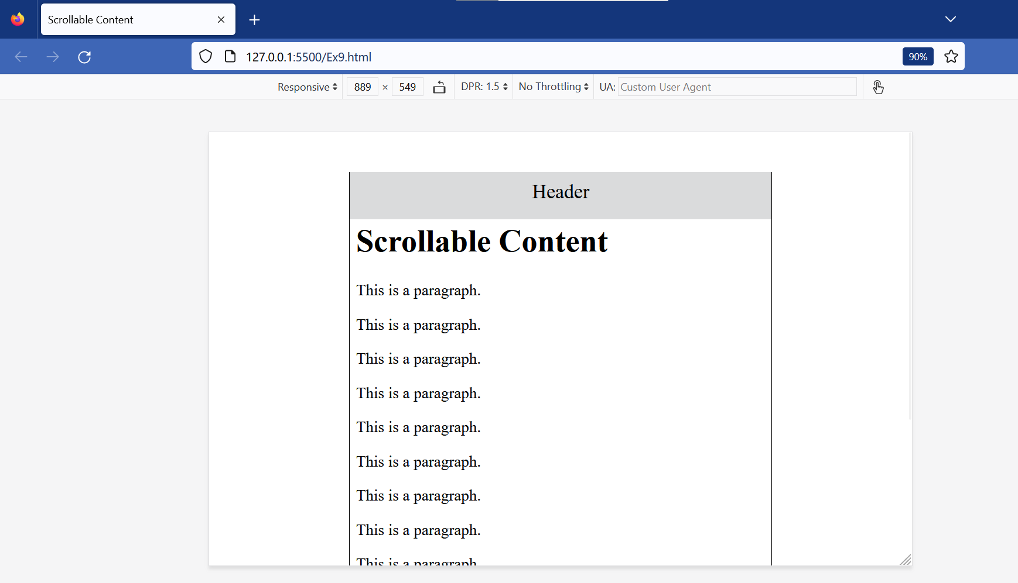

Ex10:

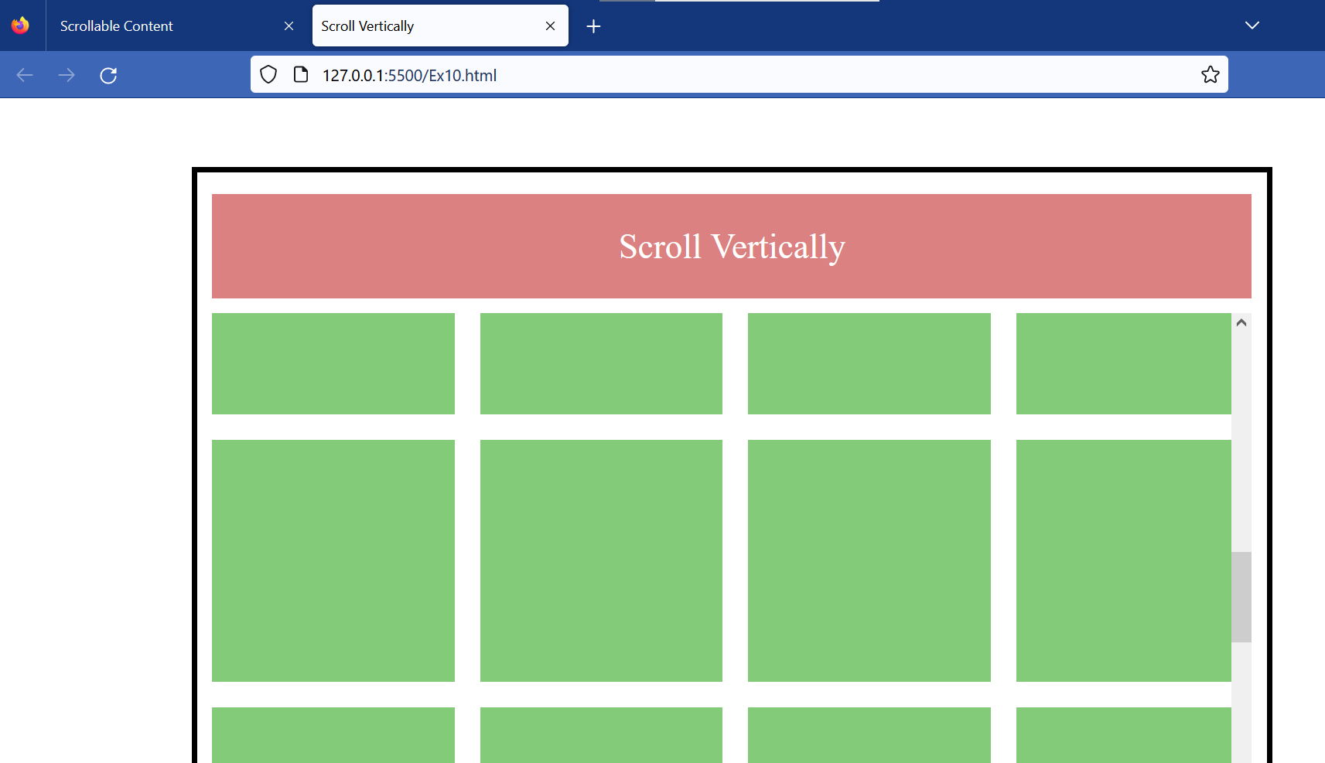

Ex11:

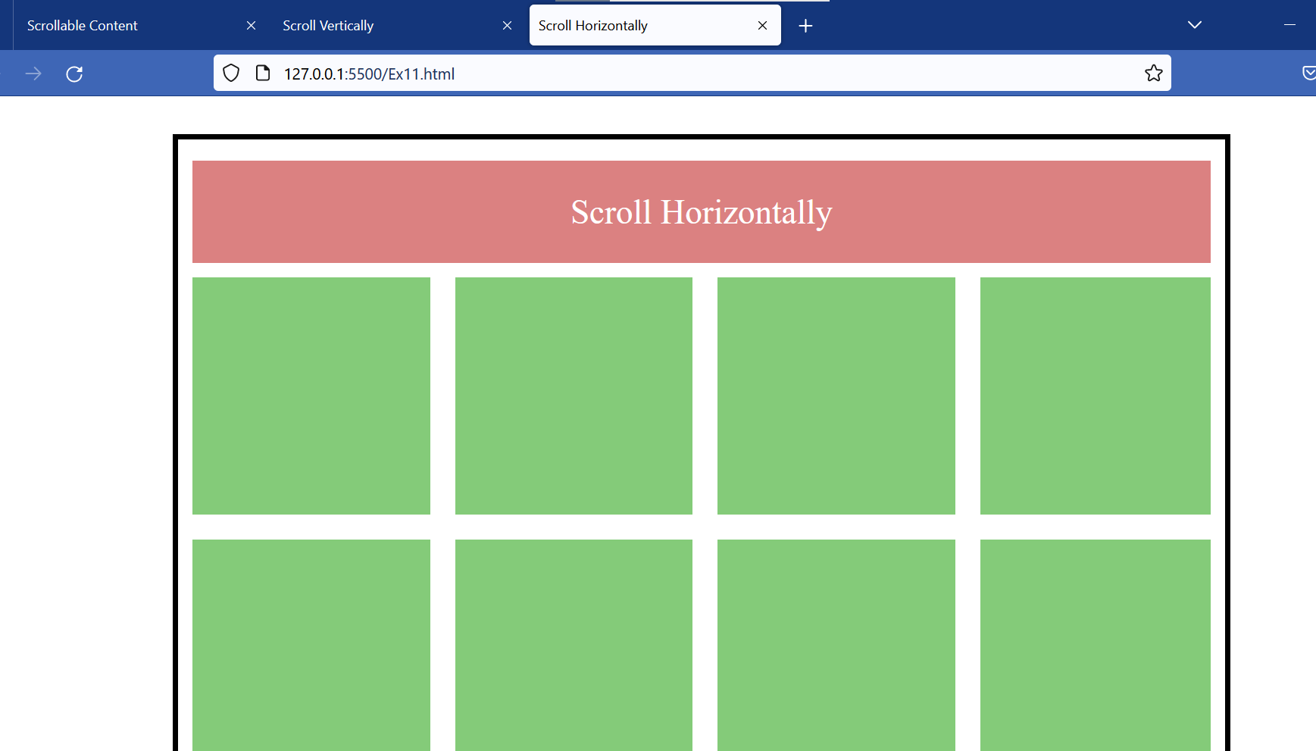

Ex12:

