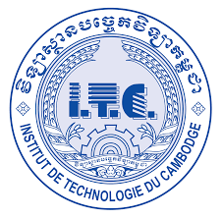



**TP03**

2022-2023

Subject : Internet-Programming

Lecturer : HOK TIN

Student Name : Tuon Sreynit

ID : e20191215

**INSTITUTE OF TECHNOLOGY OF CAMBDIA**

DEPARTEMENT OF INFORMATION AND COMMUNICATION ENGINERING

Table of Contents

Ex1 2

Ex2 4

Ex3 7

Ex4 11

Ex5 13

TP03

Github url: <https://github.com/Tuon-Sreynit/Internet-Programming/tree/tp-ip/TP03>

# Ex1

Src:

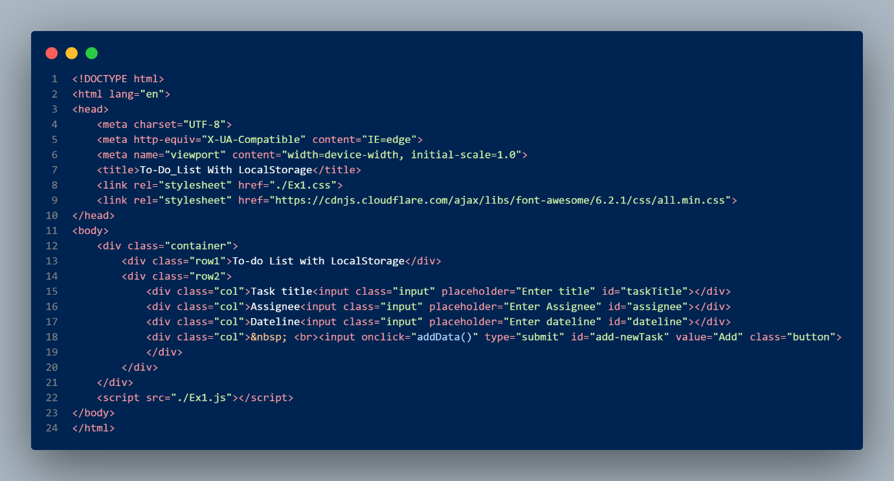

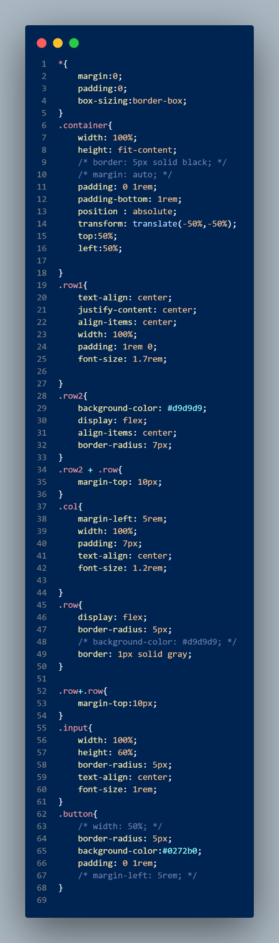

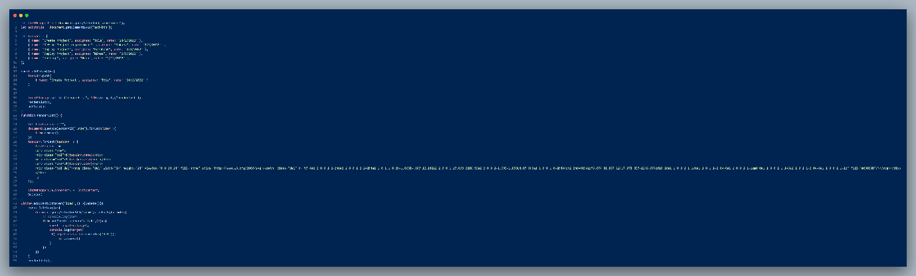

Output:

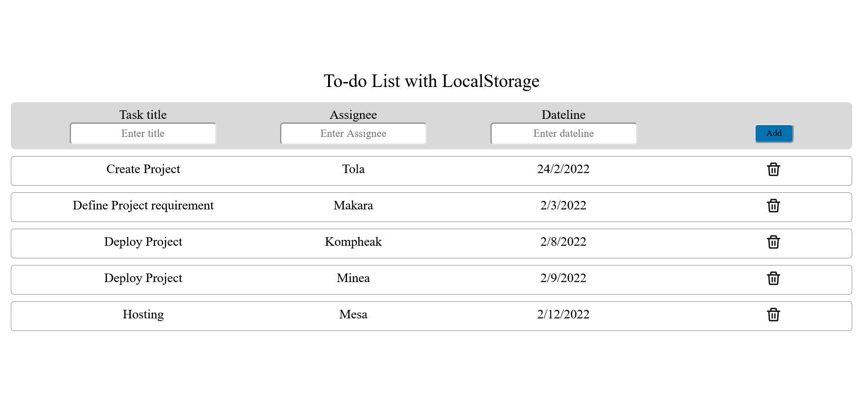

# Ex2

Src:

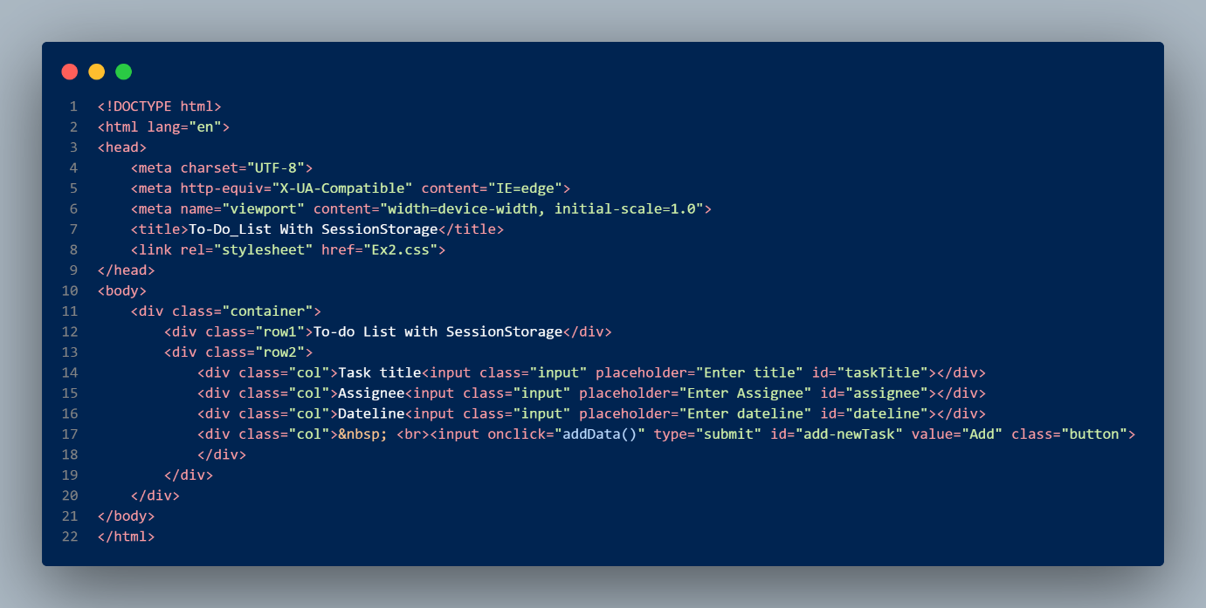



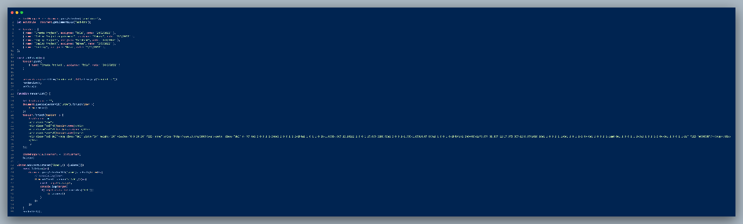

Output:

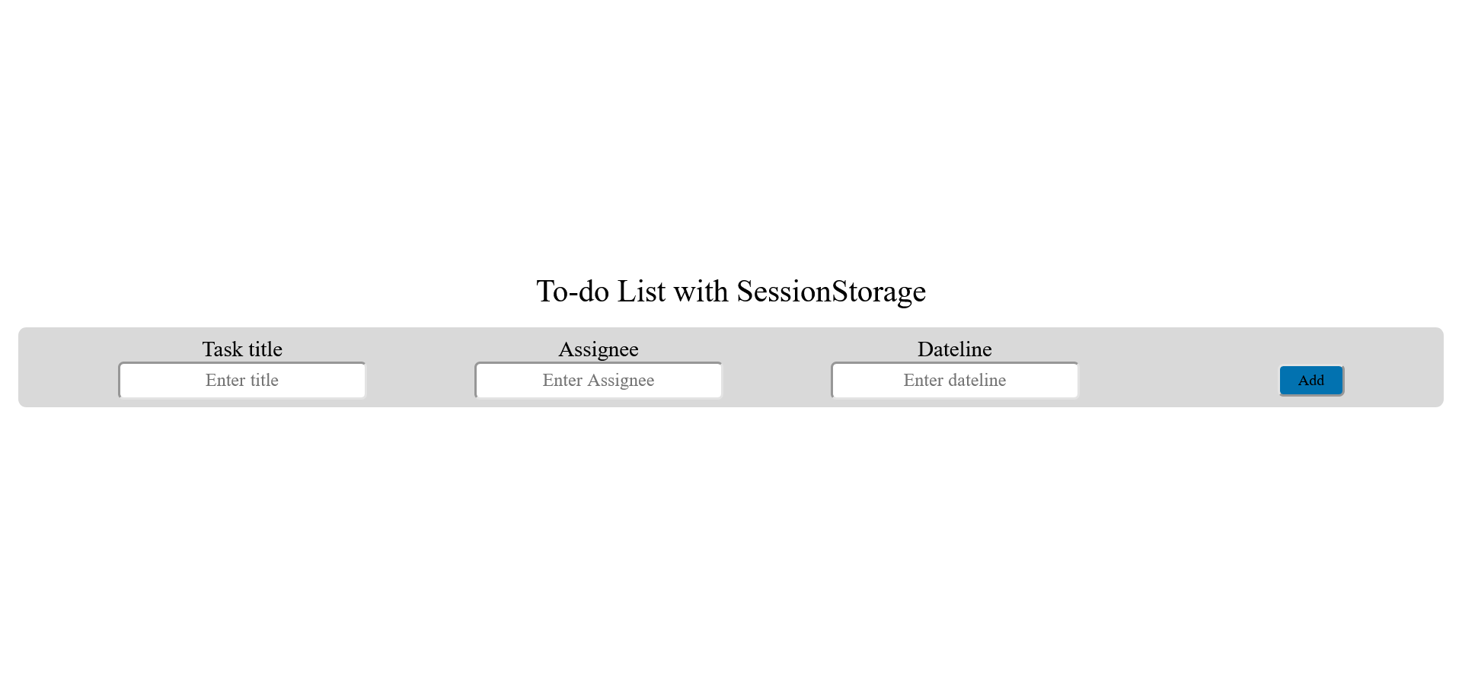

# Ex3

Src:

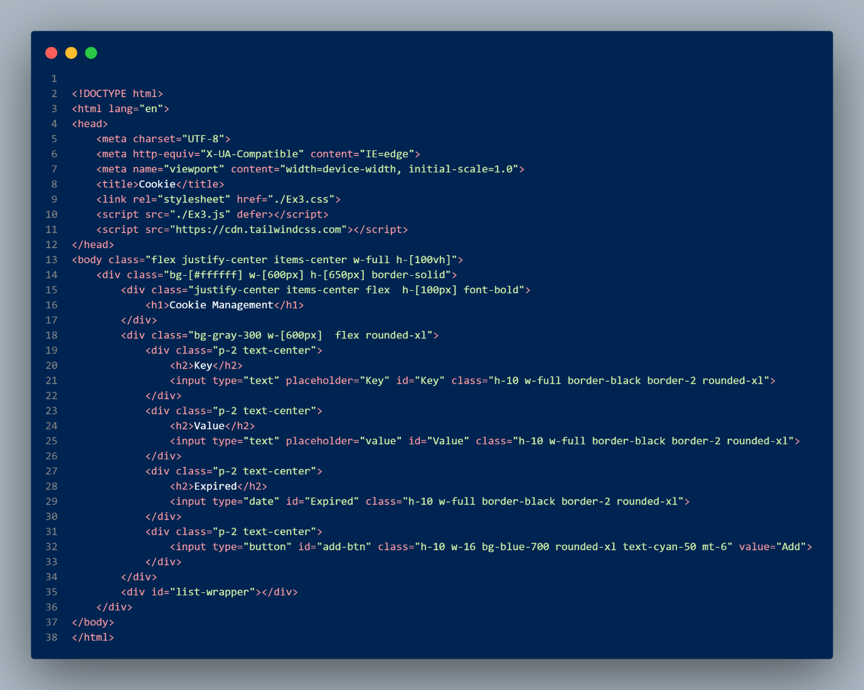

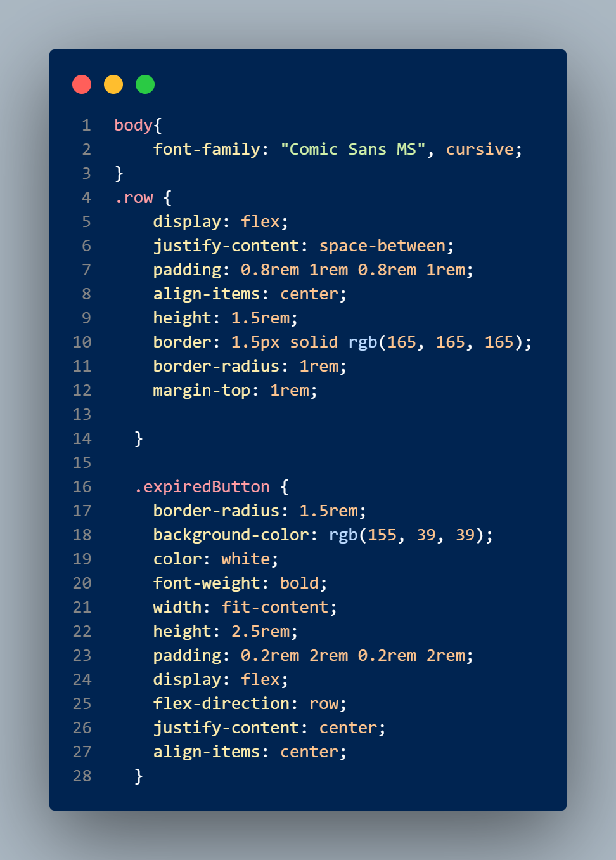

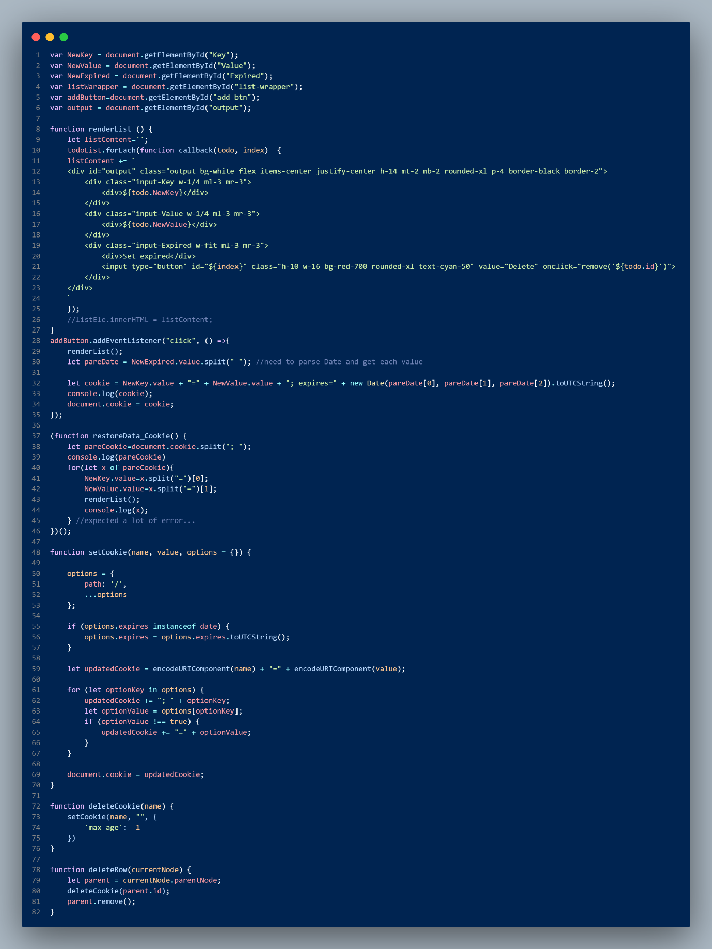

Output:

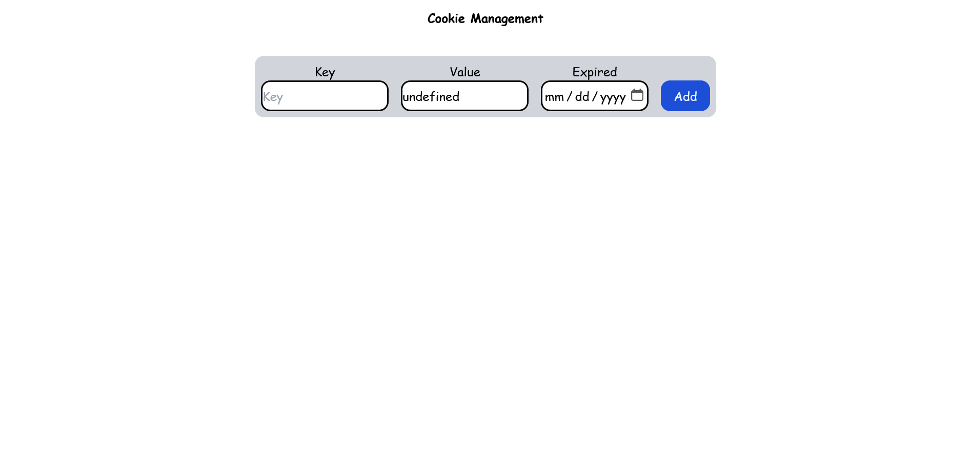

# Ex4

Src:

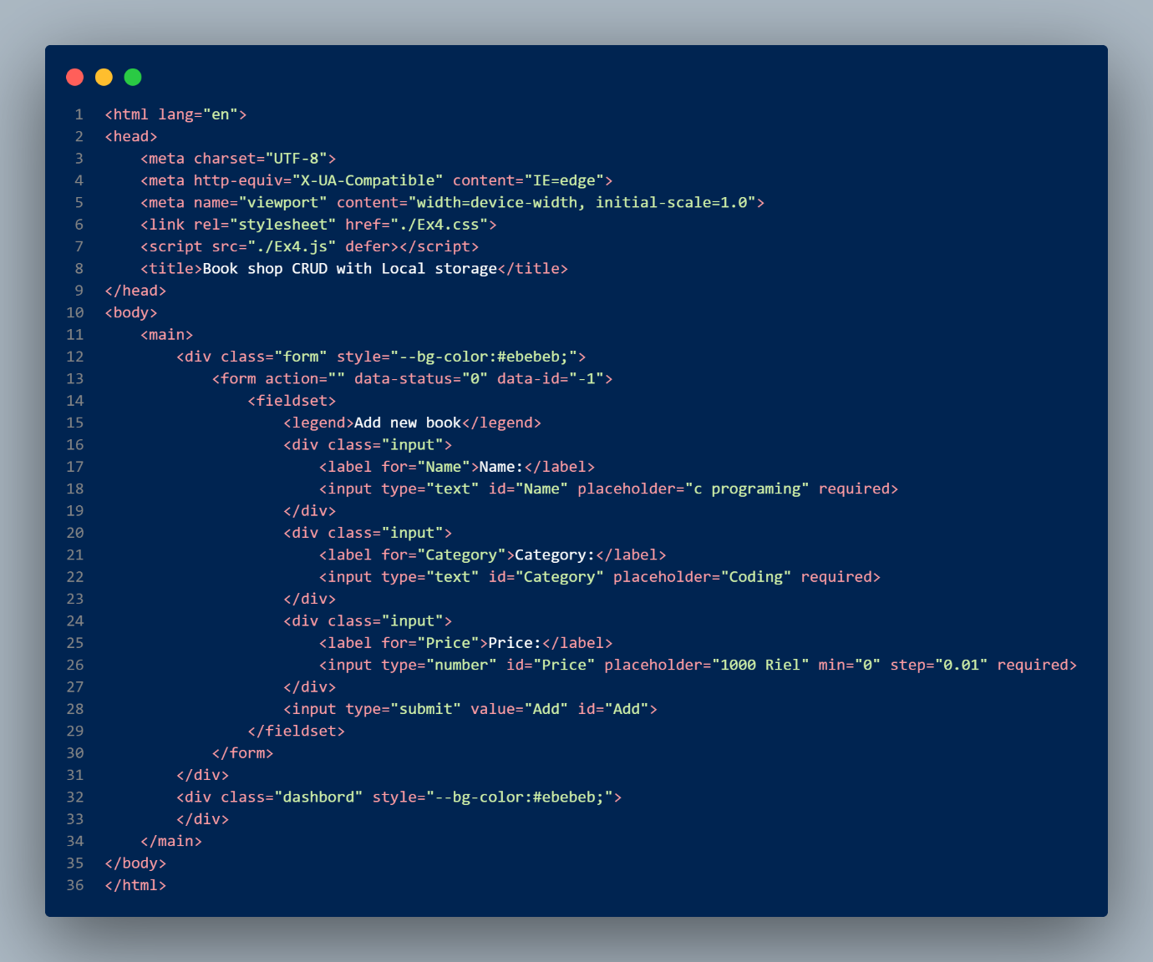

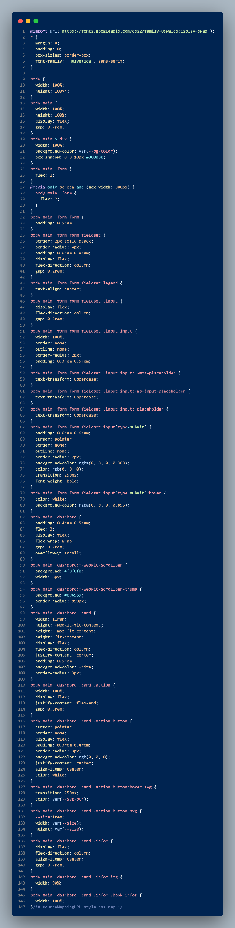

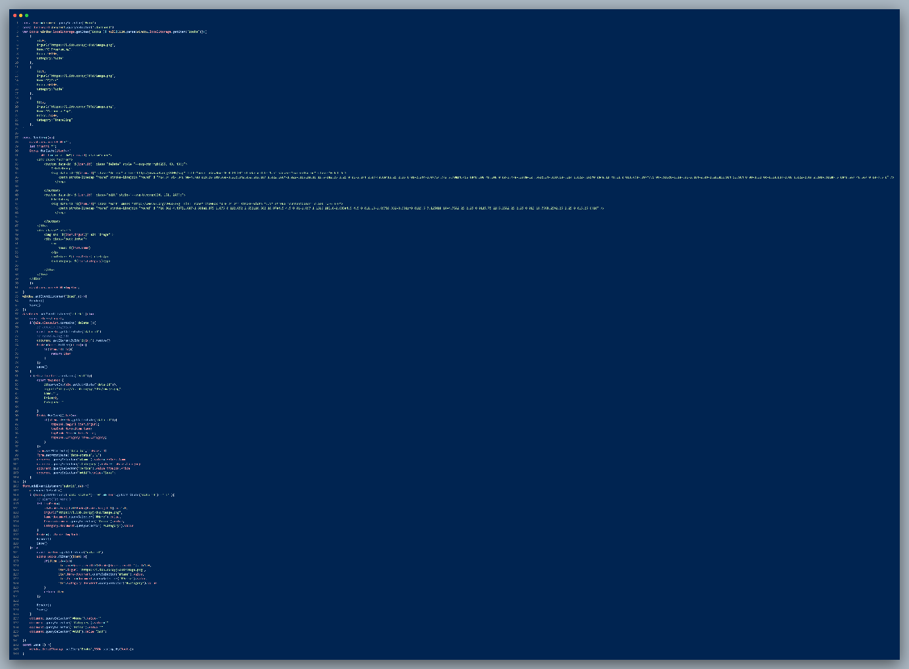

Output:

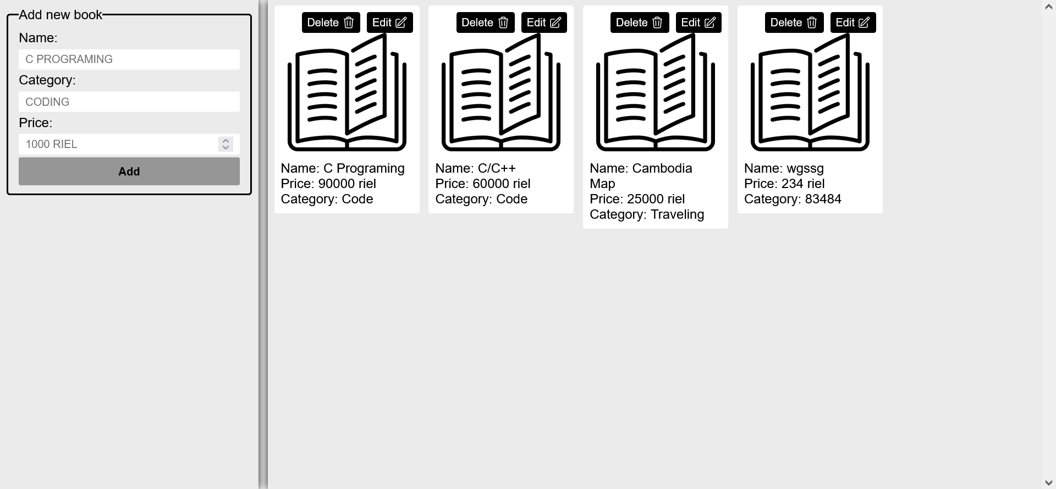

# Ex5

Src:

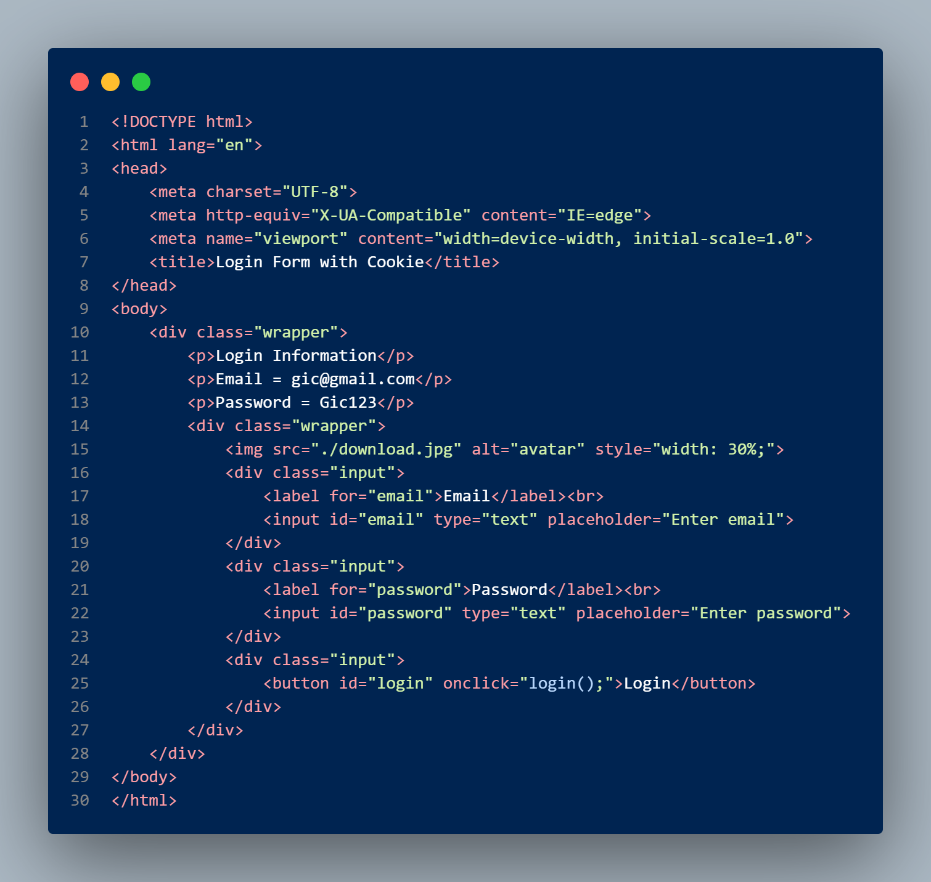

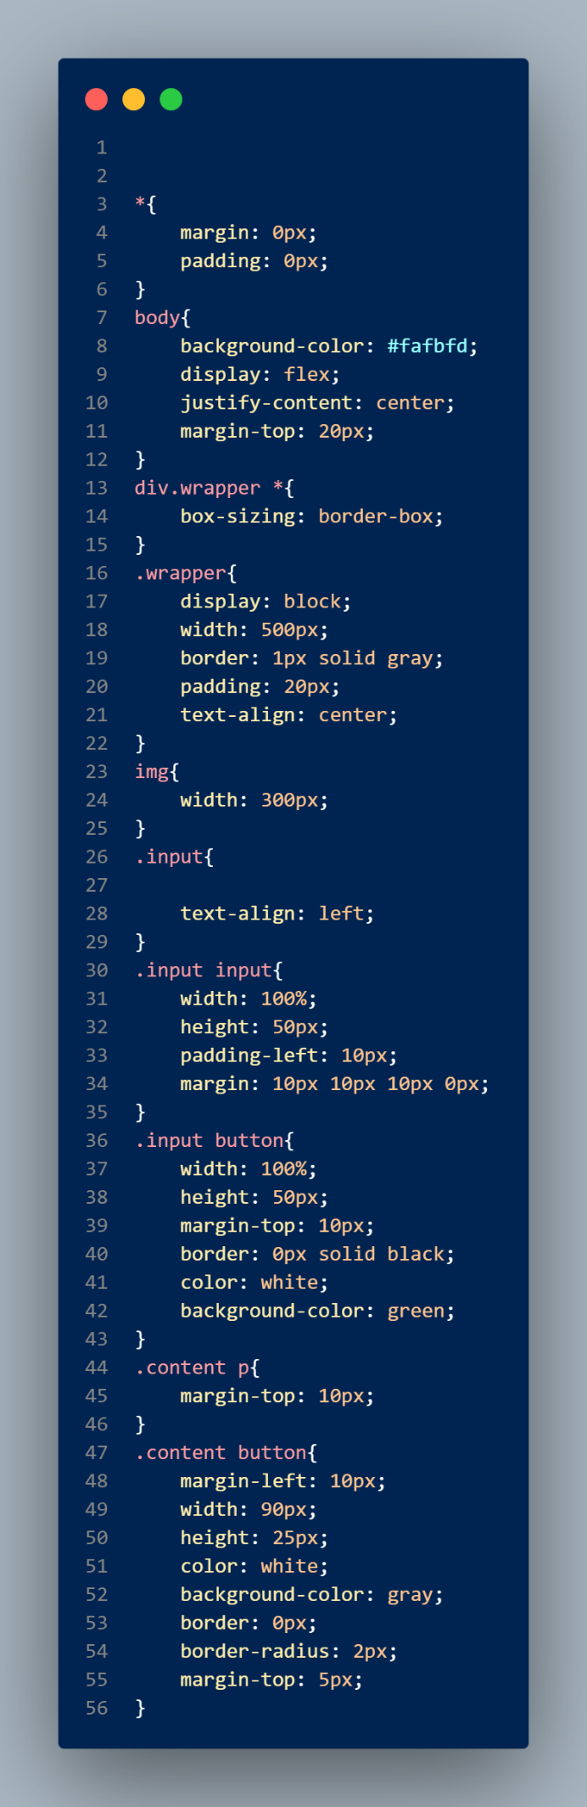

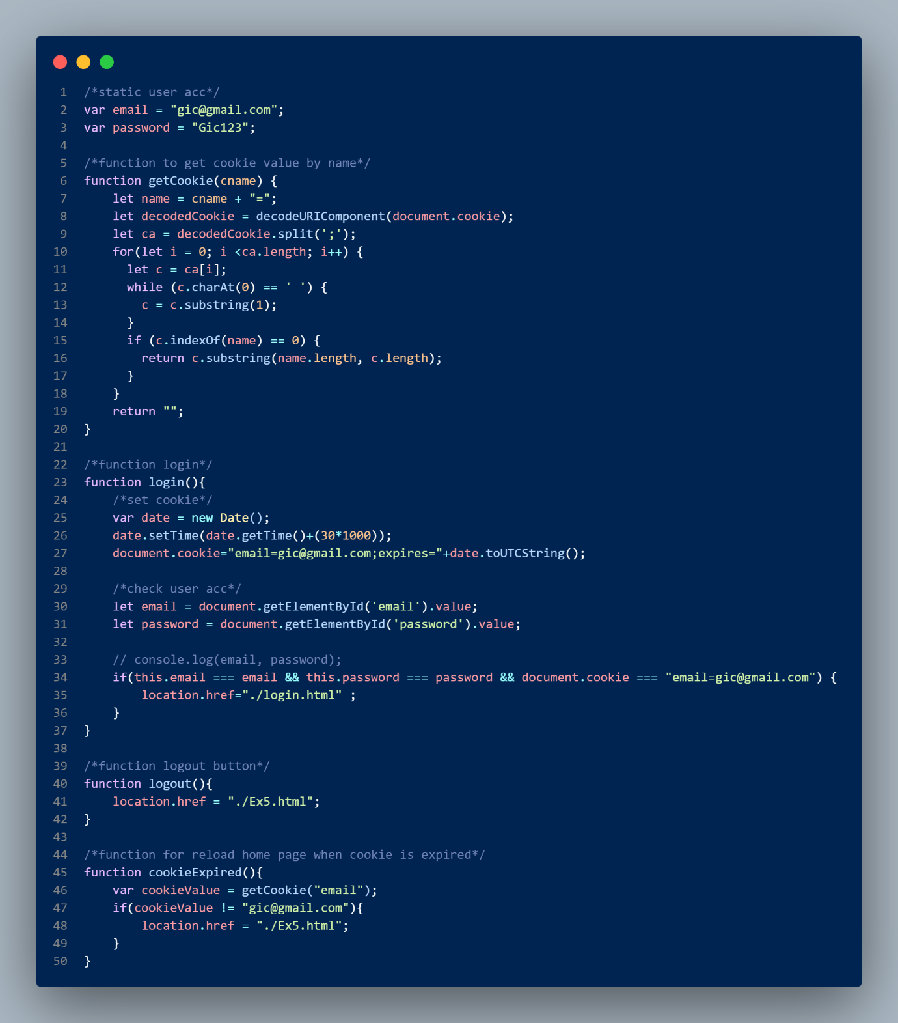

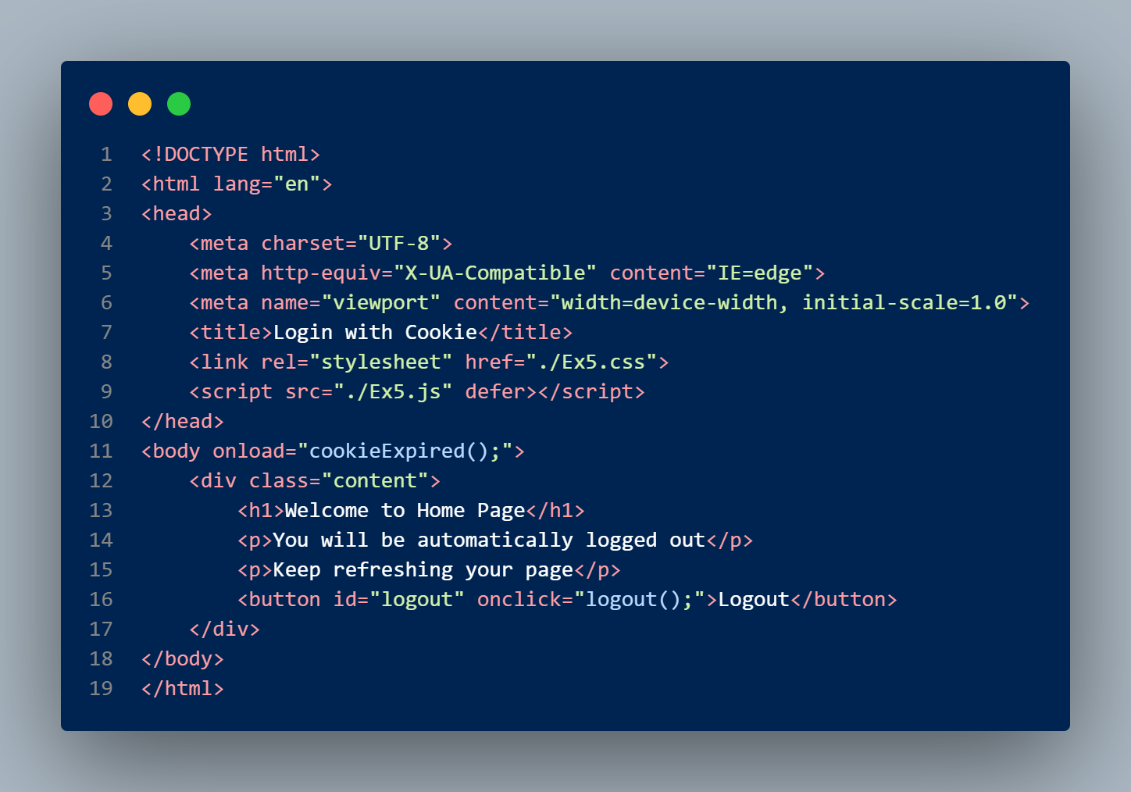

Output:

