SOFTWARE REQUIREMENT SPECIFICATION (SRS)
Module: User Management & Authentication
Version: 1.0 (Initial Baseline)
Project: SmartLogi - AI-Powered Intelligent Logistics System
Date: April 05, 2026
1. INTRODUCTION
1.1 Purpose
This document specifies the functional and non-functional requirements for the User Management Module (v1.0). The primary goal is to establish a secure foundation for user registration, authentication, and basic profile management for the SmartLogi project.
1.2 Document Conventions
- REQ-F: Functional Requirement.
- REQ-NF: Non-functional Requirement.
- Priority: High (Mandatory), Medium (Important), Low (Optional/Future).
1.3 Intended Audience
This document is intended for the Project Development Team (Developers), Quality Assurance Team (Testers), and the Academic Thesis Committee.
2. SYSTEM OVERVIEW
2.1 Product Perspective
The User Module serves as the primary gateway for the SmartLogi system. All subsequent modules, such as Route Optimization and Document RAG, rely on the identity and session data validated within this module.
2.2 User Classes and Characteristics
In version 1.0, the system supports two primary actor groups:
- Standard User (Staff): Regular users who access the dashboard to manage logistics tasks.
- System Administrator: High-level users responsible for initial data seeding and system configuration.
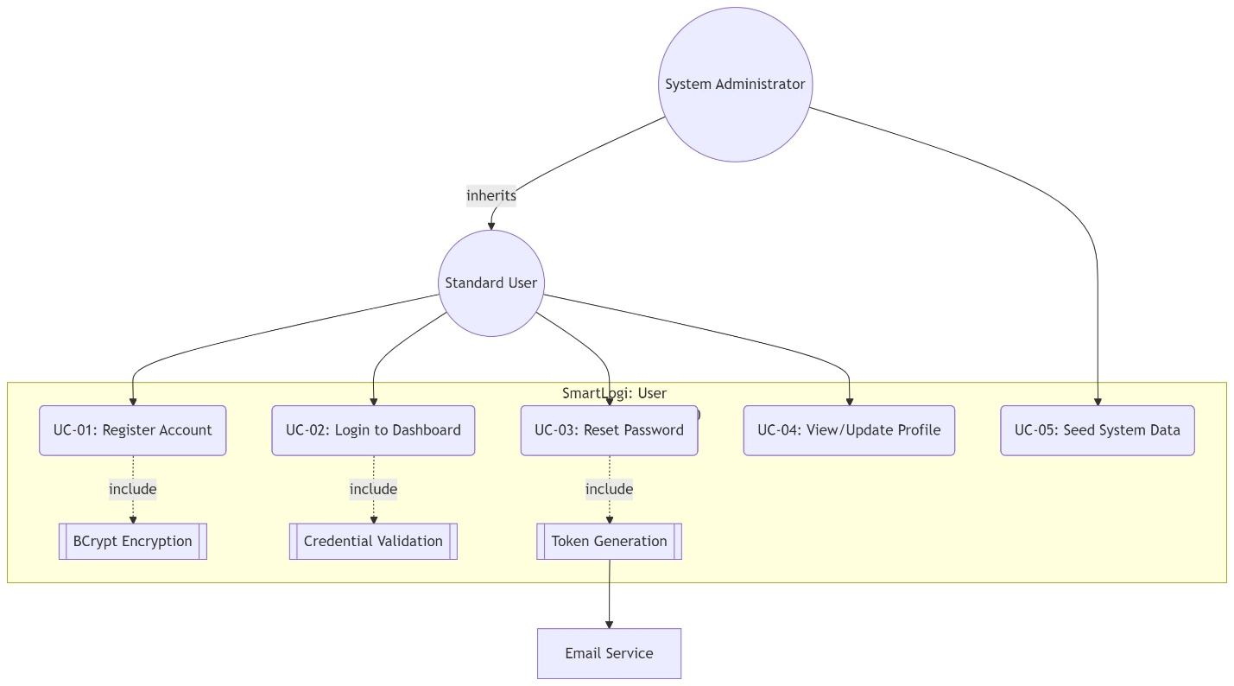
Image 1 Use case Diagram
3. FUNCTIONAL REQUIREMENTS (REQ-F)
3.1 User Registration (Sign-up)
- ID: REQ-F-01
- Description: Allows new users to create an account using a unique email address.
- Input Fields: - Full Name (String, max 100 characters)
  - Email (Must follow valid RFC 5322 format)
  - Password (Min 8 characters, must include 1 uppercase letter and 1 numeric digit)
  - Confirm Password (Value must match the Password field)
- Validation Logic: - The system must verify that the Email does not already exist in the database.
  - Passwords must be hashed using the BCrypt algorithm before storage.
3.2 User Authentication (Login)
- ID: REQ-F-02
- Description: Verifies user identity to grant access to the system dashboard.
- Standard Workflow:
  - User enters Email and Password.
  - The system compares the hash of the input password with the stored hash.
  - Upon success, a secure Session/JWT is generated, and the user is redirected to the Dashboard.
- Error Scenarios:
  - Incorrect Credentials: Display "Invalid email or password."
  - Unverified Account: Display "Please verify your email to activate your account."
3.3 Password Recovery (Forgot Password)
- ID: REQ-F-03
- Description: Enables users to regain access if they forget their password.
- Process: The system sends a unique, time-sensitive token (valid for 15 minutes) to the user's registered email address via SMTP.
4. DATA ARCHITECTURE & DATABASE SCHEMA
Version 1.0 requires the following data attributes for the Users table:
Attribute | Data Type | Constraint | Description
user_id | UUID | Primary Key | Globally Unique Identifier
email | Varchar(255) | Unique, Not Null | Login username
password_hash | Varchar(512) | Not Null | Hashed security credential
full_name | Varchar(100) | Not Null | Display name
status | SmallInt | Default: 1 | 1: Active, 0: Suspended
created_at | Timestamp | Current_Time | Account creation timestamp

5. NON-FUNCTIONAL REQUIREMENTS (REQ-NF)
5.1 Security Requirements
- REQ-NF-01 (Data Encryption): Plain-text passwords must never be stored. Hashing must include a unique "salt" per user.
- REQ-NF-02 (Brute-Force Protection): The system must temporarily lock an account (for 30 minutes) after 5 consecutive failed login attempts.
- REQ-NF-03 (Transmission Security): All authentication endpoints must be secured using TLS 1.2 or higher (HTTPS).
5.2 Performance & Reliability
- REQ-NF-04 (Latency): Login authentication should process in less than 2 seconds under normal network conditions.
- REQ-NF-05 (Scalability): The module must support up to 100 concurrent registration requests without database deadlock.

6. EXTERNAL INTERFACE REQUIREMENTS
6.1 User Interface (UI) Design
- Login Screen: Minimalist layout with two input fields and a "Login" button.
- Error Feedback: Error messages must be displayed in Red (#FF0000) immediately below the problematic field.
6.2 Software Interfaces
- Backend Framework: Node.js or Java Spring Boot (RESTful API).
- Database: SQL Server 2022.
- Email Service: Integration with Gmail SMTP or SendGrid for transactional emails.
7. APPENDICES & TRACEABILITY MATRIX
7.1 Glossary
- BCrypt: A password-hashing function designed to defend against brute-force attacks.
- JWT (JSON Web Token): A compact, URL-safe means of representing claims to be transferred between two parties.
- UUID: A 128-bit number used to identify information in computer systems.
7.2 Requirements Traceability Matrix (RTM)
Req ID | Test Case ID | Test Objective
REQ-F-01 | TC-AUTH-01 | Verify successful registration with valid data.
REQ-F-01 | TC-AUTH-02 | Verify rejection of duplicate email addresses.
REQ-F-02 | TC-AUTH-03 | Verify session creation after successful login.

