SOFTWARE REQUIREMENT SPECIFICATION (SRS)
Module: User Management & RBAC
Version: 2.0 (Role-Based Evolution)
Project: SmartLogi - AI-Powered Intelligent Logistics System
Date: May 15, 2026

1. VERSION 2.0 OVERVIEW
1.1 Scope of Changes
Version 2.0 expands the authentication foundation of v1.0 by introducing a granular Authorization layer. The system now distinguishes between administrative, managerial, and operational roles to ensure data security and operational integrity.
1.2 New Technical Components
- RBAC Engine: A logic layer to check user permissions before executing API calls.
- JWT Authentication: Moving from stateful sessions to stateless JSON Web Tokens for better scalability.

2. ACTOR DEFINITIONS & PERMISSIONS
In v2.0, the "Standard User" from v1.0 is split into specific business roles:
Role | Description | Key Permissions
Super Admin | System Owner | Manage all users, assign roles, view system logs.
Logistics Manager | Office Staff | Manage delivery schedules, assign tasks to drivers.
Driver | Field Staff | View assigned trips, update delivery status (GPS).
Customer | End User | Track their own packages only.

3. FUNCTIONAL REQUIREMENTS (REQ-F)
3.1 Role Assignment & Management
- ID: REQ-F-04 (Continued from v1.0)
- Description: Allows Super Admins to promote or demote users to specific roles.
- Rules: - A user can only have one primary role at a time.
  - Role changes take effect immediately upon the next JWT refresh.
3.2 Stateless Authentication (JWT)
- ID: REQ-F-05
- Description: The system must issue a signed JWT upon successful login.
- Payload Requirements: The token must contain user_id, role, and exp (expiration time).
- Security: Tokens must be stored in HttpOnly Cookies on the frontend to prevent XSS attacks.
3.3 Enhanced Profile Management
- ID: REQ-F-06
- Description: Users can now upload an Avatar and link a Phone Number.
- Constraint: Phone numbers must be verified via a placeholder SMS logic (to be fully implemented in v3.0).

4. UPDATED DATA ARCHITECTURE
The Users table is expanded, and a new Roles table is introduced to support the many-to-one relationship.
Table: Roles
| Attribute | Data Type | Description |
| :--- | :--- | :--- |
| role_id | Int (PK) | Unique ID for the role. |
| role_name | Varchar(50) | Admin, Manager, Driver, Customer. |
Table: Users (Updated)
| Attribute | Data Type | Constraint |
| :--- | :--- | :--- |
| role_id | Int (FK) | Links to the Roles table. |
| phone_number | Varchar(20) | User contact info. |
| avatar_url | Varchar(512) | Link to S3/Cloudinary storage. |

5. NON-FUNCTIONAL REQUIREMENTS (REQ-NF)
5.1 Authorization Security
- REQ-NF-06: The system must return a 403 Forbidden error if a Driver attempts to access Admin-only endpoints (e.g., /api/admin/delete-user).
- REQ-NF-07: JWT secret keys must be rotated every 30 days and stored in environment variables.
5.2 Scalability
- REQ-NF-08: Because JWTs are stateless, the backend must be able to verify tokens without querying the database for every single request (using the public/private key pair).
6. USE CASE DIAGRAMLOGIC: ROLE REDIRECTION
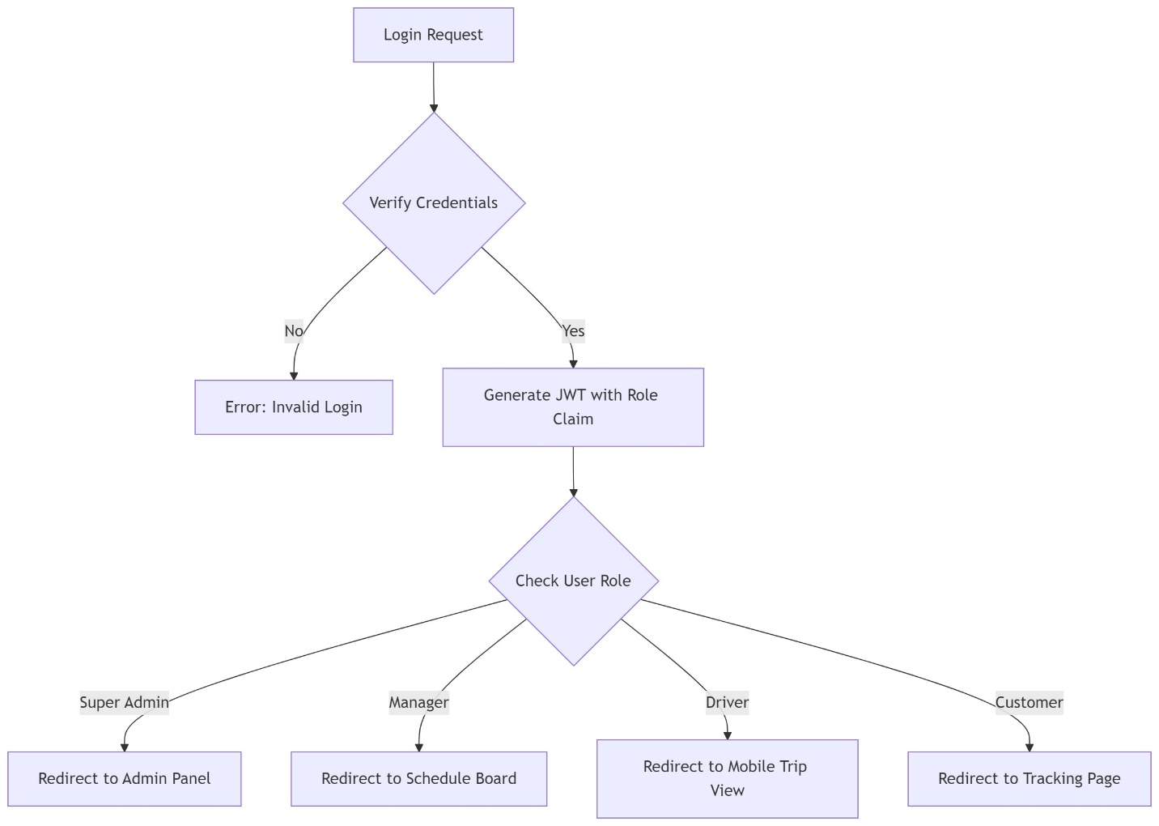
Image 1 Use Case v2.0

