1. OVERVIEW
1.1 Scope of Changes
Version 3.0 addresses the vulnerabilities of static passwords. We introduce Multi-Factor Authentication (MFA) to provide a second layer of defense and OAuth 2.0 (Social Login) to reduce friction for new users during the registration process.
1.2 New Technical Components
- OTP Engine: A service to generate and validate 6-digit Time-based One-Time Passwords (TOTP).
- OAuth 2.0 / OpenID Connect: Integration with Google and Facebook Identity Providers.
- Mail/SMS Gateway: To deliver security codes to the user’s verified device.

2. UPDATED AUTHENTICATION FLOW
Authentication is now a multi-step process for high-privilege roles (Super Admin and Logistics Manager).
Step | Action | Description
Step 1 | Primary Auth | User enters Email and Password (as defined in v1.0).
Step 2 | MFA Challenge | System detects if MFA is enabled and prompts for a 6-digit code.
Step 3 | Token Issuance | Upon valid OTP, the system issues the final JWT (as defined in v2.0).

3. FUNCTIONAL REQUIREMENTS (REQ-F)
3.1 Social Login Integration (OAuth 2.0)
- ID: REQ-F-07
- Description: Users can register or log in using their Google or Facebook accounts.
- Logic: - If the email exists, link the social ID to the existing account.
  - If the email is new, create a profile and assign the "Customer" role by default.
3.2 Multi-Factor Authentication (MFA)
- ID: REQ-F-08
- Description: Users can enable MFA via their Profile Settings.
- Methods:
  - Email OTP: A code is sent to the registered email address.
  - Authenticator App: Support for Google Authenticator (TOTP).
- Requirement: Admin roles must have MFA enabled to access the management dashboard.
3.3 Account Recovery Enhancements
- ID: REQ-F-09
- Description: Introduction of Backup Codes.
- Logic: Upon enabling MFA, the system generates 5 one-time-use backup codes for emergency access if the user loses their device.

4. DATA ARCHITECTURE UPDATES
We add security-specific fields to the Users table to track MFA status and linked accounts.
Table: Users (Extended)
| Attribute | Data Type | Description |
| :--- | :--- | :--- |
| mfa_enabled | Boolean | True if MFA is active for this account. |
| mfa_secret | Varchar(255) | Encrypted secret key for TOTP apps. |
| social_provider| Varchar(50) | 'Google', 'Facebook', or 'Native'. |
| social_id | Varchar(255) | Unique ID provided by the Social platform. |

5. NON-FUNCTIONAL REQUIREMENTS (REQ-NF)
5.1 Security Protocols
- REQ-NF-09: All OTP codes must expire within 5 minutes of issuance.
- REQ-NF-10: Social Login tokens must be validated on the backend using the Provider’s public keys (Signature verification).
5.2 User Experience
- REQ-NF-11: The MFA entry screen must support "Auto-focus" on the first digit and "Paste" functionality for 6-digit codes.

6.USE CASE DIAGRAM LOGIC: MFA CHALLENGE FLOW
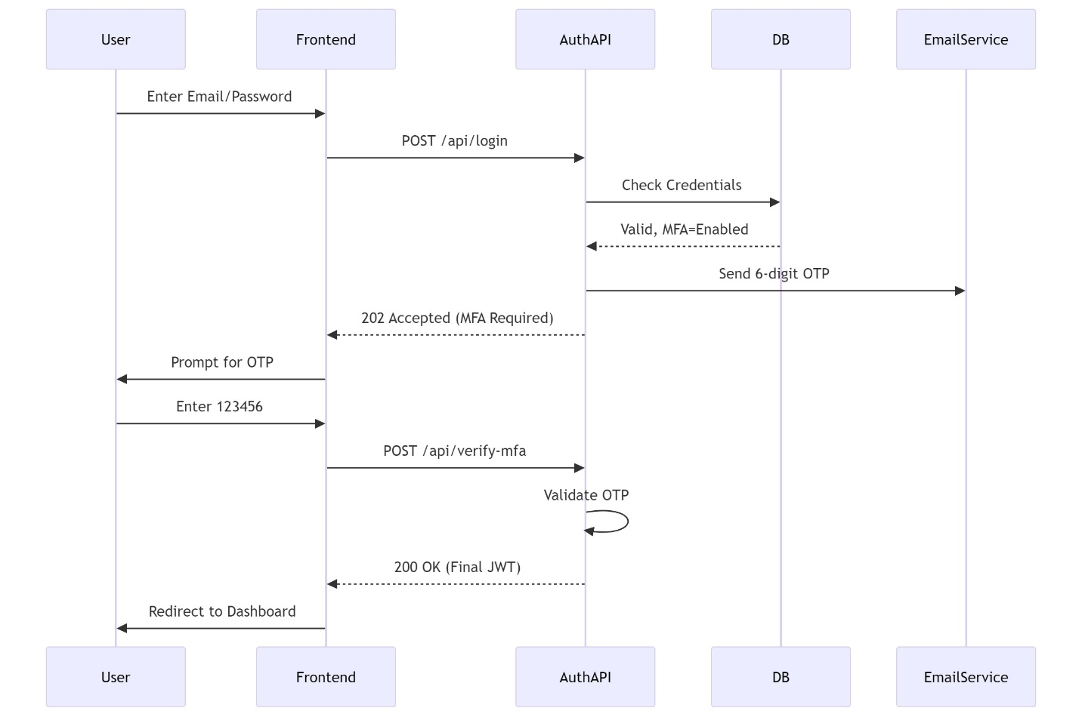
Figure 1 MFA CHALLENGE FLOW

