SOFTWARE REQUIREMENT SPECIFICATION (SRS)
Module: Enterprise Governance & Audit Logging
Version: 4.0 (Compliance & Monitoring)
Project: SmartLogi - AI-Powered Intelligent Logistics System
Date: July 25, 2026

1. VERSION 4.0 OVERVIEW
1.1 Scope of Changes
Version 4.0 introduces an immutable Audit Logging system and automated Account Security Policies. The goal is to provide full transparency into "who did what, and when" while protecting the system from malicious actors through automated suspension.
1.2 New Technical Components
- Audit Logger: A non-blocking service that records every sensitive transaction to a dedicated log table.
- Security Policy Engine: A set of background rules that monitor login attempts and session behavior.
- Admin Security Console: A specialized UI for Super Admins to review system-wide security events.

2. SECURITY GOVERNANCE POLICIES
Policy ID | Name | Logic | Action
POL-01 | Brute-Force Lock | 5 failed attempts in 10 minutes. | Suspend account for 1 hour.
POL-02 | Session Timeout | Inactivity for 30 minutes. | Force Logout (Invalidate JWT).
POL-03 | Geo-Anomaly | Login from a new Country/IP. | Trigger MFA Challenge (REQ-F-08).

3. FUNCTIONAL REQUIREMENTS (REQ-F)
3.1 Immutable Audit Logs
- ID: REQ-F-10
- Description: Every sensitive action (Login, Password Change, Role Update, Delivery Deletion) must be logged.
- Data Points: Timestamp, UserID, IP Address, Action Performed, and "Before/After" values for data changes.
- Constraint: Audit logs must be Read-Only and cannot be deleted by any user, including the Super Admin.
3.2 Automatic Account Suspension
- ID: REQ-F-11
- Description: The system will automatically mark a user as status = 0 (Suspended) if they violate Security Policies (POL-01).
- Notification: An automated email is sent to the user with instructions on how to appeal the suspension.
3.3 GDPR & Privacy Controls
- ID: REQ-F-12
- Description: Compliance with data privacy laws.
- Features: - Right to be Forgotten: A button to request permanent account deletion.
  - Data Portability: Users can export their profile data into a JSON file.

4. AUDIT DATA ARCHITECTURE
A dedicated table is created for high-performance logging, separate from the primary Users table.
Table: Audit_Logs
| Attribute | Data Type | Description |
| :--- | :--- | :--- |
| log_id | BigInt (PK) | Auto-incrementing ID. |
| actor_id | UUID (FK) | The user who performed the action. |
| event_type | Varchar(50) | LOGIN, UPDATE_ROLE, DELETE_ORDER, etc. |
| ip_address | Varchar(45) | IPv4 or IPv6 of the request. |
| metadata | JSON | Details of the change (e.g., {"old_role": "Driver", "new_role": "Manager"}). |

5. NON-FUNCTIONAL REQUIREMENTS (REQ-NF)
5.1 System Integrity
- REQ-NF-12: Audit logs must be written asynchronously so that the logging process does not slow down the user's experience.
- REQ-NF-13: Log data must be backed up daily to a separate secure storage (AWS S3 Glacier).
5.2 Regulatory Compliance
- REQ-NF-14: All User data fields must be encrypted at rest (AES-256) to ensure privacy compliance.

6. USE CASE DIAGRAM-: AUDIT LOGGING FLOW
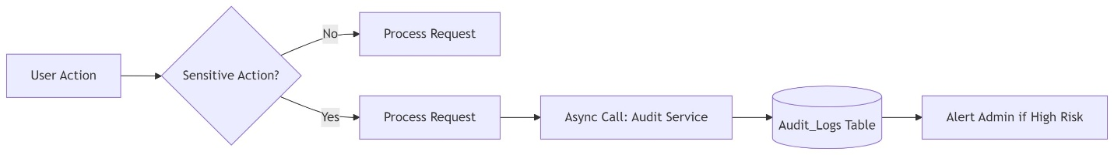
Figure 1 Use case diagram: Audit logging flow

