SOFTWARE REQUIREMENT SPECIFICATION (SRS)
Module: AI-Enhanced Identity & Biometrics
Version: 5.0 (Intelligence & Innovation)
Project: SmartLogi - AI-Powered Intelligent Logistics System
Date: August 30, 2026

1. VERSION 5.0 OVERVIEW
1.1 Scope of Changes
Version 5.0 introduces Biometric Authentication for the mobile application and Agentic AI Insights for user profile management. The system now utilizes the RAG (Retrieval-Augmented Generation) framework to allow users to interact with their own security and profile data via natural language.
1.2 New Technical Components
- Biometric API: Integration with Android BiometricPrompt and iOS FaceID/TouchID.
- AI Profile Agent: An LLM-based service that analyzes user activity logs (from v4.0) to provide security recommendations.
- RAG Interface: Connects the User Management documentation to the SmartLogi Chatbot.

2. SMART IDENTITY FEATURES
Feature ID | Name | Description
FEAT-01 | Biometric Unlock | Use Face/Fingerprint to bypass MFA for 24 hours on trusted devices.
FEAT-02 | AI Security Scoring | AI analyzes login patterns and flags "High-Risk" users for review.
FEAT-03 | Natural Language Auth | Query the chatbot for login history or permission status.

3. FUNCTIONAL REQUIREMENTS (REQ-F)
3.1 Biometric Authentication (Mobile Only)
- ID: REQ-F-13
- Description: Drivers and Field Staff can use FaceID or Fingerprint to access the SmartLogi Mobile App.
- Logic: - Biometric data is stored strictly in the device's "Secure Enclave."
  - The backend only receives a signed cryptographic success/fail signal.
3.2 AI-Driven Profile Completion
- ID: REQ-F-14
- Description: The system identifies missing data (e.g., emergency contact, updated license) and prompts the user via the Chatbot.
- Logic: The AI Agent scans the Users table and generates a personalized "To-Do" list for the user upon login.
3.3 RAG Documentation Integration
- ID: REQ-F-15
- Description: All User SRS versions (v1.0 - v5.0) are indexed in the vector database (ChromaDB).
- Function: Users can ask the chatbot: "What are my role permissions?" or "How do I reset my MFA?" and get answers directly from these documents.

4. ADVANCED DATA ARCHITECTURE
To support AI and Biometrics, we add metadata fields and audit-tracking for AI interactions.
Table: Users (Final Schema)
| Attribute | Data Type | Description |
| :--- | :--- | :--- |
| is_biometric_enabled | Boolean | If user allows FaceID/Fingerprint. |
| security_score | Decimal(3,2) | 0.00 to 1.00 based on AI risk analysis. |
| last_ai_interaction | Timestamp | Tracking when the user last used the Chatbot for support. |

5. NON-FUNCTIONAL REQUIREMENTS (REQ-NF)
5.1 Privacy & Ethics (AI)
- REQ-NF-15: The AI Agent must not store or leak PII (Personally Identifiable Information) in its chat history logs.
- REQ-NF-16: Biometric data must never be transmitted to the server; only the local hardware-backed signature is verified.
5.2 Accessibility
- REQ-NF-17: AI-generated notifications must support Screen Readers and Voice-over for visually impaired staff.
6.USE CASE DIAGRAM LOGIC: AGENTIC AI & RAG FLOW
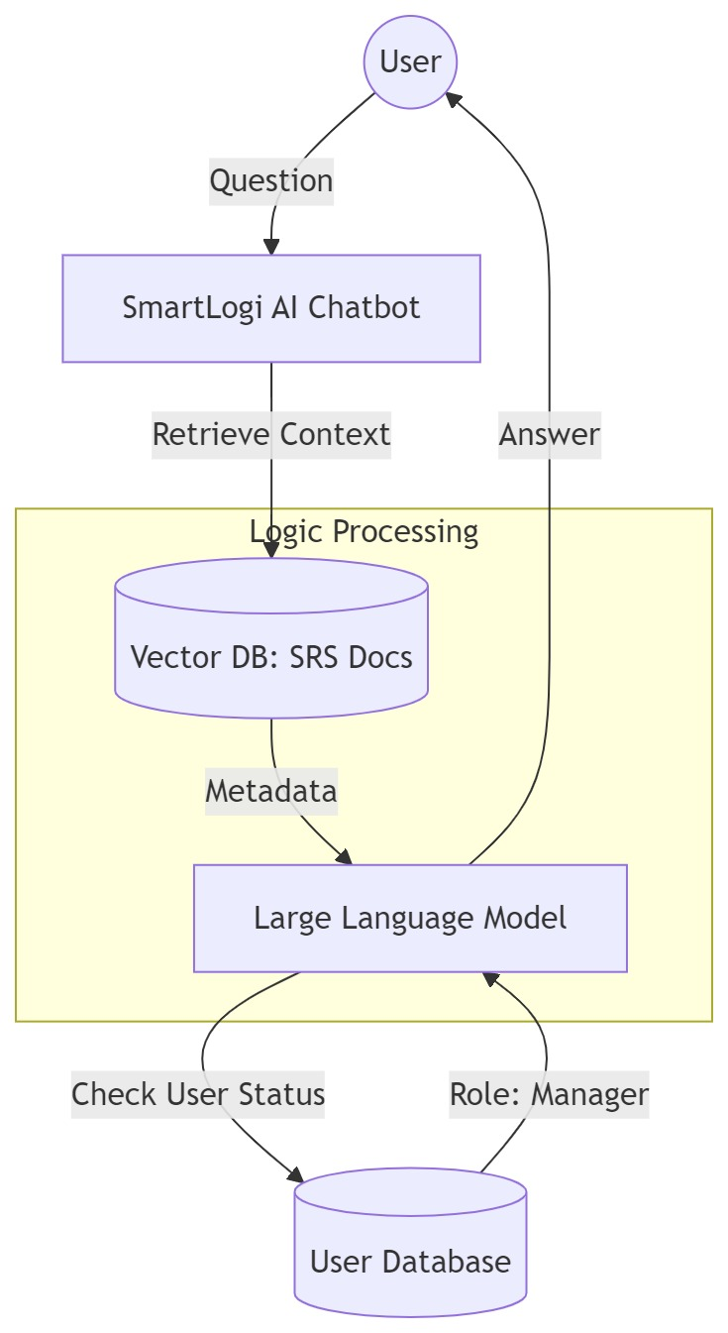
Figure 1 Use case diagram logic: agentic ai& rag flow

