BUSINESS PROCESS FLOW: SMARTLOGI SYSTEM
Document ID: SLG-BPF-2026-ENG
Project: SmartLogi - AI-Powered Logistics Management
Version: 1.0
Classification: Internal Use Only

1. EXECUTIVE SUMMARY
This document outlines the end-to-end business workflows of the SmartLogi platform. The system integrates Agentic AI for decision-making and Retrieval-Augmented Generation (RAG) for policy compliance and document processing. These flows are designed to minimize manual intervention and maximize "Last-Mile" delivery efficiency.
2. CORE BUSINESS WORKFLOWS
2.1 Order Ingestion & AI Validation
This is the entry point where customer requests are converted into actionable logistics tasks.
- Request Input: Customers or Warehouse Staff submit delivery requests via the Web Portal or Mobile API.
- AI Data Validation: An autonomous Validation Agent checks the integrity of the shipping address, contact details, and cargo type.
- RAG Policy Check: The system cross-references the order against internal shipping policies (stored in the Knowledge Base) to ensure the items are shippable (e.g., checking hazardous material restrictions).
- Confirmation: If valid, the order status transitions to "Ready for Dispatch."
2.2 Intelligent Route Optimization (AI-Driven)
The core value proposition of SmartLogi, where the Agentic AI creates the most efficient delivery path.
- Grouping: Orders are automatically clustered based on geographical proximity and delivery deadlines.
- Environmental Analysis: The AI Agent retrieves real-time data regarding traffic congestion, weather conditions, and vehicle availability.
- Optimization Algorithm: AI calculates the "Shortest Path" while balancing vehicle load capacity and fuel efficiency.
- Automatic Dispatch: The system assigns the optimized route to the nearest available Driver and pushes the data to their Mobile App.
2.3 Field Execution & Real-Time Tracking
The physical movement of goods handled by the Driver actor.
- Mobile Notification: The Driver receives a push notification containing the optimized route and turn-by-turn navigation.
- QR Verification: Upon arrival at the warehouse, the Driver scans a QR code to confirm the "Pick-up" of specific packages.
- Execution: The Driver follows the AI-suggested route, providing real-time GPS pings back to the Admin Dashboard.
- Proof of Delivery (PoD): Upon arrival at the destination, the Driver captures a digital signature or a photo as proof.
- Completion: The system updates the status to "Delivered," triggering the invoicing process.
3. VISUAL PROCESS MAP (MERMAID)
This diagram visualizes the logic flow for developers and stakeholders.
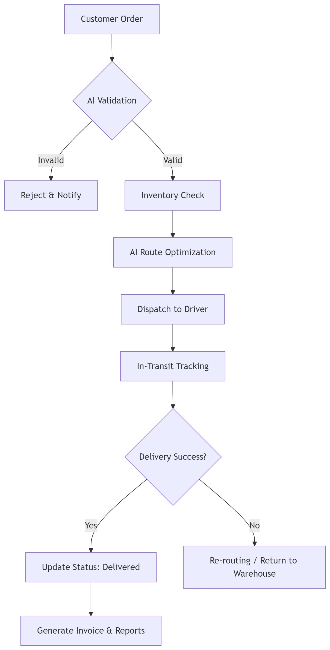
Figure 1 Visual process map
4. EXCEPTION & RISK MANAGEMENT
- Route Disruption: In the event of an accident or roadblock, the AI Agent detects the GPS delay and automatically recalculates an alternative route in real-time.
- Failed Delivery Attempt: If a customer is unavailable, the system logs a "Failed Attempt" and automatically reschedules the delivery for the next available window based on current route density.
5. STAKEHOLDER RESPONSIBILITIES
- Logistics Manager: Oversees the "Macro" flow and handles exceptions flagged by the AI.
- AI Agent: Performs the "Micro" decisions (Validation, Routing, and Notifications).
- Driver: Executes the physical delivery and provides "Ground-Truth" data updates via the app.

