UNCTIONAL VS. NON-FUNCTIONAL REQUIREMENTS
Project: SmartLogi - AI-Powered Logistics
Document ID: SLG-REQ-COMP-2026
Version: 1.0

1. FUNCTIONAL REQUIREMENTS (FR)
Functional Requirements define the specific behaviors, services, and tasks the SmartLogi system must provide. If these are not met, the system is considered incomplete.
ID | Category | Requirement Description
FR-01 | Auth | The system shall allow users to log in via Email/Password and MFA.
FR-02 | Routing | The AI Agent shall calculate the shortest delivery path for a set of 10+ orders.
FR-03 | Tracking | The mobile app shall transmit GPS coordinates every 30 seconds during a trip.
FR-04 | Inventory | Managers shall be able to import SKU data via Excel/CSV file upload.
FR-05 | AI/RAG | The chatbot shall retrieve shipping policy answers from indexed PDF documents.

2. NON-FUNCTIONAL REQUIREMENTS (NFR)
Non-Functional Requirements define the quality attributes, constraints, and performance goals. They describe the "experience" and "reliability" of the system.
ID | Category | Requirement Description
NFR-01 | Performance | The Route Optimization API must return results in under 3 seconds.
NFR-02 | Security | All passwords must be hashed using BCrypt with a work factor of 10.
NFR-03 | Availability | The system dashboard must maintain 99.9% uptime during business hours.
NFR-04 | Scalability | The database must handle up to 1,000 concurrent orders without latency.
NFR-05 | Usability | The Driver Mobile App must be operable with one hand (large buttons/icons).

3. KEY DIFFERENCES AT A GLANCE
Feature | Functional Requirements (FR) | Non-Functional Requirements (NFR)
Definition | What the system DOES. | How the system WORKS.
Focus | User tasks and features. | User experience and system properties.
Violation | Feature is "Missing." | System is "Slow" or "Unsafe."
Example | "System sends an email." | "Email is sent within 5 seconds."

4. SYSTEM ARCHITECTURE IMPACT
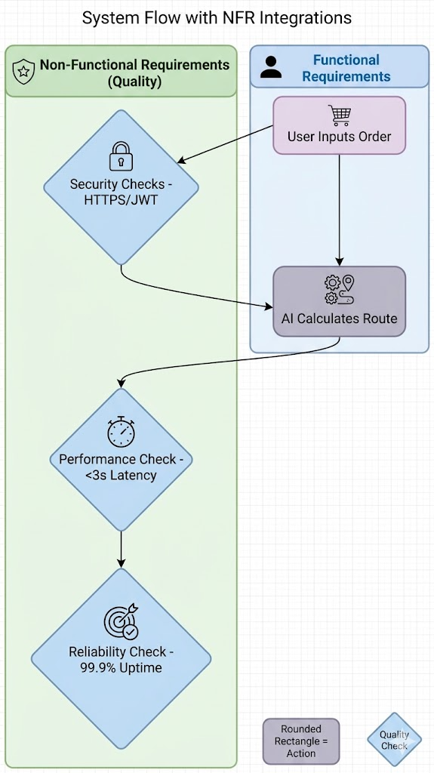
Figure 1 SYSTEM ARCHITECTURE IMPACT

