DETECTION OF PLANT DISEASE USING MACHINE LEARNING AND DEEP LEARNING ALGORITHMS

Objective: The main objective of this to detect and classify the plant disease using the machine learning (SVM) and deep learning (CNN, MobileNet, ResNet) algorithms.

Agriculture plays a crucial role in the Indian economy. Early detection of plant diseases is very much essential to prevent crop loss and further spread of diseases. Most plants such as apple, tomato, cherry, grapes show visible symptoms of the disease on the leaf. These visible patterns can be identified to correctly predict the disease and take early actions to prevent it. This can be overcome by the use of machine learning and deep learning algorithms. Hence, we are proposing a method that which is detecting the disease of a tomato plant from their leaf images. Here the process is performed with the Support Vector Machine (SVM), Random Forest algorithms of machine learning along with deep learning algorithms Convolutional Neural Network (CNN), Recurrent Neural Network (RNN) and ResNet, which is a one of the transfer learning method of CNN. Once after training the dataset with the algorithms, the accuracy of algorithms is compared and the images are classified. And the precautions are also provided for the classified plant.
Keywords: Plant diseases, machine learning, deep learning, CNN, MobileNet, ResNet, SVM.

Existing System: This model emphasizes an existing method where the disease prediction is performed manually by farmers. It is very difficult for the farmers to manually identify many diseases accurately with their limited knowledge. This difficulty can be overcome by using deep learning techniques.
Disadvantages of Existing System:
- More Expensive.
- Difficult to scale up.
- Time consuming.

Proposed System:
In our proposed method we are performing the prediction of the plant diseases. Here, we are proposing a method that which is detecting the disease of a tomato plant from their leaf images. Here the process is performed with the Support Vector Machine (SVM) algorithm of machine learning along with deep learning algorithms Convolutional Neural Network (CNN), MobileNet and ResNet, which is a one of the transfer learning method of CNN. Once after training the dataset with the algorithms, and the precautions are also provided for the classified plant. Block diagram of proposed method is shown below.
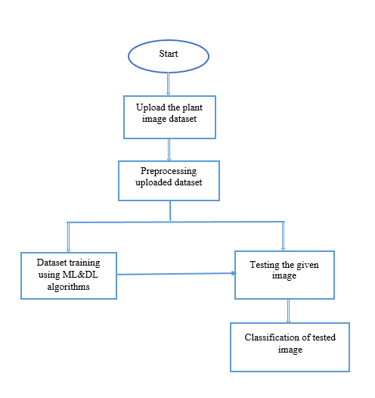
Fig. Block diagram of proposed method

Advantages of proposed system:
• Accurate classification
• Less complexity
• High performance
MODULES:
MODULES:
System
User
1. System:
1.1 Create Dataset:
The dataset containing images of the plant leaf images which are normal and effected with disease are split into training and testing dataset with the test size of 30-20%.
1.2 Pre-processing:
Resizing and reshaping the images into appropriate format to train our model.
1.3 Training:
Use the pre-processed training dataset is used to train our model using machine learning (SVM) and deep learning (CNN, MobileNet, ResNet) algorithms
1.4 Classification:
The results of our model is predicted output along with the accuracy comparison.

2. User:
2.1 View training accuracy
User can check the trained algorithms accuracy
2.2 Upload Image
The user has to upload an image which needs to be classified.
2.3 View Results and precautions
The classified image results are viewed by user along with precautions.

Software & Hardware Requirements:

H/W Configuration:

Processor : I3/Intel Processor
- Hard Disk : 160GB
- RAM : 8Gb
S/W Configuration:
- Operating System : Windows 7/8/10 .
- IDE : Jupyter Notebook/Pycharm.
- Libraries Used : Numpy, IO, OS, keras.
- Technology : Python 3.6+.

LEARNING OUTCOMES:
- Practical exposure to
      - Hardware and software tools
      - Solution providing for real time problems
      - Working with team/individual
      - Work on creative ideas
- Testing techniques
- Error correction mechanisms
- What type of technology versions is used?
- Working of Tensor Flow
- Implementation of Deep Learning techniques
- Implementation of Machine Learning techniques
- Working of Transfer Learning methods
- Building of model creations
- Scope of project
- Applications of the project
- About Python language
- About Deep Learning Frameworks
- Use of Data Science

