Name: Ha Thuc Tu Quy
ID: 2231200024

Q2:


GET | http://localhost:3000/api/users
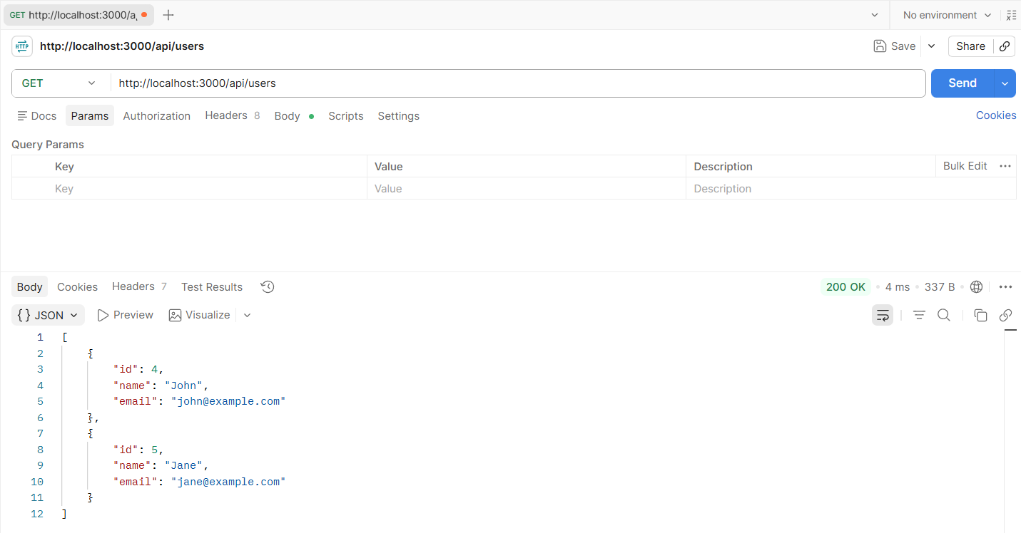

POST | http://localhost:3000/api/users
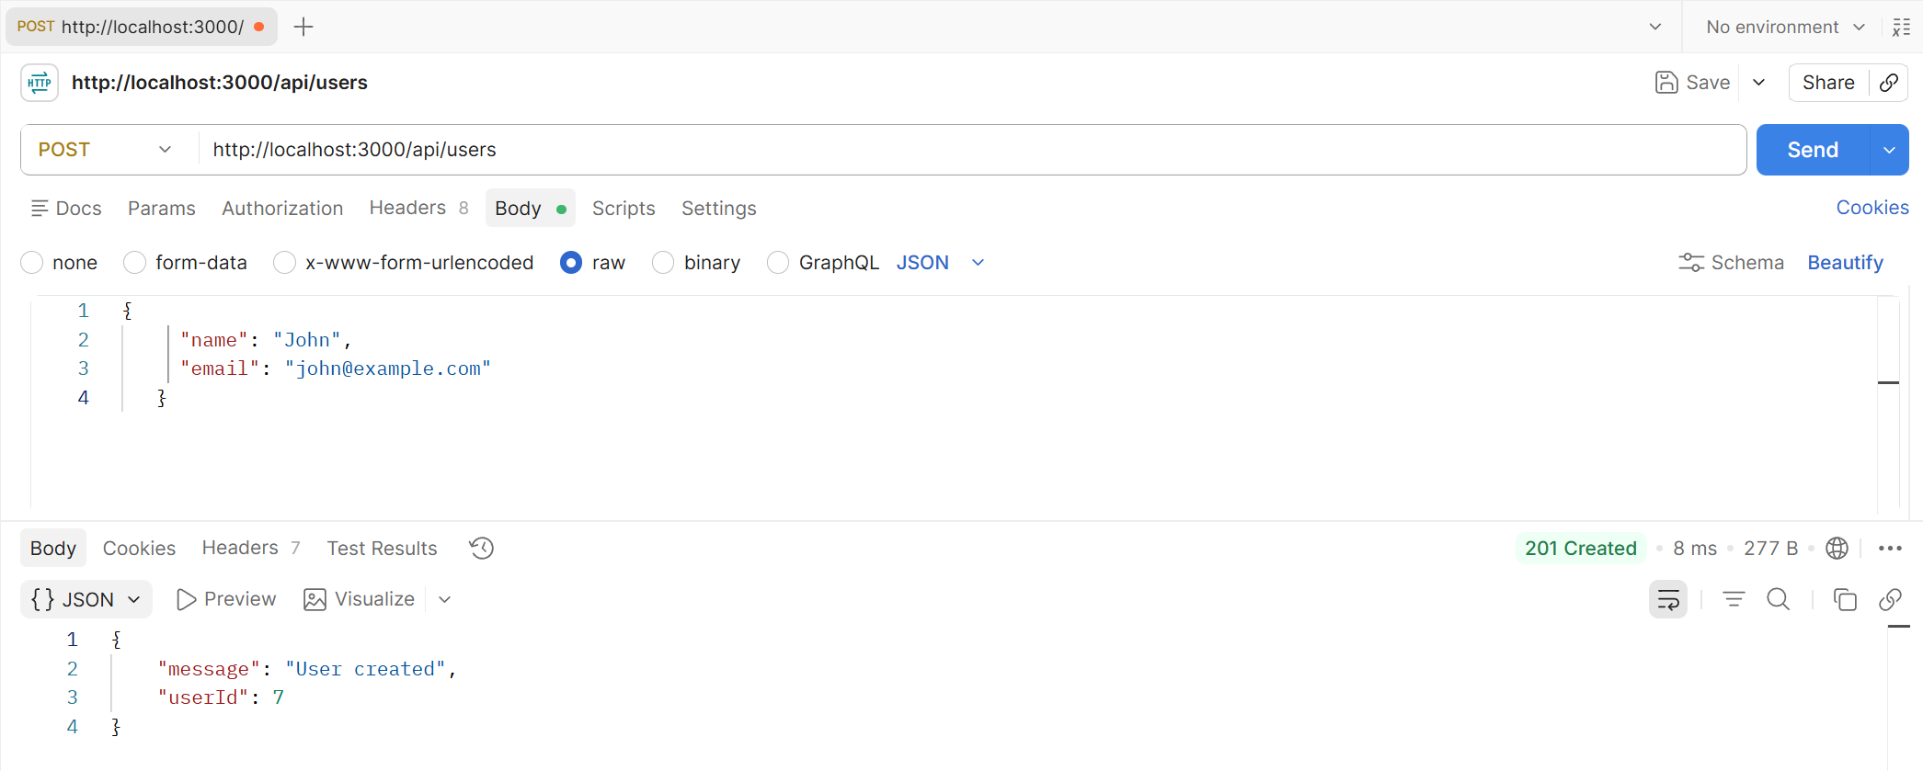

GET | http://localhost:3000/api/users/7
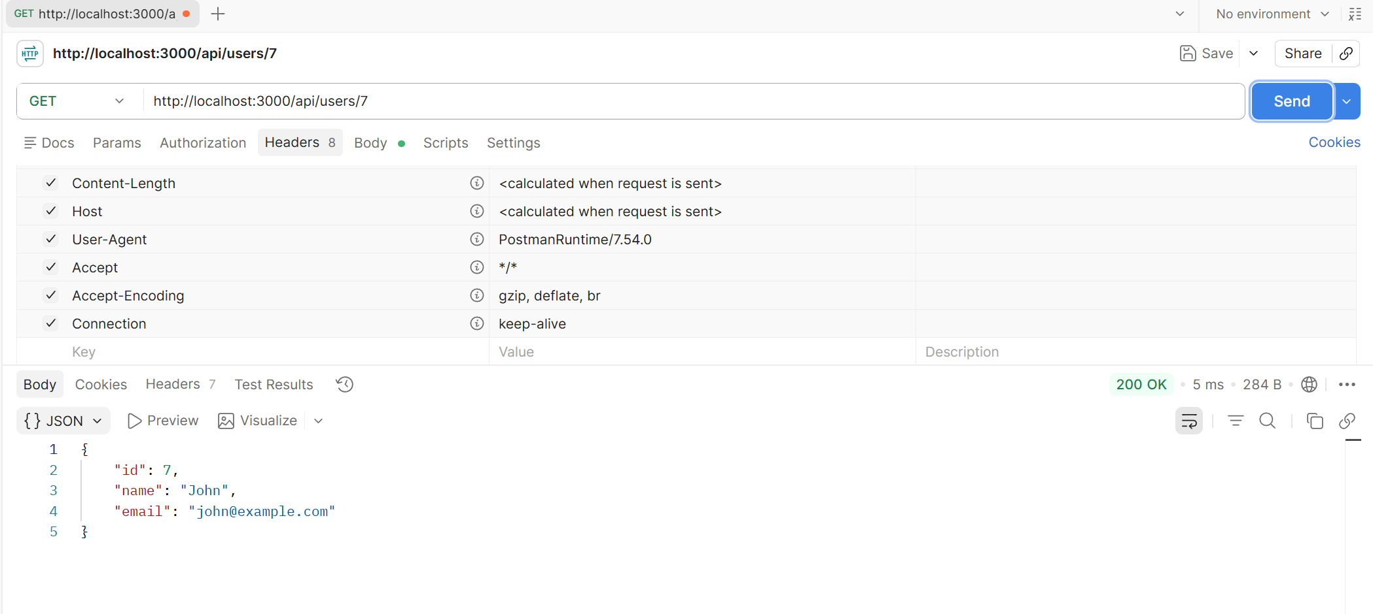

PUT | http://localhost:3000/api/users/7

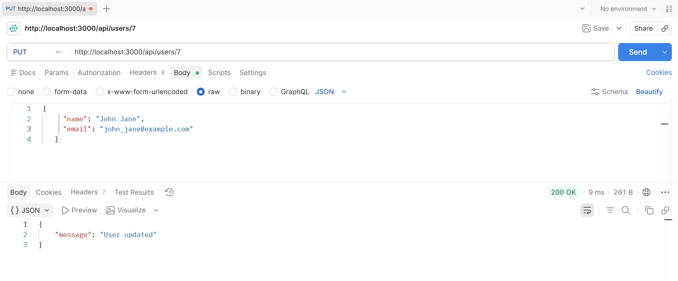
DELETE | http://localhost:3000/api/users/7
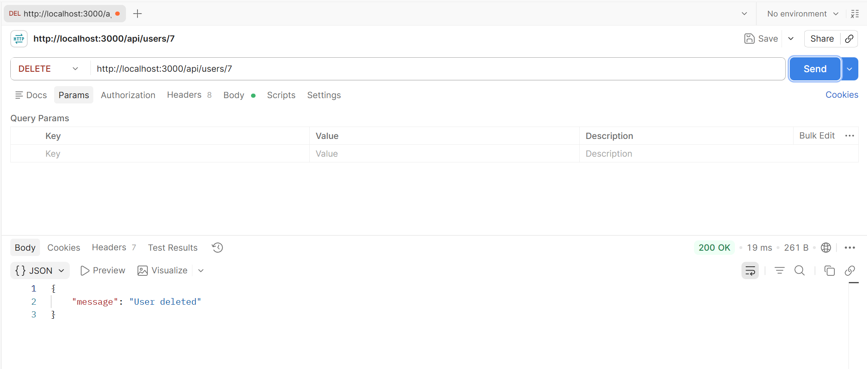

Q3:

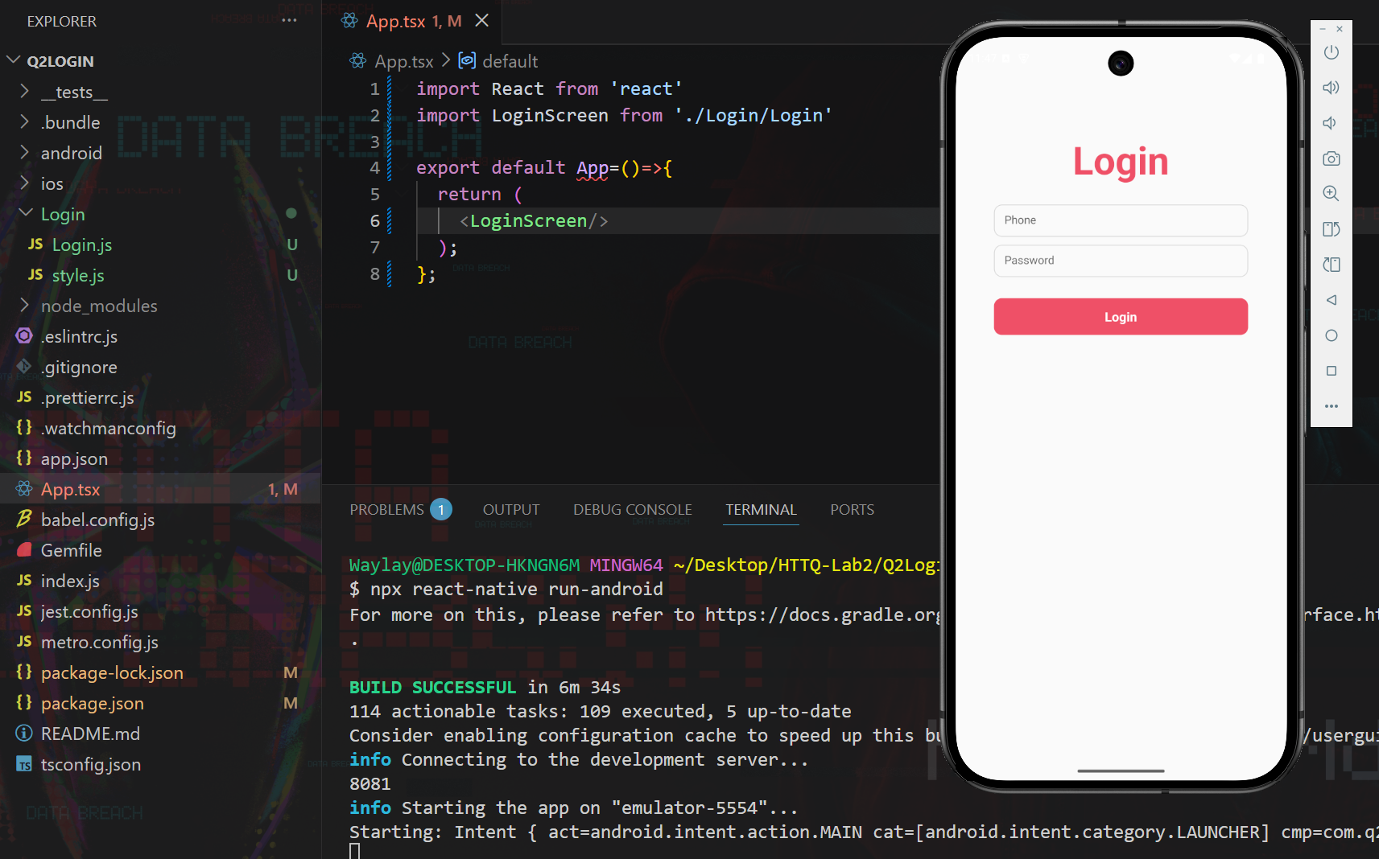
Q4:

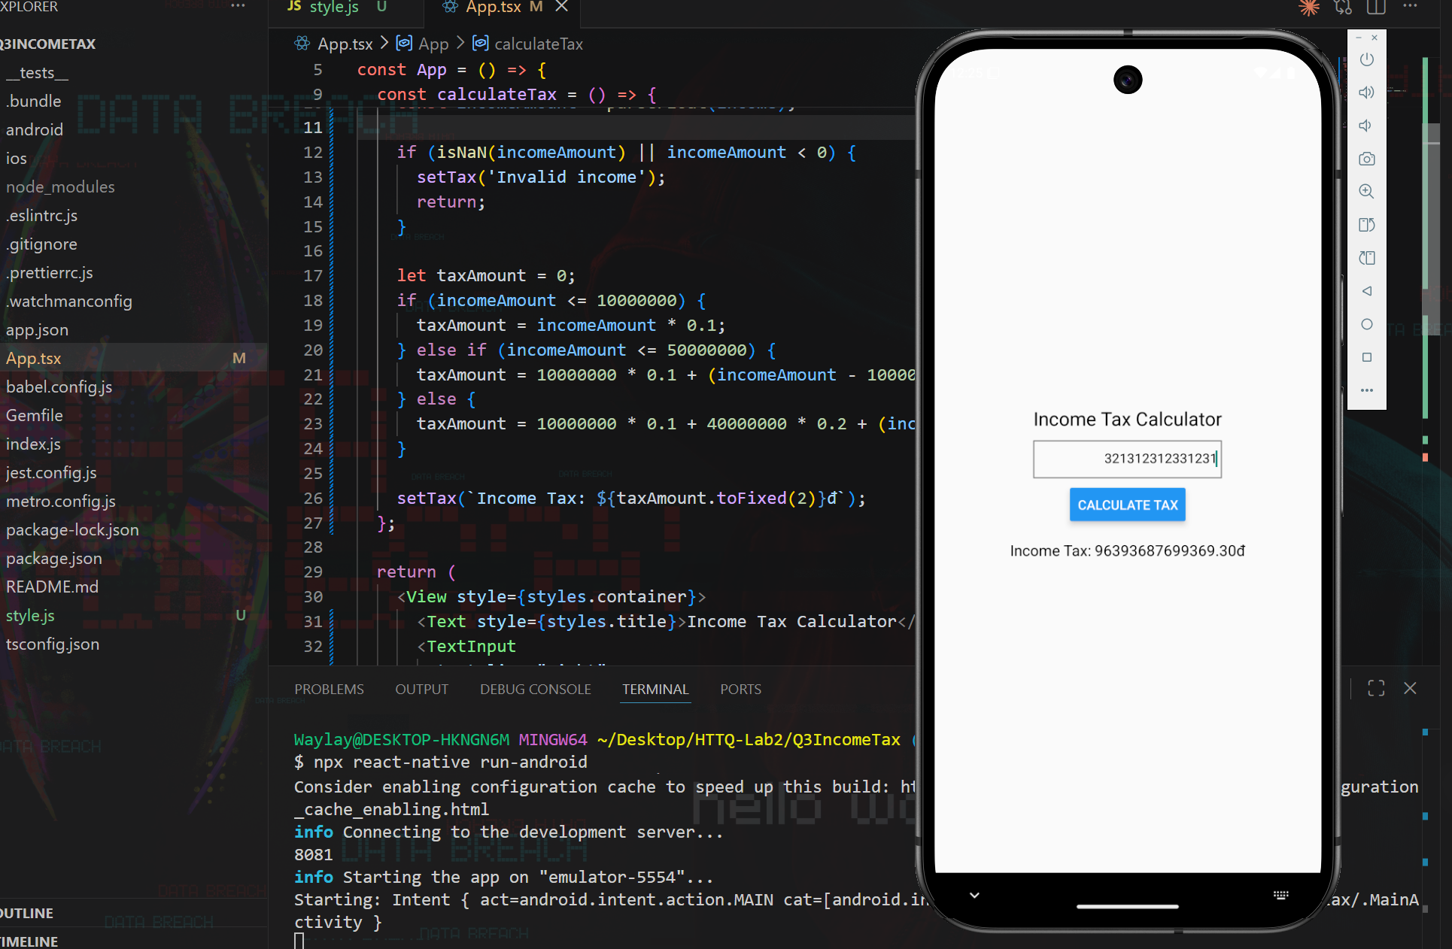

Q5:
