STA5077Z: UNSUPERVISED LEARNING - PROJECT

Corne Oosthuizen - OSTAND005

Due: 14 August 2017

# 2 -

## Warning: package 'formattable' was built under R version 3.3.3

tracks

type

count

mean.queue_time

mean.run_time

mean.full_time

A

edit

19

7.3684

3706.4

3713.8

A

publish

5

6.4000

3493.4

3499.8

B

edit

24

6.9583

9838.2

9845.2

B

publish

17

7.0000

12127.5

12134.5

C

edit

19

7.6316

14124.6

14132.2

C

publish

18

7.5556

14228.6

14236.1

## type tracks duration queue run   
## edit :62 A:24 Min. : 0 Min. : 4.00 Min. : 32   
## publish:40 B:41 1st Qu.: 3600 1st Qu.: 6.00 1st Qu.: 3517   
## C:37 Median : 6600 Median : 7.00 Median : 8024   
## Mean : 8216 Mean : 7.25 Mean :10340   
## 3rd Qu.: 9000 3rd Qu.: 8.75 3rd Qu.:13274   
## Max. :25201 Max. :10.00 Max. :57596   
##   
## operations day hour   
## Min. : 4.0 2:22 13 :19   
## 1st Qu.:39.0 3:15 14 :15   
## Median :41.0 4:25 10 :14   
## Mean :39.3 5:18 12 : 9   
## 3rd Qu.:41.0 6:10 8 : 6   
## Max. :43.0 7:12 9 : 6   
## (Other):33

type

count

mean.queue_time

mean.run_time

mean.full_time

encode

111

63.4759

1799.512432

1862.9883

inspect

122

4.8023

1836.707426

1841.5097

prepare-av

294

3.3084

1244.919524

1248.2279

editor

37

4.5976

830.501351

835.0989

normalize-audio

37

4.1483

654.284865

658.4331

composite

360

4.3615

363.622264

367.9838

segment-video

74

3.5653

304.147203

307.7125

compose

403

4.6836

51.144799

55.8284

publish-engage

40

4.3926

35.315300

39.7079

waveform

61

4.3897

10.748705

15.1384

silence

61

4.8200

10.298984

15.1190

image

148

4.0062

10.370709

14.3769

segmentpreviews

74

3.8805

8.172892

12.0534

archive

196

4.6306

7.422255

12.0529

publish-configure

98

4.6028

6.763429

11.3663

cleanup

101

4.6648

4.575446

9.2402

ingest-download

61

4.9244

0.082328

5.0067

defaults

40

4.6178

0.284350

4.9022

comment

98

4.6775

0.179184

4.8567

include

469

4.5313

0.167808

4.6991

analyze-tracks

355

4.5188

0.174623

4.6934

tag

575

4.4767

0.152317

4.6291

publish-youtube

37

4.4282

0.000000

4.4282

series

61

2.9586

0.511984

3.4706

export-wf-properties

61

2.8971

0.196787

3.0939

## type queue run   
## analyze-tracks :355 Min. : 0.0 Min. : 0.0   
## archive :196 1st Qu.: 4.3 1st Qu.: 0.1   
## cleanup :101 Median : 4.6 Median : 0.2   
## comment : 98 Mean : 6.0 Mean : 258.3   
## compose :403 3rd Qu.: 4.9 3rd Qu.: 10.4   
## composite :360 Max. :4035.1 Max. :11566.7   
## defaults : 40   
## editor : 37   
## encode :111   
## export-wf-properties: 61   
## image :148   
## include :469   
## ingest-download : 61   
## inspect :122   
## normalize-audio : 37   
## prepare-av :294   
## publish-configure : 98   
## publish-engage : 40   
## publish-youtube : 37   
## segment-video : 74   
## segmentpreviews : 74   
## series : 61   
## silence : 61   
## tag :575   
## waveform : 61   
## full day hour tracks duration   
## Min. : 0.0 2: 845 0 : 9 A: 946 Min. : 300   
## 1st Qu.: 4.6 3: 595 1 : 21 B:1596 1st Qu.: 3600   
## Median : 5.1 4:1027 6 : 5 C:1432 Median : 7200   
## Mean : 264.3 5: 701 7 : 21 Mean : 8400   
## 3rd Qu.: 15.1 6: 336 8 :112 3rd Qu.: 9000   
## Max. :11569.5 7: 470 9 :205 Max. :25201   
## 10:418   
## 11:261   
## 12:305   
## 13:317   
## 14:597   
## 15:403   
## 16:297   
## 17:199   
## 18:209   
## 19:248   
## 20:140   
## 21: 77   
## 22: 63   
## 23: 67   
##   
##   
##   
##   
##

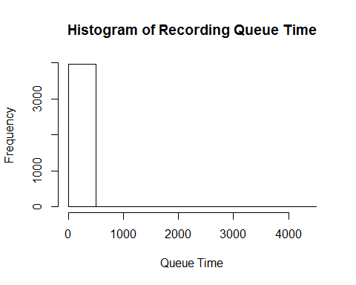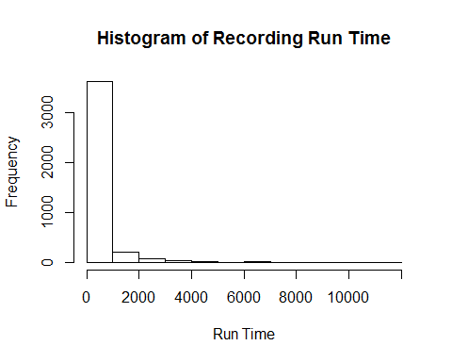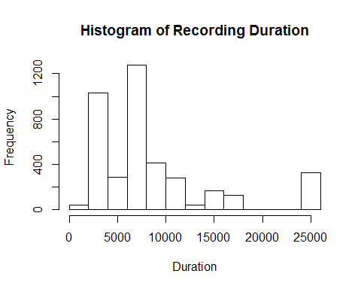

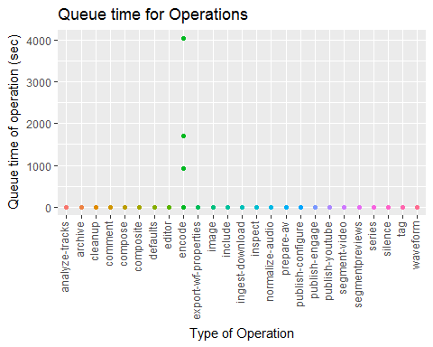

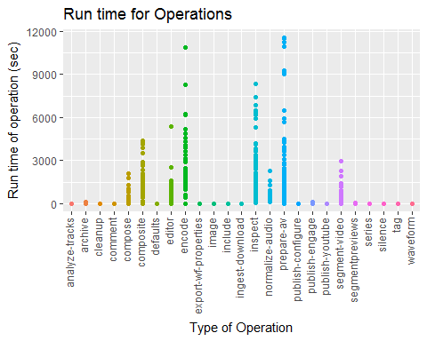

type

mean.run

mean.duration

mean.ratio

composite

363.62

8642.1

0.038616

editor

830.50

9041.6

0.083055

inspect

1836.71

7962.5

0.218937

normalize-audio

654.28

9041.6

0.077611

prepare-av

1244.92

8369.9

0.127188

segment-video

304.15

9041.6

0.031606

## Warning: package 'kohonen' was built under R version 3.3.3

##   
## Attaching package: 'kohonen'

## The following object is masked from 'package:purrr':  
##   
## map

## Problem Statement

## Data Description

## Conclusion