# Tural Asgarov – 221ADB123

# Tural Mammadli – 221ADB166

# Rza Mirzayev – 221ADB213

# Customer Identification Report

## 1. Customer Name & Business Type

Customer Name: Abel Albuquerque

Business Type: Wedding Planning and Management

## 2. Problem Description (What IT solution do they need?)

Abel Albuquerque requires a Wedding Management App that helps users plan and organize weddings. The application should include:

- User roles & accounts

- Guest management

- Venue booking

- Vendor tracking

- Budget management

- Task scheduler with reminders

- Dashboard with an overview of guests, expenses, and pending tasks

Managing wedding arrangements by hand may be taxing, hence Abel is seeking a dependable and quick IT solution. Having a well-organized software helps him to minimize human mistakes, simplify event preparation, and give customers and suppliers a better experience. He asked outside help to realize his vision since he lacks the technical knowledge to create such an application on his own. Based on our Fiverr knowledge, he thinks we can create a working and user-friendly site in the period provided.

## 3. Why This Customer Was Chosen

- The customer found Tural Mammadli's gig on Fiverr related to Java-based IT projects.

- The project aligns with the university's requirement for an IT project under 20-30 hours of development.

- The customer agreed to the tech stack (Java, Spring Boot, PostgreSQL) and overall scope.

## 4. Estimated Development Time (Feasibility Check: 20-30 Hours)

- Given the scope, the project fits within 20-30 hours if developed with a basic UI and essential features only.

- Complex features like real-time collaboration, deep analytics, or advanced AI recommendations are not included due to time constraints.

## 5. Proof of Customer Agreement

- Screenshot of the Fiverr conversation discussing project details and email exchange.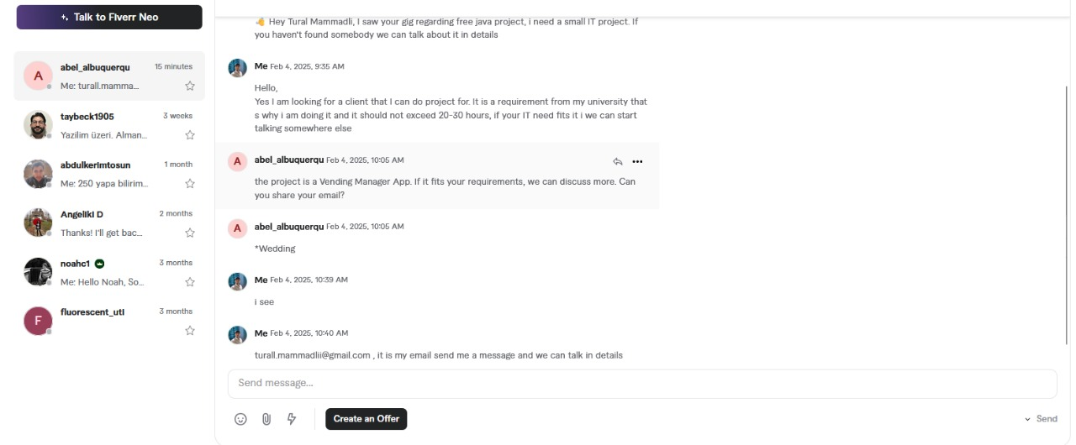

- Email confirmation from Abel Albuquerque stating: