**App „Guess number”**

1. Title screen

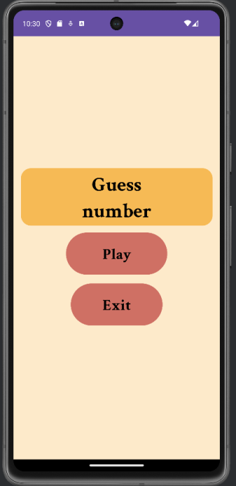

„Play” – start a game.

„Exit” – close app.

1. Game

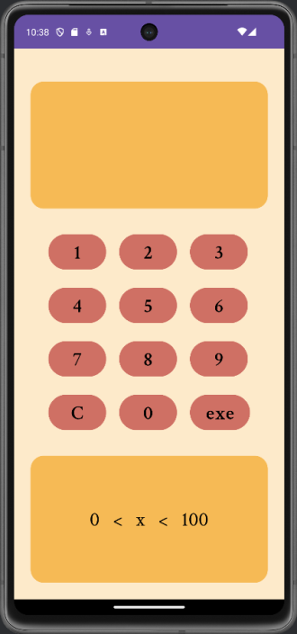We guess a number from the range (0, 100).

Buttons with numbers – we enter the numbers in the field at the top of the screen.

Button „C” – we clear the numbers entered so far.

„exe” – we check the number we entered.

At the bottom of the screen, after pressing "exe", it shows us from which new range the number we are guessing is.

At this point, if we pause the game and close the application, when we reopen it we will be back to the point where we left off.

1. Post-game summary

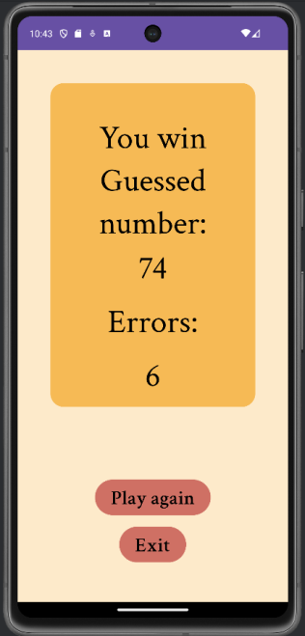It displays what number we guessed and how many mistakes we made.

„Zagraj jeszcze raz” – restarts the game with a new number.

„Wyjdź” – closes the application.