**Application „Quiz about music bands”**

1. Main screen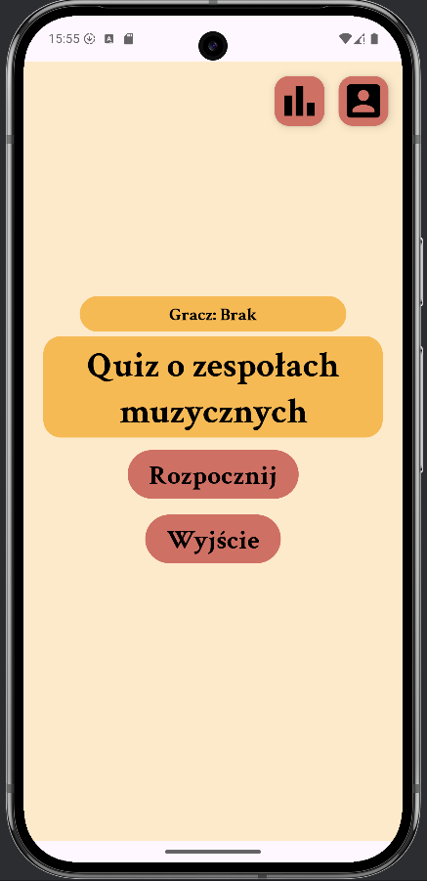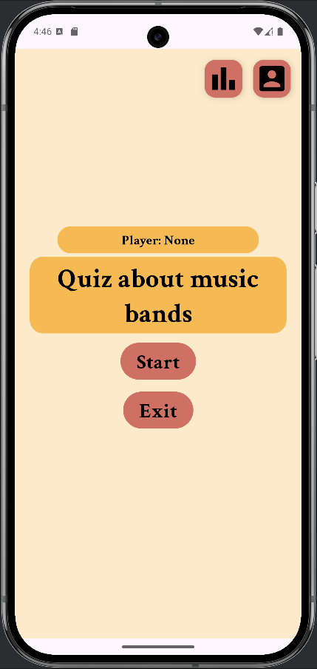

 - start quiz

 - closes the application

 - opens the player accounts panel

 - opens the statistics panel

2. Panel with records

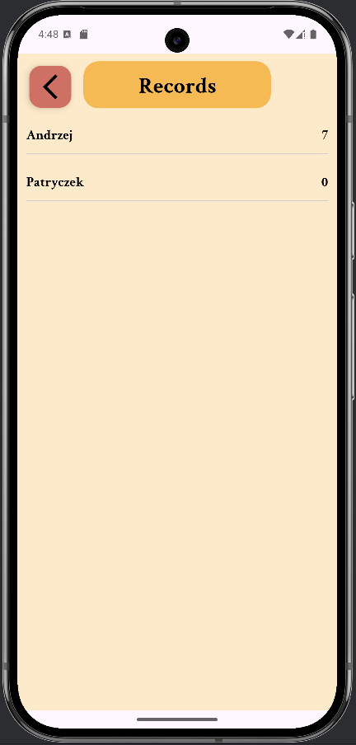

Displays player records sorted from best to worst.

 - return to a main screen

3. Panel with players’ accounts

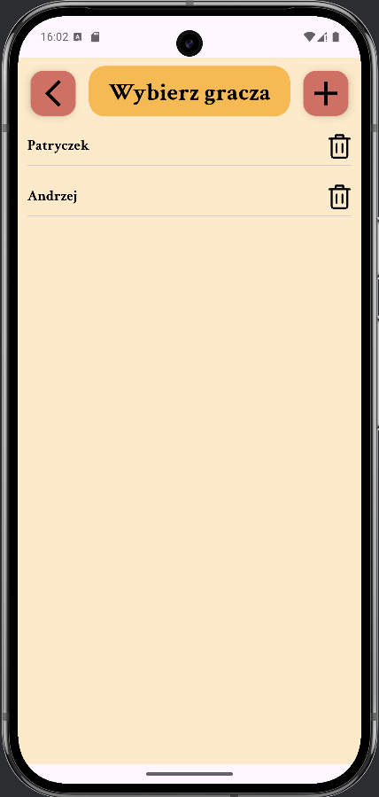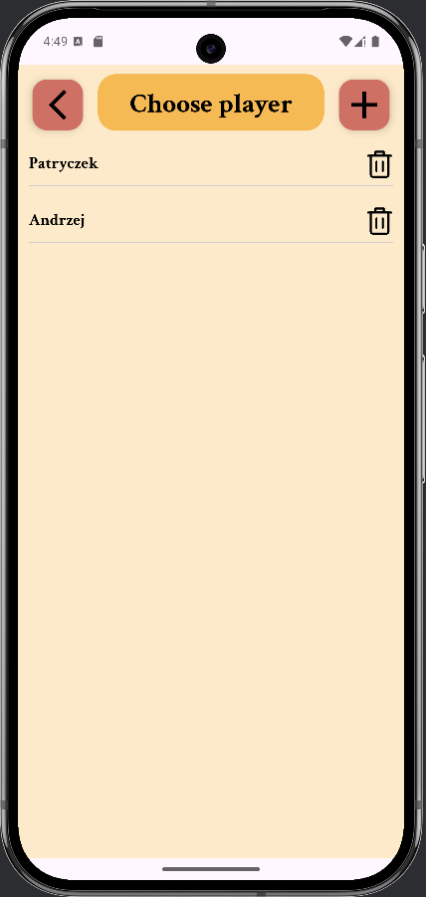

Displays a list of players.

 - return to a main screen

 - navigates to the new player creation panel

 - deletes the player next to the clicked button

Clicking on a player's name takes us to the main screen with the selected player.

4. Add Player Panel

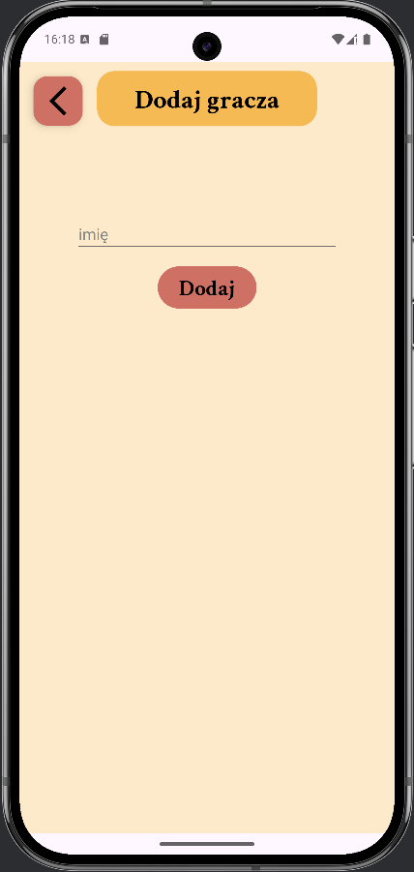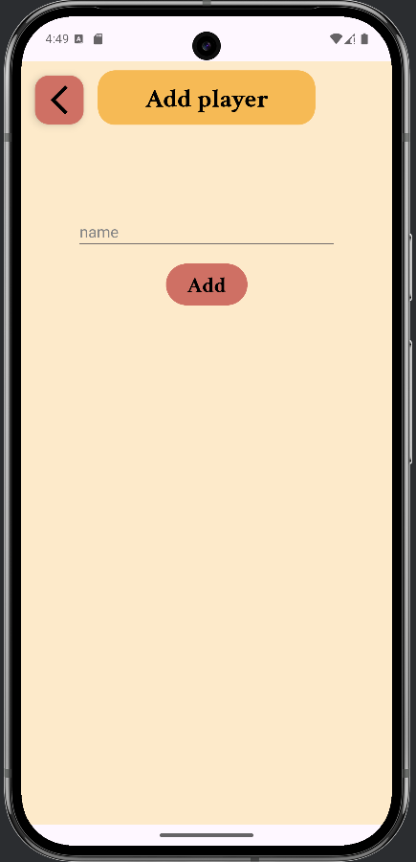

 - return to a main screen

 - here we enter a name that will be our player nickname (it must not be the same as an existing player's name)

 - add a new player

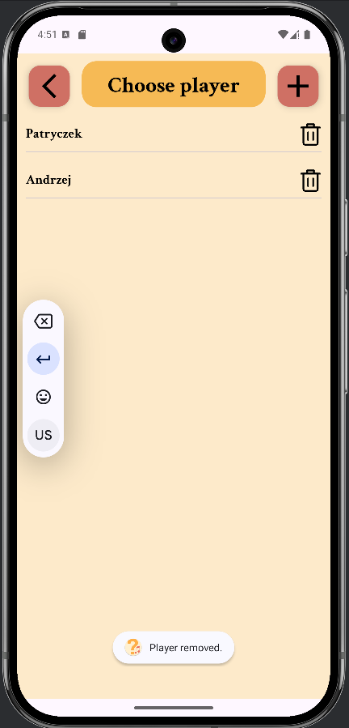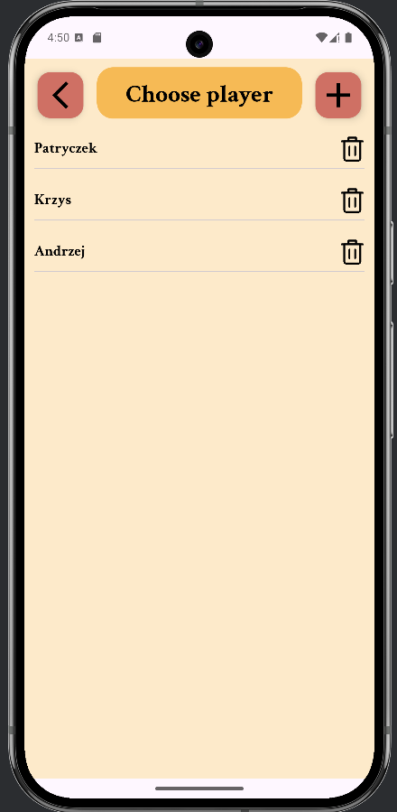

New player has been added.

(on the left)

And then deleted.

(on the right)

5. Main Screen with Selected Player.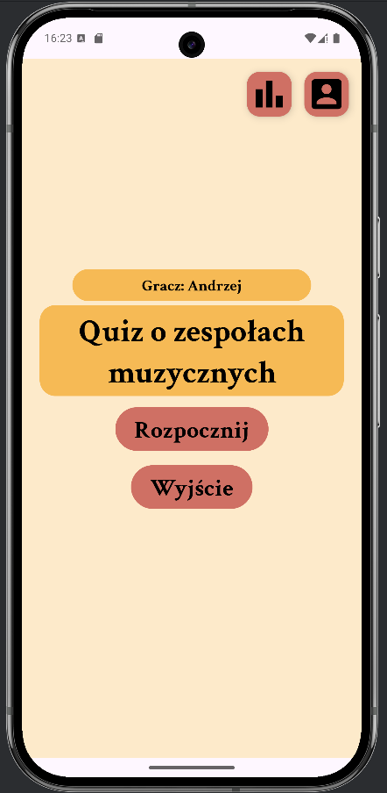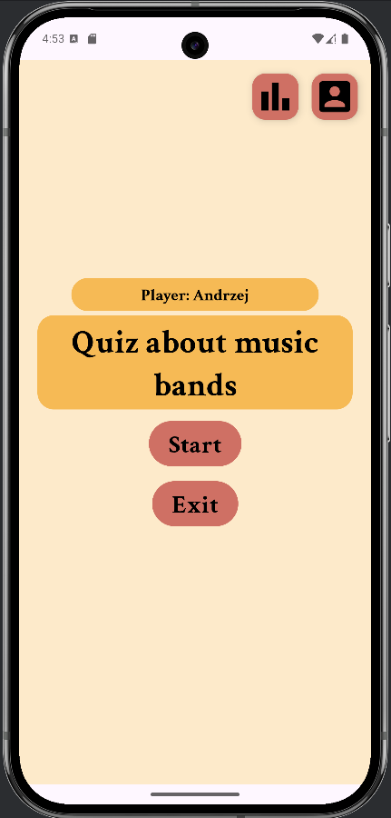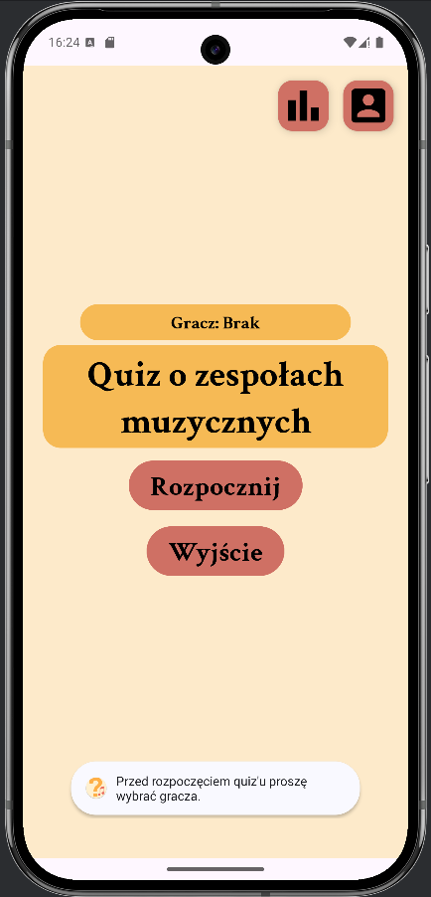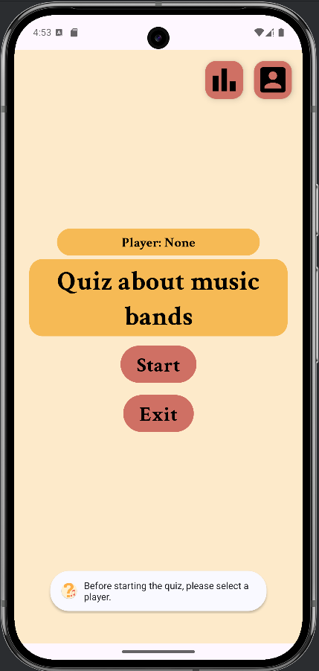

Without selecting a player, we cannot start the game.

(on the right)

After selecting a player, click "Start".

6. Quiz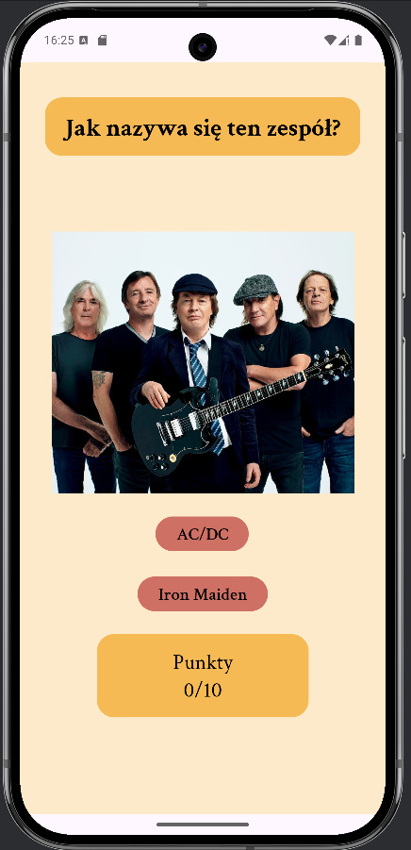

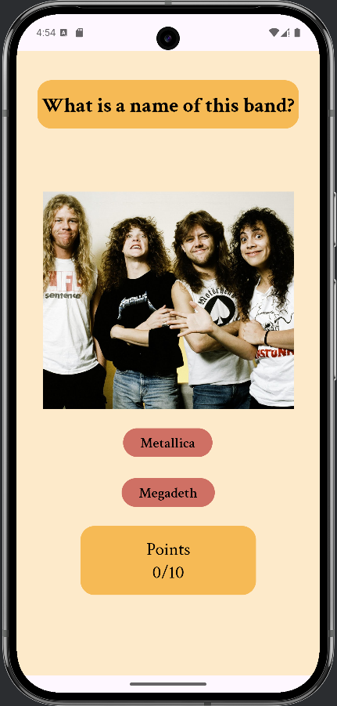

The quiz is about recognizing a music band from a photo. Questions are randomly selected from a pool. Each quiz consists of 10 questions.

 - displays how many points we've already earned

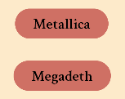- answer buttons, click one to answer and move to the next question (on the right).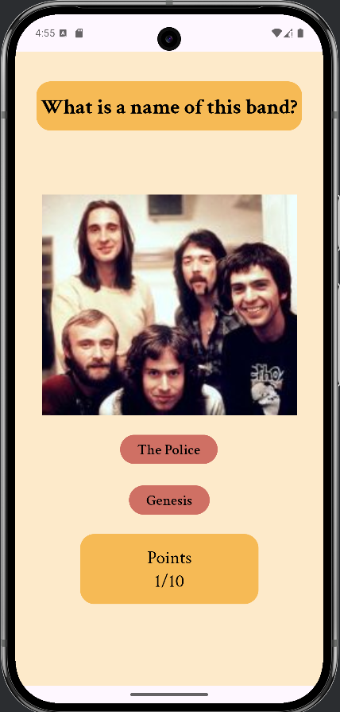

7. Summary 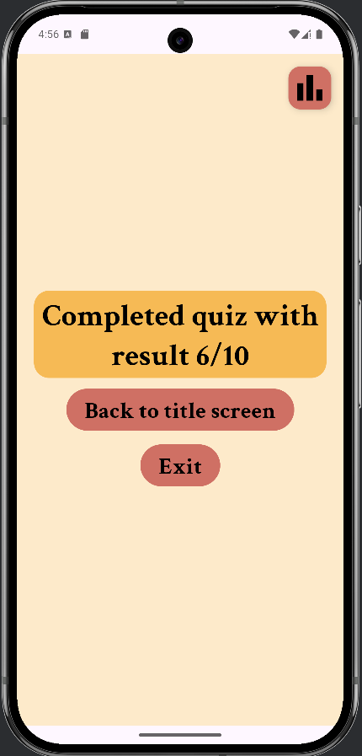

After answering all the questions, a summary with our score is displayed.

We can:

 - return to a main screen

 - close the application

 - go to the statistics