Nesneye Yönelik Programlama

Öğrenci Ders Seçimi Projesi

1. Uygulama tanıtımı:

Uygulamam lisede 11 sınıfa geçenlerin ortak derslerini ve seçtiği seçmeli derslini (Sayısal Sözel Eşit Ağırlık) gibi dersleri kullanıcıya seçtirip ekrana yazdıran bir Java uygulaması;

1. Uygulamamın Çalışma Şekli:

Kullanıcıdan Adını, Soyadını, Öğrenci Numarasını, Doğum yılını, Doğum Ayını, Doğum Gününü, Ve Seçtiği Ders programını (Sayısal Sözel Eşit Ağırlık) Kullanıcıdan İsteyip Ekrana Kullanıcıdan Adını, Soyadını, Öğrenci Numarasını, Doğum yılını, Doğum Ayını, Doğum Gününü, Ortak Derslerini Ve Seçtiği Ders programını (Sayısal Sözel Eşit Ağırlık) Ekrana yazdırır.

1. Uygulamanın Görselleri

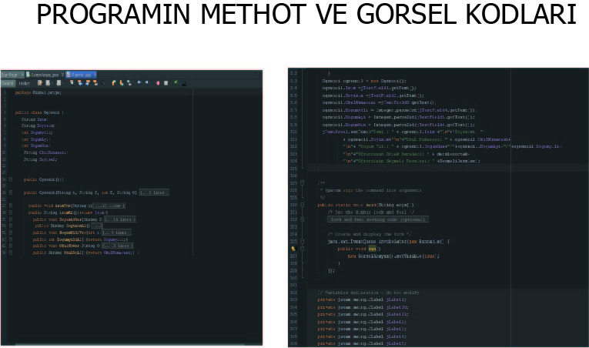

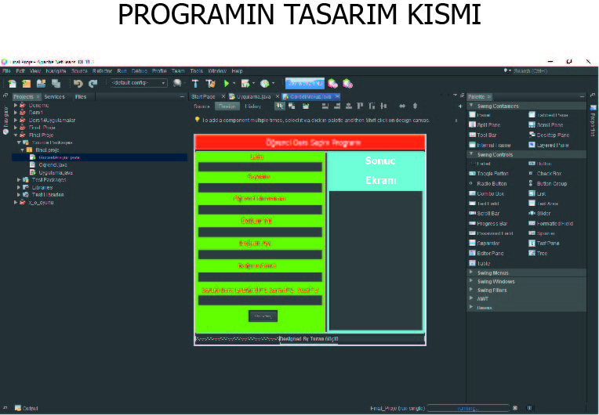

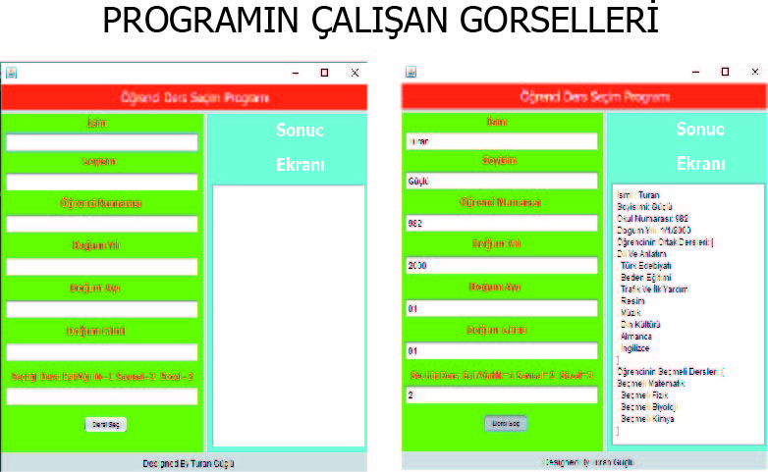

d)Uygulamanın Kodları:

METHOT KISIM

|  |
| --- |
| Ogrenci.java  package fiinal.proje;  public class Ogrenci {  String Isim;  String Soyisim;  int Dogumyili;  int DogumAyi;  int DogumGun;  String OkulNumarasi;  String Sayisal;    public Ogrenci(){}  public Ogrenci(String i, String S, int D, String O) {  Isim = i;  Soyisim = S;  Dogumyili = D;  OkulNumarasi = O;  }    public void isimVer(String i){  if(i.length()< 3){  System.out.println("Uygun Olmayan İsim Girişi Yapıldı. Varsayılan Olarak İsminiz Kullanıcı Atandı");  Isim = "Kullanıcı";    }  else {    Isim =i ;      }  }  public String isimAl(){return Isim;}  public void SoyisimVer(String S){  if(S.length()< 3){  System.out.println("Uygun Olmayan Soyİsim Girişi Yapıldı. Varsayılan Olarak soyisminiz Kullanıcı Atandı");  Soyisim = "Yılmaz";    }  else {    Soyisim =S ;      }    }  public String SoyisimAl(){return Soyisim;}  public void DogumYiliVer(int i){  if( i < 1900 || i > 2017){  System.out.println("Uygun Olmayan Doğum Tarihi Girişi Yapıldı. Varsayılan Olarak Doğum Tarihiniz 0 olarak Atandı");  i = 0;  }  else{  Dogumyili = i;    } }  public int DogumyiliAl(){return Dogumyili;}  public void OkulNoVer(String O){  if(O.length() != 4){  System.out.println("Uygun Olmayan OkulNumarası Girişi Yapıldı. Varsayılan Olarak OkulNumaranız 0 Atandı");  OkulNumarasi = "0";    }  else {    OkulNumarasi= O ;      }    }  public String OkulNoAl(){return OkulNumarasi;} } |

GÖRSEL KISIM

|  |
| --- |
| Gorsel Arayuz.java  /*  * To change this license header, choose License Headers in Project Properties.  * To change this template file, choose Tools | Templates  * and open the template in the editor.  */  package fiinal.proje;  import java.util.ArrayList;  /**  *  * @author Turan Güçlü  */  public class GorselArayuz extends javax.swing.JFrame {  /**  * Creates new form GorselArayuz  */  public GorselArayuz() {  initComponents();  }  /**  * This method is called from within the constructor to initialize the form.  * WARNING: Do NOT modify this code. The content of this method is always  * regenerated by the Form Editor.  */  @SuppressWarnings("unchecked")  // <editor-fold defaultstate="collapsed" desc="Generated Code">  private void initComponents() {  jPanel1 = new javax.swing.JPanel();  jLabel1 = new javax.swing.JLabel();  jPanel2 = new javax.swing.JPanel();  jToggleButton1 = new javax.swing.JToggleButton();  jTextField1 = new javax.swing.JTextField();  jTextField2 = new javax.swing.JTextField();  jTextField3 = new javax.swing.JTextField();  jTextField4 = new javax.swing.JTextField();  jTextField5 = new javax.swing.JTextField();  jTextField6 = new javax.swing.JTextField();  jTextField7 = new javax.swing.JTextField();  jLabel3 = new javax.swing.JLabel();  jLabel4 = new javax.swing.JLabel();  jLabel5 = new javax.swing.JLabel();  jLabel6 = new javax.swing.JLabel();  jLabel7 = new javax.swing.JLabel();  jLabel8 = new javax.swing.JLabel();  jLabel9 = new javax.swing.JLabel();  jPanel3 = new javax.swing.JPanel();  jScrollPane1 = new javax.swing.JScrollPane();  jTextArea1 = new javax.swing.JTextArea();  jLabel10 = new javax.swing.JLabel();  jLabel11 = new javax.swing.JLabel();  jLabel2 = new javax.swing.JLabel();  setDefaultCloseOperation(javax.swing.WindowConstants.EXIT_ON_CLOSE);  setBackground(new java.awt.Color(255, 102, 255));  jPanel1.setBackground(new java.awt.Color(255, 51, 0));  jLabel1.setFont(new java.awt.Font("Tahoma", 0, 18)); // NOI18N  jLabel1.setForeground(new java.awt.Color(255, 255, 255));  jLabel1.setText("Öğrenci Ders Seçim Programı");  javax.swing.GroupLayout jPanel1Layout = new javax.swing.GroupLayout(jPanel1);  jPanel1.setLayout(jPanel1Layout);  jPanel1Layout.setHorizontalGroup(  jPanel1Layout.createParallelGroup(javax.swing.GroupLayout.Alignment.LEADING)  .addGroup(javax.swing.GroupLayout.Alignment.TRAILING, jPanel1Layout.createSequentialGroup()  .addContainerGap(javax.swing.GroupLayout.DEFAULT_SIZE, Short.MAX_VALUE)  .addComponent(jLabel1)  .addGap(153, 153, 153))  );  jPanel1Layout.setVerticalGroup(  jPanel1Layout.createParallelGroup(javax.swing.GroupLayout.Alignment.LEADING)  .addGroup(jPanel1Layout.createSequentialGroup()  .addContainerGap()  .addComponent(jLabel1)  .addContainerGap(javax.swing.GroupLayout.DEFAULT_SIZE, Short.MAX_VALUE))  );  jPanel2.setBackground(new java.awt.Color(51, 255, 51));  jToggleButton1.setFont(new java.awt.Font("Tahoma", 0, 10)); // NOI18N  jToggleButton1.setText("Dersi Seç");  jToggleButton1.addActionListener(new java.awt.event.ActionListener() {  public void actionPerformed(java.awt.event.ActionEvent evt) {  jToggleButton1ActionPerformed(evt);  }  });  jLabel3.setFont(new java.awt.Font("Tahoma", 1, 14)); // NOI18N  jLabel3.setForeground(new java.awt.Color(255, 51, 51));  jLabel3.setText("İsim");  jLabel4.setFont(new java.awt.Font("Tahoma", 1, 14)); // NOI18N  jLabel4.setForeground(new java.awt.Color(255, 51, 51));  jLabel4.setText("Öğrenci Numarası");  jLabel5.setFont(new java.awt.Font("Tahoma", 1, 14)); // NOI18N  jLabel5.setForeground(new java.awt.Color(255, 51, 51));  jLabel5.setText("Soyisim");  jLabel6.setFont(new java.awt.Font("Tahoma", 1, 14)); // NOI18N  jLabel6.setForeground(new java.awt.Color(255, 51, 51));  jLabel6.setText("Doğum Ayı");  jLabel7.setFont(new java.awt.Font("Tahoma", 1, 14)); // NOI18N  jLabel7.setForeground(new java.awt.Color(255, 51, 51));  jLabel7.setText("Doğum Yılı");  jLabel8.setFont(new java.awt.Font("Tahoma", 1, 14)); // NOI18N  jLabel8.setForeground(new java.awt.Color(255, 51, 51));  jLabel8.setText("Doğum Günü");  jLabel9.setFont(new java.awt.Font("Tahoma", 1, 12)); // NOI18N  jLabel9.setForeground(new java.awt.Color(255, 51, 51));  jLabel9.setText("Seçtiği Ders: EşitAğırlık=1 Sayısal=2 Sözel=3");  javax.swing.GroupLayout jPanel2Layout = new javax.swing.GroupLayout(jPanel2);  jPanel2.setLayout(jPanel2Layout);  jPanel2Layout.setHorizontalGroup(  jPanel2Layout.createParallelGroup(javax.swing.GroupLayout.Alignment.LEADING)  .addGroup(jPanel2Layout.createSequentialGroup()  .addGroup(jPanel2Layout.createParallelGroup(javax.swing.GroupLayout.Alignment.LEADING)  .addGroup(jPanel2Layout.createSequentialGroup()  .addGap(127, 127, 127)  .addComponent(jToggleButton1)  .addGap(0, 0, Short.MAX_VALUE))  .addGroup(jPanel2Layout.createSequentialGroup()  .addContainerGap()  .addGroup(jPanel2Layout.createParallelGroup(javax.swing.GroupLayout.Alignment.LEADING)  .addGroup(jPanel2Layout.createSequentialGroup()  .addGap(10, 10, 10)  .addComponent(jLabel9, javax.swing.GroupLayout.PREFERRED_SIZE, 289, javax.swing.GroupLayout.PREFERRED_SIZE)  .addGap(0, 0, Short.MAX_VALUE))  .addComponent(jTextField1, javax.swing.GroupLayout.Alignment.TRAILING)  .addComponent(jTextField7, javax.swing.GroupLayout.Alignment.TRAILING)  .addComponent(jTextField2, javax.swing.GroupLayout.Alignment.TRAILING)  .addComponent(jTextField3, javax.swing.GroupLayout.Alignment.TRAILING)  .addComponent(jTextField4, javax.swing.GroupLayout.Alignment.TRAILING)  .addComponent(jTextField5, javax.swing.GroupLayout.Alignment.TRAILING)  .addComponent(jTextField6))))  .addContainerGap())  .addGroup(javax.swing.GroupLayout.Alignment.TRAILING, jPanel2Layout.createSequentialGroup()  .addGap(0, 0, Short.MAX_VALUE)  .addGroup(jPanel2Layout.createParallelGroup(javax.swing.GroupLayout.Alignment.LEADING)  .addGroup(javax.swing.GroupLayout.Alignment.TRAILING, jPanel2Layout.createSequentialGroup()  .addComponent(jLabel5, javax.swing.GroupLayout.PREFERRED_SIZE, 76, javax.swing.GroupLayout.PREFERRED_SIZE)  .addGap(109, 109, 109))  .addGroup(javax.swing.GroupLayout.Alignment.TRAILING, jPanel2Layout.createSequentialGroup()  .addComponent(jLabel3, javax.swing.GroupLayout.PREFERRED_SIZE, 51, javax.swing.GroupLayout.PREFERRED_SIZE)  .addGap(127, 127, 127))  .addGroup(javax.swing.GroupLayout.Alignment.TRAILING, jPanel2Layout.createSequentialGroup()  .addComponent(jLabel4, javax.swing.GroupLayout.PREFERRED_SIZE, 148, javax.swing.GroupLayout.PREFERRED_SIZE)  .addGap(71, 71, 71))  .addGroup(javax.swing.GroupLayout.Alignment.TRAILING, jPanel2Layout.createSequentialGroup()  .addComponent(jLabel7, javax.swing.GroupLayout.PREFERRED_SIZE, 95, javax.swing.GroupLayout.PREFERRED_SIZE)  .addGap(105, 105, 105))  .addGroup(javax.swing.GroupLayout.Alignment.TRAILING, jPanel2Layout.createSequentialGroup()  .addComponent(jLabel6, javax.swing.GroupLayout.PREFERRED_SIZE, 96, javax.swing.GroupLayout.PREFERRED_SIZE)  .addGap(108, 108, 108))  .addGroup(javax.swing.GroupLayout.Alignment.TRAILING, jPanel2Layout.createSequentialGroup()  .addComponent(jLabel8, javax.swing.GroupLayout.PREFERRED_SIZE, 114, javax.swing.GroupLayout.PREFERRED_SIZE)  .addGap(95, 95, 95))))  );  jPanel2Layout.setVerticalGroup(  jPanel2Layout.createParallelGroup(javax.swing.GroupLayout.Alignment.LEADING)  .addGroup(jPanel2Layout.createSequentialGroup()  .addGap(4, 4, 4)  .addComponent(jLabel3, javax.swing.GroupLayout.PREFERRED_SIZE, 14, javax.swing.GroupLayout.PREFERRED_SIZE)  .addPreferredGap(javax.swing.LayoutStyle.ComponentPlacement.RELATED)  .addComponent(jTextField1, javax.swing.GroupLayout.PREFERRED_SIZE, javax.swing.GroupLayout.DEFAULT_SIZE, javax.swing.GroupLayout.PREFERRED_SIZE)  .addGap(3, 3, 3)  .addComponent(jLabel5)  .addPreferredGap(javax.swing.LayoutStyle.ComponentPlacement.RELATED)  .addComponent(jTextField2, javax.swing.GroupLayout.PREFERRED_SIZE, javax.swing.GroupLayout.DEFAULT_SIZE, javax.swing.GroupLayout.PREFERRED_SIZE)  .addPreferredGap(javax.swing.LayoutStyle.ComponentPlacement.RELATED)  .addComponent(jLabel4)  .addPreferredGap(javax.swing.LayoutStyle.ComponentPlacement.RELATED)  .addComponent(jTextField3, javax.swing.GroupLayout.PREFERRED_SIZE, javax.swing.GroupLayout.DEFAULT_SIZE, javax.swing.GroupLayout.PREFERRED_SIZE)  .addPreferredGap(javax.swing.LayoutStyle.ComponentPlacement.RELATED)  .addComponent(jLabel7)  .addGap(7, 7, 7)  .addComponent(jTextField4, javax.swing.GroupLayout.PREFERRED_SIZE, javax.swing.GroupLayout.DEFAULT_SIZE, javax.swing.GroupLayout.PREFERRED_SIZE)  .addPreferredGap(javax.swing.LayoutStyle.ComponentPlacement.RELATED)  .addComponent(jLabel6)  .addGap(7, 7, 7)  .addComponent(jTextField5, javax.swing.GroupLayout.PREFERRED_SIZE, javax.swing.GroupLayout.DEFAULT_SIZE, javax.swing.GroupLayout.PREFERRED_SIZE)  .addGap(7, 7, 7)  .addComponent(jLabel8)  .addPreferredGap(javax.swing.LayoutStyle.ComponentPlacement.RELATED)  .addComponent(jTextField6, javax.swing.GroupLayout.PREFERRED_SIZE, javax.swing.GroupLayout.DEFAULT_SIZE, javax.swing.GroupLayout.PREFERRED_SIZE)  .addPreferredGap(javax.swing.LayoutStyle.ComponentPlacement.UNRELATED)  .addComponent(jLabel9, javax.swing.GroupLayout.PREFERRED_SIZE, 14, javax.swing.GroupLayout.PREFERRED_SIZE)  .addPreferredGap(javax.swing.LayoutStyle.ComponentPlacement.RELATED)  .addComponent(jTextField7, javax.swing.GroupLayout.PREFERRED_SIZE, javax.swing.GroupLayout.DEFAULT_SIZE, javax.swing.GroupLayout.PREFERRED_SIZE)  .addPreferredGap(javax.swing.LayoutStyle.ComponentPlacement.UNRELATED)  .addComponent(jToggleButton1)  .addContainerGap(26, Short.MAX_VALUE))  );  jPanel3.setBackground(new java.awt.Color(0, 255, 255));  jPanel3.setForeground(new java.awt.Color(255, 255, 255));  jTextArea1.setColumns(20);  jTextArea1.setForeground(new java.awt.Color(0, 0, 0));  jTextArea1.setRows(5);  jScrollPane1.setViewportView(jTextArea1);  jLabel10.setFont(new java.awt.Font("Tahoma", 1, 24)); // NOI18N  jLabel10.setForeground(new java.awt.Color(255, 255, 255));  jLabel10.setText("Ekranı");  jLabel11.setFont(new java.awt.Font("Tahoma", 1, 24)); // NOI18N  jLabel11.setForeground(new java.awt.Color(255, 255, 255));  jLabel11.setText("Sonuc ");  javax.swing.GroupLayout jPanel3Layout = new javax.swing.GroupLayout(jPanel3);  jPanel3.setLayout(jPanel3Layout);  jPanel3Layout.setHorizontalGroup(  jPanel3Layout.createParallelGroup(javax.swing.GroupLayout.Alignment.LEADING)  .addGroup(jPanel3Layout.createSequentialGroup()  .addContainerGap()  .addComponent(jScrollPane1)  .addContainerGap())  .addGroup(javax.swing.GroupLayout.Alignment.TRAILING, jPanel3Layout.createSequentialGroup()  .addContainerGap(javax.swing.GroupLayout.DEFAULT_SIZE, Short.MAX_VALUE)  .addGroup(jPanel3Layout.createParallelGroup(javax.swing.GroupLayout.Alignment.LEADING, false)  .addComponent(jLabel11, javax.swing.GroupLayout.DEFAULT_SIZE, javax.swing.GroupLayout.DEFAULT_SIZE, Short.MAX_VALUE)  .addComponent(jLabel10, javax.swing.GroupLayout.DEFAULT_SIZE, javax.swing.GroupLayout.DEFAULT_SIZE, Short.MAX_VALUE))  .addGap(64, 64, 64))  );  jPanel3Layout.setVerticalGroup(  jPanel3Layout.createParallelGroup(javax.swing.GroupLayout.Alignment.LEADING)  .addGroup(jPanel3Layout.createSequentialGroup()  .addComponent(jLabel11, javax.swing.GroupLayout.PREFERRED_SIZE, 41, javax.swing.GroupLayout.PREFERRED_SIZE)  .addPreferredGap(javax.swing.LayoutStyle.ComponentPlacement.RELATED)  .addComponent(jLabel10, javax.swing.GroupLayout.PREFERRED_SIZE, 41, javax.swing.GroupLayout.PREFERRED_SIZE)  .addPreferredGap(javax.swing.LayoutStyle.ComponentPlacement.RELATED)  .addComponent(jScrollPane1)  .addContainerGap())  );  jLabel2.setText("Designed By Turan Güçlü");  javax.swing.GroupLayout layout = new javax.swing.GroupLayout(getContentPane());  getContentPane().setLayout(layout);  layout.setHorizontalGroup(  layout.createParallelGroup(javax.swing.GroupLayout.Alignment.LEADING)  .addComponent(jPanel1, javax.swing.GroupLayout.DEFAULT_SIZE, javax.swing.GroupLayout.DEFAULT_SIZE, Short.MAX_VALUE)  .addGroup(layout.createSequentialGroup()  .addComponent(jPanel2, javax.swing.GroupLayout.PREFERRED_SIZE, javax.swing.GroupLayout.DEFAULT_SIZE, javax.swing.GroupLayout.PREFERRED_SIZE)  .addPreferredGap(javax.swing.LayoutStyle.ComponentPlacement.RELATED)  .addComponent(jPanel3, javax.swing.GroupLayout.PREFERRED_SIZE, javax.swing.GroupLayout.DEFAULT_SIZE, javax.swing.GroupLayout.PREFERRED_SIZE)  .addGap(0, 0, Short.MAX_VALUE))  .addGroup(javax.swing.GroupLayout.Alignment.TRAILING, layout.createSequentialGroup()  .addContainerGap(javax.swing.GroupLayout.DEFAULT_SIZE, Short.MAX_VALUE)  .addComponent(jLabel2)  .addGap(208, 208, 208))  );  layout.setVerticalGroup(  layout.createParallelGroup(javax.swing.GroupLayout.Alignment.LEADING)  .addGroup(layout.createSequentialGroup()  .addComponent(jPanel1, javax.swing.GroupLayout.PREFERRED_SIZE, javax.swing.GroupLayout.DEFAULT_SIZE, javax.swing.GroupLayout.PREFERRED_SIZE)  .addPreferredGap(javax.swing.LayoutStyle.ComponentPlacement.RELATED)  .addGroup(layout.createParallelGroup(javax.swing.GroupLayout.Alignment.LEADING, false)  .addComponent(jPanel3, javax.swing.GroupLayout.DEFAULT_SIZE, javax.swing.GroupLayout.DEFAULT_SIZE, Short.MAX_VALUE)  .addComponent(jPanel2, javax.swing.GroupLayout.DEFAULT_SIZE, javax.swing.GroupLayout.DEFAULT_SIZE, Short.MAX_VALUE))  .addPreferredGap(javax.swing.LayoutStyle.ComponentPlacement.RELATED)  .addComponent(jLabel2)  .addContainerGap(javax.swing.GroupLayout.DEFAULT_SIZE, Short.MAX_VALUE))  );  pack();  }// </editor-fold>  private void jToggleButton1ActionPerformed(java.awt.event.ActionEvent evt) {    ArrayList<String> derslerortak = new ArrayList<>();  derslerortak.add("\n"+"Dil Ve Anlatım"+"\n");  derslerortak.add("Türk Edebiyatı"+"\n");  derslerortak.add("Beden Eğitimi"+"\n");  derslerortak.add("Trafik Ve İlk Yardım"+"\n");  derslerortak.add("Resim"+"\n");  derslerortak.add("Müzik"+"\n");  derslerortak.add("Din Kültürü"+"\n");  derslerortak.add("Almanca"+"\n");  derslerortak.add("İngilizce"+"\n");    ArrayList<String> SecmeliDersler = new ArrayList<>();  int dersNo = Integer.parseInt(jTextField7.getText());  if(dersNo==1){  SecmeliDersler.add("\n"+"Seçmeli Dil Ve Anlatım\n");  SecmeliDersler.add("Seçmeli Türk Edebiyatı"+"\n");  SecmeliDersler.add("Seçmeli Matematik"+"\n");  SecmeliDersler.add("Seçmeli Cografya"+"\n");}  else if(dersNo==2){  SecmeliDersler.add("\n"+"Seçmeli Matematik"+"\n");  SecmeliDersler.add("Seçmeli Fizik"+"\n");  SecmeliDersler.add("Seçmeli Biyoloji\n");  SecmeliDersler.add("Seçmeli Kimya"+"\n");}  else if(dersNo==3){  SecmeliDersler.add("\n"+"Seçmeli Dil Ve Anlatım\n");  SecmeliDersler.add("Seçmeli Türk Edebiyatı\n");  SecmeliDersler.add("Seçmeli Tarih\n");  SecmeliDersler.add("Seçmeli Felsefe\n");}  else{    SecmeliDersler.add("Seçmeli Seçmeli Ders Girişi Yapılmadı");  }  Ogrenci ogrenci1 = new Ogrenci();  ogrenci1.Isim =jTextField1.getText();  ogrenci1.Soyisim =jTextField2.getText();  ogrenci1.OkulNumarasi =jTextField3.getText();  ogrenci1.Dogumyili = Integer.parseInt(jTextField4.getText());  ogrenci1.DogumAyi = Integer.parseInt(jTextField5.getText());  ogrenci1.DogumGun = Integer.parseInt(jTextField6.getText());  jTextArea1.setText("İsmi : " + ogrenci1.Isim +"\n"+"Soyisimi: "  + ogrenci1.Soyisim+"\n"+"Okul Numarası: " + ogrenci1.OkulNumarasi+  "\n"+ "Dogum Yılı: " + ogrenci1.DogumGun+"/"+ogrenci1.DogumAyi+"/"+ogrenci1.Dogumyili+  "\n"+"Öğrencinin Ortak Dersleri: " + derslerortak+  "\n"+"Öğrencinin Seçmeli Dersleri: " +SecmeliDersler);  }  /**  * @param args the command line arguments  */  public static void main(String args[]) {  /* Set the Nimbus look and feel */  //<editor-fold defaultstate="collapsed" desc=" Look and feel setting code (optional) ">  /* If Nimbus (introduced in Java SE 6) is not available, stay with the default look and feel.  * For details see http://download.oracle.com/javase/tutorial/uiswing/lookandfeel/plaf.html  */  try {  for (javax.swing.UIManager.LookAndFeelInfo info : javax.swing.UIManager.getInstalledLookAndFeels()) {  if ("Nimbus".equals(info.getName())) {  javax.swing.UIManager.setLookAndFeel(info.getClassName());  break;  }  }  } catch (ClassNotFoundException ex) {  java.util.logging.Logger.getLogger(GorselArayuz.class.getName()).log(java.util.logging.Level.SEVERE, null, ex);  } catch (InstantiationException ex) {  java.util.logging.Logger.getLogger(GorselArayuz.class.getName()).log(java.util.logging.Level.SEVERE, null, ex);  } catch (IllegalAccessException ex) {  java.util.logging.Logger.getLogger(GorselArayuz.class.getName()).log(java.util.logging.Level.SEVERE, null, ex);  } catch (javax.swing.UnsupportedLookAndFeelException ex) {  java.util.logging.Logger.getLogger(GorselArayuz.class.getName()).log(java.util.logging.Level.SEVERE, null, ex);  }  //</editor-fold>  /* Create and display the form */  java.awt.EventQueue.invokeLater(new Runnable() {  public void run() {  new GorselArayuz().setVisible(true);  }  });  }  // Variables declaration - do not modify  private javax.swing.JLabel jLabel1;  private javax.swing.JLabel jLabel10;  private javax.swing.JLabel jLabel11;  private javax.swing.JLabel jLabel2;  private javax.swing.JLabel jLabel3;  private javax.swing.JLabel jLabel4;  private javax.swing.JLabel jLabel5;  private javax.swing.JLabel jLabel6;  private javax.swing.JLabel jLabel7;  private javax.swing.JLabel jLabel8;  private javax.swing.JLabel jLabel9;  private javax.swing.JPanel jPanel1;  private javax.swing.JPanel jPanel2;  private javax.swing.JPanel jPanel3;  private javax.swing.JScrollPane jScrollPane1;  private javax.swing.JTextArea jTextArea1;  private javax.swing.JTextField jTextField1;  private javax.swing.JTextField jTextField2;  private javax.swing.JTextField jTextField3;  private javax.swing.JTextField jTextField4;  private javax.swing.JTextField jTextField5;  private javax.swing.JTextField jTextField6;  private javax.swing.JTextField jTextField7;  private javax.swing.JToggleButton jToggleButton1;  // End of variables declaration  } |