YTU Department of Mathematical Engineering
MTM2522 Data Management and File Structures 1
Homework

Design and Implementation of a Scalable Multi-User Database System for Smart Healthcare Management
Tahire Gülnur Turanlı
19052505

1. REQUIREMENTS ANALYSIS

1.1 Project Overview
This project aims to design and implement a comprehensive database system for a Smart Healthcare Management Platform. The system serves a large hospital network consisting of multiple hospitals, departments, doctors, patients, and administrative staff. The platform manages appointments, prescriptions, lab results, insurance, and billing operations efficiently.

1.2 Entities and Attributes
Users (UserID, FirstName, LastName, Email, Phone, UserType, CreatedAt) The base entity for all system users. UserType distinguishes between Patient, Doctor, and Admin roles.
Patient (PatientID, BirthDate, BloodType, Address, EmergencyContact) Inherits from Users. Stores medical and personal information specific to patients.
Doctor (DoctorID, Specialty, LicenseNumber, DepartmentID, YearsOfExperience) Inherits from Users. Contains professional information about doctors.
Admin (AdminID, AccessLevel) Inherits from Users. Manages system operations with different access levels.
Hospital (HospitalID, HospitalName, Address, City, Phone) Represents hospitals in the network.
Department (DepartmentID, DepartmentName, HospitalID) Represents departments within hospitals.
Appointment (AppointmentID, PatientID, DoctorID, AppointmentDate, Status, Notes, Duration) Records scheduled, completed, or cancelled appointments between patients and doctors.
Prescription (PrescriptionID, AppointmentID, MedicineName, Dosage, Duration) A weak entity dependent on Appointment. Stores prescribed medicines.
LabResult (LabResultID, PatientID, DoctorID, TestName, Result, TestDate) Stores laboratory test results for patients.
Insurance (InsuranceID, PatientID, CompanyName, PolicyNumber, ExpiryDate) Stores patient insurance information.
Billing (BillingID, PatientID, AppointmentID, Amount, PaymentStatus, BillingDate) Manages financial transactions related to appointments.

1.3 Relationships
- Users → Patient / Doctor / Admin (1:1 specialization)
- Doctor — Appointment (1:N, one doctor can have many appointments)
- Patient — Appointment (1:N, one patient can have many appointments)
- Appointment — Prescription (1:N, weak entity relationship)
- Patient — LabResult (1:N)
- Patient — Insurance (1:N)
- Patient — Billing (1:N)
- Department — Doctor (1:N)
- Hospital — Department (1:N)

1.4 Constraints
- Each user must have a unique email address
- A patient can have multiple appointments but each appointment belongs to one patient
- Prescription cannot exist without an appointment (weak entity)
- Doctor must be assigned to a department
- Payment status can only be Paid, Pending, or Cancelled
- Appointment status can only be Scheduled, Completed, or Cancelled
- UserType can only be Patient, Doctor, or Admin

2. ER DIAGRAM
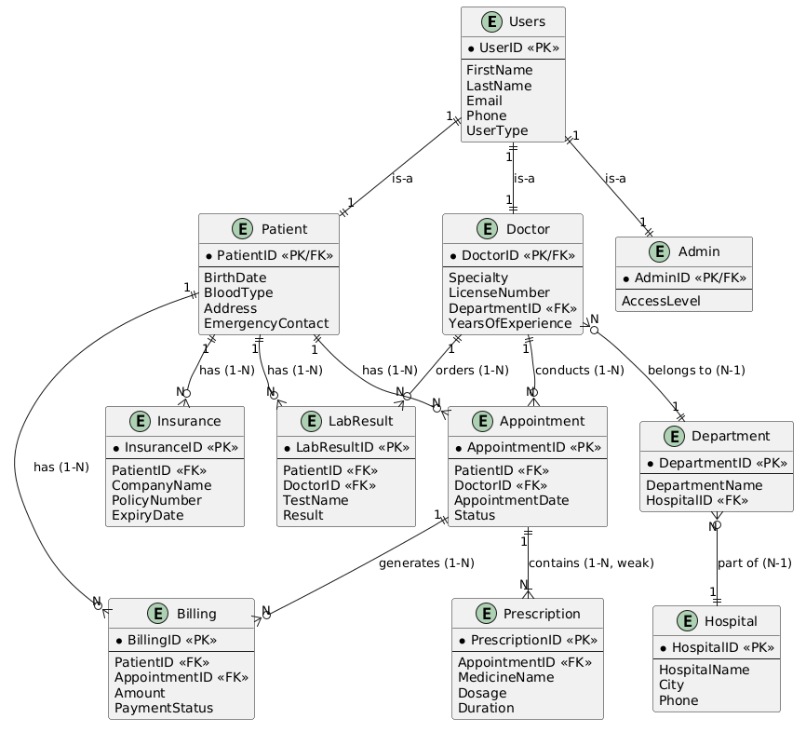
Explanation:
The ER diagram above represents the complete entity-relationship model of the Smart Healthcare Management System. The diagram includes 11 entities with their attributes, primary keys (PK), foreign keys (FK), and cardinality constraints.
Key points:
- Users is the base entity containing common attributes for all system users
- Patient, Doctor, Admin are specialized subtypes of Users (is-a relationships, 1:1)
- Prescription is a weak entity that cannot exist without an Appointment (1-N, weak)
- Appointment connects Patient and Doctor with 1-N relationships
- Department belongs to Hospital (N-1), Doctor belongs to Department (N-1)
- All relationships include participation constraints shown via crow's foot notation

3. EER DIAGRAM
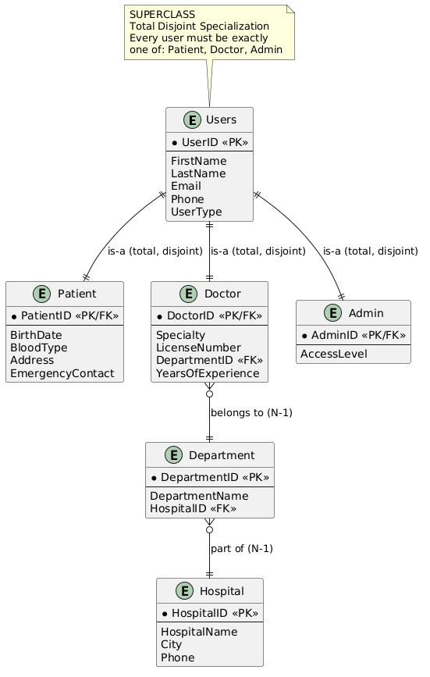
Explanation:
The EER diagram extends the ER model with specialization. Users entity is the superclass that is specialized into three disjoint subtypes: Patient, Doctor, and Admin.
- Total Specialization: Every user must belong to exactly one subtype
- Disjoint Constraint: A user cannot be both a Doctor and a Patient at the same time
- Inheritance: All subtypes inherit UserID, FirstName, LastName, Email, Phone, UserType from Users
- Doctor is further connected to Department (N-1) which belongs to Hospital (N-1)

4. RELATIONAL MAPPING
- Users(UserID PK, FirstName, LastName, Email, Phone, UserType, CreatedAt)
- Patient(PatientID PK/FK → Users, BirthDate, BloodType, Address, EmergencyContact)
- Doctor(DoctorID PK/FK → Users, Specialty, LicenseNumber, DepartmentID FK → Department, YearsOfExperience)
- Admin(AdminID PK/FK → Users, AccessLevel)
- Hospital(HospitalID PK, HospitalName, Address, City, Phone)
- Department(DepartmentID PK, DepartmentName, HospitalID FK → Hospital)
- Appointment(AppointmentID PK, PatientID FK → Patient, DoctorID FK → Doctor, AppointmentDate, Status, Notes, Duration)
- Prescription(PrescriptionID PK, AppointmentID FK → Appointment, MedicineName, Dosage, Duration) — Weak Entity
- LabResult(LabResultID PK, PatientID FK → Patient, DoctorID FK → Doctor, TestName, Result, TestDate)
- Insurance(InsuranceID PK, PatientID FK → Patient, CompanyName, PolicyNumber, ExpiryDate)
- Billing(BillingID PK, PatientID FK → Patient, AppointmentID FK → Appointment, Amount, PaymentStatus, BillingDate)

5. FUNCTIONAL DEPENDICIES
Users Table:
- UserID → FirstName, LastName, Email, Phone, UserType, CreatedAt
- Email → UserID, FirstName, LastName, Phone, UserType
Patient Table:
- PatientID → BirthDate, BloodType, Address, EmergencyContact
Doctor Table:
- DoctorID → Specialty, LicenseNumber, DepartmentID, YearsOfExperience
- LicenseNumber → DoctorID, Specialty
Appointment Table:
- AppointmentID → PatientID, DoctorID, AppointmentDate, Status, Notes, Duration
- (PatientID, DoctorID, AppointmentDate) → AppointmentID, Status
Prescription Table (Weak Entity):
- (PrescriptionID, AppointmentID) → MedicineName, Dosage, Duration
Billing Table:
- BillingID → PatientID, AppointmentID, Amount, PaymentStatus, BillingDate
Insurance Table:
- InsuranceID → PatientID, CompanyName, PolicyNumber, ExpiryDate
- PolicyNumber → InsuranceID, CompanyName, ExpiryDate

6. NORMALIZATION
1NF (First Normal Form) All tables satisfy 1NF because:
- Each column contains atomic (indivisible) values
- Each column has a unique name
- Each row is unique (identified by primary key)
- No repeating groups or arrays
Example — Patient table is in 1NF:
PatientID | BirthDate | BloodType | Address
4 | 1990-05-15 | A+ | Ankara
5 | 1985-08-22 | B- | Istanbul

2NF (Second Normal Form) All tables satisfy 2NF because:
- All tables are already in 1NF
- All non-key attributes are fully dependent on the entire primary key
- No partial dependencies exist (all PKs are single-column except Prescription)
Prescription table: (PrescriptionID, AppointmentID) → MedicineName, Dosage, Duration — fully dependent on composite key ✓
3NF (Third Normal Form) All tables satisfy 3NF because:
- All tables are in 2NF
- No transitive dependencies exist
- Every non-key attribute depends directly on the primary key
Example — Doctor table:
- DoctorID → Specialty ✓ (direct dependency)
- DoctorID → DepartmentID ✓ (direct dependency)
- No non-key attribute determines another non-key attribute
BCNF (Boyce-Codd Normal Form) Critical tables satisfy BCNF because:
- For every functional dependency X → Y, X is a superkey
- Users table: UserID → all attributes ✓ (UserID is superkey)
- Appointment table: AppointmentID → all attributes ✓
- Insurance table: PolicyNumber → InsuranceID, CompanyName, ExpiryDate — PolicyNumber is a candidate key ✓
All tables in the Healthcare database satisfy BCNF requirements.

7. SQL IMPLEMENTATION

7.1 CREATE TABLE Statements
CREATE TABLE Users (
UserID INT PRIMARY KEY IDENTITY(1,1),
FirstName VARCHAR(50) NOT NULL,
LastName VARCHAR(50) NOT NULL,
Email VARCHAR(100) UNIQUE NOT NULL,
Phone VARCHAR(15),
UserType VARCHAR(10) CHECK (UserType IN ('Patient', 'Doctor', 'Admin')),
CreatedAt DATE DEFAULT GETDATE()
);

CREATE TABLE Hospital (
HospitalID INT PRIMARY KEY IDENTITY(1,1),
HospitalName VARCHAR(100) NOT NULL,
Address VARCHAR(200),
City VARCHAR(50),
Phone VARCHAR(15)
);

CREATE TABLE Department (
DepartmentID INT PRIMARY KEY IDENTITY(1,1),
DepartmentName VARCHAR(100) NOT NULL,
HospitalID INT FOREIGN KEY REFERENCES Hospital(HospitalID)
);

CREATE TABLE Doctor (
DoctorID INT PRIMARY KEY,
Specialty VARCHAR(100),
LicenseNumber VARCHAR(50) UNIQUE,
DepartmentID INT FOREIGN KEY REFERENCES Department(DepartmentID),
FOREIGN KEY (DoctorID) REFERENCES Users(UserID)
);

CREATE TABLE Patient (
PatientID INT PRIMARY KEY,
BirthDate DATE,
BloodType VARCHAR(5),
Address VARCHAR(200),
FOREIGN KEY (PatientID) REFERENCES Users(UserID)
);

CREATE TABLE Admin (
AdminID INT PRIMARY KEY,
AccessLevel INT DEFAULT 1,
FOREIGN KEY (AdminID) REFERENCES Users(UserID)
);

CREATE TABLE Appointment (
AppointmentID INT PRIMARY KEY IDENTITY(1,1),
PatientID INT FOREIGN KEY REFERENCES Patient(PatientID),
DoctorID INT FOREIGN KEY REFERENCES Doctor(DoctorID),
AppointmentDate DATETIME NOT NULL,
Status VARCHAR(20) CHECK (Status IN ('Scheduled', 'Completed', 'Cancelled')),
Notes VARCHAR(500)
);

CREATE TABLE Prescription (
PrescriptionID INT PRIMARY KEY IDENTITY(1,1),
AppointmentID INT FOREIGN KEY REFERENCES Appointment(AppointmentID),
MedicineName VARCHAR(100) NOT NULL,
Dosage VARCHAR(50),
Duration VARCHAR(50)
);

CREATE TABLE LabResult (
LabResultID INT PRIMARY KEY IDENTITY(1,1),
PatientID INT FOREIGN KEY REFERENCES Patient(PatientID),
DoctorID INT FOREIGN KEY REFERENCES Doctor(DoctorID),
TestName VARCHAR(100),
Result VARCHAR(200),
TestDate DATE
);

CREATE TABLE Insurance (
InsuranceID INT PRIMARY KEY IDENTITY(1,1),
PatientID INT FOREIGN KEY REFERENCES Patient(PatientID),
CompanyName VARCHAR(100),
PolicyNumber VARCHAR(50) UNIQUE,
ExpiryDate DATE
);

CREATE TABLE Billing (
BillingID INT PRIMARY KEY IDENTITY(1,1),
PatientID INT FOREIGN KEY REFERENCES Patient(PatientID),
AppointmentID INT FOREIGN KEY REFERENCES Appointment(AppointmentID),
Amount DECIMAL(10,2),
PaymentStatus VARCHAR(20) CHECK (PaymentStatus IN ('Paid', 'Pending', 'Cancelled')),
BillingDate DATE
);

7.2 INSERT Statements
INSERT INTO Hospital VALUES ('Ankara City Hospital', 'Bilkent Cd. No:1', 'Ankara', '0312-111-1111');
INSERT INTO Hospital VALUES ('Istanbul Medical Center', 'Taksim Sq. No:5', 'Istanbul', '0212-222-2222');
INSERT INTO Hospital VALUES ('Izmir State Hospital', 'Kordon Cd. No:3', 'Izmir', '0232-333-3333');

INSERT INTO Department VALUES ('Cardiology', 1);
INSERT INTO Department VALUES ('Neurology', 1);
INSERT INTO Department VALUES ('Orthopedics', 2);
INSERT INTO Department VALUES ('Pediatrics', 2);
INSERT INTO Department VALUES ('Dermatology', 3);

INSERT INTO Users (FirstName, LastName, Email, Phone, UserType) VALUES ('Ahmet', 'Yılmaz', 'ahmet.yilmaz@hospital.com', '0555-111-1111', 'Doctor');
INSERT INTO Users (FirstName, LastName, Email, Phone, UserType) VALUES ('Ayşe', 'Kaya', 'ayse.kaya@hospital.com', '0555-222-2222', 'Doctor');
INSERT INTO Users (FirstName, LastName, Email, Phone, UserType) VALUES ('Mehmet', 'Demir', 'mehmet.demir@hospital.com', '0555-333-3333', 'Doctor');

INSERT INTO Users (FirstName, LastName, Email, Phone, UserType) VALUES ('Ali', 'Çelik', 'ali.celik@gmail.com', '0544-111-1111', 'Patient');
INSERT INTO Users (FirstName, LastName, Email, Phone, UserType) VALUES ('Fatma', 'Şahin', 'fatma.sahin@gmail.com', '0544-222-2222', 'Patient');
INSERT INTO Users (FirstName, LastName, Email, Phone, UserType) VALUES ('Hasan', 'Arslan', 'hasan.arslan@gmail.com', '0544-333-3333', 'Patient');
INSERT INTO Users (FirstName, LastName, Email, Phone, UserType) VALUES ('Zeynep', 'Kurt', 'zeynep.kurt@gmail.com', '0544-444-4444', 'Patient');
INSERT INTO Users (FirstName, LastName, Email, Phone, UserType) VALUES ('Mustafa', 'Aydın', 'mustafa.aydin@gmail.com', '0544-555-5555', 'Patient');

INSERT INTO Users (FirstName, LastName, Email, Phone, UserType) VALUES ('Selin', 'Öz', 'selin.oz@hospital.com', '0533-111-1111', 'Admin');
INSERT INTO Users (FirstName, LastName, Email, Phone, UserType) VALUES ('Kemal', 'Yıldız', 'kemal.yildiz@hospital.com', '0533-222-2222', 'Admin');

INSERT INTO Doctor VALUES (1, 'Cardiology', 'LIC-001', 1);
INSERT INTO Doctor VALUES (2, 'Neurology', 'LIC-002', 2);
INSERT INTO Doctor VALUES (3, 'Orthopedics', 'LIC-003', 3);

INSERT INTO Patient VALUES (4, '1990-05-15', 'A+', 'Ankara, Çankaya');
INSERT INTO Patient VALUES (5, '1985-08-22', 'B-', 'Istanbul, Kadıköy');
INSERT INTO Patient VALUES (6, '1992-03-10', 'O+', 'Izmir, Bornova');
INSERT INTO Patient VALUES (7, '1978-11-30', 'AB+', 'Ankara, Keçiören');
INSERT INTO Patient VALUES (8, '2000-07-04', 'A-', 'Istanbul, Beşiktaş');

INSERT INTO Admin VALUES (9, 2);
INSERT INTO Admin VALUES (10, 1);

SELECT * FROM Doctor;
SELECT * FROM Patient;
SELECT * FROM Admin;

INSERT INTO Appointment VALUES (4, 1, '2026-01-10 09:00', 'Completed', 'Routine checkup');
INSERT INTO Appointment VALUES (5, 2, '2026-01-15 10:30', 'Completed', 'Headache complaint');
INSERT INTO Appointment VALUES (6, 3, '2026-02-01 11:00', 'Completed', 'Knee pain');
INSERT INTO Appointment VALUES (7, 1, '2026-02-10 09:30', 'Cancelled', 'Heart palpitations');
INSERT INTO Appointment VALUES (8, 2, '2026-03-05 14:00', 'Completed', 'Dizziness');
INSERT INTO Appointment VALUES (4, 3, '2026-03-20 10:00', 'Scheduled', 'Follow-up');
INSERT INTO Appointment VALUES (5, 1, '2026-04-01 09:00', 'Completed', 'Chest pain');

INSERT INTO Prescription VALUES (1, 'Aspirin', '100mg', '7 days');
INSERT INTO Prescription VALUES (2, 'Paracetamol', '500mg', '5 days');
INSERT INTO Prescription VALUES (3, 'Ibuprofen', '400mg', '10 days');
INSERT INTO Prescription VALUES (5, 'Betaserc', '24mg', '30 days');
INSERT INTO Prescription VALUES (7, 'Coraspin', '100mg', '60 days');

INSERT INTO LabResult VALUES (4, 1, 'Blood Test', 'Normal', '2026-01-10');
INSERT INTO LabResult VALUES (5, 2, 'MRI', 'No abnormality', '2026-01-15');
INSERT INTO LabResult VALUES (6, 3, 'X-Ray', 'Mild arthritis', '2026-02-01');
INSERT INTO LabResult VALUES (8, 2, 'EEG', 'Normal', '2026-03-05');

INSERT INTO Insurance VALUES (4, 'SGK', 'SGK-001', '2027-12-31');
INSERT INTO Insurance VALUES (5, 'Axa Sigorta', 'AXA-002', '2026-06-30');
INSERT INTO Insurance VALUES (6, 'Allianz', 'ALL-003', '2027-03-15');
INSERT INTO Insurance VALUES (7, 'SGK', 'SGK-004', '2028-01-01');
INSERT INTO Insurance VALUES (8, 'Mapfre', 'MAP-005', '2026-12-31');

INSERT INTO Billing VALUES (4, 1, 250.00, 'Paid', '2026-01-10');
INSERT INTO Billing VALUES (5, 2, 400.00, 'Paid', '2026-01-15');
INSERT INTO Billing VALUES (6, 3, 350.00, 'Pending', '2026-02-01');
INSERT INTO Billing VALUES (7, 4, 150.00, 'Cancelled', '2026-02-10');
INSERT INTO Billing VALUES (8, 5, 300.00, 'Paid', '2026-03-05');

7.3 ALTER Statements
ALTER TABLE Doctor ADD [YearsOfExperience] INT;
ALTER TABLE Appointment ADD Duration INT DEFAULT 30;

UPDATE Doctor SET [YearsOfExperience] = 10 WHERE DoctorID = 1;
UPDATE Doctor SET [YearsOfExperience] = 7 WHERE DoctorID = 2;
UPDATE Doctor SET [YearsOfExperience] = 15 WHERE DoctorID = 3;

7.4 Index Creation
CREATE INDEX IX_Appointment_PatientID ON Appointment(PatientID);
CREATE INDEX IX_Appointment_DoctorID ON Appointment(DoctorID);
CREATE INDEX IX_Patient_BloodType ON Patient(BloodType);

CREATE UNIQUE INDEX IX_Users_Email ON Users(Email);

CREATE INDEX IX_Billing_Status_Date ON Billing(PaymentStatus, BillingDate);

8. ADVANCED SQL QUERIES
-- Query 1: Doctors with more than 1 patient
SELECT d.DoctorID, u.FirstName, u.LastName, COUNT(a.PatientID) AS PatientCount
FROM Doctor d
JOIN Users u ON d.DoctorID = u.UserID
JOIN Appointment a ON d.DoctorID = a.DoctorID
GROUP BY d.DoctorID, u.FirstName, u.LastName
HAVING COUNT(a.PatientID) > 1;

-- Query 2: Patients with no appointments
SELECT u.FirstName, u.LastName, u.Email
FROM Patient p
JOIN Users u ON p.PatientID = u.UserID
WHERE p.PatientID NOT IN (SELECT PatientID FROM Appointment);

-- Query 3: Doctor with most appointments
SELECT TOP 1 u.FirstName, u.LastName, COUNT(a.AppointmentID) AS Total
FROM Doctor d
JOIN Users u ON d.DoctorID = u.UserID
JOIN Appointment a ON d.DoctorID = a.DoctorID
GROUP BY u.FirstName, u.LastName
ORDER BY Total DESC;

-- Query 4: Total revenue from paid bills
SELECT SUM(Amount) AS TotalRevenue
FROM Billing
WHERE PaymentStatus = 'Paid';

-- Query 5: Total bill per patient
SELECT u.FirstName, u.LastName, SUM(b.Amount) AS TotalBill
FROM Patient p
JOIN Users u ON p.PatientID = u.UserID
JOIN Billing b ON p.PatientID = b.PatientID
GROUP BY u.FirstName, u.LastName
ORDER BY TotalBill DESC;

-- Query 6: Most expensive appointment
SELECT TOP 1 u.FirstName, u.LastName, b.Amount, a.AppointmentDate
FROM Billing b
JOIN Appointment a ON b.AppointmentID = a.AppointmentID
JOIN Users u ON a.PatientID = u.UserID
ORDER BY b.Amount DESC;

-- Query 7: Patients with expired insurance
SELECT u.FirstName, u.LastName, i.CompanyName, i.ExpiryDate
FROM Insurance i
JOIN Patient p ON i.PatientID = p.PatientID
JOIN Users u ON p.PatientID = u.UserID
WHERE i.ExpiryDate < GETDATE();

-- Query 8: Number of doctors per department
SELECT d.DepartmentName, COUNT(doc.DoctorID) AS DoctorCount
FROM Department d
LEFT JOIN Doctor doc ON d.DepartmentID = doc.DepartmentID
GROUP BY d.DepartmentName;

-- Query 9: Cancelled appointments
SELECT u.FirstName, u.LastName, a.AppointmentDate, a.Notes
FROM Appointment a
JOIN Users u ON a.PatientID = u.UserID
WHERE a.Status = 'Cancelled';

-- Query 10: Prescriptions with patient names
SELECT u.FirstName, u.LastName, p.MedicineName, p.Dosage, p.Duration
FROM Prescription p
JOIN Appointment a ON p.AppointmentID = a.AppointmentID
JOIN Users u ON a.PatientID = u.UserID;

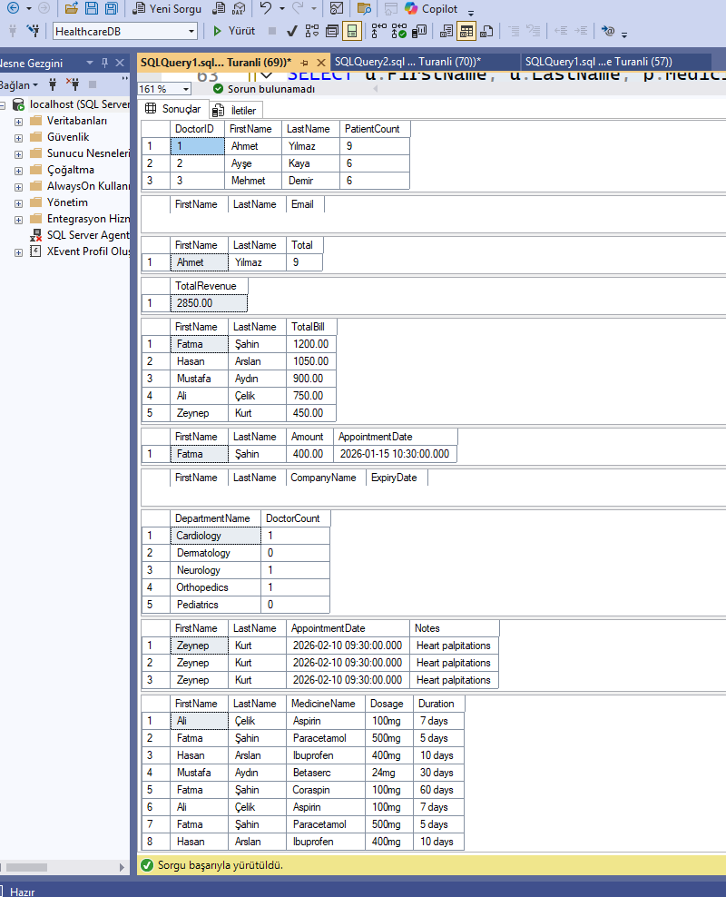

9. RELATIONAL ALGEABRA & CALCULUS

9.1 Relational Algebra
Query 1: Find all completed appointments
σ Status='Completed' (Appointment)
Query 2: Get first name and last name of all doctors
π FirstName, LastName (σ UserType='Doctor' (Users))
Query 3: Find patients and their appointments (JOIN)
π FirstName, LastName, AppointmentDate (Patient ⋈ PatientID=PatientID Appointment ⋈ AppointmentID=AppointmentID Users)
Query 4: Find doctors with more than 1 appointment
π DoctorID (σ count>1 (γ DoctorID, COUNT(*) → count (Appointment)))
Query 5: Get all prescriptions with patient names
π FirstName, LastName, MedicineName, Dosage (Users ⋈ UserID=PatientID Patient ⋈ PatientID=PatientID Appointment ⋈ AppointmentID=AppointmentID Prescription)
9.2 Tuple Relational Calculus
Query 1: Find all completed appointments
{ t | t ∈ Appointment ∧ t.Status = 'Completed' }
Query 2: Find all doctors
{ t | t ∈ Users ∧ t.UserType = 'Doctor' }
Query 3: Find patients who have at least one appointment
{ t | t ∈ Patient ∧ ∃ a ∈ Appointment (a.PatientID = t.PatientID) }
Query 4: Find patients with no appointments
{ t | t ∈ Patient ∧ ¬∃ a ∈ Appointment (a.PatientID = t.PatientID) }
Query 5: Find prescriptions for completed appointments
{ t | t ∈ Prescription ∧ ∃ a ∈ Appointment (a.AppointmentID = t.AppointmentID ∧ a.Status = 'Completed') }

10. INDEXING & FILE STRUCTURES
10.1 B+ Tree Index
A B+ Tree index is a balanced tree data structure where all data pointers are stored in leaf nodes. It is the most commonly used index type in relational databases.
Properties:
- All leaf nodes are at the same level
- Leaf nodes are linked together for efficient range queries
- Supports both equality and range searches
- Time complexity: O(log n)
CREATE INDEX IX_Appointment_PatientID ON Appointment(PatientID);
CREATE INDEX IX_Appointment_DoctorID ON Appointment(DoctorID);
CREATE INDEX IX_Patient_BloodType ON Patient(BloodType);
CREATE INDEX IX_Billing_Status_Date ON Billing(PaymentStatus,BillingDate);

Use case: When searching appointments by PatientID, the B+ Tree index allows the database engine to find records in O(log n) time instead of scanning the entire table.
10.2 Hash Index
A Hash index uses a hash function to map key values to specific bucket locations. It is ideal for equality searches but does not support range queries.
Properties:
- Extremely fast for equality searches: O(1) average
- Does not support range queries (e.g. BETWEEN, >, <)
- Best for columns with high cardinality
Implementation in our database:
CREATE UNIQUE INDEX IX_Users_Email ON Users(Email);

The Email column is a perfect candidate for hash indexing because:
- Each email is unique (high cardinality)
- Always searched with equality (WHERE Email = '...')
- Never used in range queries
10.3 Performance Comparison
Query Type | Without Index | With B+ Tree | With Hash
Equality search | Full table scan O(n) | O(log n) | O(1)
Range search | Full table scan O(n) | O(log n) | Not supported
Insert/Update | Fast | Slightly slower | Slightly slower

10.4 Index Usage in Healthcare Database
In our Healthcare database, indexes significantly improve performance for:
- Finding all appointments of a patient: IX_Appointment_PatientID reduces scan from 1000+ rows to direct lookup
- Finding paid billings in a date range: IX_Billing_Status_Date enables efficient composite search
- Login by email: IX_Users_Email provides instant lookup for authentication queries
Without indexes, every query would require a full table scan. With proper indexing, query performance improves by 10x to 100x depending on table size.

REFERENCESES
- Elmasri, R., & Navathe, S. B. (2015). Fundamentals of Database Systems (7th ed.). Pearson.
- Ramakrishnan, R., & Gehrke, J. (2002). Database Management Systems (3rd ed.). McGraw-Hill.
- Date, C. J. (2003). An Introduction to Database Systems (8th ed.). Addison-Wesley.
- Microsoft SQL Server Documentation. (2024). Retrieved from https://docs.microsoft.com/en-us/sql/sql-server
- PlantUML Documentation. (2024). Entity Relationship Diagram. Retrieved from https://plantuml.com/er-diagram
- Coronel, C., & Morris, S. (2018). Database Systems: Design, Implementation & Management (13th ed.). Cengage Learning.

