# FINITE POINTSET METHOD (FPM) FOR COMPRESSIBLE FLUID FLOW WITH TURBULENCE MODELING

ABSTRACT

This paper focuses on the complete development of a second order (space+time) meshfree flow solver for compressible fluid flows with integrated turbulence modeling. The meshfree method we concentrate on is the so called Finite Poinset Method (FPM), an already well established CFD solver for compressible and incompressible flow tasks. The solution idea of FPM is a general Finite Difference Ansatz, acting on a pointcloud. FPM is a purely meshfree ansatz, approximations of derivatives are provided my FPM-specialized (stability oriented) moving-least-squares formulations. Up to now, FPM was based on a first order (space+time) integration scheme for Euler equations (in-viscid, no turbulence modelling) for compressible problems. In this paper now, we derive a new, second order (space+time) scheme, that allows integration of the Navier-Stokes equations (compressible) on an explicit basis, including viscous and turbulent effects.

FINITE POINTSET METHOD (FPM) FOR COMPRESSIBLE FLUID FLOW WITH TURBULENCE MODELING 1

1 Motivation 2

2 Derive a 1D FPM scheme for Euler Equations 2

2.1 Differential equations 2

2.2 Characteristic analysis of the differential equations 4

2.3 Numerical scheme with artificial viscosity 5

3 Complete numerical analysis of compressible FPM in 3D without viscosity terms 7

3.1 General numerical evolution scheme 7

3.2 Second derivatives of the conservative variables 8

3.3 Numerical integration of the non-viscous evolution scheme 14

4 Numerical scheme with viscous terms 16

4.1 General evolution equations with viscous terms 16

4.2 Differential equations for turbulence modelling 17

4.3 Numerical evolution scheme and time integration of the turbulence model 17

4.4 Boundary conditions for solid walls 18

5 Optimal local values for the numerical viscosity 19

5.1 Avoid overshooting in the characteristic formulation 19

5.2 Avoid high frequencies in the numerical solution 20

5.3 Attack overshoots in the numerical solution 21

6 Numerical Integration with improved mass conservation 21

6.1 Classical second order time integration 22

6.2 Improved integration, partially analytic 22

6.3 Integrate specific volume instead of density 23

7 First results and validation of the method presented 25

7.1 Rectangular shock tube 25

7.2 Tank Test 26

8 Industrial application of this method 28

# Motivation

kkkk

# Derive a 1D FPM scheme for Euler Equations

First, we would like to establish a 1D FPM scheme for the Euler equations (in-viscid flow), that enables us to study the behovior of the numerical scheme. As compressible fluid flow with regular equation of state usually results in a system of hyperbolic differential equations, our numerical scheme will have to contain stabilization procedures. For our method, we propose artificial viscosity terms that damp out instabilities generated by the numerical scheme. The

## Differential equations

### Conservative form

The general 3D Euler equations for in-viscid gas dynamics on a Lagrangian basis are



The variables used are



Out of this, the resulting 1D scheme is



### Primitive form

This set of differential equations is written down in conservative form. For analytical reason it will be more easy to use the primitive form:



With the thermodynamic identity



and by using equations , we find an explicit expression for the change of the pressure by



which suggests the definition of the sound speed



Finally, in equation , we replace the equation for the temperature by the equation for the pressure



## Characteristic analysis of the differential equations

The system is perfect for numerical analysis. We would like to establish a stable scheme for this system, well knowing that it is of hyperbolic character. If we are applying a centralized FPM scheme (i.e. using the FPM MLS approximation for all the occurring  and ), then we will encounter unstable behaviour of the numerical solution. We suggest here a local viscosity in order to stabilize the scheme. First, we need to decouple the system of equations into separate differential equations. In compact form, the equations can be written down as



with expansions



The matrix  can be decomposed by its eigenvectors



where



and thus, appears as



The resulting scheme in expanded form is



In a more consistent form, this looks like



The scheme consist of several, uncoupled scalar differential equations, each of which form a separate transport task for some dedicated pieces of information, e.g. or are called the characteristic, whereas  is the speed of transport. It is not surprising, that the speed of transport for each of the single characteristic variables turns out to be the sound speed as defined in equation .

## Numerical scheme with artificial viscosity

The discrete differential MLS operators used by FPM form a general finite difference approximation, which turn out to be a centralized difference ansatz. It is well known, that a numerical treatment of (sets of) hyperbolic differential equations run into instabilities. That’s why we try to add to each of the characteristic (and hyperbolic!) sub-equations a damping term.

A locally stabilized numerical time evolution scheme using additional damping terms (similar numerical artificial viscosity) would be



with artificial numerical viscosity terms  , , , and , the size of which can be determined by the locally given state. The sub-indices signify discrete FPM-MLS approximation. Equation is rewritten as



Finally, we multiply the system from left with  and, furthermore by supposing (just for simplicity!) , we obtain



where



We suggest a definition of numerical velocity and pressure functions of the form



With this definition and equation , we find the modified, but stable, numerical system to be solved



Coming back to the conservative formulation, the above system is represented as



# Complete numerical analysis of compressible FPM in 3D without viscosity terms

Similar considerations as in chapter 2 which have been leading to equations , will also lead to a system of equations in 3D (see equation ).

## General numerical evolution scheme

The 3D numerical evolution scheme similar to is



The symbol  signifies the gradient operator on the discrete FPM basis, i.e. it means the FPM-specialized moving-least-squares (MLS) operators. Similarly,

*  mean the MLS approximation of the derivatives with respect , , and 
*  signifies the FPM-MLS approximation of the Poisson operator,

which will be used later on. Throughout this paper, the tilde symbol ~ indicates the strict usage of the specialized FPM-MLS operators.

The numerical pressure and velocity expressions are



 is called “numerical velocity” or “upwind velocity”

 is called “numerical pressure” or “upwind pressure”

The components of the numerical velocity are defined as



By virtue of equation we define



We will later see, that plays an important role as numerical stabilization quantity. For example,  has nearly the same character as a physical viscosity. For the present chapter, let us assume that we know the values of  at any location. In chapter 5, we will study how to locally evaluate an optimal value for it.

## Second derivatives of the conservative variables

In order to establish a second order numerical time integration of the system , we have to provide second order time derivatives of density, momentum und total energy.

### Second derivative of density

The second time derivative of the density can directly be derived from the mass conservation part in the system



How do we evaluate the term ? On one hand we have



On the other hand we have



With the definition



we have



And moreover, with the expansion



we obtain



So, finally we have



Equally, this is



We introduce the definition



which allows us to provide another characteristic quantity by



And we obtain a final compact form



### Second derivative of momentum

We start with the regular equation



and differentiate it with respect to the time



Here, we can replace some terms by using equations and



We recognize that we have to find a representation for the term . We start with the identity



The complementary consideration leads to



Which is equally



Changing the order of differentiation brings



For simplification, we define



and use equation , obtaining



It remains to provide some estimation for the term by



And thus we obtain



Equation finally enables us to provide a complete formulation for the second total time derivative of the momentum



This equation suggest to introduce a further definition, given by



Consequently, the final representation of the second total time derivative of the density is



### Second derivative of total energy

We start with the regular formulation for the total energy.



The steps now are similar to what was done for the momentum. First, we apply the time derivative operator again to equation in order to obtain



We use equations and in order to rewrite equation by



Where we can rearrange a little bit by



And even more easy



We observe, that also this equation behaves similar to the others, so we have to find out a way to express the term . On one hand, we have



One the other hand, we switch the operators and find



For which the chain rule gives



Using , the equation can be simplified



We define



Which gives



It remains to give an expression for  which is similar to what was done in equations and







Thus, from equation we obtain



Equation enables us to further modify equation in the following sense



And furthermore, with the additional definition



We can give the formulation of the second total time derivative of the total energy by



## Numerical integration of the non-viscous evolution scheme

The second order derivatives as exhibited in section 3.2 enable us to implement a numerical scheme of second order in time.

### General Remarks

Suppose we search for a numerical solution of the scalar differential equation



and suppose we are given the second order derivative of this by



A second order explicit numerical integration is simply given through Taylor’s expansion by



### Time integration algorithm for density

Using equations and , together with the general second order explicit time integration idea, the density update of FPM reads

,

which expands as



### Time integration for momentum and total energy

The integration of momentum and total energy follows strictly the pattern and is therefore similar also to the treatment of the density shown in section 3.3.2.

### Time step restrictions

The characteristic equations reveal the general characteristic speed as to be the sound speed . Since we are working with an explicit scheme, the local time step size at particle “i” should obey



In this manner, the characteristic information can travel no further than from particle to particle during one step. In ,  is the radius of the neighbor-sphere around particles.  is a global user given constant and shall be less than 1.

Another restriction to the time step is suggested by equation . The time step should be reduced such that the density does not change dramatically. Hence, with the restriction



We can compute a restriction for the local time step size such that is fulfilled.  and  are user given constants,  should be strictly bigger than 1,  should be positive and strictly less than one.

The global time step size is finally computed as the minimum of the local ones



# Numerical scheme with viscous terms

## General evolution equations with viscous terms

Starting from numerical integration scheme , we simply add the viscous terms



The additional terms contain the stress tensor, which is given by



The viscosity splits into its natural and turbulent parts



The quantities  and  are the principle variables of the k-epsilon turbulence model used for our purposes. In the next section (4.2) this model will be exhibited, in the subsequent section we briefly explain the numerical handling.

## Differential equations for turbulence modelling

For the purpose of this paper, we will concentrate on the k-epsilon-turbulence formulation. The model equations are



Here, means the turbulent production rate, and it is determined by



A similar expression, , is dedicated to turbulent buoyancy effects.

The turbulent viscosity is a function of the turbulent quantities k and epsilon, its quantification is



The given constants are .

## Numerical evolution scheme and time integration of the turbulence model

The numerical evolution scheme is



which just arises by replacing the spatial derivatives by its FPM-MLS operators.

For better numerical analysis, we can rewrite this scheme by replacing  by its formal expression together with and, for simplicity, omitting the term 



From system , we derive a singularity formulation, which is either



or



If not bot values  and  are zero, we can provide numerical mean values



and



It remains to provide a possibly precise numerical time integration of the scheme where we avoid singularities by using the mean values and . Thus, the numerical evolution scheme is



For the scheme , we can now apply an second order explicit time integration scheme, just in the same fashion as already discussed in section 3.3 and especially in 3.3.2.

## Boundary conditions for solid walls

kkk

# Optimal local values for the numerical viscosity

As  triggers a numerically viscous behaviour of the scheme, we try to locally minimize  such that it influences our solver as little as possible.

## Avoid overshooting in the characteristic formulation

One very localized idea of giving optimal values goes back to the characteristic formulation . We remember, that the values , , , and  act as numerical artificial viscosity terms. In , we can consider each single, scalar hyperbolic law separately, .i.e. we consider the set of equations



Each value of , , , and  can now be adjusted such that the scalar equation does not produce overshoots. For an equation of the general form , the procedure is as follows:

1. at location “i”, compute reference solution by at time level n+1 without artificilal viscosity, i.e. compute 
2. determine maximum and minimum values which should not be trespassed, i.e. determine  and 
3. determine the viscosity by 

With the above procedure, all the four values , , , and  can be determined, and a global value  for all numerical locations can be provided. Since the system is derived in 1D,  however is provided for a 3D scheme, we have to turn our local 3D-coordinate system such that the direction of the pressure gradient coincides with the direction x in the 1D equations. The direction of the pressure gradient is the driving direction, principal changes, especially shocks, take place along this direction.

## Avoid high frequencies in the numerical solution

Another localized idea is to use equation , which represents a differential equation whose solution is providing oscillations if the term  is negative. The analytical solution to the differential equation is given by



For negative  it is obvious that  provides oscillatory behaviour with the time of period



And the amplitude



i.e. we have a direct measure of the periodic time and amplitude of the numerical solution. As  occurs in the second derivatives of all conservative quantities, the measure  is a global measure for the complete scheme and shall help us to derive local values for the artificial viscosity.

An important value therefore is the ratio between the reference time step size of the scheme and the periodic time



Defining the representative time step to be .

A simple ansatz would be



which just acts as a penalty viscosity if the numerical periodic time is going towards natural time step size. The parameters  and  have to be determined empirically. In FPM2, we use  and .

## Attack overshoots in the numerical solution

Another idea would be to ask, how does the value of  influence the magnitude of oscillation. First, we find the functional dependency of  on  (after some simplifications) by



Then we find out, how  acts on the ration of the amplitude with and without numerical viscosity.



The final aim shall be to determine  such that



As slightly different approach of the same fashion would be to



# Numerical Integration with improved mass conservation

Let us start with the differential equation of conservation of mass, see equation .



## Classical second order time integration

Equation suggest to integrate this equation using a second order term in the sense



This amounts to defining an efficient divergence of velocity by



And integrate equation by



## Improved integration, partially analytic

Let us start again with equation . We can rewrite it in the sense



This equation promisses more accurate results as we integrate it analytically provided the divergence of velocity remains constant throughout the timestep. However, we can even improve the accuracy by using equation . A second order time integration of would be given by



With



This provides a solution of



Similarly to equation , this allows us to provide a formulation for the effective divergence of velocity by



## Integrate specific volume instead of density

A different approach is to numerically integrate the specific volume attached to each particle. Suppose a particles volume is denoted as . The volume after a certain small time  is computed as follows.

Each (arbitrary) vector  around the particle will be transformed due to the differential equation



where the matrix  is simply the gradient of the numerical velocity (movement of the points), i.e.



(the second term is not necessary, however it provides second order). The analytical solution of any arbitrary vector is



We now have to ask, what an initial sphere looks like after the deformation process. It will look like an ellipsoid, the main axes of the ellipsoid are the eigenvectors of the symmetric matrix



The volume of the ellipsoid is given by the product of the square roots of the eigenvalues of , i.e.



Finally, the mass conservation for any given control element of initial volume and density is given by



From , it immediately follows that the new density obeys



With this, clearly the effective numerical divergence of velocity is



# First results and validation of the method presented

## Rectangular shock tube

### 2D

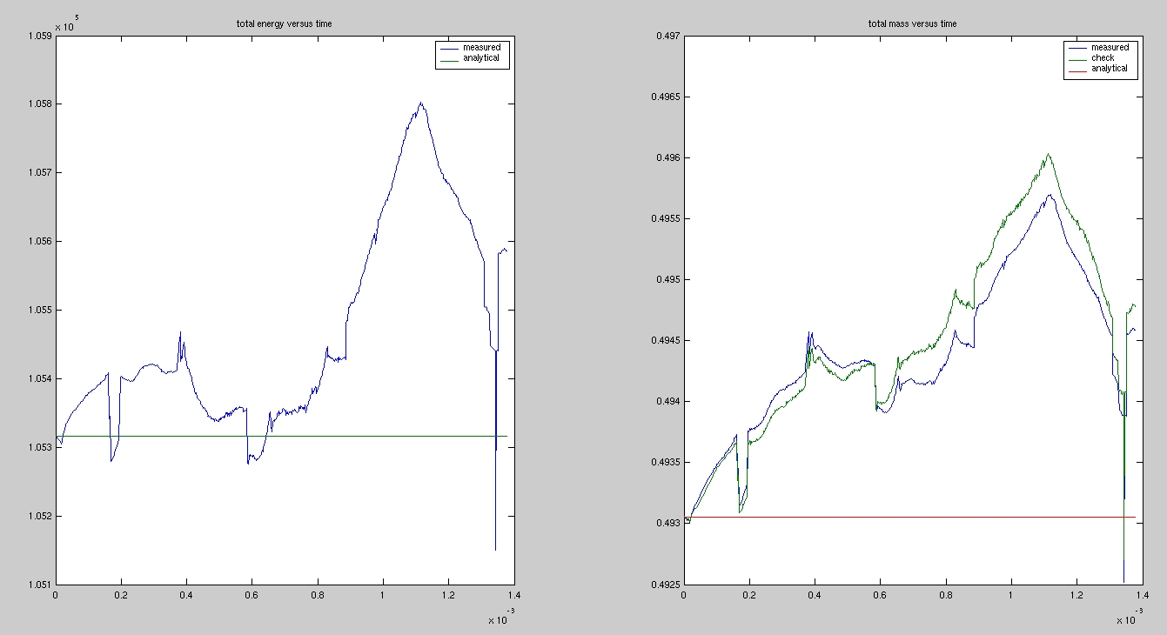

For the simple rectangular 45degree shock tube we have a very precise mass and energy conservation. Even over a long simulation period, the measured total mass and total energy is less than one percent away from the exact mass and energy (which are constant in this case as the box is totally closed)

### 3D

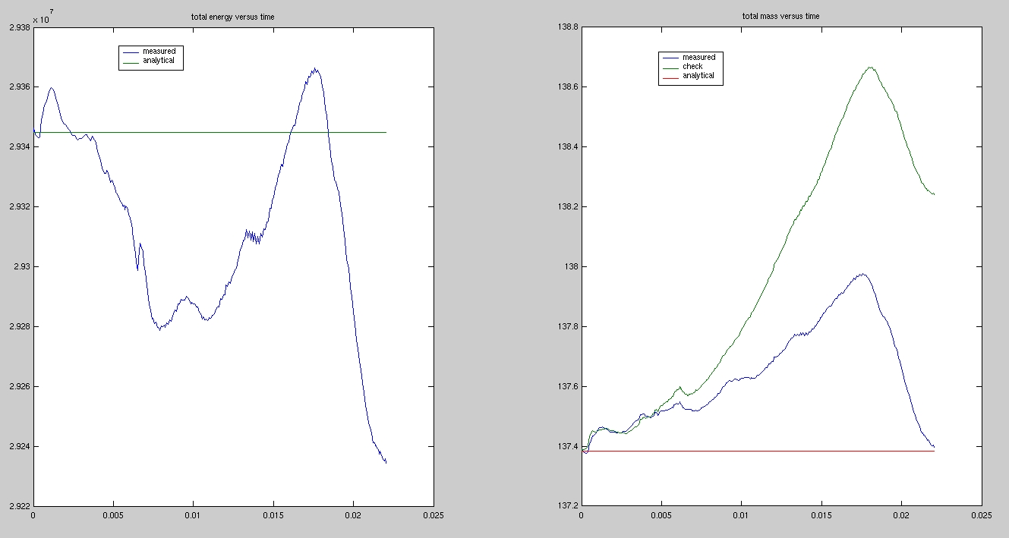

## Tank Test

### 2D

The 2D case also show surprising conservation properties. The conservation plots for different smoothing lengths.

1.) h=0.008

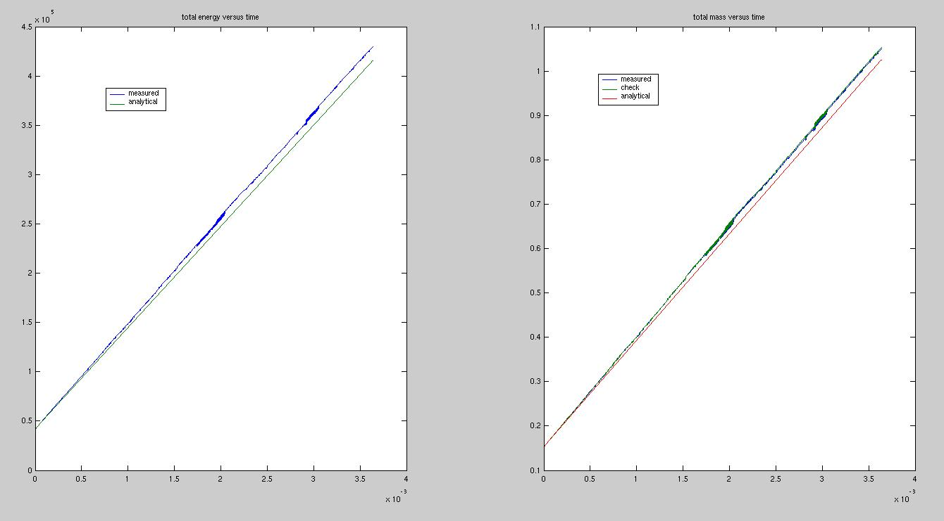

2.) h=0.015

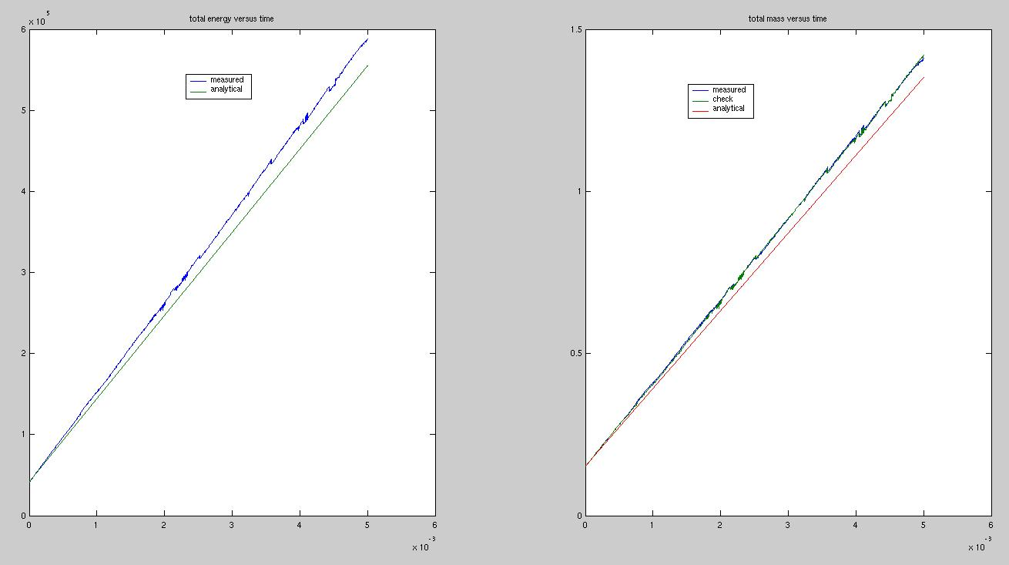

3.) h = 0.020

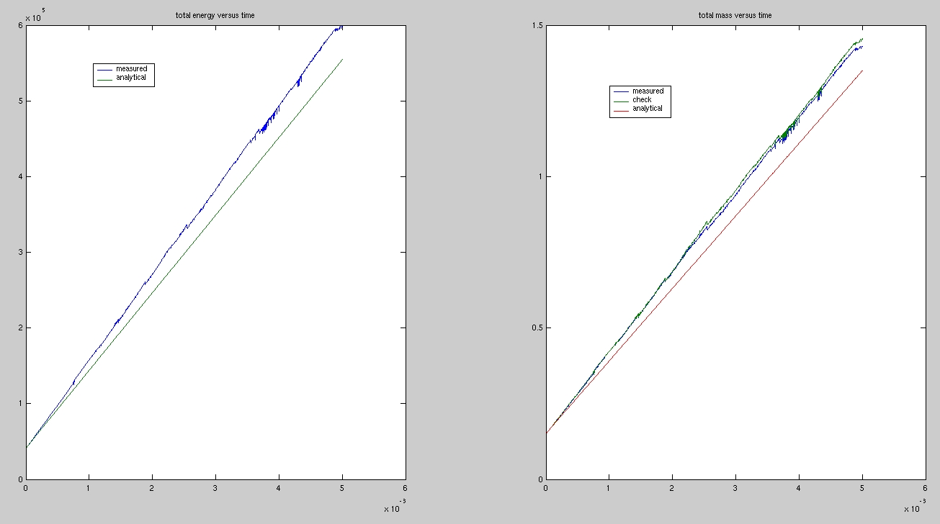

we see a linear dependency, because the mass production effects are not connected to the 2nd order FPM scheme, but they are connected to the effects at the sharp corner. These ones fade away linearly and not quadratically.

### 3D

1. h=0.008

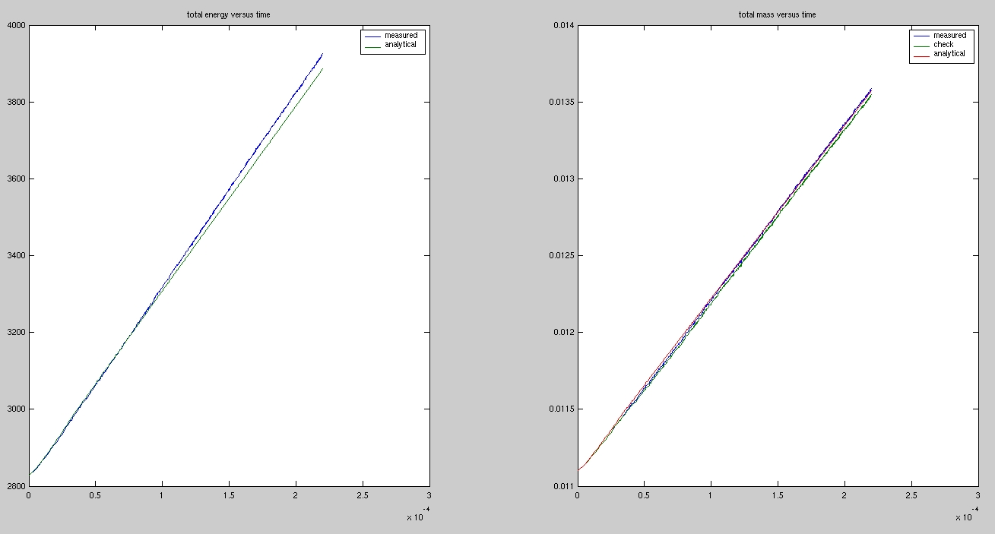

2. h=0.02

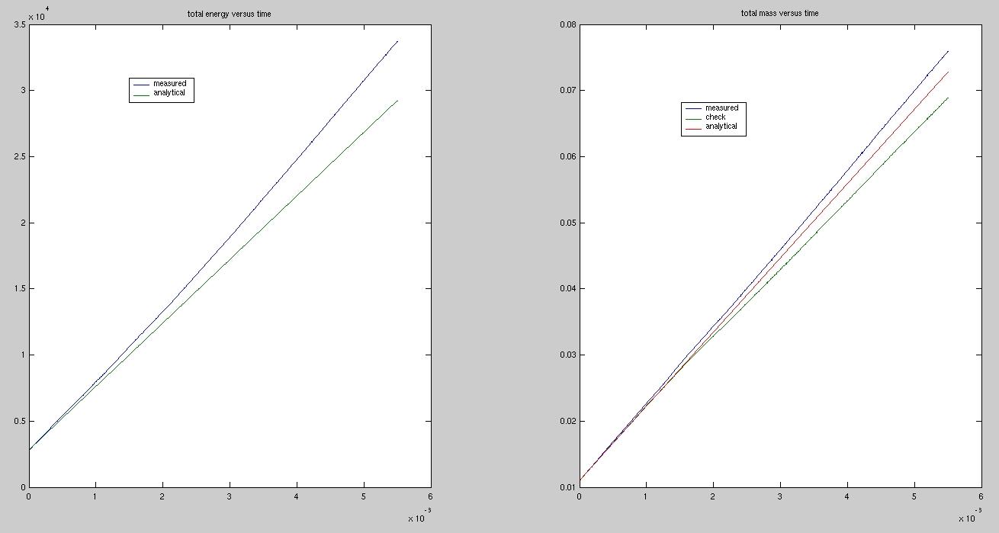

# Industrial application of this method

See Report 2010