Karunya Institute of Technology and Sciences
Division of Data Science and Cyber Security
25DC2012 – Quantum Computing and Cryptography

Internal Assessment III – Quantum Algorithm Project
Project Report (Parts A and B)

Case 03: Deutsch's Algorithm
Variant: f(x) = 1

Team members
No. | Name | Register number
1 | [Name 1] | [Register number 1]
2 | [Name 2] | [Register number 2]
3 | [Name 3 – delete row if team of 2] | [Register number 3]

Submitted to: [Faculty name]
Date of submission: [Date]

2. Aim and Circuit

Aim
The aim is to find out whether a one-bit function f is constant (f(0) = f(1)) or balanced (f(0) ≠ f(1)) while calling the function only once. We use quantum parallelism and phase kickback to do this. Our function is f(x) = 1, where f(0) = 1 and f(1) = 1, so we expect it to be constant. We compare it with the constant function f(x) = 0.

Circuit
- Two qubits are used: the input qubit x and the ancilla y. Both start in |0⟩.
- X(y) changes the ancilla to |1⟩. H is then applied to both qubits, so x = |+⟩ and y = |−⟩.
- The oracle U_f maps |x⟩|y⟩ to |x⟩|y ⊕ f(x)⟩. For f(x) = 1 the oracle is X(y). For the comparison function f(x) = 0 the oracle contains no gate.
- H is applied to x again and x is measured. A result of 0 means constant and 1 means balanced.
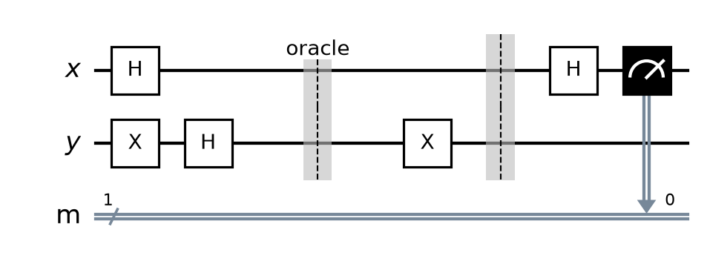
Figure 1: Deutsch circuit for f(x) = 1. The oracle is between the two barriers. The comparison run uses the same circuit with an empty oracle.

3. Code
Full Q# program (file: [RegNo]_Case03.qs). The oracle is in its own operation, and the first line of output prints the register numbers of all team members.
// 25DC2012 IA3 - Case 03: Deutsch's Algorithm, f(x) = 1
// Before submitting: rename this file to <YourRegNo>_Case03.qs and
// replace REG_NO_1, REG_NO_2, REG_NO_3 with your team's register numbers.

operation Main() : (Result, Result) {
Message("Register numbers: REG_NO_1, REG_NO_2, REG_NO_3");

// Run 1: our function f(x) = 1
let mine = RunDeutsch(OracleMine);
Message($"f(x) = 1 : measured x = {mine} -> {Verdict(mine)}");

// Run 2: comparison function f(x) = 0
let comparison = RunDeutsch(OracleZero);
Message($"f(x) = 0 : measured x = {comparison} -> {Verdict(comparison)}");

return (mine, comparison);
}

// Oracle for f(x) = 1: X(y)
operation OracleMine(x : Qubit, y : Qubit) : Unit {
X(y);
}

// Oracle for f(x) = 0: no gate
operation OracleZero(x : Qubit, y : Qubit) : Unit {
}

// Circuit: X(y) -> H on x and y -> oracle -> H(x) -> measure x
operation RunDeutsch(oracle : ((Qubit, Qubit) => Unit)) : Result {
use x = Qubit();
use y = Qubit();

X(y);
H(x);
H(y);
oracle(x, y);
H(x);

let result = M(x);
ResetAll([x, y]);
return result;
}

// 0 = constant, 1 = balanced
function Verdict(r : Result) : String {
return r == Zero ? "constant" | "balanced";
}

4. Output
The program runs the circuit twice: once with our oracle and once with the comparison oracle f(x) = 0. It prints both results after the register numbers.
[Insert screenshot: Q# code in VS Code]
Figure 2: Q# program in VS Code.
[Insert screenshot: output of both runs – register numbers must be visible]
Figure 3: Program output for both runs.

Observed result
- Our function f(x) = 1: measured x = 0, so the function is constant.
- Comparison function f(x) = 0: measured x = 0, so the function is constant.
- The result was the same every time we ran the program, because Deutsch's algorithm is deterministic and has no randomness in its output.

5. Answers

Q1. Explain phase kickback. Why is the ancilla prepared in |−⟩ (using X then H)? (3 marks)
Phase kickback happens when an oracle that looks like it should change the ancilla leaves the ancilla unchanged. Instead, it puts a phase on the input qubit.
The ancilla is prepared as |−⟩ = (|0⟩ − |1⟩)/√2: X turns |0⟩ into |1⟩, and H turns |1⟩ into |−⟩. The oracle maps |x⟩|y⟩ to |x⟩|y ⊕ f(x)⟩. If f(x) = 0, the ancilla stays (|0⟩ − |1⟩)/√2 = |−⟩. If f(x) = 1, it becomes (|1⟩ − |0⟩)/√2 = −|−⟩. So in both cases U_f|x⟩|−⟩ = (−1)^f(x) |x⟩|−⟩. The ancilla is unchanged, and the value of f(x) has been "kicked back" onto the input as the phase (−1)^f(x).
In our circuit x is in |+⟩, so after the oracle the input qubit is (1/√2)[−|0⟩ − |1⟩]. With f(0) = 1 and f(1) = 1, this is −|+⟩. The final H turns it into −|0⟩, so we measure 0 (constant). An overall minus sign is a global phase and cannot be measured. For the comparison function f(x) = 0, the input stays |+⟩, and H gives |0⟩ (constant).
If the ancilla were left in |0⟩ or |1⟩, the oracle would only write f(x) into the ancilla. No relative phase would appear on x, so measuring x once could not tell a constant function from a balanced one. That is why the ancilla must be prepared in |−⟩.

Q2. How many oracle calls does a classical computer need for a 1-bit function? How many did you use? (2 marks)
A classical computer needs 2 oracle calls. It must evaluate both f(0) and f(1), because knowing one value tells you nothing about the other.
Our quantum circuit used only 1 oracle call for each function. The single call evaluates f on |0⟩ and |1⟩ together (superposition), and phase kickback plus interference give us the global property f(0) ⊕ f(1) directly.

6. Conclusion and References

Conclusion
We implemented Deutsch's algorithm in Q# and showed that f(x) = 1 is constant using one oracle call, compared with two classically. We learned how preparing the ancilla in |−⟩ turns the oracle's output into a phase (phase kickback), and how the final Hadamard converts that phase into a measurable 0 or 1. Even though the speed-up is small, this is the simplest example of a quantum algorithm beating every classical algorithm in the number of queries.

References
- [Course textbook – author, title, publisher, year], Chapter 10, pp. 197–210.
- 25DC2012 lecture notes – Lecture 17 (Deutsch's algorithm).
- M. A. Nielsen and I. L. Chuang, Quantum Computation and Quantum Information, 10th anniversary ed., Cambridge University Press, 2010.
- Microsoft, "Azure Quantum Development Kit and Q# documentation," learn.microsoft.com/azure/quantum.
- IBM Quantum Learning, "Fundamentals of quantum algorithms," quantum.cloud.ibm.com/learning/en/courses/fundamentals-of-quantum-algorithms.
- D. Deutsch, "Quantum theory, the Church–Turing principle and the universal quantum computer," Proc. R. Soc. Lond. A, vol. 400, pp. 97–117, 1985.

