Karunya Institute of Technology and Sciences
Division of Data Science and Cyber Security
25DC2012 – Quantum Computing and Cryptography

Internal Assessment III – Quantum Algorithm Project
Project Report (Parts A and B)

Case 08: Deutsch–Jozsa Algorithm
Variant: f = x0 ⊕ x1 ⊕ x2 ⊕ 1

Team members
No. | Name | Register number
1 | [Name 1] | [Register number 1]
2 | [Name 2] | [Register number 2]
3 | [Name 3 – delete row if team of 2] | [Register number 3]

Submitted to: [Faculty name]
Date of submission: [Date]

2. Aim and Circuit

Aim
The aim is to find out whether a 3-bit Boolean function is constant (the same output for all 8 inputs) or balanced (0 for exactly half of the inputs and 1 for the other half) using a single oracle call. Our function is f = x0 ⊕ x1 ⊕ x2 ⊕ 1, which is balanced. We compare it with the constant function f = 1.

Circuit
- Four qubits are used: inputs q[0], q[1], q[2] and the ancilla y. All start in |0⟩.
- X(y) changes y to |1⟩. H is then applied to all four qubits, which creates an equal superposition of all 8 inputs and puts the ancilla in |−⟩.
- The oracle for f = x0 ⊕ x1 ⊕ x2 ⊕ 1 is CNOT(q[0], y), CNOT(q[1], y), CNOT(q[2], y), then X(y). For the comparison function f = 1 the oracle is only X(y).
- H is applied to q[0], q[1], q[2] again and they are measured. A result of 000 means constant; anything else means balanced.
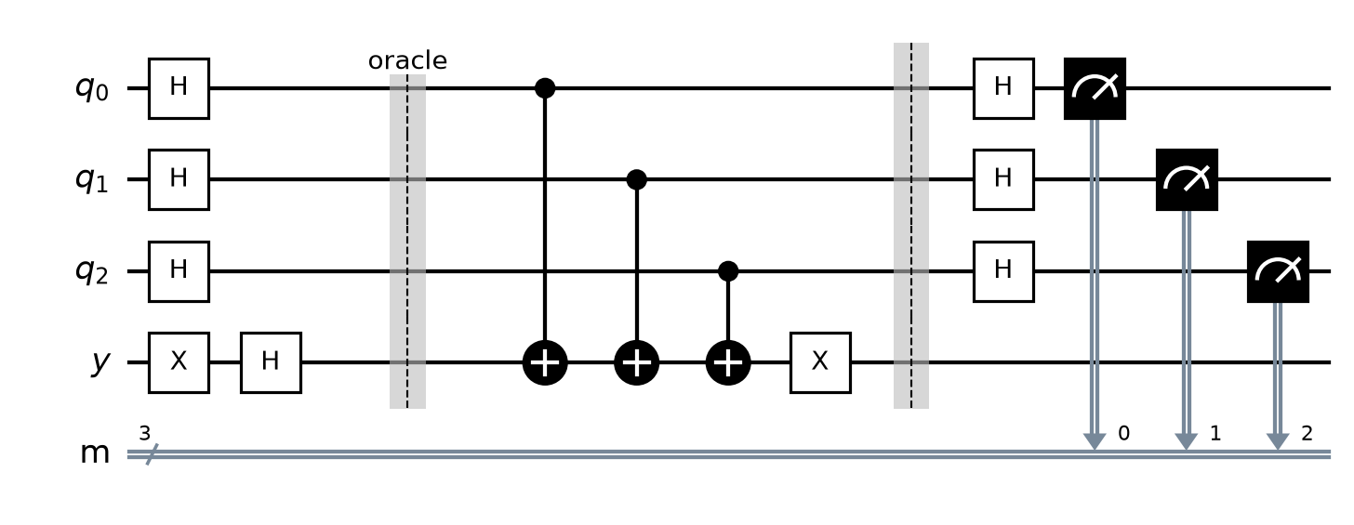
Figure 1: Deutsch–Jozsa circuit for f = x0 ⊕ x1 ⊕ x2 ⊕ 1. The oracle is between the barriers. The comparison run (f = 1) has only X(y) in the oracle.

3. Code
Full Q# program (file: [RegNo]_Case08.qs). The oracle is in its own operation, and the first line of output prints the register numbers of all team members.
// 25DC2012 IA3 - Case 08: Deutsch-Jozsa Algorithm, f = x0 XOR x1 XOR x2 XOR 1
// Before submitting: rename this file to <YourRegNo>_Case08.qs and
// replace REG_NO_1, REG_NO_2, REG_NO_3 with your team's register numbers.

operation Main() : (Result[], Result[]) {
Message("Register numbers: REG_NO_1, REG_NO_2, REG_NO_3");

// Run 1: our function f = x0 XOR x1 XOR x2 XOR 1 (balanced)
let mine = RunDeutschJozsa(OracleMine);
Message($"f = x0 XOR x1 XOR x2 XOR 1 : measured {BitString(mine)} -> {Verdict(mine)}");

// Run 2: comparison function f = 1 (constant)
let comparison = RunDeutschJozsa(OracleOne);
Message($"f = 1 : measured {BitString(comparison)} -> {Verdict(comparison)}");

return (mine, comparison);
}

// Oracle for f = x0 XOR x1 XOR x2 XOR 1: CNOT(q[0], y), CNOT(q[1], y), CNOT(q[2], y), then X(y)
operation OracleMine(q : Qubit[], y : Qubit) : Unit {
CNOT(q[0], y);
CNOT(q[1], y);
CNOT(q[2], y);
X(y);
}

// Oracle for f = 1: X(y) only
operation OracleOne(q : Qubit[], y : Qubit) : Unit {
X(y);
}

// Circuit: X(y) -> H on all 4 qubits -> oracle -> H on q[0], q[1], q[2] -> measure q
operation RunDeutschJozsa(oracle : ((Qubit[], Qubit) => Unit)) : Result[] {
use q = Qubit[3];
use y = Qubit();

X(y);
for i in 0..2 {
H(q[i]);
}
H(y);

oracle(q, y);

for i in 0..2 {
H(q[i]);
}

let results = [M(q[0]), M(q[1]), M(q[2])];
ResetAll(q + [y]);
return results;
}

// 000 = constant, anything else = balanced
function Verdict(results : Result[]) : String {
return BitString(results) == "000" ? "constant" | "balanced";
}

// Turns [q[0], q[1], ...] results into a string like "101" (q[0] first).
function BitString(results : Result[]) : String {
mutable s = "";
for r in results {
set s += r == One ? "1" | "0";
}
return s;
}

4. Output
The program runs the circuit twice: once with our oracle and once with the comparison oracle f = 1. It prints both results after the register numbers.
[Insert screenshot: Q# code in VS Code]
Figure 2: Q# program in VS Code.
[Insert screenshot: output of both runs – register numbers must be visible]
Figure 3: Program output for both runs.

Observed result
- Our function f = x0 ⊕ x1 ⊕ x2 ⊕ 1: measured q[0]q[1]q[2] = 111, which is not 000, so the function is balanced.
- Comparison function f = 1: measured 000, so the function is constant.
- Both results were the same on every run, because the algorithm is deterministic.

5. Answers

Q1. Explain why the result 000 means constant and any other result means balanced. Use the amplitude of |000⟩ in your answer. (3 marks)
With the ancilla in |−⟩, the oracle applies the phase (−1)^f(x) to each input through phase kickback. The input register becomes (1/√8) Σₓ (−1)^f(x) |x⟩. The final H⊗3 sends each |x⟩ to (1/√8) Σ_z (−1)^(x·z) |z⟩. For z = 000, x·z = 0 for every x, so the amplitude of |000⟩ is:
a(000) = (1/8) Σₓ (−1)^f(x)
Constant f = 1: every term is (−1)¹ = −1, so a(000) = (1/8)(−8) = −1 and P(000) = |a|² = 1. We always measure 000. (For f = 0 it would be +1, which gives the same probability.)
Our balanced function f = x0 ⊕ x1 ⊕ x2 ⊕ 1: f = 0 for the inputs x0x1x2 = 001, 010, 100, 111 and f = 1 for 000, 011, 101, 110. The sum is 4(+1) + 4(−1) = 0, so a(000) = 0 and P(000) = 0. The result 000 is impossible for a balanced function, so any other result proves the function is balanced.
We measured exactly 111. Our function is s·x ⊕ 1 with s = 111: the "⊕ 1" only adds a global phase of −1, so the final Hadamards return the bit pattern 111 of the variables used in f.

Q2. How many oracle calls does a classical computer need in the worst case for 3 bits? How many did you use? (2 marks)
There are 2³ = 8 possible inputs, and a balanced function gives 0 for 4 of them. In the worst case a classical computer sees 4 identical outputs and still can't decide, because those could be the four 0s of a balanced function. It needs 2^(n−1) + 1 = 4 + 1 = 5 calls.
Our quantum circuit used only 1 oracle call.

6. Conclusion and References

Conclusion
We implemented the Deutsch–Jozsa algorithm in Q# for f = x0 ⊕ x1 ⊕ x2 ⊕ 1 and correctly found that it is balanced (result 111) and that f = 1 is constant (result 000), with one oracle call instead of 5. We learned how the amplitude of |000⟩ is the average of (−1)^f(x), so interference cancels it exactly for a balanced function. This shows an exponential separation between quantum and deterministic classical query complexity.

References
- [Course textbook – author, title, publisher, year], Chapter 10, pp. 197–210.
- 25DC2012 lecture notes – Lecture 17 (Deutsch–Jozsa algorithm); textbook Figure 10.4.
- M. A. Nielsen and I. L. Chuang, Quantum Computation and Quantum Information, 10th anniversary ed., Cambridge University Press, 2010.
- Microsoft, "Azure Quantum Development Kit and Q# documentation," learn.microsoft.com/azure/quantum.
- IBM Quantum Learning, "Fundamentals of quantum algorithms," quantum.cloud.ibm.com/learning/en/courses/fundamentals-of-quantum-algorithms.
- D. Deutsch and R. Jozsa, "Rapid solution of problems by quantum computation," Proc. R. Soc. Lond. A, vol. 439, pp. 553–558, 1992.

